ABSTRACT
Improving the detrimental health consequences of Vitamin D deficiency in elderly patients receiving long-term prescription of anti-epileptic medication and lipid-lowering (statins) medication.
Harvard Medical School Post Graduate Education Safety, Quality, Informatics and Leadership (SCQIL) 1-year program (2020-2021) Capstone research project.
Background: Disease may cause malnutrition and malnutrition may cause disease. Long-term prescribed medicine may cause malnutrition and disease. This interconnected triad complex of malnutrition, disease and prescribed medication has a negative outcome not limited to patient safety and quality of patient care, but it also results in billions of Pounds wasted and ultimately putting strain on healthcare costs and resources in the United Kingdom.
The health problem that needs to be addressed is that drug-nutrient interactions causing malnutrition (nutrient deficiencies) receive very little attention from national health authorities, clinicians, pharmacists, medical school pharmacology departments, and pharmaceutical companies, despite the debilitating morbidity and mortality linked to prescribed medicine-induced malnutrition and disease, particularly in the elderly over 65 years of age. To the contrary, the focus is on side-effects and complications caused by drugs and drug-drug interactions.

Vitamin D deficiency is a global pandemic dilemma and > 30% of adults are reported as having low 25(OH)D levels and an even higher prevalence in elderly patients > 65 years without compromised renal function. Vitamin D deficiency is a possible aetiological factor in several chronic debilitating conditions associated with high risk of morbidity and mortality including cardio-vascular diseases, autoimmune diseases, inflammatory bowel disease, immune deficiency, upper respiratory tract infections, malignancies, osteoporosis, type 1 and 2 diabetes mellitus, statin-intolerance and neurodegenerative disorder e.g., Alzheimer’s disease. Vitamin D deficiency is also associated with statin-intolerance.
Epilepsy is the most common neurological disorder affecting approximately 50 million people worldwide. By the year 2037 it is estimated that 24% of the UK population will be over 65 years of age. However, from the age of 60 years the incidence of epilepsy increases sharply and results in increased healthcare costs not only due to prescribed anti-epileptic drugs (AEDs) but even more importantly due to AEDs-induced Vitamin D deficiency morbidity and mortality. Despite the widespread use of AEDs in the elderly there is limited information available on their kinetics in this age group and no formal practical guidelines for the management of bone disease among those taking AEDs.
The main aim is either alternative AEDs prescribing or deprescribing of AEDs that are strongly related to Vitamin D deficiency by 50% over a 12-month period. The secondary aim is to prescribe Vitamin D supplementation to patients who are Vitamin D deficient and for those patients who are statin-intolerance.
Methods: Proposing a pilot study using data collection instruments, electronic health records (EHRs) in one NHS Family Practice Clinic and two Community Pharmacies in a United Kingdom National Health Service Trust to identify elderly patients who are at risk from receiving long-term prescription AEDs.
Anticipated challenges and barriers include assembling a multidisciplinary care team to assess and provide timely interventions, obtaining funding for costly additional screening consultations and laboratory investigations enabling early identification of patients at risk of developing osteoporosis, statin-intolerance and incident type 2 diabetes mellitus, implementing a new clinical pathway during the Covid-19 pandemic, patients with Intellectual disability, poor literacy, language barriers and patient apprehension. Strategies to overcome barriers that can make complex elderly care more manageable include the 4Ms — What Matters, Medication, Mentation, and Mobility.
Sustainability depends on the study design, given the lack of a direct comparator group, and potentially finding low literacy might interfere with implementing the intervention.
Results: Successful feasibility and scalability of this project depends on the following factors: (1) The importance of his project in terms of having a big enough impact in health improvement that will lead to adoption and implementation by a National Health Trust. (2) Education and motivation of clinicians and auxiliary staff is key to performing the intervention successfully and the setting up of an outreach program in creating awareness of the detrimental health effects of AEDs in the elderly. (3) Obviously, training and IT infrastructure (EMR alerts and order sets) are necessary components of an effective alert system that is mainly managed by the Superintendent Pharmacist. (4) In terms of cost, a successful project will save private patients with access to health insurance, and the National Healthcare System (NHS), money due to the reduction in unwanted morbidity. (5) As regards the system, once it's programmed, it will be easily implemented, and data can be collated, analysed and feedback provided by pharmacists.
The goal is escalating this project on a United Kingdom nation-wide National Healthcare System level.
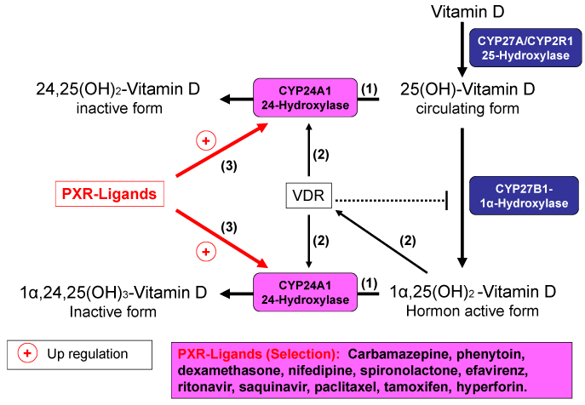
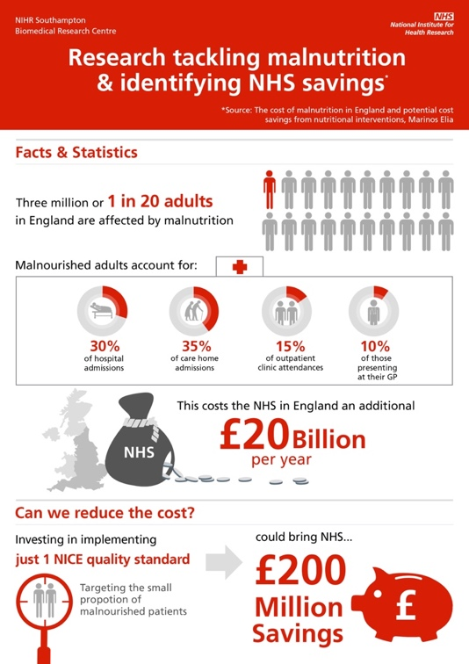

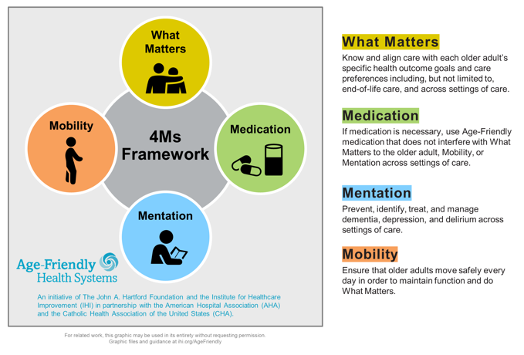
Bibliography

“Age-Friendly Health Systems: Guide to Using the 4Ms in the Care of Older Adults”, July 2020, Institute for Healthcare Improvement • ihi.org
http://www.ihi.org/Engage/Initiatives/Age-Friendly-Health-Systems/Documents/IHIAgeFriendlyHealthSystems_GuidetoUsing4MsCare.pdf

Arora E, Singh H, Gupta YK. “Impact of antiepileptic drugs on bone health: Need for monitoring, treatment, and prevention strategies”, J Family Med Prim Care 2016;5:248-53

“Atlas of Epilepsies”, Springer Science and Business Media LLC, 2010

Baker DW, Parker RM, Williams MV, et al. “The health care experience of patients with low literacy”, Arch Fam Med. 1996;5:329-34

Boucher Barbara J. “The Problems of Vitamin D Insufficiency in Older People”, Aging Dis. 2012 Aug; 3(4): 313–329

Charles P. Friedman, Adam K. Wong, David Blumenthal, “Achieving a Nationwide Learning Health System”, ScienceTranslationalMedicine, Vol 2 Issue 57, 2010

Gröber Uwe. “Common Drugs as Vitamin D disruptors”, Review Article J Transl Sci, March 26, 2020, Volume 6: 1-4. doi: 10.15761/JTS.1000378 (ISSN:2059-268X)

“Handbook of Clinical Nutrition and Aging”, Springer Nature, 2015

“Handbook of Drug-Nutrient Interactions”, Springer Science and Business Media LLC, 2010 (Humana Press)

Jane Murphy. “Malnutrition: A significant threat to our health as we age”, British Geriatric Society, Category: Nutrition, 2019 (www.bgs.co.uk)

Jonathan M. Teich, MD, PhD Department of Medicine and Emergency Medicine, Harvard Medical School Chief Medical Informatics Officer, InterSystems. “Clinical Decision Support for Improved Quality and Safety”, SQIL I Lecture 6, 2021

J. Zochling, Y.Y. Sitoh, T.C. lau, I.D. Cameron et al. “Quantitative Ultrasound of the Calcaneus and Falls Risk in the Institutionalised Elderly: sex differences and Relationship to Vitamin D Status”, Osteoporosis International, 2002

Jon Allard, Charlotte Lawthorn, William Henley, Brendan Mclean et al. “Eslicarbazepine Acetate response in Intellectual Disability population versus general population”, Acta Neurologica Scvandinavica, 2020

Miles S, Davis T. “Patients who can’t read: implications for the health care system”, JAMA. 1995; 274:1719–20
Parikh NS, Parker RM, Nurss JR, Baker DW, Williams MV. “Shame and health literacy: the unspoken connection”, Patient Educ Counsel. 1996; 27:33

Parker RM, Baker DW, Williams MV, Nurss JR. “The test of functional health literacy in adults: a new instrument for measuring patients’ literacy skills”, J Gen Intern Med. 1995;10:537–41

Philip N. Patsalos, †David J. Berry, ‡Blaise F. D. Bourgeois, §James C. Cloyd, ¶Tracy A. Glauser, #Svein I. Johannessen, $Ilo E. Leppik, ∗∗Torbjorn Tomson, and ††Emilio Perucca
“Antiepileptic drugs—best practice guidelines for therapeutic drug monitoring: A position paper by the sub commission on therapeutic drug monitoring”, The ILAE Commission on Therapeutic Strategies, Epilepsia, 49(7):1239–1276, 2008 doi: 10.1111/j.1528-1167.2008. 01561.x

Picton C BSc MBA MRPharmS, Wright H BPharm MRPharmS. “Medicines Optimisation: Helping patients to make the most of medicines”, Royal Pharmaceutical Society. May 2013.
https://www.rpharms.com/Portals/0/RPS%20document%20library/Open%20access/Policy/helping-patients-make-the-most-of-their-medicines.pdf

“Physical Health of Adults with Intellectual and Developmental Disabilities”, Springer Science and Business Media LLC, 2019

Royal College of Psychiatrists. “Prescribing anti-epileptic drugs for people with epilepsy and intellectual disability (ID)”, College Report CR206 October 2017.
https://www.rcpsych.ac.uk/improving-care/campaigning-for-better-mental-health-policy/college-reports/2017-college-reports/prescribing-anti-epileptic-drugs-for-people-with-epilepsy-and-intellectual-disability-cr206-oct-2017

Rebecca Stratton, Trevor Smith, and Simon Gabe. “Managing malnutrition to improve lives and save money”, Published on BAPEN (British Association of Parenteral and Enteral Nutrition) website www.bapen.org.uk. October 2018. ISBN: 978-1-899467-23-8
Simon Borghs*, Laura Byram, Jane Chan, Peter Dedeken, John Logan, Victor Kiri, Matthias Noack-Rink, Philip N. Patsalos and Solène Thieffry. “Comparing healthcare cost associated with the use of enzyme-inducing and non-enzyme active antiepileptic drugs in elderly patients with epilepsy in the UK: a long-term retrospective matched cohort study”, BMC Neurology (2020) 20:7. https://doi.org/10.1186/s12883-019-1587-9

Vicente Villaneuva, Juan Carlos Sanchez-Alvarez, Mar Carrerio, Javier Salas-Puig et al. “Initiating antiepilepsy treatment: “An update of expert consensus in Spain”, Epilepsy & Behavior, 2020

Williams MV, Parker RM, Baker DW, et al. “Inadequate functional health literacy among patients at two public hospitals”, JAMA. 1995; 274:1677–82

MJ Otto. 104 Oak Road, Tiptree CO50NA, Essex UK. +447540878775. jacquesotto@btinternet.com

