A longitudinal assessment of technical efficiency in the outpatient production of
maternal health services in México
EdsonServán-Mori, CarlosChivardi,*,Miguel Ángel Mendoza and Gustavo Nigenda

Abstract.
Introduction. We assess technical efficiency (TE) level for Mexican Ministry of Health (MoH) primary care units. Assessment was focused on the production of adequate maternal health services defined as the coverage level of women who received timely and frequent antenatal care, and institutional and medical care during childbirth.
Methodology. We conducted a longitudinal analysis of administrative and socio-demographic information concerning 233 health jurisdictions for the period 2008–15. Crude TE was calculated using window data envelopment analysis (Windows-DEA). Empirical analysis included the description of several factors affecting the production of maternal health services, including the heterogeneity and trends assessment of TE among health jurisdictions. We estimated a pooled regression model with robust standard errors to identify correlates of TE and estimated adjusted performance scores.
Results. Results indicate that while the production of adequate maternal- health services and TE in health jurisdictions proved insufficient, they rose by 22% (from 40.9% to 49.8%) and 14% (from 54.3% to 62%), respectively, over time. Furthermore, variance in efficiency among production units diminished and persistent regularities were observed. Performance was highest in the Northern as opposed to the Southern and Southeastern health jurisdictions, but low- est in the most marginalized zones of the country marked by economic inequality and the presence of indigenous populations.
Conclusions. The Mexican Health System has reached a paradoxical situation: the steady escalation of financial resources in the public health subsystem over the past 15 years has yielded sub-optimal results as regards coverage for essential maternal health interventions among the poorest. Mexican government must put in place a set of measures to guarantee efficiency in the system’s performance without affecting equity gains. This necessarily involves reconsidering, and where necessary replacing, the criteria behind the allocation and distribution of resources, as well as the mechanisms for controlling how resources are used and accountability is fulfilled.

Table 1. Production and availability of maternal-health services, and the contextual characteristics of the health jurisdictions analyzed. Mexico, 2008-2015
No. of health jurisdictions analyzed = 233 | 2008 | 2011 | 2015
No. of health jurisdictions analyzed = 233 | Average [SE]
Product (coverage at the level of health jurisdictions)
Antenatal care during pregnancy (A)** (%) | 95.6 [0.23] | 97.0 [0.14] | 97.4 [0.14]
Timely antenatal care (B)^{a,}** (%) | 67.3 [0.63] | 70.7 [0.52] | 73.6 [0.53]
Frequent antenatal care (C)^{b,}** (%) | 85.7 [0.41] | 88.0 [0.37] | 89.1 [0.32]
Institutional care during childbirth (D)^{c} (%) | 75.7 [1.01] | 79.3 [0.90] | 79.7 [0.88]
Medical care during childbirth (E)**, % | 95.6 [0.43] | 97.4 [0.25] | 97.3 [0.32]
Adequate maternal-health care (A-E)^{d,}** (%) | 40.9 [0.90] | 47.2 [0.84] | 49.8 [0.80]
Inputs (at the level of health jurisdictions)
Human resources
Medical and nursing students^{e,}** | 47.1 [2.23] | 46.3 [2.41] | 53.5 [2.73]
Medical and nursing staff^{f} | 145.0 [6.29] | 158.4 [6.86] | 177.3 [7.79]
Administrative staff^{g} | 6.2 [0.51] | 7.5 [0.67] | 5.9 [0.51]
Other staff^{h,}* | 26.0 [1.79] | 28.5 [1.91] | 32.1 [1.95]
Capital
Hospital beds earmarked for specific purposes* | 29.1 [3.04] | 18.8 [2.77] | 11.3 [2.64]
Doctor’s offices* | 61.9 [2.65] | 66.1 [2.86] | 68.0 [2.98]
Delivery rooms* | 14.8 [1.72] | 13.8 [1.73] | 7.3 [1.43]
Contextual characteristics
At the level of health jurisdictions
Marginalization index** (%) | 31.1 [0.93] | 31.2 [0.93] | 31.3 [0.91]
Cumulative SP coverage** (%) | 59.0 [1.47] | 86.4 [0.80] | 87.2 [0.80]
Demand for maternal-health services^{i,}** (%) | 67.2 [0.20] | 67.3 [0.18] | 67.4 [0.16]
Gini coefficient | 47.2 [0.26] | 39.3 [0.18] | 39.3 [0.18]
Indigenous population** (%) | 9.3 [1.17] | 9.3 [1.15] | 9.2 [1.14]
At the state level
Type of political party in control
Right-wing* | 18.88 [0.02] | 13.73 [0.02] | 5.57 [0.01]
Center* | 61.80 [0.03] | 65.23 [0.03] | 67.81 [0.03]
Left-wing | 19.31 [0.02] | 12.87 [0.02] | 17.16 [0.02]
Other (alliances and other parties) | ncr | 8.15 [0.01] | 9.44 [0.01]
Notes: ^{a-i} Operational definitions are shown in Table 1; ncr: no cases reported; ** p<0.01, * p<0.05, + p<0.10

Table 3. Contextual factors affecting efficiency in the production of maternal-health services. Mexico, 2008-2015
 | Coefficient [SE]
Average [SE] technical efficiency score observed, 2008-2015 (%) | 60.1 [0.30]
At the level of health jurisdictions
Marginalization index (%)¶ | -0.12**
Marginalization index (%)¶ | [0.04]
Cumulative SP coverage (%)¶ | 0.13**
Cumulative SP coverage (%)¶ | [0.03]
Demand for maternal-health services¶ | -3.10**
Demand for maternal-health services¶ | [0.18]
Gini coefficient (%)¶ | -0.40**
Gini coefficient (%)¶ | [0.13]
Indigenous population (%)¶ | -0.15**
Indigenous population (%)¶ | [0.03]
At the state level
Type of political party in control (ref.: right-wing)¶
Center | 0.98
Center | [1.38]
Left-wing | -2.15
Left-wing | [1.86]
Other (alliances and other parties) | -0.26
Other (alliances and other parties) | [2.58]
No. of health jurisdictions | 233
R² | 0.51
Note: ¶Operational definitions are shown in Table 1. Standard error in brackets; ** p<0.01, * p<0.05, + p<0.10. Estimated model included a dummy variable of each state and year (results not shown).

Table 4. Adjusted technical efficiency scores: production of maternal-health services in the health jurisdictions analyzed. Mexico, 2008-2015
No. of health jurisdictions = 233 | 2008 | 2009 | 2010 | 2011 | 2012 | 2013 | 2014 | 2015 | p for trend
No. of health jurisdictions = 233 | Average [SE] |  |  |  |  |  |  |  | p for trend
Adjusted technical efficiency scores | 52.5 [0.84] | 56.9 [0.83] | 58.4 [0.82] | 60.8 [0.82] | 61.7 [0.83] | 62.6 [0.82] | 63.5 [0.83] | 63.8 [0.83] | <0.01
Mín. | 21.1 | 26.3 | 27.9 | 32.7 | 34.5 | 36.8 | 36.5 | 35.4 | ---
Max. | 90.6 | 93.1 | 93.2 | 98.5 | 99.6 | 100 | 100 | 100 | ---
Max./Mín. | 4.3 | 3.5 | 3.3 | 3.0 | 2.9 | 2.7 | 2.7 | 2.8 | ---
By socioeconomic regions**
Region 1: lowest | 39.8 [1.69] | 44.0 [1.68] | 46.0 [1.77] | 47.7 [1.81] | 47.8 [1.84] | 49.4 [1.70] | 49.9 [1.75] | 49.8 [1.79] | <0.01
Region 2 | 53.4 [1.43] | 57.8 [1.41] | 59.2 [1.42] | 61.3 [1.38] | 62.1 [1.39] | 62.2 [1.32] | 63.2 [1.31] | 63.6 [1.31] | <0.01
Region 3 | 58.0 [2.32] | 62.7 [2.28] | 64.0 [2.33] | 68.4 [2.38] | 69.4 [2.37] | 70.2 [2.38] | 71.3 [2.37] | 71.7 [2.37] | <0.01
Region 4 | 47.8 [2.30] | 52.3 [2.23] | 54.4 [2.12] | 56.2 [2.06] | 57.1 [2.03] | 57.8 [2.00] | 58.5 [2.03] | 58.9 [1.99] | <0.01
Region 5 | 57.4 [2.26] | 61.2 [2.25] | 63.1 [2.19] | 65.0 [2.16] | 66.0 [2.16] | 66.7 [2.15] | 67.8 [2.17] | 68.2 [2.16] | <0.01
Region 6: highest | 55.1 [1.49] | 59.7 [1.47] | 60.7 [1.49] | 63.5 [1.48] | 64.8 [1.53] | 66.5 [1.57] | 67.9 [1.60] | 68.0 [1.60] | <0.01
Difference test between regions (p-val) | <0.01 | <0.01 | <0.01 | <0.01 | <0.01 | <0.01 | <0.01 | <0.01 | ----

Note:**We grouped the states into socio-demographic regions according to the INEGI classification: region 1: Chiapas, Oaxaca and Guerrero; region 2: Campeche, Tabasco, Veracruz, Puebla, San Luis Potosí and Hidalgo; region 3: Durango, Zacatecas, Guanajuato, Michoacán and Tlaxcala; region 4: Nayarit, Sinaloa, Colima, Querétaro, State of Mexico, Morelos, Quintana-Roo and Yucatán; region 5: Baja California, Sonora, Tamaulipas and Chihuahua; region 6: Coahuila, Nuevo León, Jalisco, Aguascalientes, and Mexico City.

Fig. 2 Mapa de eficiencia técnica ajustada en la producción de servicios de salud materna por jurisdicción sanitaria: 2008-2015

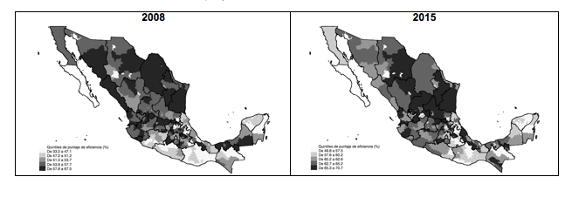

Figure 1. Kernel density of the crude and adjusted technical efficiency scores for the period 2008-2015
Crude efficiency score | Adjusted efficiency score
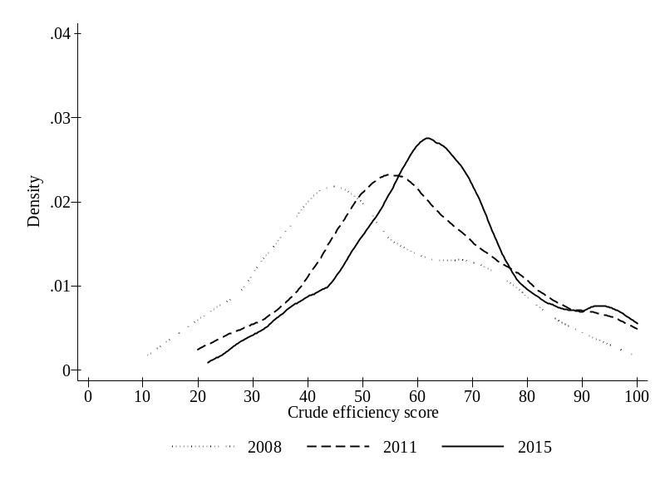 | 