Don’t be mistaken! (true or false)
A rare case of true broad ligament fibroid
Prutha B ¹ Jyothi Rao ²

INTRODUCTION

Broad ligament fibroid is a benign smooth muscle tumor (1%) which arises from the uterine smooth muscle or hormone sensitive broad ligament smooth muscle.
False broad ligament fibroid - originates from uterus but grows laterally between the two layers of the broad ligament with attachment to the uterus. Uterine vessels and ureter lie lateral to fibroid
True broad ligament fibroid - arises from muscle fibres normally found in the mesometrium. Ureter is medial to the mass.

CASE STUDY

A 45 years old P1L1A1 with LMP - 18/11/21 came with complaints of urinary incontinence since 2 to 3 years. Also lower abdominal pain since 3 months with regular menstrual cycles.
On examination, moderately built and nourished with mass corresponding to 20 weeks size on per abdomen. On per speculum cervix pulled up. Bimanually uterus cannot be made separately. Cervix pulled up. Multiple masses felt more on the right side extending upto the umbilicus. Restricted mobility.
Relevant investigations sent and were within normal parameters. Usg abdomen and pelvis : a large 12*13 cm hypoechoic solid mass seen in the right adnexa. This mass extends till the umbilical quadrant- f/s/o large right broad ligament fibroid. Another 5*6 cm solid hypoechoic mass seen in the vesicouterine pouch adherent to the wall of the cervix - ? cervical fibroid. Both ovaries are not separately visualised.

MRI pelvis:

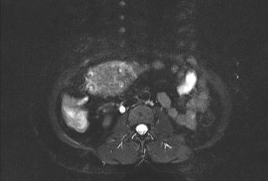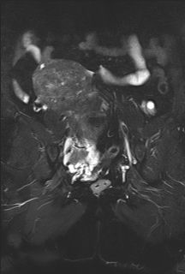

Impression

- A large well defined heterogenous predominantly T1/T2 hypointense lesion with a few cystic areas in the pelvis
- Differentials : Broad ligament fibroid
solid right ovarian tumor
fibroid uterus

INTRAOPERATIVE FINDINGS

Uterus corresponding to 20 to 24 weeks size. Firm in consistency, restricted mobility.
Uterus atrophic, pushed towards left.The uterus and mass separately visualised.Right fallopian tube stretched. A large bosselated true broad ligament fibroid of 18*20 cms noted at the mesometrium of broad ligament extending up to umbilicus. Right and left fallopian tube and ovary normal morphology.
Myomectomy with Total abdominal hysterectomy and bilateral salpingo-oophorectomy done.
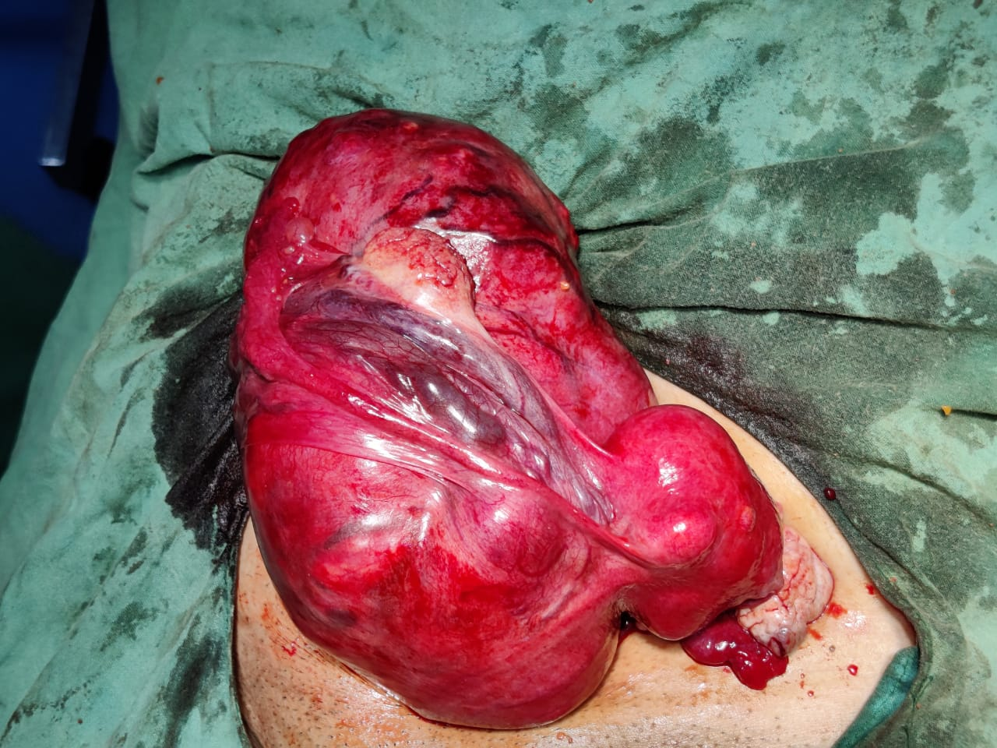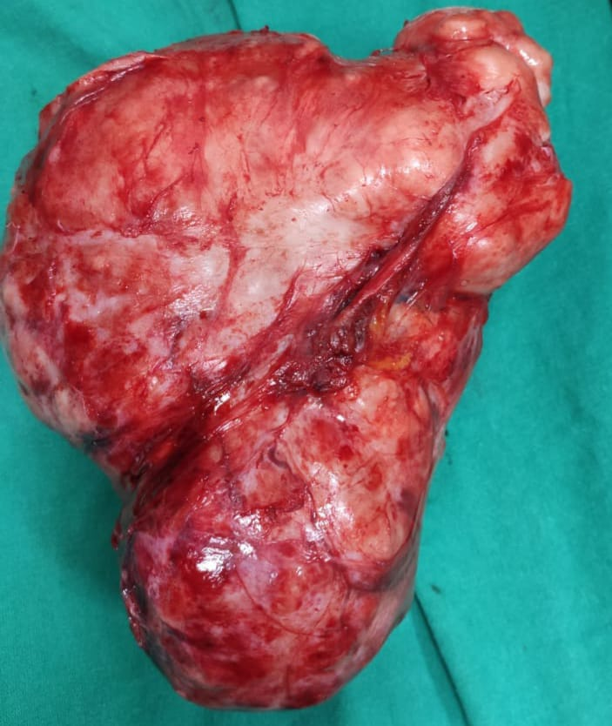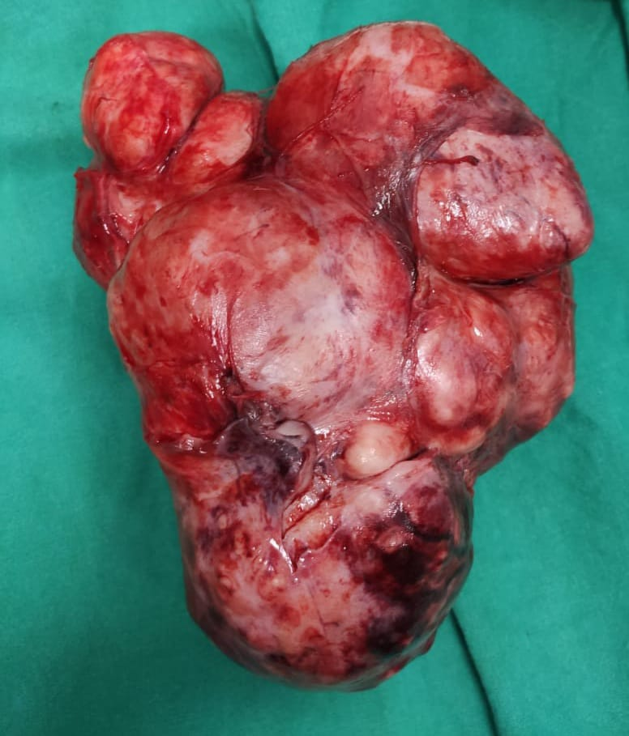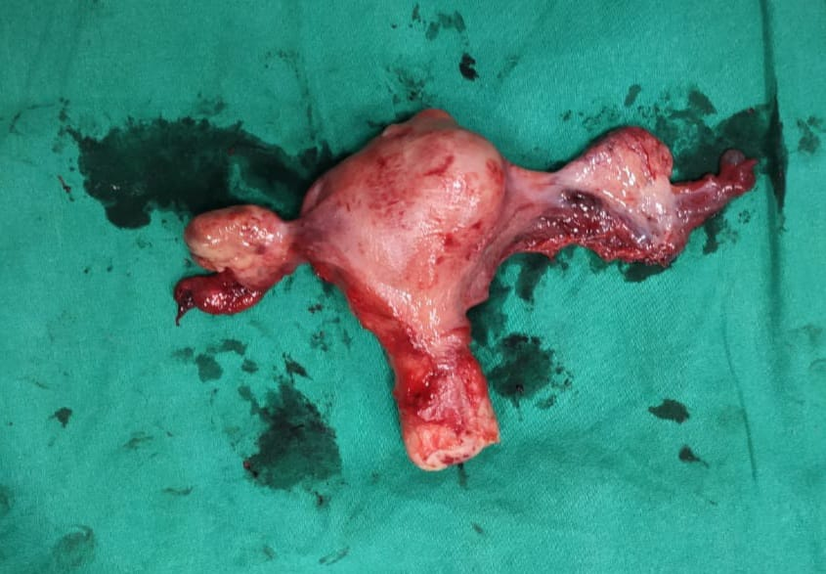
HISTOPATHOLOGY REPORT:
Impression: Leiomyoma with hyaline degeneration
Left fallopian tube showed adenomatoid tumor

DISCUSSION

Broad ligament fibroids ; also known as parasitic leiomyomas. While in most cases it is asymptomatic, patients may present as pelvic pain or a palpable mass. When long standing, the pain may be as a result of pressure effects on adjacent organs or due to complicating torsion and also causing urinary incontinence due to pressure on the bladder. In ultrasound it is usually seen as hypoechoic, solid, well circumscribed adnexal mass. In MRI, T1- iso to low signal; T2- typically low signal. If pedunculated, torsion of leiomyoma can occur. Da vinci system is also applied in hospitals for laparoscopic approach.
Differential diagnosis: pedunculated subserosal leiomyoma projecting towards the broad ligament, ovarian fibroma, brenner tumor, neurofibroma in the pelvis

CONCLUSION

True broad ligament fibroid rarely causes clinical manifestations distorting the pelvic anatomy. Preop diagnosis is important to prevent further injury to pelvic organs.Further trans vaginal ultrasound with doppler might help in determining the degree of attachment, location and vascularity between the uterus and the broad ligament fibroid.MRI helped in confirming the diagnosis. In broad ligament fibroid the mainstay of management is surgical.

References
https://pubmed.ncbi.nlm.nih.gov/ https://onlinelibrary.wiley.com/doi/10.1002/(SICI)1097-0096(199909)27:7%3C402:
:AID-JCU7%3E3.0.CO;2-Whttps://pubs.rsna.org/doi/10.1148/rg.287085095

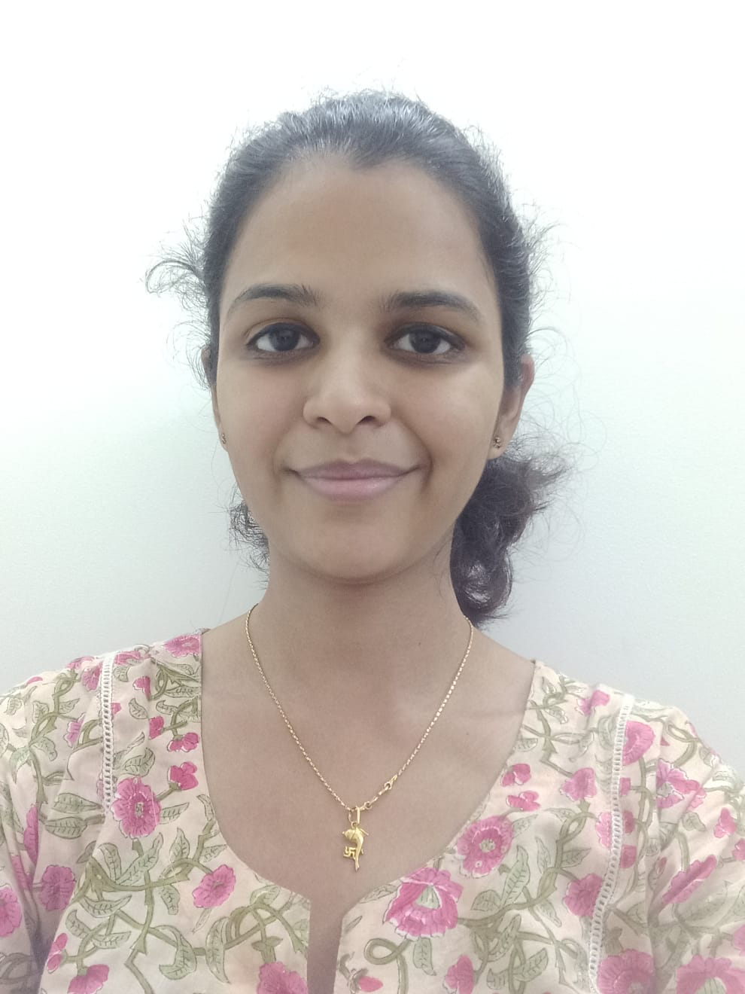

Dr. Prutha B is currently pursuing her Post graduation degree in MS Obstetrics and Gynecology in Kasturba Medical College Mangalore. Her interests lie in research work, infertility clinics. This being her first of the many research works, looks forward to all the support and constructive criticism.
Email:- pruthabyathnal92@gmail.com

Presenting author details
Full name:- Dr. Prutha B
Contact number:- 9620370935
Linked in account:- pruthabyathnal92@gmail.com
Category:- e-poster

