Title :“ TVSS” in female stress urinary incontinence: A Novel Technique. 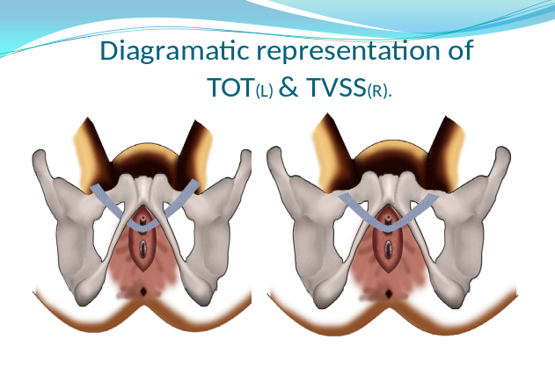
Name: Dr.Abdul Rouf khawaja
Sheri Kashmir institute of Medical sciences Srinagar Kashmir India

Introduction:
we describe a new simple ,minimally invasive,easy to learn technique,which we term as transvaginal subfascial sling (TVSS),in which the ends of mid urethral sling are brought out superficial to ischiopubic rami without piercing the obturator membrane.
Aim and objectives:
To assess the effectiveness of novel technique (TVSS) in comparison to standard TOT in female stress incontinence . (Results and complications).
Materials and Methods:
The patients (206 )were distributed into 2 comparable groups (Group A as TOT and Group B as TVSS) , . Postoperatively patients were checked for improvement in stress incontinence,urinary retention,voiding difficulty and denovo urge incontinence.
Results:
Symptomatic improvement after the procedure was seen in all patients with complete resolution of symptoms in 91 patients (91.%) in the TOT-O group (group A) versus 96 patients (90.56%) in the TVSS (group B).. Mesh incision was done in 1 (1%) versus none (0%), and local mesh excision for mesh erosion in 2 (2%) versus 1 (0.9%) at 3 months after the procedure in the TOT-O group and the TVSS group, respectively
Conclusion:
The TVSS as a novel technique for female SUI is less invasive, simpler to learn, with less postoperative pain with resolution of SUI, rapid recovery, and good personal satisfaction compared to the standard TOT-O in procedure.
Biography
Dr Abdul Rouf khawaja is working as additional professor with subspeciality as uroncologist and reconstructive surgeon .I have published more than 30 papers in reputed journals.
Presenting author details
Full name :Dr Abdul Rouf khawaja
Contact Number :+91 9419087992
Session name/number: Uro Gynecology.
Category: Oral presentation.

