HOLOPROSENCEPHALY : A CASE REPORT
Firman Budi Setiawan, MD
Email : simatupangbudie@gmail.com
Klinik HMC Kandis, Siak Districts, Riau Province, Indonesia

ABSTRACT
Background : Holoprosencephaly is a rare spectrum of cerebral and facial malformation that can be detected by routine ultrasound during antenatal care. Estimated to occur in 1 of 10.000 – 20.000 live births. Management for such cases need multidiscipline collaboration, ethics and psicosocial.
Case : A twenty five years old gravida presented for routine obstetric ultrasonography. There were no symptoms or signs suggestive of any clinical condition. The patient had no history of diabetes mellitus, hypertension and no history take a medicine. On examination vital signs are normal. Abdominal examination uterus at level umbilical; cephalic presentation; fetus heart sound 142 bpm. Mother haemoglobin level 9.4 gr/dl. Ultrasonography revealed a single live fetus of calculated gestation age of 20 weeks, fundal placentation, liquor volume was adequate, Both thalami are fused and corpus callosum, interhemispheric fissure, cavum septum pellucidum & 3rd ventricle is absent. Cerebellum is markedly hypoplastic with a median single eye, absence of nose.
Disccusion : The etiology of holoprosencephaly indicates interactions with both genetic and environmental factors, including chromosomal anomalies, teratogens and several risk factors have been proposed, including smoking habits, alcoholism, maternal diabetes mellitus, pregnancy infections and use of medications during pregnancy. In this case we get the mother is likely to be infected from a cat because she often brings the cat in bed. look for the exact cause need chromosome examination and Toxoplasma screening.
Conclusions : patients diagnosed with HPE should receive individualized management despite possible complications; in general, Treatment is symptomatic and supportive. Prognosis of HPE depends on the severity of brain abnormalities, facial malformations and clinical complications.
Keywords : congenital anomaly, holoprosencephaly, prenatal ultrasonography
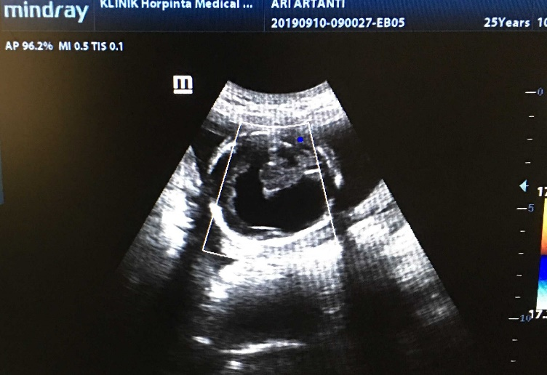
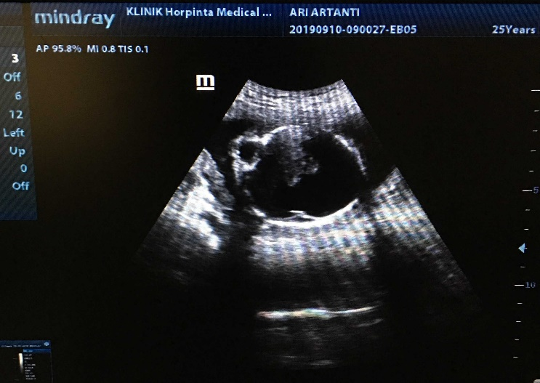
Biografi
I get Bachelor Degree in Medicine from The Methodist University of Indonesia in Medan. Have strong leadership, integrity and good interpersonal skill.
Author:
Full Name: FIRMAN BUDI SETIAWAN
Contact Number: +6285277711147
Instagram: dr_budiesimatupang


