Metabolic profiling and targeted lipidomics in small for gestational age and fetal growth restriction

Jezid Miranda, MD, MSc

Fetal i+D Fetal Medicine Research, BCNatal – Barcelona Center for Maternal-Fetal and Neonatal Medicine (Hospital Clínic and Hospital Sant Joan de Deu), Institut Clinic de Ginecologia, Obstetricia i Neonatologia, IDIBAPS, University of Barcelona, and Centre for Biomedical Research on Rare Diseases (CIBER-ER), Barcelona, Spain.

Abstract (300 word limit)
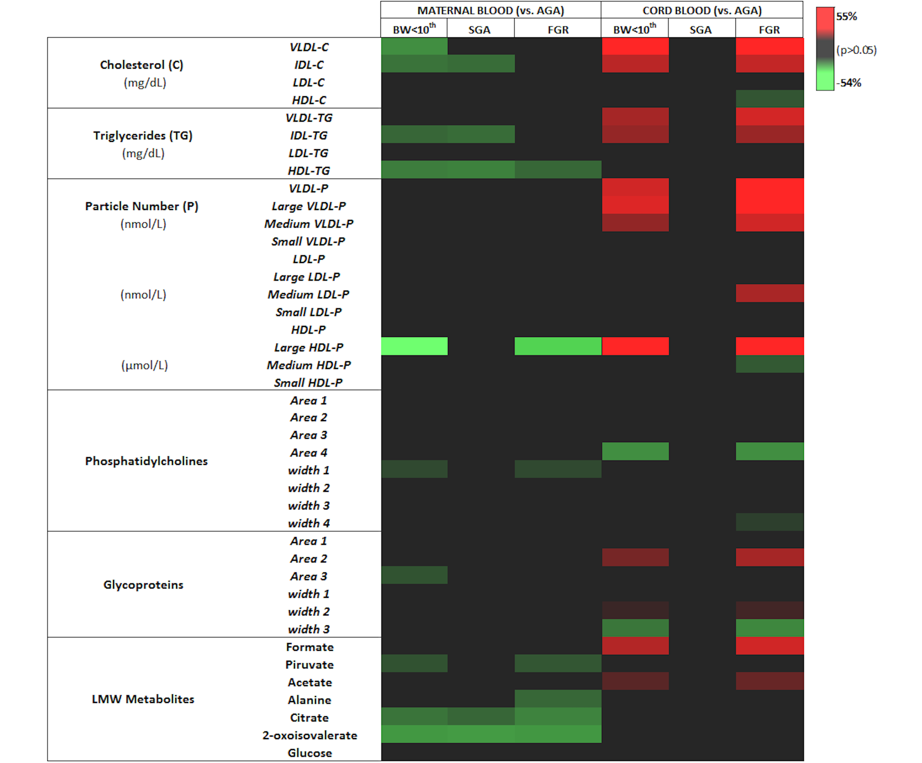
Statement of the Problem: While fetal smallness is, overall, associated with poor perinatal outcomes, small fetuses can be clinically categorized under two phenotypes: small for gestational age (SGA) and fetal growth restriction (FGR). SGA is usually associated with near-normal perinatal outcomes, whereas FGR is characterized by fetoplacental Doppler changes and a higher risk of fetal death and poor perinatal outcome. It is unclear whether these clinical phenotypes are different entities or represent variable degrees of severity of the same condition. Large-scale studies of metabolites (metabolomics) are key to understanding cellular metabolism and pathophysiology and might aid in the identification of specific changes in metabolites classes and subclasses that underpin metabolic responses to pathologic conditions. The purpose of this study was to characterize metabolic profile changes in maternal and umbilical cord blood plasma in full-term singleton gestations with different clinical phenotypes of fetal smallness. Methodology & Theoretical Orientation: Herein, maternal and cord blood plasma samples were used for NMR-based metabolic fingerprinting and profiling, including analysis of the enrichment of circulating lipid classes and subclasses, as well as the number of sub-fraction particles and their size. Changes in phosphatidylcholines and glycoproteins were prominent in growth-restricted fetuses indicating significant alterations in their abundance and biophysical properties. Lipoprotein profiles showed significantly lower plasma concentrations of cholesterol-intermediate density lipoprotein (IDL), triglycerides-IDL and –high-density lipoprotein (HDL) in mothers of growth-restricted fetuses compared to controls (p<0.05). In contrast, growth-restricted fetuses had significantly higher plasma concentrations of cholesterol and triglycerides transporting lipoproteins [LDL, IDL, and VLDL, (p<0.005; all)], as well as increased VLDL particle types (large, medium and small). Significant changes in plasma concentrations of formate, histidine, isoleucine and citrate in growth-restricted fetuses were also observed. Comprehensive metabolic profiling reveals that both, mother and fetuses of pregnancies complicated with fetal growth restriction have a substantial disruption in lipid metabolism.

Image

Figure legend: Heat map following metabolomic profiling on the annotated and significant (among the three groups) identified in plasma samples of mothers and neonates. A colored heat map of significant LMW metabolites and the Liposcale analysis along with their p-values, and percentage of fold change was obtained to visualize and characterize the differences between adequate for gestational age (AGA), small-for-gestational age (SGA) and fetal growth restriction (FGR) groups from maternal and umbilical cord blood. Fold change of significant differences (p<0.05) for each metabolite are on a graded color scale from green (lower value) to black (no differences) to red (high values).

Recent Publications (minimum 5)
• Miranda J, Paules C, Nair S, Lai A, Palma C, Scholz-Romero K, Rice GE, Gratacos E, Crispi F, Salomon C. Placental exosomes profile in maternal and fetal circulation in intrauterine growth restriction - Liquid biopsies to monitoring fetal growth. Placenta. 2018 Apr;64:34-43.
• Crispi F, Miranda J, Gratacós E. Long-term cardiovascular consequences of fetal growth restriction: biology, clinical implications, and opportunities for prevention of adult disease. Am J Obstet Gynecol. 2018 Feb;218(2S):S869-S879.
• Levinson A, Miranda J, Rojas-Suarez JA. Predictors of Maternal Mortality and Prognostic Models in Obstetric Patients. Semin Respir Crit Care Med. 2017 Apr;38(2):191-200.
• Miranda J, Rodriguez-Lopez M, Triunfo S, Sairanen M, Kouru H, Parra-Saavedra M, Crovetto F, Figueras F, Crispi F, Gratacos E. Prediction of fetal growth restriction using estimated fetal weight vs. a combined screening model in the third trimester. Ultrasound Obstet Gynecol. 2017 Nov;50(5):603-611
• Miranda J, Triunfo S, Rodriguez-Lopez M, Sairanen M, Kouru H, Parra-Saavedra M, Crovetto F, Figueras F, Crispi F, Gratacos E. Performance of a third trimester combined screening model for the prediction of adverse perinatal outcome. Ultrasound Obstet Gynecol. 2017 Sep;50(3):353-360.

Photograph



Biography (150 word limit)
Obstetrician at the Maternal-Fetal Medicine Unit of BCNatal (Hospital Clinic and San Joan de Deu, Barcelona, ​​Spain). Subspecialist in Maternal Fetal Medicine, currently a PhD candidate in the Fetal I&D Medicine Research Center and FetalMed PhD, the only worldwide consortium developed in three centers of excellence in fetal and perinatal medicine in Europe: Barcelona (Spain), Leuven (Belgium) and Lund (Sweden). Large experience in translational research with emphasis on biomarkers in several pregnancy complications, such as preterm labor, placental pathology, prevention of maternal and perinatal morbidity and mortality. As a result of this research, it has published more than 20 articles in international journals with impact factor. Committed to an academic career, member of evaluation commits for research projects in maternal and perinatal health as well as associate reviewer in international journals of Gynecology and Obstetrics.
Email: jemiranda@clinic.ub.es

Notes/Comments:

