Outer retinal changes in preeclampsia

Tehila Avitan
Department of Obstetrics and Gynecology, Shaare Zedek MedicalCenter

Joel Hanhart
Department of Ophthalmology, Shaare Zedek Medical Center,
Jerusalem, Israel

Yishay Weill
Department of Ophthalmology, Shaare Zedek Medical Center,
Jerusalem, I srael

Sorina Grisaru-Granovsky
Department of Obstetrics and Gynecology, Shaare Zedek Medical
Center

David Zadok
Department of Ophthalmology, Shaare Zedek Medical Center,
Jerusalem, Israel

Objective

The most common ocular finding in preeclampsia is severe arteriolar spasm. Optical Coherence Tomography (OCT) provides a non-invasive technique for visualization of the various retinal layers.
The purpose of the study is to describe vascular retinal changes seen in preeclampsia.

Study Design

Swept source OCT was used during the study. We extracted depth-integrated images using the IMAGEnet software by selecting the outer retina in accordance with the automated layer segmentation system.

Results

We report a case of a primigravida 40-year-old pregnant with monochorionic twins. She was admitted at 29 weeks of gestation due to elevated blood pressure (BP) without proteinuria. Blood tests were normal. Visual acuity was 20/20 bilaterally and funduscopy unremarkable. During hospitalization, the patient developed preeclampsia manifested by increasing BP and proteinuria. At 33 weeks the patient complained of bilateral visual blur. The visual acuity was right 3/20, left 2/20, as bilateral extensive, punctate, pale-yellow Elschnig's spots were present in the posterior fundus. We also noticed bilaterally swollen discs, discrete left peripapillary flame-shaped hemorrhages as well as some degree of macular edema. At that time, the BP increased and a cesarean section was performed. Two healthy babies were delivered. Over the next three weeks, as the patient recovered hemodynamically and visually the optic disc regained its usual appearance and the spots gradually faded.

Figure 1 illustrates the deep retinal changes over time. The first row consists of images taken at admission, four weeks prior to the onset of preeclampsia. It shows regular deep retinal vasculature (first column) and en-face pattern (second column) without any exudation (third column).
At the paroxysmal phase (second row) there is diffuse structural changes well beyond the area of thickened retina. Two days later (third row), as the blood pressure is regularized and proteinuria resolving, the general changes in vascular texture persist but the central avascular area looks closer to baseline. Peripapillary macular edema is decreasing.
Ten days later (last row), after substantial decrease of the retinal thickness, the overall texture of the deep vascular plexus has not returned to its initial state but the central avascular area looks normalized.

Conclusion

OCT analysis revealed extensive outer retinal changes. No similar changes were detected at the level of the superficial capillary plexus (figure 2) or at other selected planes.

The described ocular findings should be regarded as the first documentation of the selective effect of preeclampsia on the deep vascular plexus and outer retina.

With its angiographic modalities, OCT should improve our understanding on the impact of preeclampsia on the retina. This novel modalities, considered to be safe in pregancy, are crucial in characterizing vascular and structural changes in normal and complicated pregnancy.

Figure 1: OCT-A composite image of the different vascular plexuses at the acute phase
The retinal large vessels and the superficial plexus appear in orange and the deep plexus in green. Peripapillary, the disappearance of the vascular signal can at least partially be attributed to the macular edema. While the large vessels superficial plexus is preserved, the deep plexus looks inhomogeneous, sectorially absent and perifoveally irregular.

OCT-A: optical coherence tomography angiography
. 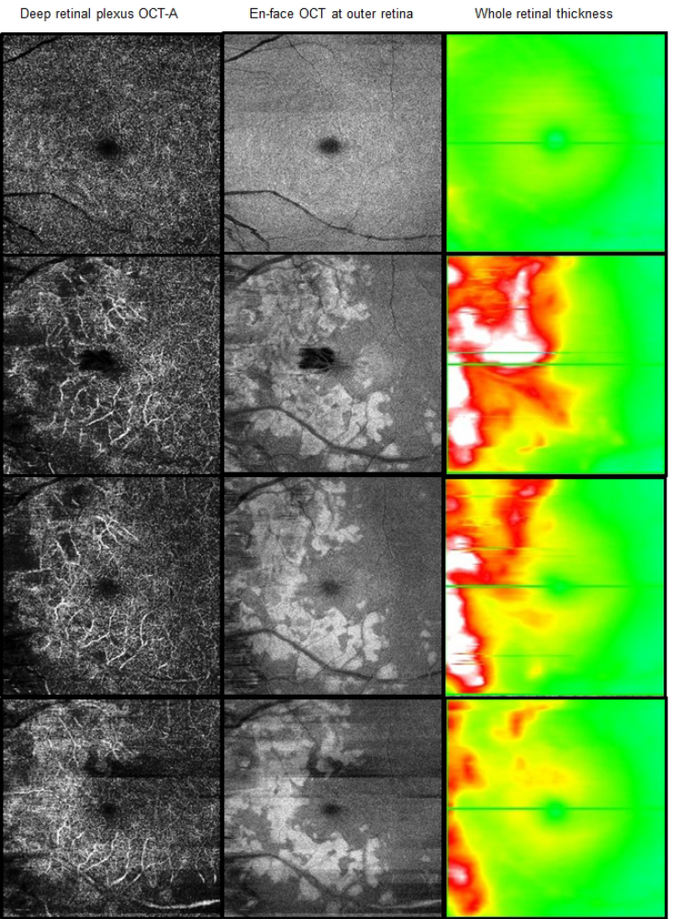

Figure 2: OCT-A composite image of the different vascular plexuses at the acute phase
The retinal large vessels and the superficial plexus appear in orange and the
deep plexus in green. Peripapillary, the disappearance of the vascular signal can at least partially be attributed to the macular edema. While the large vessels of the superficial plexus are preserved, the deep plexus looks non-homogeneous, sectorially absent and perifoveally irregular.
