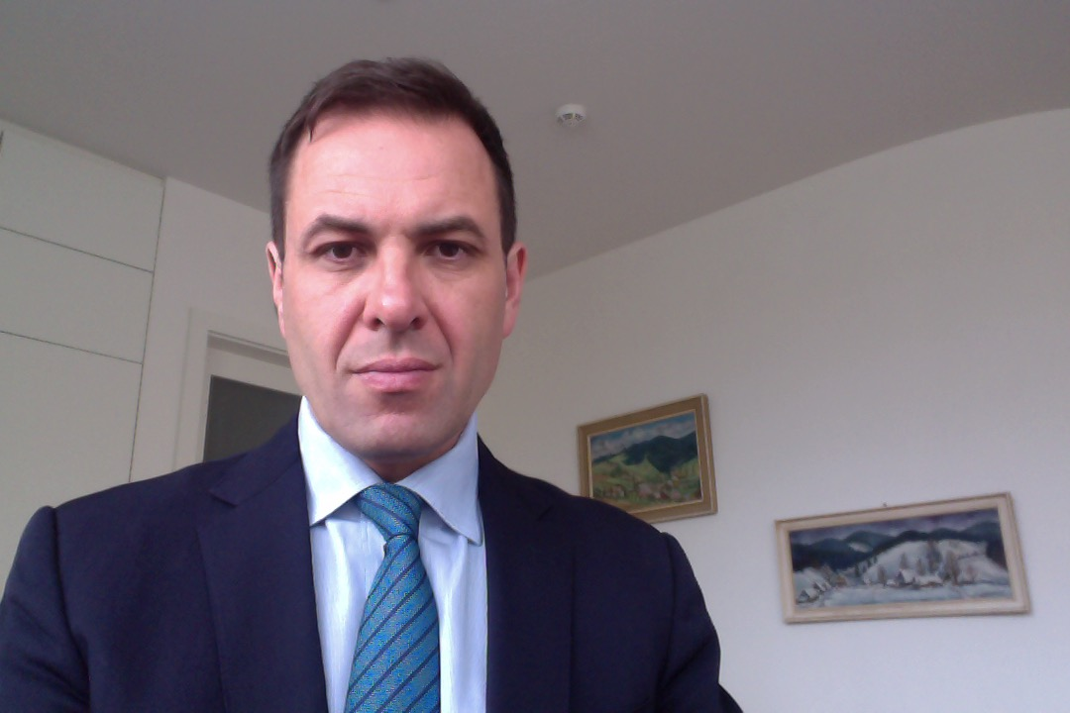

BIOGRAPHY:

Ian M. Vasicka was born and raised in New York City. In 1995, he obtained his B.A. from the University of Vermont and M.D. from the First Faculty of Medicine of the Charles University in Prague in 2004. Dr. Vasicka trained as a specialist in obstetrics and gynecology at the University Hospitals of Charles University in Prague developing research interests in pelvic floor disorders, clinical obstetrics, and gynecological surgery. He has published in various high impact peer-review journals and presented his work at both national and international meetings. Dr. Vasicka serves as an editorial board member of the International Urogynecology Journal (Blue Journal) and active member of numerous professional societies including the Society for Reproductive Investigation (previously SGI), International Urogynecological Association (IUGA), Society of Laparoendoscopic and Robotic Surgeons (SLS), and New European Surgical Academy (NESA).

Ian M. Vasicka, M.D.
(+420) 605.914.746
ivasicka@hotmail.com
linkedin.com/in/ian-vasicka-81a313a5
https://scholar.harvard.edu/ivasicka
Gynecological Surgery
Oral Presentation

