SEEING DOUBLE
A CASE OF DOUBLE PRIMARY CANCER: NEUROENDOCRINE TUMOR OF THE OVARY AND ENDOMETRIAL ADENOCARCINOMA IN A 45 YEAR OLD NULLIGRAVID

ABSTRACT

A 45 year old nulligravid presented with changes in sensorium after losing balance and hitting her head, with noted symptoms of restlessness, disorientedness and intermittent febrile episodes. Upon work-up, serum calcium and parathyroid hormone were noted to be significantly elevated. Investigating the pathology of hypercalcemia led to an incidental finding of a pelvoabdominal mass. Computed tomography (CT) scan of the whole abdomen showed a heterogeneously enhancing mass noted in the bilateral hemipelvis measuring 8.5 x 5.0 x 6.4 cm in the right and 3.4 x 2.5 x 4.1 cm in the left and pelvic and retroperitoneal lymphadenopathy, for which a neoplastic process was considered, probably gynecologic in origin. With the aforementioned signs and symptoms, patient was managed as a case of Pelvoabdominal mass, to consider Anti-NMDAR encephalitis vs. Parathyroid hormone-secreting tumor vs. Germ Cell tumor of the ovary. Patient underwent extrafascial abdominal hysterectomy with bilateral salpingoophorectomy, bilateral lymph node dissection with frozen section. Intraoperatively, tumor was found to be on the paratubal area of the right fallopian tube. It was then sent for frozen section revealing a histopathologic diagnosis of metastatic high grade papillary adenocarcinoma. Other specimens that were submitted include the cervix, uterus, ovaries left fallopian tube had a final histopathologic diagnosis of a mixed endometrioid and undifferentiated carcinoma with carcinoma involving more than half of the myomterial depth with invasion into the cervix, right and left parametria, right and left fallopian tube and ovaries. Lymph node dissection also revealed an extensive lymphovascular invasion. The specimens were stained with synaptophysin and chromogranin A, two of the most common used neuroendocrine markers. It was then confirmed that there are two separate malignancies present in the patient, the Endometrial Endometrioid Adenocarcinoma (Figo Grade 1) well differentiated, confined to the endometrium and the other, a Large cell Neuroendocrine carcinoma involving the right and left ovaries with extension to bilateral fallopian tube, bilateral parametria and invasion into the myometrium and cervix
Metastatic large cell neuroendocrine carcinoma to the pelvic lymph nodes.
Neuroendocrine tumors are spectrum of malignancies that arise from the diffuse neuroendocrine cell system that can cause debilitating symptoms and potentially life threatening conditions for patients. At present, neuroendocrine tumors of the gynecologic tract are increasingly common, and pose a significant clinical challenge because of the tumor heterogeneity and lack of standardized guidelines for treatment (Gardner, Reidy-Lagunes & Gehrig, 2011)

INTRODUCTION

Neuroendocrine tumors (NETs), are abnormal growths that begin in the neuroendocrine cells, which are widely spread out throughout the body with various histologic and biologic behaviors. While some features of NETs are unique to the site of origin, other characteristics are shared, like their endocrine differentiation potential. In the ovary, the term neuroendocrine relates mainly to widely known carcinoids which at present, is rare and infrequent. Nonetheless, NETs of the ovary still provide a diagnostic and clinical challenge.
Neuroendocrine tumors are rarely encountered in the gynecologic tract; comprising approximately 2% of all gynecological tumors (Chun et al., 2015). While most occur in the cervix, they can also arise from other sites including vulva, vagina, uterus, and ovary. Carcinoid tumors represent 0.1 % of organic lesions of the ovary (Moubaker et al., 2013). They mostly belong to surface epithelial neoplasms which express endocrine pathway of differentiation. This type of tumor, resulting in germ cells, is considered in the WHO classification as a highly specialized teratoma.
Often the correct diagnosis is not made until years after the onset of symptoms. The relative rarity of these diseases and the lack of specificity of the symptoms make them often be diagnosed several years after onset. Several factors are responsible for the late diagnosis of neuroendocrine tumors: slow evolution, primary tumor of ten small and little talking symptoms. Symptoms of neuroendocrine tumors are often nonspecific such as redness in the face, diarrhea, asthma and abdominal pain and sometimes confused with more common diseases (“Carcinoid Syndrome- NORD (National Organization for Rare Disorders)”, 2017)

CASE REPORT

A 45 year old, nulligravid, a known diabetic and hypertensive came in with a history of fall after losing her balance. There was no noted headache, blurring of vision, nausea or vomiting, however she sustained a superficial lapceration at the occipital area. CT scan of the head was done which was negative for any kind of bleeding or mass that may result from the trauma. She was sent home stable. Three days after being discharged there was noted incoherent speech, disorientedness and restlessness. This was accompanied by intermittent febrile episodes. Persistence of symptoms prompted consult in our institution.

At the emergency room, she presented with restlessness, incoherent speech, hallucinations and visual disturbances. Vital signs showed elevated temperature of 38.1C and high blood pressure at 200/110 mmHg. Primary work up was requested where there was low potassium (3.30 mEqs/L), elevated calcium 17.24 mg/dl and creatinine (1.44 mg/dl). She was admitted and had an emergency dialysis.
Upon admission, the following were the problems that needed attention: neurologic symptoms, hypoglycemia, hypertension and elevated calcium levels. For the neurologic symptoms such as lethargy, incoherent speech, disorientedness and hallucinations, a CT scan of the brain was done which was unremarkable. Lumbar tap was done and the CSF was sent for analysis which showed elevated protein (48.7) and glucose (71.16) and was positive for Neisseria meningitides and Streptoccocus pneumoniae. EEG reading was noted to be abnormal. At this time, Bacterial encephalitis was being considered from neurology standpoint. With the results of the CSF analysis, infectious disease then started the patient on Ceftriaxone and Ampicillin. Cause of infection at this time is still being investigated hence, CSF was subjected for PCR which had a negative result.
The cause of hypercalcemia was the primary problem of the case. With the level of calcium on admission at 17.24 mg/dl, aggressive management was warranted. Patient was subjected to emergency dialysis along with low potassium and an elevated creatinine. To the best of our knowledge, hypercalcemia may be caused by hyperparathyroidism or a paraneoplastic syndrome thus, thyroid ultrasound with color doppler and intact parathyroid hormone was done. Results showed a normal thyroid gland and a significantly elevated intact parathyroid hormone at 306.7 pg/ml (normal 15-65 pg/ml). At this point, working impression was Hyperparathyroidism, Hypercalcemia and bacterial encephalitis was agreed upon.

On physical examination, an incidental finding of a fixed, firm hypogastric mass was noted measuring 8 x 6 cm. Whole abdominal ultrasound was done revealing a heterogeneously enhancing mass noted in the bilateral hemipelvis measuring 8.5 x 5.0 x 6.4 cm in the right and 3.4 x 2.5 x 4.1 cm in the left and pelvic and retroperitoneal lymphadenopathy, for which a neoplastic process was considered, probably gynecologic in origin. Patient was then referred to OBGYN for further evaluation. Pelvic examination revealed: cervix short and soft, 1 cm dilated with a nodular firm mass at 10 o’clock position, a nodular mass located at the upper 1/3 of the vagina, mobile uterus enlarged to 18 weeks size. A bilateral fixed firm adnexal mass was appreciated approximately 8 cm. This concluded a working diagnosis of “Primary parathyroid Secreting Hormone probably Ovarian Mass”. At that time, plan to do exploratory laparotomy with frozen section, possible extrafascial hysterectomy with bilateral salpingoophorectomy was suggested once the patient is medically stable.

After optimizing the patient for planned surgery, she underwent extrafascial hysterectomy with bilateral salpingoophorectomy with frozen section under combined epidural-spinal anesthesia. Pertinent intraoperative findings were as follows: enlarged uterus measuring 10.5 x 10 x 5.5 cm, right and left ovary was converted into a solid structure that measured approximately 7-9 cm. The ovaries have a whitish firm and soft cut surface. There was a ruptured area in the right ovarian serosa with friable tissues extending out and encroaching the right paratubal area. The right and left fallopian tube were dilated but intact. On cut section of the uterus, there were brownish polypoid masses at the posterofundal area of the endometrial cavity with no myometrial invasion noted. The cervix was friable with a 1 x 1 cm nodular mass at the 10 o’clock position. There were multiple solid lymph nodes in both the right and left external, internal and obturator lymph nodes measuring 1-3 cm. The left fallopian tube, a cream, soft tubular tissue measuring 4.1 x 1.1 cm with papillary like projections was sent for frozen section. Frozen section diagnosis was a “metastatic high grade papillary adenocarcinoma”. The tumor was located on the paratubal area of the right fallopian tube. The uterine corpus, cervix, right and left ovaries, right and left fallopian tube, right and left pelvic lymph nodes and omentum was subsequently sent for histopathology. The case had a histopathologic diagnosis of a “Mixed endometrioid and undifferentiated carcinoma”. Carcinoma involves more than half of the myomterial depth with invasion into the cervix, right and left parametria, right and left fallopian tube and ovaries. Lymph node dissection revealed an extensive lymphovascular invasion, with 10 out of 17 right pelvic lymph nodes and 12 out of 12 left pelvic lymph nodes were positive for tumor metastasis. No tumor present in the omentum. The specimens were sent for immunostaining using Synapthophysin and Chromogranin which showed positive and weakly positive in the invasive tumor cells, respectively in both the myometrium and ovary. These two stains are the most common neuroendocrine markers that are used in practice. The case was then signed out as a Large cell Neuroendocrine carcinoma involving the right and left ovaries with extension to bilateral fallopian tube, bilateral parametria and invasion into the myometrium and cervix and Metastatic large cell neuroendocrine carcinoma to the pelvic lymph nodes (Figo Stage IIIA), Endometrial Endometrioid Adenocarcinoma (Figo Grade 1) well differentiated, confined to the endometrium (Figo Stage 1). Patient was then advised combined chemotherapy post operatively with Carboplatin 450 mg and Paclitaxel 270 mg.

DISCUSSION
Neuroendocrine cells are present in the normal epithelium of the female genital tract. It has been shown that primitive endodermal cells have the potential to differentiate into both endocrine and other cell types and that ovarian neuroendocrine tumors may develop from non-neuroendocrine cells through activation of genes that promote neuroendocrine differentiation (Ki, Park, Lee, Bae & Hur, 2014).
Cervical small cell carcinoma and ovarian carcinoid are the most common gynecological neuroendocrine tumor. They are known to behave aggressively and in a benign fashion respectively. Neuroendocrine differentiation may be expressed in a variety of ovarian neoplasms including surface epithelial tumor, Sertoli-Leydig cell tumors, teratomas, carcinoid tumor, small cell carcinoma of pulmonary type, small cell carcinoma of hypercalcemic type, and non-small cell undifferentiated carcinoma of neuroendocrine type (Lopes Dias, Cunha, Gomes, Callé & Félix, 2015). In the process of growth, these tumors may or may not secrete hormones. According to Moubaker et al., 2013 they are classified according to several criteria: location of the tumor; type of secretion of tumor (or lack of secretion); level of proliferation: speed cell division; level of differentiation of cells: cancer cells are they close to normal cell or have they lost their basic characteristics; size of the tumor and the presence or absence of metastases. Although there are many types of neuroendocrine tumor, they are treated as a separate group because the cells of these tumors have several common features: they are physically quite similar neoplasms and produce a secretory granule often with a production biogenic amines and hormones (polypeptides) (Moubaker et al., 2013). Primary carcinoid tumors of the ovary account for less than 5% of all carcinoid tumors and for less than 0.1% of all ovarian neoplasms. The median age of diagnosis is 55 years of age (range 17– 83 years) (Gardner, Reidy-Lagunes & Gehrig, 2011.

The majority of women with primary ovarian carcinoid tumors are found incidentally on cross sectional or ultrasound imaging. Rarely, they may also present with abdominal pain, constipation, hirsutism and a pelvic mass. Some of these tumors secrete substances such as serotonin and may be responsible for: episodes of redness in the face and neck, episodes of infectious diarrhea without cause, asthma attacks, abdominal pain and chest pain. However, there are some symptoms that typical and often attributed to other illnesses such as irritable bowel syndrome or Crohn’s disease. Furthermore 50% of neuroendocrine tumors are not accompanied by these symptoms and are therefore diagnosed only when their size becomes too large or by chance during physical examination.

At present, there are specific blood tests have been studied to help in the diagnosis and monitoring of neuroendocrine tumors. According to Moubaker et al., 2013, various hormones can be secreted by several neuroendocrine tumor. CA125 is a tumor antigen found in 75% to 83% of all epithelial ovarian cancer which can be used to monitor epithelial ovarian cancer. According to another study by Ngan et.al, 5-hydroxyindole acetic acid (5-HIAA) is a tumor marker that is markedly increased in neuroendocrine carcinomas of the ovary, thus making it also a sensitive marker. The neuroendocrine differentiation of the tumors can be confirmed by non-hormonal immunohistochemical stainings that is positive for chromogranin, synaptophysin, and CD56 which are the most common neuroendocrine markers used in practice. The special substance called Chromogranin A is found in the blood, regardless of the location and type of neuroendocrine tumor. In certain circumstances where there is increased blood levels of the chromogranin, dosages of specific hormones can be utilized to specify what type of neuroendocrine tumor it is. A positive chromogranin staining is diagnostic of a neuroendocrine tumor alongside with synaptophysin. Imaging studies such as CT Scan and magnetic resonance can help in the localization of the tumor. Moreover, it can determine the size of the tumor; whether there are metastases in other organs such as the liver. In addition, we must keep in mind that in order to diagnose endocrine differentiation within a tumor, we should first see the histological characteristics suggesting such differentiation and apply special studies to confirm the suspicion.
Unlike some tumors, the rarity of the neuroendocrine tumor of the ovary posts a therapeutic challenge. General consensus on the standard therapy has not been established. (Gardner, Reidy-Lagunes & Gehrig, 2011) states that in the ovarian carcinoid tumors, fertility sparing surgery is permissible since these tumors are mostly unilateral with good prognosis. The surgical approach can include everything from fertility sparing surgery to radical debulking dependent on patient age and disease distribution. At present, standard surgical principles apply for neuroendocrine tumors. In young patients with an isolated ovarian tumor, conservative surgery of fertility in combination with adjuvant chemotherapy may be applied. However, it is important to take note that there are no clear recommendations regarding surgical management of ovarian carcinoid or ovarian NETs. Adjuvant treatment with chemotherapy should then be presented to the patient. With regards to chemotherapy, the recommendation is somewhat similar to that for small cell lung cancer, with Platinum and Etoposide as the drug of choice. Carboplatin offers convenience of delivery. Reed et. al states that reports of carboplatin and paclitaxel and the dose-dense weekly schedule offers potential cure in this type of cancer. Due to paucity of literature and heterogeneity in presentation and response to surgery, chemotherapy, and radiation it is difficult to predict the efficacy of surgical debulking, chemotherapy and radiation protocols, hence there is a need for prospective clinical studies for most optimal modalities of treatment. May be a combination of optimal debulking, adjuvant chemotherapy (ifosamide, mesna, and cisplatin) with close follow up of patients and use of radiation when appropriate may improve the progression free and survival rates of this rare tumor. Relapse is often observed in younger patients, hence, second or third line therapies may be tried. Standard patterns of follow up are highly encouraged, mainly relying on clinical, immunohistochemical markers and imaging examinations (Shakuntala, Uma Devi, Shobha, Bafna & Geetashree, 2012).

CONCLUSION

Neuroendocrine tumors consist of a spectrum of malignancies that arise from the diffuse neuroendocrine cell system. Prognosis is dependent on histologic subtype and site of origin. Symptoms of neuroendocrine tumors are often and confused with more common diseases. Often the correct diagnosis is not made until years after the onset of symptoms. The relative rarity of these diseases and the lack of specificity of the symptoms make them often be diagnosed several years after onset. Primary NETs rarely seen in the female reproductive system thus, creating a clinical and diagnostic challenges because of their rarity significant clinical challenge. Thus, further studies regarding this type of tumor is of importance at our present time.

APPENDICES

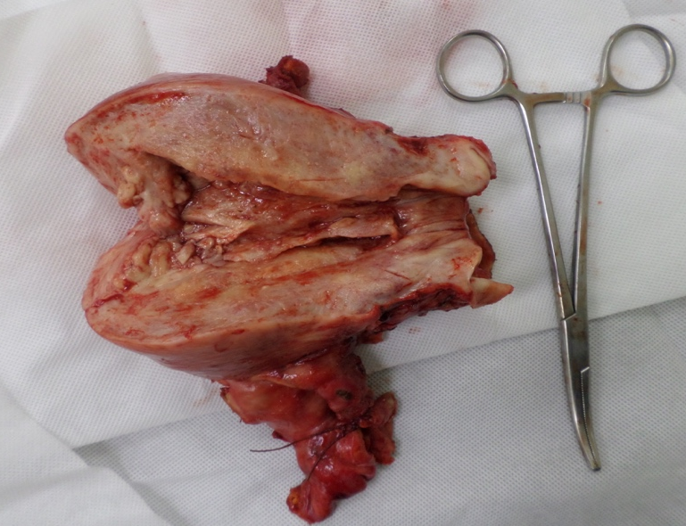
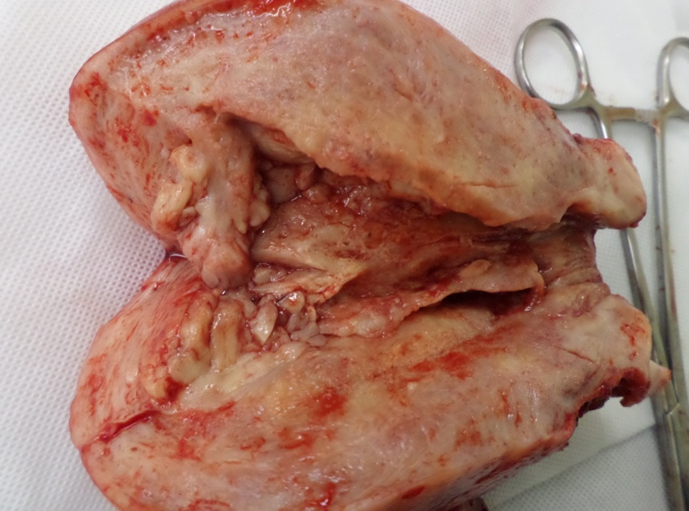

Figure 1. The uterus was enlarged measuring 10.5 x 10 x 5.5 cm, right and left ovary was converted into a solid structure that measured approximately 7-9 cm.

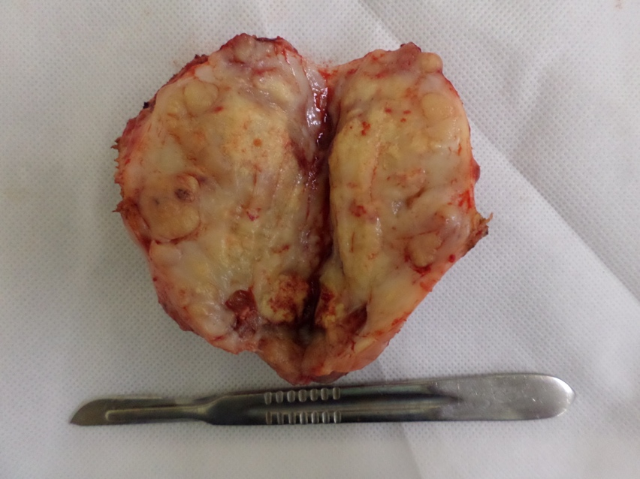

Figure 2. The ovary has a whitish firm and soft cut surface. There was a ruptured area in the right ovarianserosa with friable tissues extending out and encroaching the right paratubal area.

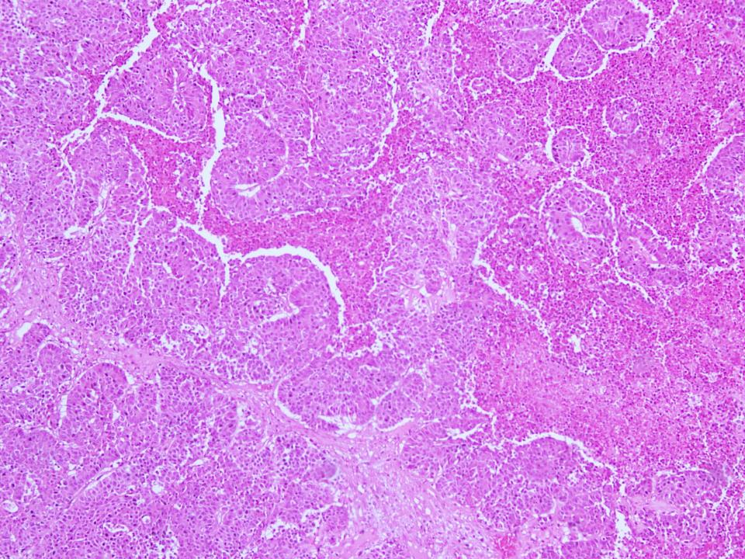

Figure 3. The ovarian tumor on low power view. Grossly there are nests of neoplastic cells with the background of necrosis. It has enlarged round to polygonal cells with scanty to moderate eosinophilic cytoplasm and frequent mitotic figures.
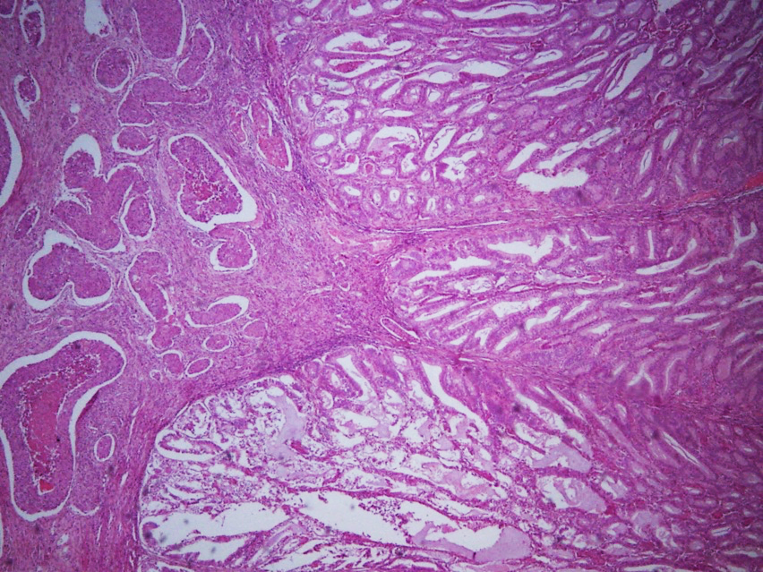

Figure 4. This slide shows two different tumors. on the left, is the myometrium infiltrated by the high grade large cell neuroendocrine carcinoma from the ovary. At the right side, which is the endometrium we can see the low grade endometrial endometrioid adenocarcinoma confined to the endometrium.

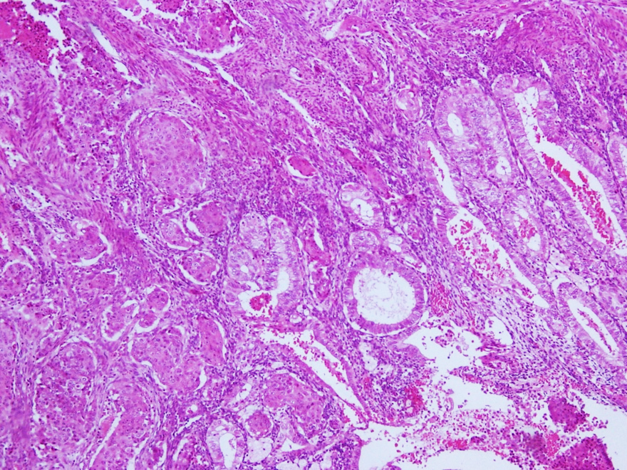

Figure 5. The same neuroendocrine cells from the ovary are seen infiltrating up to the myometrium at the (upper left side of the picture). Seen on the lower part of the slide, is the endometrium which is lined by neoplastic cells, this time forming back to back glandular pattern.
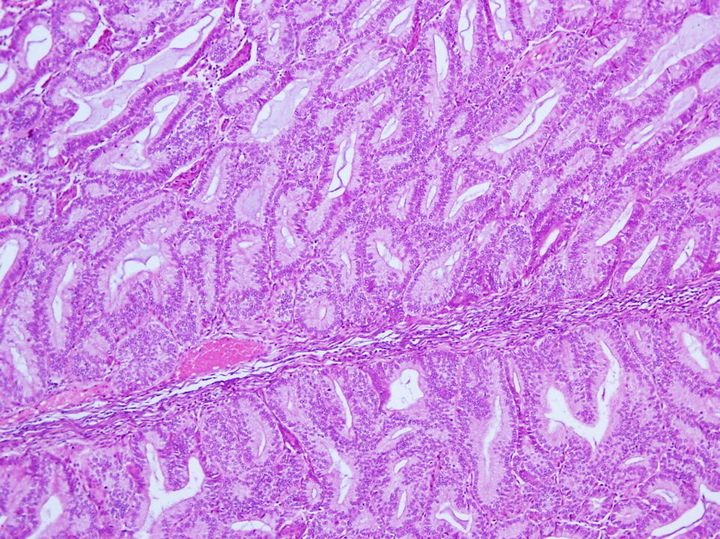

Figure 6. Closer view of the endomerial endometrioid adenocarcinoma shows neoplastic columnar cells forming back to back pattern suggestive of a neoplastic process.

REFERENCES

[1] Gardner, G., Reidy-Lagunes, D., & Gehrig, P. (2011). Neuroendocrine tumors of the gynecologic tract: A Society of Gynecologic Oncology (SGO) clinical document. Gynecologic Oncology, 122(1), 190-198. http://dx.doi.org/10.1016/j.ygyno.2011.04.011

[2] Moubaker, H., Errarhay, S., Mahmoud, S., Bennani, A., Bouchikhi, C., Amarti, A., & Banani, A. (2013). Neuroendocrine tumors of the ovary: What support?. Open Journal Of Obstetrics And Gynecology, 03(10), 739-742. http://dx.doi.org/10.4236/ojog.2013.310136

[3] Chun, Y. (2015). Neuroendocrine Tumors of the Female Reproductive Tract: A Literature Review. Journal Of Pathology And Translational Medicine, 49(6), 450-461. http://dx.doi.org/10.4132/jptm.2015.09.20

[4] Carcinoid Syndrome - NORD (National Organization for Rare Disorders). (2017). NORD (National Organization for Rare Disorders). Retrieved 26 July 2017, from https://rarediseases.org/rare-diseases/carcinoid-syndrome/

[5] Ki, E., Park, J., Lee, K., Bae, S., & Hur, S. (2014). Large cell neuroendocrine carcinoma of the ovary: a case report and a brief review of the literature. World Journal Of Surgical Oncology, 12(1), 314. http://dx.doi.org/10.1186/1477-7819-12-314

[6] What are neuroendocrine tumors (NETs)? - Cancer Treatment Centers of America | CTCA. (2017). CancerCenter.com. Retrieved 26 July 2017, from http://www.cancercenter.com/neuroendocrine-tumors/

[7] Lopes Dias, J., Cunha, T., Gomes, F., Callé, C., & Félix, A. (2015). Neuroendocrine tumours of the female genital tract: a case-based imaging review with pathological correlation. Insights Into Imaging, 6(1), 43-52. http://dx.doi.org/10.1007/s13244-014-0378-5

[8] Reed, N. (2016). Neuroendocrine tumours of the gynecological tract. Current Opinion In Oncology, 28(5), 412-418. http://dx.doi.org/10.1097/cco.0000000000000321

[9] Shakuntala, P., Uma Devi, K., Shobha, K., Bafna, U., & Geetashree, M. (2012). Pure Large Cell Neuroendocrine Carcinoma of Ovary: A Rare Clinical Entity and Review of Literature. Case Reports In Oncological Medicine, 2012, 1-4. http://dx.doi.org/10.1155/2012/120727

[10] (2017). Retrieved 26 July 2017, from https://www.researchgate.net/publication/13755801_Neuroendocrine_tumors_of_the_ovary--a_review

[11] LINDBOE, C. (2007). Large cell neuroendocrine carcinoma of the ovary. APMIS, 115(2), 169-176. http://dx.doi.org/10.1111/j.1600-0463.2007.apm_570.x

[12] Crochet, P., Luneau, F., Rojat-Habib, M., & Agostini, A. (2013). Primary neuroendocrine carcinoma of the fallopian tube: A case report. Gynecologic Oncology Case Reports, 4, 38-40. http://dx.doi.org/10.1016/j.gynor.2012.12.004

[13] (2017). Retrieved 26 July 2017, from https://synapse.koreamed.org/Synapse/Data/PDFData/2021KJOG/kjog-55-43.pdf

[14] (2017). Retrieved 26 July 2017, from http://Neuroendocrine tumors of the ovary--a review.

[15] José Luis, H. (2016). Ovarian Neuroendocrine Carcinoma-Case Report. Obstetrics & Gynecology International Journal, 4(3). http://dx.doi.org/10.15406/ogij.2016.04.00106

