ROLE OF CO₂ FRACTIONAL LASER AND PRP IN GSM

DR. SANDHYA MISHRA
M.B.B.S.,M.S., F.M.A.S., FELLOWSHIP IN AESTHETIC MEDICINE (F.A.M.), FELLOWSHIP ART FROM N.U.S., FELLOWSHIP IN EMBRYOLOGY, TRAINED COSMETIC GYNACOLOGIST BY EUROPEAN SOCIETY E.S.A.G. AND AMERICAN AESTHETIC ASSOCIATION
VARANASI , INDIA

GSM -Genitourinary syndrome of menopause is a new terminology to describes anatomic changes and symptoms secondary to estrogen deficiency affecting the labia, vagina, urethra and bladder.
Prevelance rate – 45% to 63% of postmenopausal women reported that they had experienced vulvovaginal symptoms.
GSM and VVA leads to loss of sexual dysfunction and dyspaeunia and depression.
Non-estrogen options include:-
- Vaginal DHEA
- Hyaluronic acid
- Local anaesthetic
- Laser therapy
- PRP therapy

The principal therapeutic goal in the genitourinary syndrome of menopause is to relieve symptoms.
Laser Therapy in GSM
For years the CO₂ laser & PRP has been used broadly in the field of dermatology for the treatment of skin lesions. Vaginal rejuvenation performed with fractional micro-ablative technology regenerates the mucosa and improves symptoms of GSM. The 5-minute procedure is performed in the office setting and is painless when topical anaesthetic is adequately applied. A complete treatment course consists of 3 procedures 4- 6 weeks apart. This therapy provides new options for women who have contraindication to hormone therapy.
Thermoablative fractional CO₂ laser (TACO₂L) can activate collagen & elastin tissue and may increase thickness of the squamous epithelium and improve vascularity of the vagina. These morphological changes presumably alleviate symptoms of dryness, dyspareunia, and irritation.

The study done by Fariba Behnia-Willson et al on menopausal women showed promising impact of platelet rich plasma and CO₂ laser for stress urinary incontinence.
I also used Alma CO₂ Laser and PRP in different indications at my hospital and found satisfactory results in greater than 65% cases.
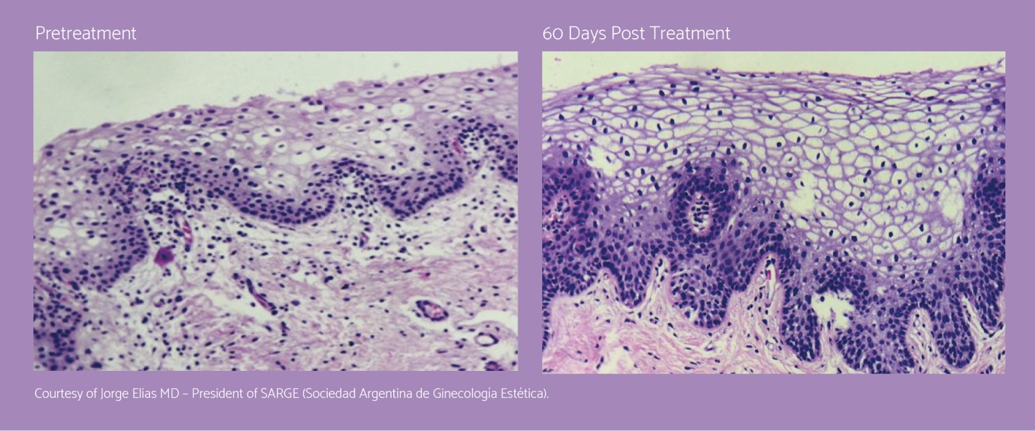
In conclusion, study suggests that the combined use of transvaginal PRP and CO₂ laser is a novel treatment option for SUI & other symptoms of GSM. This treatment protocol is minimally-invasive, requires negligible recovery time and is comparatively lower risk than surgery but needs further study and evaluation.

References

[1]HuiQ,ChangP,BingyuGuo,ZhangY,TaoK.Theclinicalefficacyofautologousplatelet-richplasmacombinedwithultra-pulsedfractionalCO2lasertherapyforfacialrejuvination.RejuvinationRes2017;20:25–31.
[2]TherapeuticGoodsAdministration.TGAactionsafterreviewintourogynaecologicalsurgicalmeshimplants[Internet].[updated2019May17;cited2019Aug31].9p.Availablefrom:.Canberra:TherapeuticGoodsAdministration;2018.https://bit.ly/2G6NuMy.

[3]SalvatoreS,LeoneRobertiMaggioreU,AthanasiouS,etal.HistologicalstudyontheeffectsofmicroablativefractionalCO2laseronatrophicvaginaltissue:anexvivostudy.Menopause2015;22:845–9.

[4]Behnia-WillisonF,MohamadiB,VancailleT,NguyenT,LamA,WillisonN,etal.FractionalCO2laserfortreatmentofstressurinaryincontinence.EurJObstGynecolReprodBiol:X2019,doi:http://dx.doi.org/10.1016/j.eurox.2019.10004.

[5]NikolopoulosKI,PergialiotisV,PerreaD,DoumouchtsisSK.Restorationofthepubourethralligamentwithplateletrichplasmaforthetreatmentofstressurinaryincontinence.MedHypotheses2016;90:29–31

Dr. Sandhya Mishra

Sandhya Mishra has her expertise in field of ART and Embryology. She is an emerging physician in the field of aesthetic medicine and first aesthetic gynae in her city. She is continuously doing a great job improving feminine health and wellness.
Email: ankurivf2@gmail.com

