Molecular expression characteristics confirm the malignancy retention concealed by morphological alterations in endometrial cancer after fertility-preserving treatment
Ting wen yi Hu, China. Zheng yu Li, PhD China
Abstract
Purpose: Fertility-preserving treatment (FPT) was widely used in young patients with endometrial cancer (EC) in early stage. However, disagreements remained in literatures on the effectiveness and safety of FPT. The aim of this study was to further confirm the malignancy alterations in EC after FPT by immunohistochemistry Methods: A retrospective analysis of pre- and post-treatment biopsy specimens from 24 patients with grade 1 endometrioid adenocarcinoma (EAC) or complex atypical hyperplasia (CAH) was performed. The expression of ARID1A, PTEN, and β-catenin were assessed by IHC. Results: The protein expression levels of ARID1A, PTEN, and β-catenin between pre- and post-treatment specimens achieved no significant differences. However, there was significant difference observed between pre-treatment and normal specimens, as well as between post-treatment and normal specimens. The protein expression of β-catenin significantly increased in patients with progression compared with those without progression after FPT. Conclusion: The morphologic normalization of EC patients after FPT may not accompanied by the absence of tumor malignancy, and β-catenin may serve as a biomarker for response to FPT. These results may be helpful in better understanding the malignancy transformation of EC after FPT, and in optimizing the treatment strategies for young patients of EC with birth demand.

Image
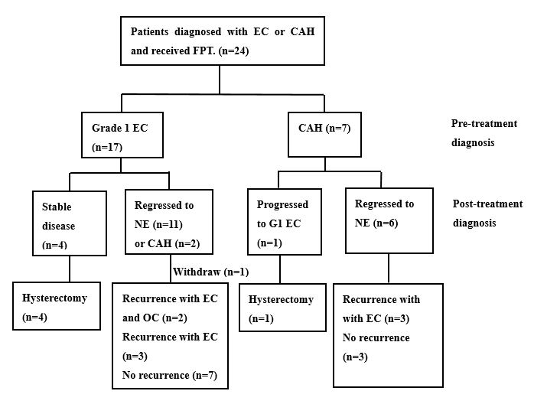
Fig. 1 Study design. EC: endometrial cancer; CAH: complex atypical hyperplasia; NE: normal endometrium; OC: ovarian cancer; G1: well-differentiated

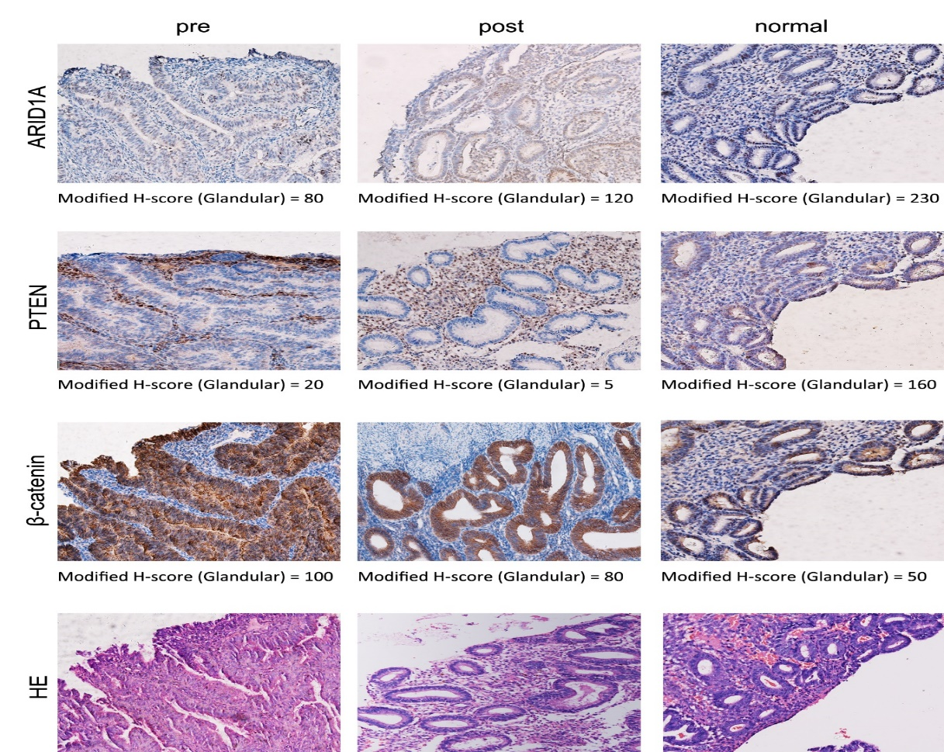
Fig. 2 IHC results of pre-FPT, post-FPT, and NE biopsy specimens. The nuclear expression of ARID1A and β-catenin and the cytoplasmic expression of PTEN were regarded as positive (×200). HE: hematoxylin-eosin staining
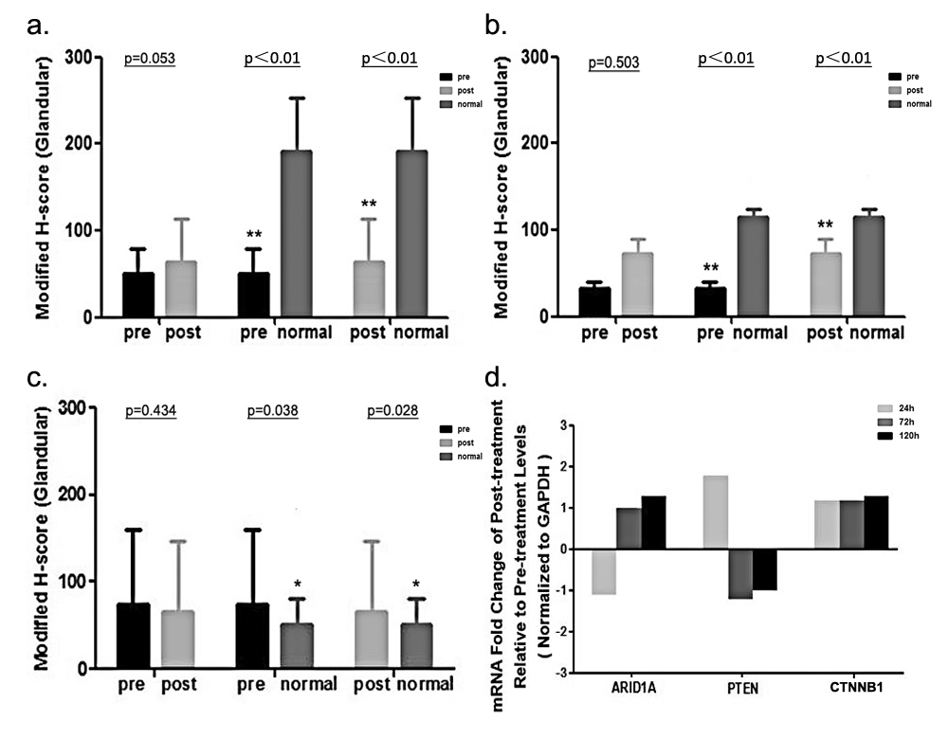
Figure 3. Effect of FPT on molecular expressions levels in biopsy specimens and Ishikawa cells. a,b,c. Average modiﬁed H-score values of ARID1A (a), PTEN (b) and β-catenin (c) in pre-FPT, post-FPT and NE biopsy specimens. d. mRNA expression levels of ARID1A, PTEN and CTNNB1 was determined by qRT-PCR, and data displayed as the fold change in the cells treated with P4 relative to the cells untreated. *p<0.05; **p<0.01.

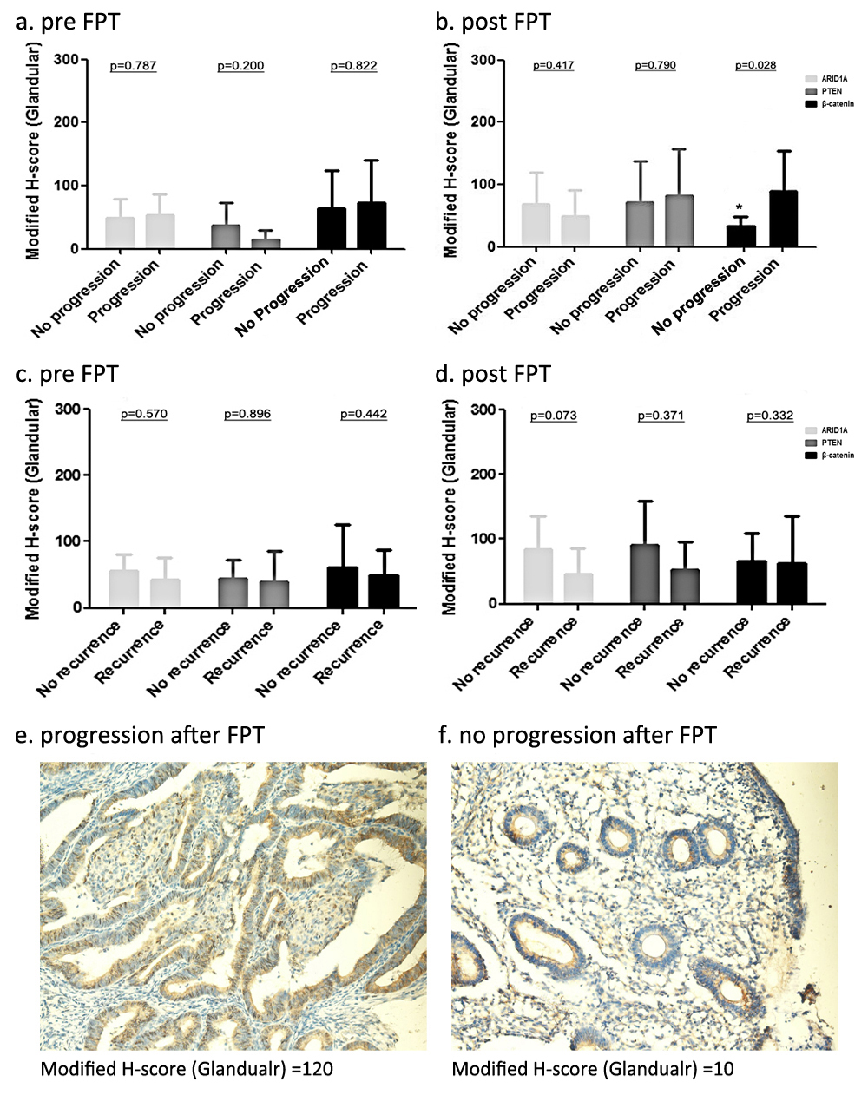
Fig. 4 Molecular expression of endometrial biopsy specimens (progression vs. no progression and recurrence vs. no recurrence). (a, b) Average modiﬁed H-score values of patients with or without progression (pre-FPT and post-FPT). (c, d) Average modiﬁed H-score values of patients with or without recurrence (pre-FPT and post-FPT). (e, f) Representative IHC images of the β-catenin staining of endometrial biopsy specimens from patients with progression and regression after FPT (×200). *p < 0.05

Recent Publications
- Koh, W. J., Abu-Rustum, N. R., Bean, S., et al. (2018). Uterine Neoplasms, Version 1.2018, NCCN Clinical Practice Guidelines in Oncology. J Natl Compr Canc Netw, 16(2), 170-199.
- Baek, J. S., Lee, W. H., Kang, W. D., et al. (2016). Fertility-preserving treatment in complex atypical hyperplasia and early endometrial cancer in young women with oral progestin: Is it effective? Obstet Gynecol Sci, 59(1), 24-31.
- Sanderson, P. A., Critchley, H. O., Williams, A. R., et al. (2017). New concepts for an old problem: the diagnosis of endometrial hyperplasia. Hum Reprod Update, 23(2), 232-254.
- Djordjevic, B., Hennessy, B. T., Li, J., et al. (2012). Clinical assessment of PTEN loss in endometrial carcinoma: immunohistochemistry outperforms gene sequencing. Mod Pathol, 25(5), 699-708.
- Mao, T. L., Ardighieri, L., Ayhan, A., et al. (2013). Loss of ARID1A expression correlates with stages of tumor progression in uterine endometrioid carcinoma. Am J Surg Pathol, 37(9), 1342-1348.
- Scholten, A. N., Creutzberg, C. L., van den Broek, L. et al. (2003). Nuclear beta-catenin is a molecular feature of type I endometrial carcinoma. J Pathol, 201(3), 460-465.

Biography
Ting wen yi is a doctoral student in Sichuan University, China. She is mainly devoted to the research of malignancy change of endometrial cancer after fertility-preserving treatment. Her research is beginning to bear fruit after years of experiments. She has her expertise in gynecologic oncology and passion in improving women’s health.
E-mail: htwy_33@163.com

