Title: Improve the safety of High alert medications (IPSG-3) in tertiary care Hospitals
Name and Affiliation (Sachin Raval, Apollo Hospitals International limited, Ahmedabad,India)

Statement of Problem:

High alert medications
High alert medications are medicines that are most likely to cause significant harm to the patient, even when used as intended. The Institute for Safe Medication Practices (ISMP) reports that the incident rates of this group of medicines may not necessarily be higher than the other medicines but when incidents occur the impact on the patients would be serious (significant).
In seeking to improve patient safety, the primary focus should be on preventing errors with the greatest potential for harm. Many of the highest risk medications – e.g., concentrated electrolyte, Chemotherapy Drugs, Narcotics, Insulin, Heparin and LASA are delivered by IV infusion. The most serious and life threatening potential adverse drug events (ADEs) are IV drug related.
Preventing the harm from High alert medications.
- Awareness, readiness, education: Training arranged for Nursing, Pharmacists and Doctors for High alert medication. List develop for High alert medications and showcash in every wards/ICUs. Develop Museum for High alert medications.
- Standardize care process: Double sign and double check at the time of Dispensing and Administration. PAT (Prescription Audit) verified by clinical pharmacist before indenting. Specific label design for each High alert medicine.
- Decision support: Include pharmacist on ward round and monitor overlapping medications prescribe for patients.
- Prevent Failure: Identify LASA Medicines and create mechanism to reduce errors (Different Location and double checking/Labeling)
- Involve the Patient & Family: Patient counseling in case of insulin. Provide patient education at literacy level understandable by all.

Image

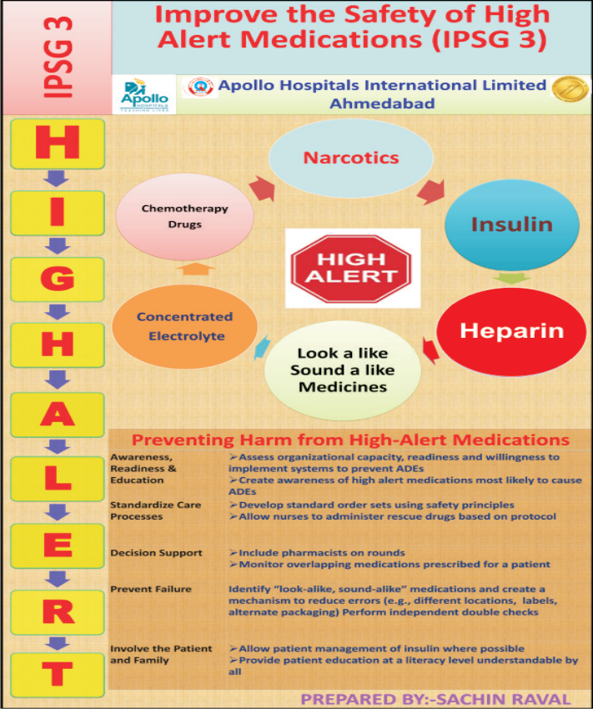
Recent Publications (minimum 5)

Gaurav Loria (2012) Reduction of harm from high risk medications, Apollo Medicine, Volume 9, Issue 2, June 2012, Pages 160-165
- 2011 Institute for Safe Medication Practices (ISMP) Medication Safety Self Assessment® for Hospitals . Retrieved at ttp://ismp.org/selfassessments/Hospital/2011/pdfs.asp
- Hsaio et al, Nurses’ knowledge of high -alert medications: instrument development and validation, Journal of Advanced Nursing 66(1), 177 -190
- Lu, M.-C.et al, Nurses’ knowledge of high -alert medications, A randomized controlled trial, Nurse Educ. Today (2011)
- Pamela Anderson, 2015 Preventing High-alert Medication Errors in Hospital Patients. Am Nurs Today. 2015;10(5)

 Biography (150 word limit)
Mr Sachin Raval working as Deputy Manager in Apollo Hospitals International limited, Ahmedabad, India. Since last more than 11 years. Took active participation in many international conferences. He is also part of JCI Audit and accredited successfully. His pharmacy was recently accredited with Platinum ranking by Pharmacie De Qualite auditee. He is constantly working on improving quality work and patient safety with recent ideas on High alert medications.
Email: sachinr@apolloahd.com

