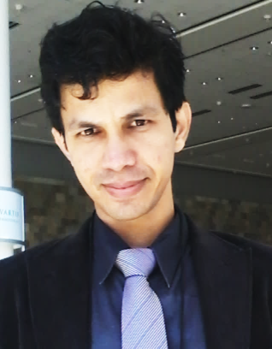


Title: Living Donor Liver Transplantation: Technique of Donor Hepatectomy, Innovations in Outflow Reconstruction and Outcome in sequential 750 cases

Name: Dr. Ashok Thorat, MBBS, DNB

China Medical University Hospital, Taichung, Taiwan 40447.

In Asia, living donor liver transplantation (LDLT) was adapted and later became the most effective source of liver allografts as the deceased organ donation remains scarce. However, LDLT procedure often challenged by complex right liver allograft anatomy, smaller caliber of hepatic artery and need of backtable venoplasty that has led the transplant surgeons to adapt new or modified surgical techniques to make donor hepatectomy safe and graft implantation feasible. We have introduced modified donor hepatectomy technique termed as “Rooftop and Skeletonization Technique” that entails meticulous dissection on and around the middle hepatic vein (MHV) to include or exclude later in the donor allograft. The most important aspect of the LDLT is the venous outflow reconstruction. Due to partial nature of the liver allograft in LDLT, backtable venoplasty procedure is required to facilitate the outflow reconstruction in recipients. However, due to scarcity of cryopreserved vascular grafts, the synthetic vascular grafts such as expanded polytetrafluoroethylene (ePTFE) grafts have been used and proven to be an effective alternative for vascular conduits. In our center, we have innovated outflow reconstruction using ePTFE vascular grafts in presence of donor hepatic venous anomalies and/or limited recipient retrohepatic space. We have achieved lowest hepatic artery thrombosis rate (< 1 %) so far that can be attributed to our center’s unique hepatic arterial reconstruction technique. In this presentation, we intend to summarize our center’s LDLT surgery techniques and postoperative management of complications in transplant recipients.

Biography

Dr. Ashok Thorat, 36 years, completed his MD in 2009 from National Board of Examinations at New Delhi, India. He did his fellowship training in HPB at prestigious IASGO center in Athens, Greece under supervision of Late Prof. Lygidakis. Later, he finished his 2 years HPB and Liver Transplantation training at Chang Gung Memorial Hospital, Taiwan. After completion of training, he is associated with China Medical University Hospital, Taiwan till date in the department of organ transplantation center. He has published more than 27 papers in the field of HPB & Liver Transplantation (few more are accepted, but not yet published) in reputed journals and has given several oral presentations in national and international conferences. His academic interest is living donor liver transplantation, hepatectomy for HCC, and clinical research in the field of liver transplantation.

