GLASS BOTTLES AS AN ARTIFICIAL REEFS

MARIA THERISA FLORA MABALOS
Special Education Teacher

ABSTRACT

Biodiversity is an important factor in all healthy ecosystems. Coral reef ecosystems support an incredibly diverse community of fish species. The coral reefs are in decline due to a combination of factors such as climate change and over fishing.
Artificial reefs (AR) have become increasingly more popular in coral reef ecosystem management and conservation. It has been commonly used in the management of fisheries. University of Colorado (2014) research study affirmed that ten percent of the fish consumed globally and the tourism industry are associated with coral reef ecosystems. It is also supported in the study of Abelson (2006) that the restoration of the degraded reefs can be restored through implementation of the artificial coral reefs.
The Naturephere is the first student-organized group in Macabalan National High School that advocated on coral reef conservation and care for marine biodiversity. The activity simply started from a simple cleaning and collection of the bottles from school campus towards the community of Barangay Macabalan.
The glass bottles were used as artificial reef regardless on its sizes, shapes or designs considering bottles is a common rubbish in Barangay Macabalan. In support of the global awareness on climate change, the glass bottles were recycled and reuse at its best. The highlight of the activity was the deployment of the AR in the marine sanctuary of Tubajon, Laguindingan, Misamis Oriental.
It was found out in that the implementation of the artificial coral reefs is widely used and apparently accepted by the public and some resource managers. Moreover, the use of glass bottles as AR is the most successful techniques use by marine environmentalist to date (Scott, 2016).

Introduction

The coral reefs in general are one of the most biodiverse ecosystems on the planet. The coral reefs has so many attributes. It protect coastlines from the damaging effects of wave action and tropical storms, provide habitats and shelter for many marine organisms, serves as the food basket, lead to economic importance, tourism wealth & medical purposes. University of Colorado (2014) research study affirmed that ten percent of the fish consumed globally and the tourism industry are associated with coral reef ecosystems.
In spite of the numerous advantages a coral reefs provide it continuously to decline due to a combination of factors such as climate change and over fishing, the species which are being supported by the reefs are at risk (Witschge, 2018).
In the Philippines, where coral reef destruction is the worst, over 70% have been destroyed and only 5% can be said to be in good condition. Thus, the use of artificial reefs are often promoted as to mitigate human impacts in coastal ecosystems and enhancing fisheries (Svane and Peterson, 2001).
The decline of natural coral reefs and loss of reef ecosystems around the world has prompted the establishment of artificial reefs to counterbalance these losses. One of the reef management strategies is the artificial coral reef. It was found out in that the implementation of the artificial coral reefs is widely used and apparently accepted by the public and some resource managers. Individuals, organizations, and government agencies have programs to place structures in marine waters through artificial reefs for the primary purpose of promotion of biodiversity among coral reef fish communities (Howard, 2003).
Artificial reefs have become increasingly more popular in coral reef ecosystem management and conservation. The restoration of the degraded reefs can be restored through implementation of the artificial coral reefs, Abelson (2006). Moreover, it has been commonly used in the management of fisheries. It enhance fish abundance and diversity, recover coastal and marine habitats, and restore damaged coral reefs, Kalam (2018)
There are various materials have been used in the construction of artificial reefs worldwide. These includes bamboo, concrete blocks, ceramic structures, glass, pipes, reinforced plastic, metal, and marine alloys. However, these materials has some drawbacks when used as artificial reefs. Bamboo and wood are easily scattered by water currents, lose their fish-aggregating integrity, and cause further degradation of the sea bed. Concrete blocks are durable and can be structured in various configurations, but have limited applications because of their cost (Kalam, 2018). On the other hand, the use of glass bottles is cheap, easy to construct and materials are easy to install.
The Bugo National High School would organized Naturesphere of Macabalan National High School and created a project entitle “Ka'bote’hang Pangkalikasan (KP)” while empowering school student leaders through engaging in environmental awareness, protection and conservation activities.
The program came from the root word “bote”, a local dialect which means “bottle”. The glass bottles were used in the project regardless on its sizes, shapes or designs considering bottles can be found anywhere in Barangay Bugo premises and not all bottles can be sold in the junk shop. Moreover, the numbers of glass bottles disposed in Barangay Bugo Material Recovery Facility (MRF) are increasing. Artificial reef construction evolve to decrease the number of unsold glass bottles in MRF.
In support also to the global awareness on climate change, the glass bottles were recycled and reuse at its best. The glass bottles will be used as artificial reef. The highlight of the program is the deployment of the artificial reefs in marine sanctuary area.
This project is in battling with the issues on climate change. The creation of the bottle artificial reefs is in support with the United Nation’s Sustainable Development Goal 13 which aims to “take urgent action to combat climate change and its impact” and other Filipino inter agencies who are taking positive steps to counteract climate change. The Environmental Management Bureau of the Department of Environment and Natural Resources (DENR) aim at harnessing and synergizing the various activities undertaken by the national government and civil society in response to the crisis posed by growing problem on climate change. Furthermore, Philippine Constitution which mandates that “The State shall protect and advance the right of the people to a balanced and healthful ecology in accord with the rhythm and harmony of nature” (1987 Philippine Constitution Art II .Sec. 16).
It is also supported in the study of Abelson (2006) that the restoration of the degraded reefs is considered to be one of the major reef management strategies to help remediate damage natural coral reefs due to the ignorance or mismanagement of the people living in the area.
The Etymology of the Group
Naturephere of Macabalan National High School is an organized group of high school learners whose efforts is helping the coral reef conservation. It is a collaborative efforts of Supreme Student Government (SSG) and YES-O (Youth for Environment in Schools-Organization), both a school-based co-curricular organizations in Department of Edcation (DepEd).
Naturephere is come from two words which are combined, nature and sphere. Nature which means the phenomena of the physical world, including plants, animals, the landscape, and other features and products of the earth and sphere which is a perfectly round solid figure representing holistic. Therefore, the naturephere is a word denotes wholesome mission on care for environment.
Thus, Naturephere of Macabalan National High School is a group who advocates the endless care for nature and working together among other stakeholders to sustain marine and coastal resources by addressing crucial issues such as care for marine biodiversity.
Significance of the Project
The artificial reefs were intentionally placed on the sea floor to influence biological, physical, and for socio economic processes for some reason relating to marine life. The artificial reef has also impact on the following:
- Enhance aquatic habitat and diversity of fishery resources, while not impeding or interfering with navigation.
- To provide enhanced hard bottom habitat to areas that may or may not be habitat limited. Thus, attract fishes to create new fishing sites.
- Provide space that is quickly colonized by sessile organisms and provides new food sources, greater protection of juveniles by providing space for refuge and possible focal point for aggregating adults to spawn.
Scope and Limitation
The glass bottles and concrete were used as the components of the artificial reefs. It was deployed in coastal area of Tubajon, Laguindingan, Misamis Oriental considering the place was a strategic place and it was a marine protected area.
Moreover the place has mangrove forests which have a large impact of reef ecosystems, and therefore considered when artificial reef management and conservation plans are being designed. The mangroves as stated by (Mumby et al. 2004; Nagelkerken et al. 2000) are also thought to act as fish nurseries for some species of coral reef fish.
Statement of the problem:
1. How do local fish communities respond to the use of structurally simple bottle artificial reefs?
Hypothesis: The utilization of artificial reefs which are structured in glass bottles would create biologically diverse fish communities, and that this could be done feasibly without extraneous added costs.
Materials Used
Glass bottles in various sizes and shapes
Wood for molder
Steel rod for support
Nails
Cement Mixtures
2 sacks of cement
1 sack of gravel
1 sack of sand
Procedures
Gather all the materials needed.
Make a molder made of wood.
Place steel rod for support to avoid breakage.
Clean the bottles. Peel off labels of glass bottles.
Create cement mixtures.
Pour cement mixture in the molder and mount the bottles.
Let it dry for at least 48 hours.

AR Design
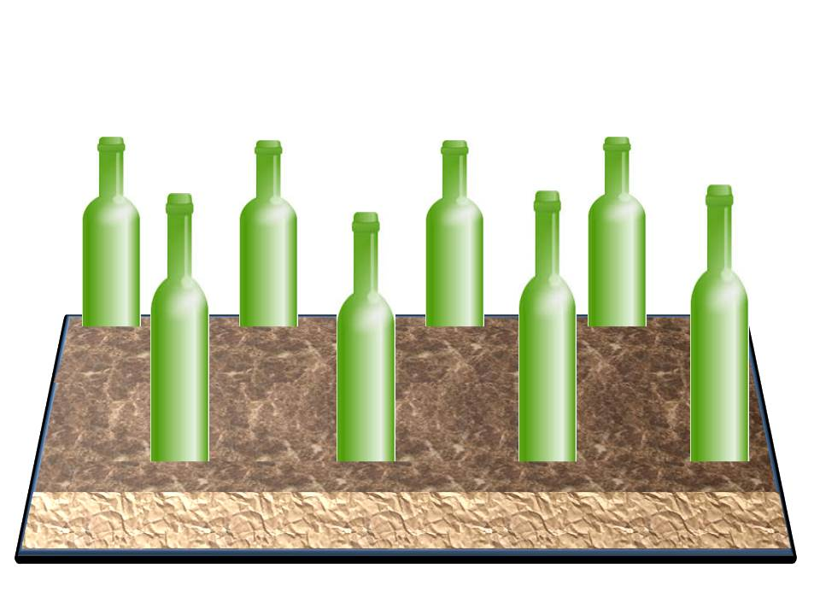

Glass Bottle

Concrete mixture

The designs of the AR were duplicated from the designs of New Heaven Reef Conservation Program (NHRCP) and Tropical Research and Conservation Centre (TRACC).

Process of the Project
Collecting of bottles during barangay cleaning
Collecting of bottles during simple school clean up drive

Recycling of glass bottles into artificial reefs
Collecting of bottles during coastal cleaning

Launching of the artificial reefs
Making of artificial reefs

FINDINGS
After three years, it was observed that the bottled reef was filled with algae and sessile organisms. Algae attached to the structures followed by sessile organisms, e.g. barnacles and oysters
The sessile organisms grow rapidly covering almost the entire bottle and concrete surface.
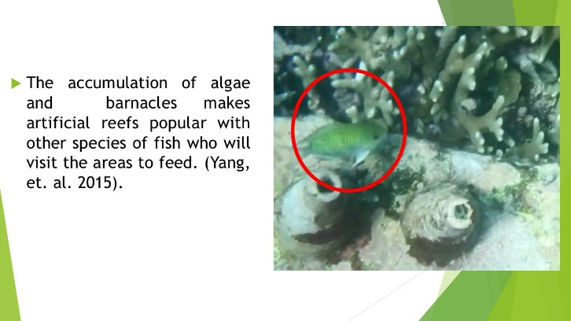
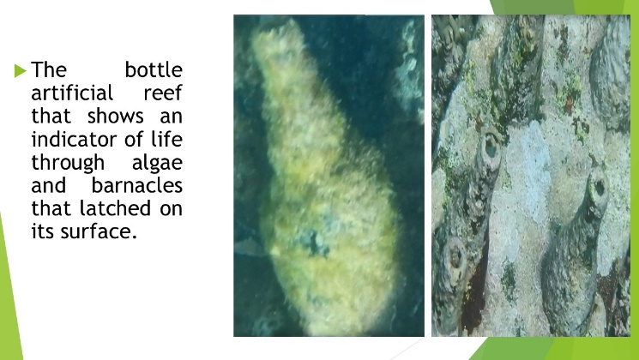
Regardless of how they are built artificial reefs generally provide hard surfaces where invertebrates such as oysters and barnacles as well as corals attach. The accumulation of these things makes artificial reefs popular with other species of fish who will visit the areas to feed. The sea cucumbers can find also an abundance of food sources such as diatoms, bacteria, protozoa, algae, whereas increasing plankton and larger benthic organisms that provide food sources for fish (Yang, et. al. 2015).
The construction of artificial reefs can enhance both the number of sea cucumber and shellfish, leading in the increase in number of crustaceans and fish, which can gradually restore the damage food web.
The implanting of artificial reefs the marine environment of key coastal area can improve the threatened wildlife and are more effectively protected and marine fisheries are becoming more sustainable, (Yang, et. al. 2015)
These results indicate that large artificial reefs can support diverse and abundant coral and fish communities. However, these communities differ structurally and functionally from those in natural habitats, and they should not be considered as replacements for natural coral and fish communities.
For artificial reefs to be able to promote fish biodiversity in a comparable way, a better understanding of this mechanism is necessary. Artificial reefs have a role to play in the conservation of fish communities and coral reef ecosystems, but should be used in combination with other conservation and management techniques.
References

https://www.coralguardian.org/en/coral-reef-important/
https://www.oceanworld.tamu.edu
https://www.un.org/sustainabledevelopment/climate-change/
https://www.pcw.gov.ph/focus-areas/environment/climate-change/initiatives

Hongsheng Yang, Jean-Francois Hamel, Annie Mercier, 2015The Sea Cucumber Apostichopus japonicus: History, Biology and Aquaculture

Svane I, Peterson J (2001) On the Problems of epibioses, fouling and Artificial reefs, a review. Mar Ecol 22: 169-188

https://tracc.org/
https://newheavenreefconservation.org/
https://newheavenreefconservation.org/index.php?option=com_content&view=article&id=147:artificial-reefs-what-works-and-what-doesn-t&catid=8

https://www.earthisland.org/journal/index.php/articles/entry/drinking_for_conservation/

https://books.google.com.ph/books?id=p_VDBAAAQBAJ&pg=PA338&lpg=PA338&dq=is+the+algae+and+sessile+organisms+food+of+the+fish&source=bl&ots=iJ2ZGFWXBD&sig=ACfU3U3HPUyG3KKXVu4qWG7zr-nVmwLsdA&hl=en&sa=X&ved=2ahUKEwjevLq-tefnAhXME4gKHSk0DDIQ6AEwCXoECAkQAQ#v=onepage&q=is%20the%20algae%20and%20sessile%20organisms%20food%20of%20the%20fish&f=false

https://www.academia.edu/36098308/Are_artificial_reefs_surrogates_of_natural_habitats_for_corals_and_fish_in_Dubai_United_Arab_Emirates-

https://www.coralguardian.org/en/coral-reef-important/

https://www.aljazeera.com/indepth/features/coral-reefs-important-dying-180128135520949.html

https://www.mjspackaging.com/blog/is-glass-really-a-sustainable-option-for-your-business/

http://jrscience.wcp.muohio.edu/fieldcourses03/PapersMarineEcologyArticles/ArtificialReefProjectRepo.html

http://eclectictrekker.com/building-more-artificial-reefs/

http://jrscience.wcp.muohio.edu/fieldcourses06/PapersMarineEcologyArticles/ArtificialReefsFinalPaper.html

https://www.earthisland.org/journal/index.php/articles/entry/drinking_for_conservation/

https://www.academia.edu/36098308/Are_artificial_reefs_surrogates_of_natural_habitats_for_corals_and_fish_in_Dubai_United_Arab_Emirates

