




Title: Resilient Energy-Water-Transportation Infrastructures for Smart Cities

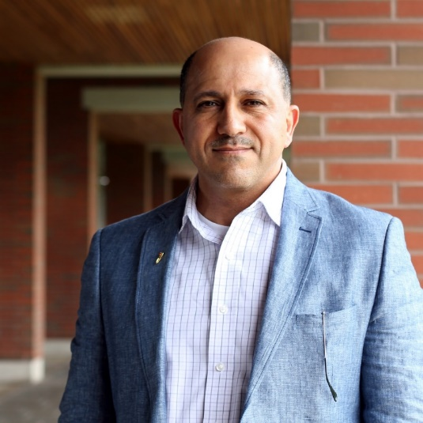
Abstract:
This talk will present research planning, design and control strategies of energy-water-transportation infrastructures to support smart cities and communities. The talk will cover resiliency and performance measures to achieve smart energy, water, and transportation infrastructures using interconnected micro energy grids and mobile microgrids with hybrid energy storage systems. The talk will demonstrate modeling, control, and optimization techniques and their applications to improve the regional and global performance of energy-water-transportation infrastructures. Integrated data centers will be discussed to support the implementation in smart cities and during emergencies.
Bio
Dr. Gabbar is a full Professor in the University of Ontario Institute of Technology (UOIT) in the Faculty of Energy Systems and Nuclear Science, and cross appointed in the Faculty of Engineering and Applied Science, where he has established both the Energy Safety and Control Lab (ESCL), Smart Energy Systems Lab, and Advanced Plasma Engineering Lab. He is the recipient of the Senior Research Excellence Aware for 2016, UOIT. He is leading national and international research in the areas of smart energy grids, energy safety and control systems, and waste to energy using advanced plasma technologies. Dr. Gabbar obtained his B.Sc. degree in 1988 with first class of honor from the Faculty of Engineering, Alexandria University (Egypt). In 2001, he obtained his Ph.D. degree from Okayama University (Japan). From 2001 till 2004, he joined Tokyo Institute of Technology (Japan), as a research associate. From 2004 till 2008, he joined Okayama University (Japan) as a tenured Associate Professor, in the Division of Industrial Innovation Sciences. From 2007 till 2008, he was a Visiting Professor at the University of Toronto. He also worked as process control, safety, and automation specialist in energy and oil & gas industries.
Dr. Gabbar has been successful in attracting national and international funds from a number of organizations. He leads successful projects in the areas of Resilient Interconnected Micro Energy Grids, Energy Conservation in Infrastructures, Regional Planning of Gas-Power Grids for Energy and Transportation Infrastructures with different fuel options in Ontario, Canada, and internationally. His research have been widely recognized and reflected to his publications in patents, books, chapters, and journal and conference papers. He has supervised and hosted undergraduate, graduate, postdocs, visiting researchers and scholars from different countries including: Japan, KSA, India, Qatar, Egypt, Mexico, Malaysia, China, Brazil, Chili, UAE, and Colombia.
He has more than 210 publications, including patents, books / chapters, journal and conference papers. He has been invited and participated in world-known conferences and delivered plenary talks on number of scientific events and through invitations to international universities. Dr. Gabbar has been active in leading national and international scientific and community events and activities, including: CSA – Canadian Standard Association, IEEE Annual Conference on Smart Energy Grid Engineering (SEGE), Smart Energy Systems and Technologies (SEST), IEEE Nuclear and Plasma Sciences Society (NPSS) Symposium on Real Time Measurement, Instrumentation, and Control (RTMIC), IEEE Nuclear and Plasma Sciences Society Symposium on Plasma and Nuclear Systems (SPANS), and other international events. He is the Editor-in-Chief of the International Journal of Process Systems Engineering (IJPSE), and member of IEEE Smart Grid Committees.

