Women, trauma and alcohol dependency: Connections and disconnections in alcohol treatment for women
Faissal Abdelhady, KAU, Saudi Arabia
Hisham Bamufleh, KAU, Saudi Arabia
Mahmoud M.El-Halwagi, Texas A&M, USA
José MaríaPonce-Ortega, Michoacana, Mexico

Abstract (300 word limit)
This paper introduces an optimization approach to the design of process combined heat and power systems that integrate the thermal profile of the process, an external fossil fuel, and solar energy. A hierarchical design approach is proposed to stage the implementation of steady-state and dynamic calculations. Initially, energy integration is used to identify minimum heating and cooling utility targets. Next, a genetic algorithm approach is employed to optimize the external heating load and generated power of the cogeneration system that includes a steam Rankine cycle. Another loop is used to optimize the flowrate, temperature, and pressure of the steam entering and exiting the turbine. A multi period optimization approach is developed to account for the diurnal variability of solar energy. Direct usage of collected solar energy is considered along with the option of thermal storage and dispatch. The solution of this mixed integer nonlinear program determines the optimal mix of energy throughout the year. A case study for a petrochemical plant in Jeddah, Saudi Arabia was solved to illustrate the applicability of the devised approach.

Published in Chemical Engineering Science, Volume 136, 2 November 2015, Pages 158-167

Image
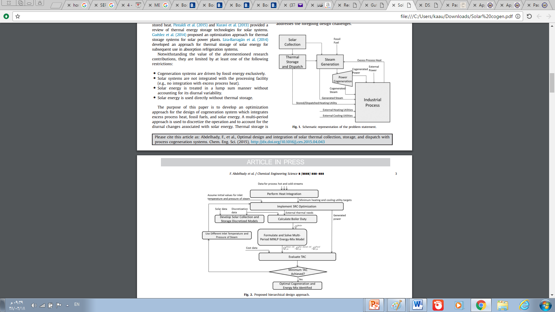
Recent Publications (minimum 5)
- Luis Fernando Lira-Barragan, Ce´sar G. Gutie´rrez-Arriaga, Hisham S. Bamufleh, Faissal Abdelhady, Jose´ Marı´a Ponce-Ortega, Medardo Serna-Gonza´lez and Mahmoud M. El-Halwagi (2015) Reduction of greenhouse gas emissions from steam power plant sthrough optimal integration with algae and cogeneration systems, Clean Techn Environ Policy 17:2401–2415.
- Hasan Uslu, Göksel Demir, Cuma Bayat,Kailas L. Wasewar and Hisham S. Bamufleh (2014) Adsorptive separation of adipic acid from aqueous solutionsby perlite or its composites by manganese or copper, Membrane Water Treatment, Vol. 5, No. 4:295-304.
- Hisham Bamufleh, Faissal Abdelhady, Hassan M. Baaqeel and Mahmoud M. El-Halwagi (2017) Optimization of multi-effect distillation with brine treatment via membrane distillation and process heat integration, Desalination, Volume 408:110-118.
- Javier Tovar-Facio, Luis F. Lira-Barragán, Fabricio Nápoles-Rivera, Hisham S. Bamufleh, JoséM. Ponce-Ortega and Mahmoud M. El-Halwagi (2016) Optimal Synthesis of Refinery Property-Based Water Networks with Electrocoagulation Treatment Systems, ACS Sustainable Chem. Eng. 4: 147−158.
5. S.A. Sulaiman1, H.S. Bamufleh, S.N.A. Tamili1, M. Inayat and M.Y. Naz, Characterization of Date Palm Fronds As A Fuel For Energy production (2016) Bull. Chem. Soc. Ethiop. 30(3): 465-472.



Biography (150 word limit)
Dr. Hisham Bamufleh Dr. Bamufleh is an associate professor in chemical engineering department at King Abdulaziz University (KAU). He worked in Saudi Aramco as a process engineer in oil processing units and utilities including desalination and steam generation plants. Dr. Bamufleh is a licensed professional engineer (PE). Dr. Bamufleh has MS and PhD from the University of Tulsa Oklahoma and BS from KAU all in chemical engineering. He also has MS from KAU in thermal engineering Dr. Bamufleh has 20 refereed publications. His main research interests involve diesel desulfurization using activated carbon derived from dates' stones and utilization of agriculture waste to produce valuable products such as furfural. Plant simulation using HYSYS is also among his interest.
Email: hbamufleh@kau.edu.sa

Notes/Comments:
Presenting author details
Full name: Dr Hisham Saeed Bamufleh
Contact number: +966504680485
Mail id: P.O. Box 4056 Jeddah 21491 Saudi Arabia
Category: (Oral presentation/ Poster presentation): oral

