Abstract Title: Thermodynamic and kinetic investigations for biosorption of Manganese (II) with green algae (Pithophora oedogonia)

Suleman Shahzad (Government College University, Pakistan)
Faizan Naeem (University of Bremen, Germany)

Abstract (300 word limit)
Environmental health of earth is the primary determinant of the health of ecosystem, but unfortunately human activities, such as industrial development have tempered the natural composition of the environment. Worldwide, a number of industrial units are responsible for the release of effluents which are toxic and these toxins do not only enter in the environment but also tend to magnify as they travel through food chain. Amongst such toxins, manganese Mn (II) is one of the major culprits. This situation is worsening even more as the industrial progress is on its way. Recently, biosorption has come up as effective tool in which biomass of various organisms have been tested. In the present study, the biosorptive potential of algae biomass of green algae (Pithophora oedogonia) has been investigated for removal of toxic heavy metal, such as manganese Mn (II) ions. Various physico-chemical factors have been optimized for biosorptive capacities of sorbates by sorbents. Optimum pH was found to be 4 and optimum temperature was 30^{O}C for manganese Mn (II). Various adsorption models were elucidated to data, such as Langmuir, Freundlich and Temkin isotherms whereas Freundlich model was found to be fittest showing multilayer sorption. Pseudo-second order kinetic model was also found to fit for this study with regression coefficient value of 0.97. Additionally, Fourier Transform Infra-red Spectroscopic studies (FTIR) indicated various electronegative functional groups on the surface of green algae (Pithophora oedogonia) which could possibly offer the binding sites for cations under investigation.

Keywords— heavy metals, biosorption, algae, kinetics, FTIR.

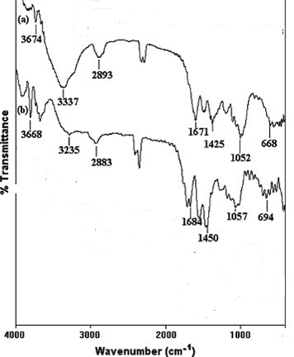
Image

Recent Publications (minimum 5)

- Paper accepted in Journal of bioremediation and biodegradation Thermodynamic and kinetic investigations for biosorption of Chromium (VI) with green algae (Pithophora oedogonia) https://www.editorialmanager.com/biobiogroup/default.aspx
- Shahzad, S., other authors (2017). Removal of heavy metal Lead (Pb) (II)
by Biosorption process using paper shell Mussel (Anodontoides Ferussacianus)
World Journal of Pharmaceutical and Medical Research. wjpmr, 2017,3(6), 281-288 ISSN 2455-3301 http://www.wjpmr.com/home/article_abstract/589

- Shahzad, S., other authors. (2016). Optimization of bio sorption of chromium and cadmium by using shell of Anodontoides ferussacianus (Paper Shell Mussel)”.

Journal of Advances in Biology & Biotechnology 5(4): 1-10, 2016; Article
no.JABB.25229. ISSN: 2394-1081 SCIENCEDOMAIN international http://sciencedomain.org/abstract/14289

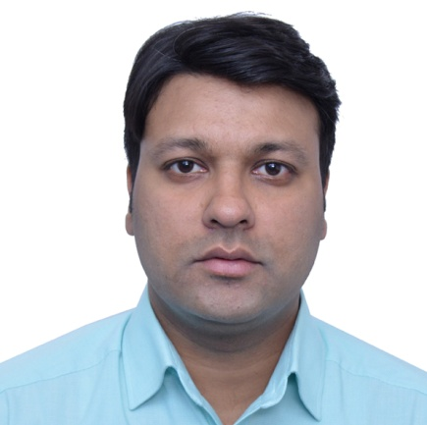Biography (150 word limit)
Paste your Logo here
Mr. Suleman Shahzad is a faculty member in the Biological Science Department at Forman Christian College (A Chartered University) Lahore, Pakistan Main research interest focuses on Environmental Studies, Eco-Toxicology Wildlife, Ethology, Fisheries. We study the heavy metals effect on living organisms and their removal from them by different techniques including biosorption, and by nanoparticles, in addition to eradication of heavy metals techniques like FTIR, TEM, SEM, adsorption, bioremediation, etc. I have published many and several papers in international refereed journals and conference proceedings, edited several books and book chapters, and I am a member of several local and international scientific societies. My expertise includes the find novel techniques for removal of heavy metals from waste water, aquatic bodies, polluted soil, and design transgenic organism for remediation of heavy metals from environment.
Email: sulemanshahzad@fccollege.edu.pk

Notes/Comments:

Presenting author details
Full name: Suleman shahzad
Contact number: 923454262054
Mail id: sulemanshahzad@fccollege.edu.pk
Category: (Oral presentation)

