Identification and evaluation of environmental impacts refineries, GTL (gas to liquid fuel conversion) Case Study :GTL Qheshm island,Iran

Zahra Peivand, Environmental engineering Msc, (Azad University, Science and Research) Iran

Email: peivand2012@yahoo.com.

Summary

Using technology (GTL), natural gas can be produced locally and converted to valuable products such as liquid petroleum products in tankers to carry the consumer market.

In recent years a lot of attention, especially the establishment of free zones and industrial activities in the Persian Gulf waters.

Such activities can damage the reproductive areas and biological diversity brought it.

The aim of this study was to evaluate and identify environmental impacts of the refinery project (GTL) is in Qeshm Island.

According to the results obtained from the matrix revealed the results of applying Iranian matrix construction activities and operation of option implementation and non-implementation of the matrix indicates that, because of the mean of any of the activities of 1 / 3 was less negative effect on the environment implementation options were considered poor and also because of the final score: 32/0 + project is confirmed.

- has received, indicating that the impact of the project on the physical environment and chemical and biological phases of construction and operation of the project in terms 75/594 confirms positive.

But in the biological environment completely different matrix symbols but these two are in the same position.

In the construction phase environmental, social, economic and cultural Iranian matrix, while negative values ​​indicate positive effects of integrated matrix.

Summed up in these two matrix are similar in design and construction of the island are positive.

Keywords: EIA, GTL, Czech list, Iranian Matrix, Matrix Integration

Image
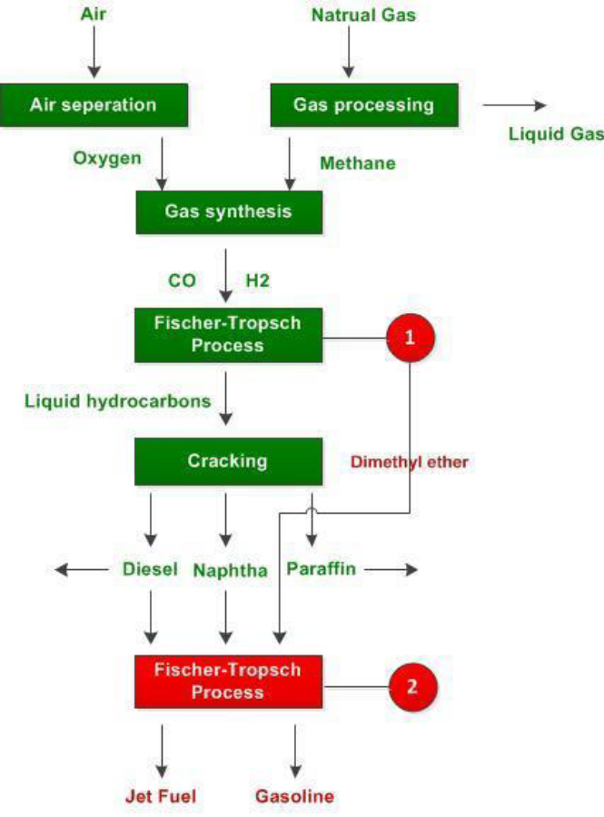
Recent Publications (minimum 5) (If not leave as blank)
[1] “Ahmad, Yusufi, George K. Sammy ; 1985; “ Guidelines to Environmental Impact Assessment”HODDER AND STOUGHTON.
[2] Arctic Offshore Oil & Gas Guidelines;( PAME), “Protection of the Arctic Marine Environemnt”; Arctic Council
[3] Canter.L. W.; 1996; “ Environmental Impact Assessment” ;(second edition); McGraw-Hill Book Co.
[4] Doeffer. J. W.; 1992; “Oil Spill Response In The Marine Environment”; Pergamon Press.
[5] Kreith,Frank;2006; “Handbook of solidwaste Management”; McGraw-Hill Book Co.
[6] ROPME;2004; “ State of the marine environment report 2003 ”,Kuwait.
[7] OLTIN YO'L GTL ProjectWaste Study for theEnvironmental, Safety, Healthand Social Impact Assessment(ESHSIA) Up-Date 2013


Biography
Zahra Peivand has her expertise in Environmental Engineeringand assessment, GIS & RS Analyst and A well-organized and outgoing Environmental Engineering with good communication and analytical skills, looking to develop a career within an international business environment. experienced in the use of geographic information system (GIS) and remote sensing (RS) and Land use expert with environmental and IT knowlage, databases, and similar software. Education and qualifications: MSc in Environmental Engineering- Tehran ,Islamic azad university Science and Research branch,back l studied civil engineering in the field of photogrammetry. My Paper is to identify and assessment to reduce the adverse environmental impact of the GTL refinery

Email:peivand2012@yahoo.com
Contact no:
LinkedIn account: Zahra peivand
Category: Oral (or) Poster

Notes/Comments:

