Numerical Analysis, Design & Optimisation of Tesla Turbine: A Carbon-zero Power Generating Source for The Future
Warmate Awoloye IG, United Kingdom.

Abstract:
Statement of the Problem: Climate change remains one of the world’s greatest challenges today and as we move faster towards actualising the UN 2030 sustainable developmental agenda and the goals of the Paris Agreement, the need for building new energy economies cannot be overemphasised howbeit, not many a country’s major energy source has shifted wholly, from those that impact negatively on the environment with circa 43.6% (Fig.1) energy generated from combustible fuels (Eurosat, 2021) and, as the world spring back to full-scale business after the Covid break, these demands are projected to increase.
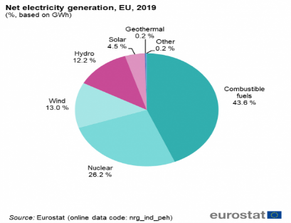
Figure 1: World's electricity generation by energy source
Suffice to say that almost all commercial power needs are still being generated by turbines with steam turbine contributing more than 80% worldwide using varieties of heat sources and hence, impacting on the environment. The purpose of this study is to suggest the use of Tesla turbine as a better substitute to steam and coal-fired turbines for world power generation as it offers more economically viable, safe, reliable, and most importantly, ozone-friendly solutions whilst in use. Methodology & Theoretical Framework: The Tesla turbine works by the principle of boundary layer effect due to the adhesive forces generated between the fluid and co-connected disk rotors (Fig.2). Numerical analysis was employed using both continuity equation and the Navier-Stokes equation for fluid modeling. Several CAD models were designed using SolidWorks and simulations done using Ansys CFX/Fluent software.

Warmate Awoloye is an oil and gas and energy enthusiast with over 10years of experience. He obtained his master’s degree in Oil and Gas Engineering with Management at the School of Computing and Engineering, University of Huddersfield where he obtained the prestigious vice-chancellor’s scholarship award for his PhD. His research area borders on numerical analysis and design of Renewable/Advanced Energy Systems for offshore and other service industries.
Email: Awoloye.Warmate@hud.ac.uk
Presenting Author Details:
Name: Warmate Awoloye IG
Contact Phone: +447770176177
Session name/number:
LinkedIn contact: https://www.linkedin.com/in/warmate-awoloye-i-g-aaa395125?
Category: Oral Presentation

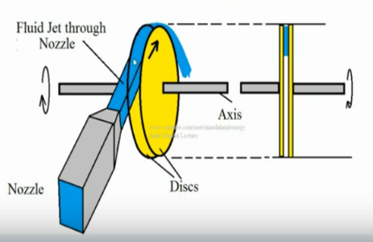
Findings: It was observed that several factors as nozzle geometry, fluid angle of attack, disk type/size and disk spacing/number significantly affected the efficiency of the turbine. A 3-disk arrangement gave maximum efficiencies >90%.

Figure 2: Operational Mechanism of the Tesla Turbine
Conclusion and Significance: Computational fluid dynamics offers a robust method for critically monitoring the flow regimes in the multicomponent Tesla turbine other than theory, as it helps us adjusts the aforementioned variable performance parameters. The experiment enabled us to proffer empirical relations for the design of the Tesla turbine as an advanced energy solution even as we pace towards the net zero carbon emission targets in the year 2050. Further recommendations were suggested for a >98% efficient turbine as proposed by Nikola Tesla (1906).
Recent Publications
N. Tesla (1913) “Turbine,” United States Patent No. 1061206
T. Engin, M. Özdemir, and ù. Çeúmeci (2009) “Design, Testing and Two-Dimensional Flow Modeling of a Multiple-Disk Fan,” Experimental Thermal and Fluid Science, 33, pp. 1180-1187.
Vedavalli G. Krishnan1, Zohora Iqbal and Michel M. Maharbiz (2015) “Design and Fabrication of cm-scale Tesla Turbines” University of California Berkeley, CA., US.
Vince Romanin, Van P Carey (2010) “Strategies for performance enhancement of Tesla turbines for combined heat and power applications”, Proceedings of the ASME 2010, 4th International conference on energy sustainability, ES2010-19251.
W Rice (1994) “Tesla Turbomachinery,” Handbook of Turbomachinery, CRC Press.
https://ec.europa.eu/eurostat/databrowser/view/nrg_ind_peh/default/table?lang=en


