A Recent Advance Electrode Materials in Microbial Fuel Cells (MFCs) 
Asim Ali Yaqoob¹, Mohamad Nasir Mohamad Ibrahim^{1*}, Mohd Rafatullah²
¹School of Chemical Science, Universiti Sains Malaysia 11800 Penang, Malaysia.
²School of Industrial Technology, Universiti Sains Malaysia, 11800 Penang, Malaysia

Abstract:

In modern era, research on production of energy and bioremediation of toxic pollutant is a priority. Microbial fuel cells (MFCs) are friendly effective power vitality sources which can convert the chemical energy into electricity form in presence of biocatalyst and simultaneously remove the toxic pollutant from water resources without any environmental pollution. Limitations have braked the progress of MFCs, including lower energy production, pollutant removal efficiency, electrode materials and incapability to design MFCs for industrial capacities. However, introduction of new innovative electrode materials has potential to develop the high-performance of MFCs. In this article, the developments and improvements of electrode materials to enhance the MFCs performances are briefly summarized. Different classes of electrode including both anode and cathode with several modification methods are reviewed and discussed. The continued research efforts on several type of materials for high-performance electrodes in order to achieve the MFCs performance at industrial-scale. This article gives a summary which is useful to decide the electrode material for future research to achieve high performance because still long-term stability is a challenge for scientific community. In conclusion, the future prospective, useful suggestions and modern challenges regarding MFCs are considered through several aspects to achieve the long-term stability task.

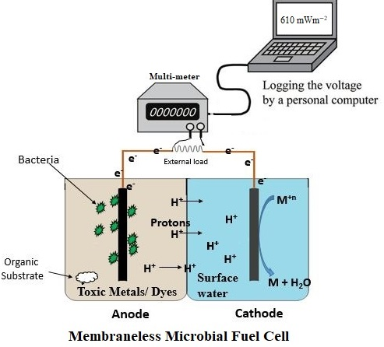
Graphical presentation of MFCs
Recent Publications (minimum 5)
- Asim Ali Yaqoob "Review Article on Applications and Classification of Gold Nanoparticles." International Journal of Research 6, no. 3 (2019): 762-768.
- Asim Ali Yaqoob "Role of Nanotechnology for design and development of cosmeceutical: Application in makeup and skin care." Frontiers in Chemistry 7 (2019): 739.
- Asim Ali Yaqoob ‘’ Review Article of Nanoparticles; Synthetic Approaches and Wastewater Treatment methods’’. International Research Journal of Engineering and Technology (IRJET), (2019); 1-7.
- Asim Ali Yaqoob ‘’ Synthesis of Ag@polycarbazole nanocables using ferric acetate as an oxidant’’. Asian Journal of Chemistry, (2019), Accepted Article

Biography
Asim Ali Yaqoob has completed his BS and Master at the age of 28 years from MUST University AJK Pakistan and currently doing PhD studies from School of Chemical Science Universiti Sains Malaysia.
Email: asim.yaqoob@student.usm

