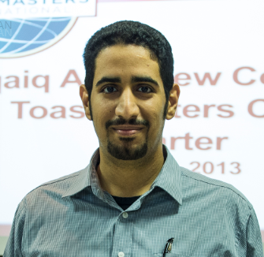

Abqaiq Plants Stabilization Operations Philosophy
Mohammed K. Al-Suwayan, Saudi Aramco, Saudi Arabia

Abstract:
Abqaiq Plants stabilize and ships oil to several terminals and refineries. The oil is received from several GOSPs thought the southern area in Saudi Arabia which is fed to the first stage of processing which atmospheric flashing takes over. The gases are sent to NGL facilities for further processing while oil is pumped to several distillation columns (Stabilizers) for additional treatment. In the stabilizers, crude is heated using steam to further extract gases and remove Hydrogen Sulfite (H2S) from the crude oil to meet storage and shipment safety requirements. The oils is then shipped to several internal and external customers through several pumping stations.
The stabilization Intensity (depth) is controlled by changing the bottom temperatures. At high bottom temperatures, the H2S concentration reaches 1 ppm (Deep Stabilization)) while at low temperatures the H2S is maintained at 60 ppm (Shallow Stabilization.
We evaluated the energy demand, production rates and benefits in each stabilization depth using simulation models and historical performance to identify the benefits of each case during summer and winter. The study showed significant savings due as a result of changing the deep stabilization from 1 ppm to 10ppm which reaches around $ 100 MM annually. In addition, to stated benefits, the exchangers fouling significantly reduced to reduction of heat flux in the exchanger.
It always beneficial to challenge the old practices of operations and maintenance in order to optimize each process and save energy and operating cost.

Biography:
Mohammed K. Alsuwayan graduated from King Fahad University of Petroleum & Minerals with a bachelor degree in Chemical Engineering in 2010. Since then, he worked with Saudi Aramco as Utilities process engineer for 4 years. During this period, he work on several processes such as boilers, HRSGs, compressors, water treatment and reverse osmoses. Following this, he work as Abqaiq Plants energy manger for 2 years leading the energy conservation and management’s efforts during which he acquired Certified Energy Manager (CEM®) from AEE.

Full Name: Mohammed Khalid M. Alsuwayan
Email: mohammed.suwayan@aramco.com
Mobile: +966505881426
LinkedIn:
Category: oral
Date of Birth: 25/05/1986

