Briquette Production Using Adapted Hyacinth Briquetting Machine

- (b) (c)
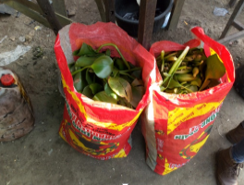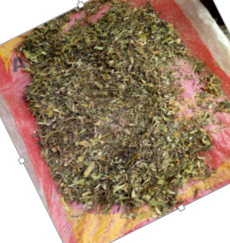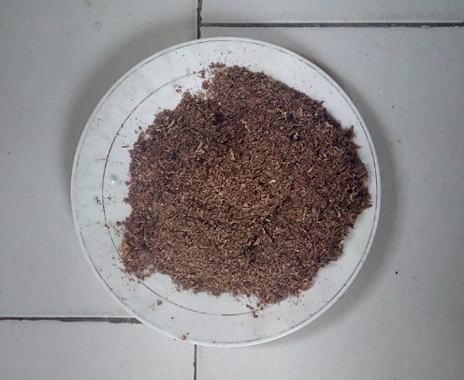
(d) (e) (f)
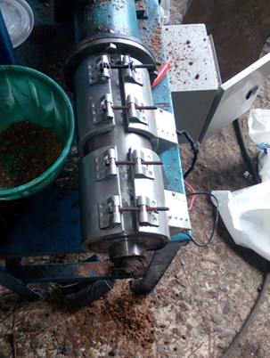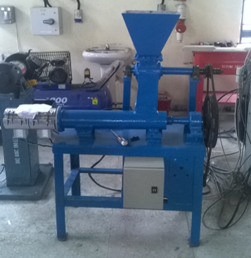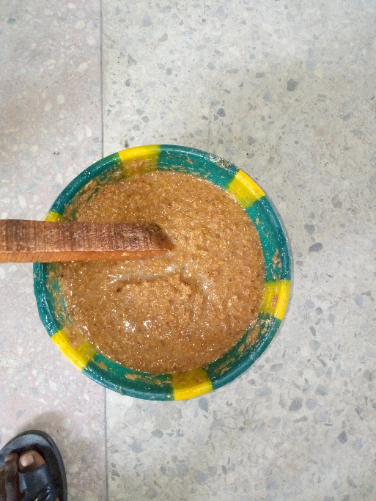

(g) (h) (i)
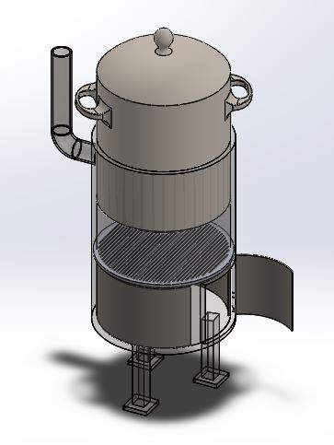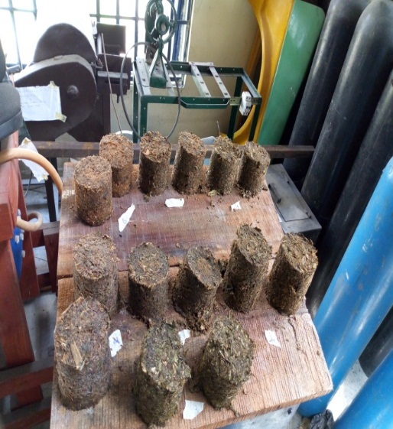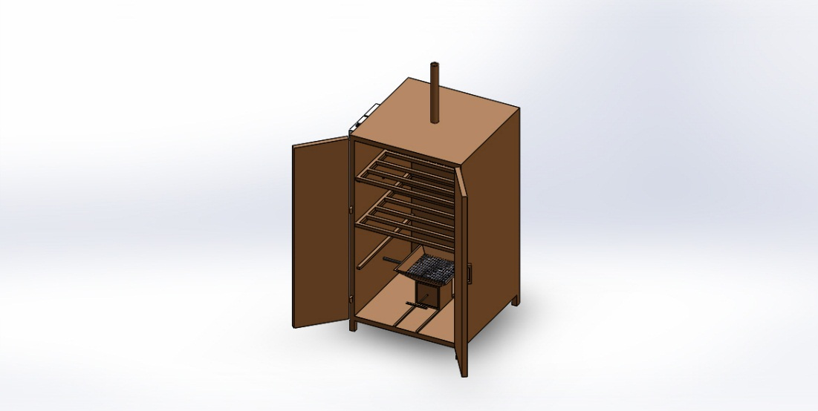

- Harvested hyacinth plants (b). dried hyacinth plants (c) crushed hyacinth (d) mixture of blend (e) mixture poured in machine (f) briquette processing (g) samples produced

Lab Head
Engr. Modestus Okwu (Ph.D)
Mechanical Engineering Department
Federal University of Petroleum Resources Effurun
Delta State, Nigeria.
mechanicalmodestus@yahoo.com
okwu.okechukwu@fupre.edu.ng

