Plant-derived oxidized nanofibrillar cellulose-chitosan composite as an absorbable hemostat
Sun-Young Lee¹, Jae-Gyoung Gwon¹, Mousumi Sukul², Byong-Taek Lee²
¹Department of Forest products, National Institute of Forest Science, South Korea
²College of Medicine, Soonchunhyang University , South Korea

Abstract
In this study, a new absorbable hemostat was developed with two most abundantly found natural polymers. Oxidized nanofibrillar cellulose (ONFC)-chitosan (Ch) sponge was prepared by lyophilization at a volume ratio of 50:50. Cytotoxicity and cell proliferation studies revealed that the sponge was noncytotoxic and the cell proliferated continuously on the sponge. ONFC-Ch sponge showed better hemostatic effect on hepatic trauma than ONFC sponge. Both sponges were implanted on hepatic trauma for1 and 3 weeks. ONFC-Ch sponge showed greater degree biodegradability and biocompatibility. Thus, ONFC-Ch sponge can be considered as a potential hemostatic material.
An oxidized nanofibrillar cellulose-chitosan sponge was prepared by lyophilization as a biomaterial for hemostasis. The pore size distribution of the sponge supported cell ingrowth. Increased cell proliferation over time indicated that the sponge was biocompatible and non-toxic. Hemostatic ability was significantly higher in the ONFC-Ch sponge. The in vivo results indicated that the ONFC-Ch sponge offered superior biodegradability and biocompatibility. These findings suggest that the ONFC-Ch sponge holds potential as a surgical hemostat.

Image

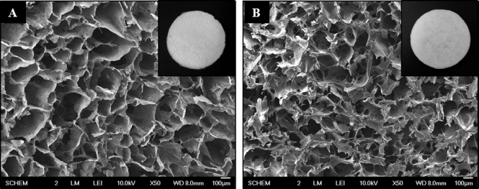

Fig. 1. SEM morphologies of (A) ONFC and (B) ONFC-Ch sponges.
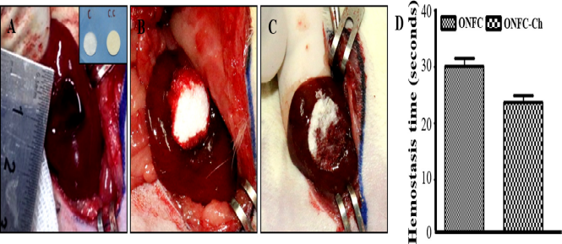
Fig. 2. Hemostatic evaluation of the sponges. Hemostasis (A) without any sponge, with (B) ONFC and (C) ONFC-Ch sponge. (D) Quantification of hemostasis time.
Recent Publications
- L. Krishnan et al. (2004) Comparative evaluation of absorbable hemostats: advantages of fibrin-based sheets. Biomaterials 25(24):5557-5563.
- C. Salas et al. (2014) Nanocellulose properties and applications in colloids and interfaces. Curr. Opin. Colloid Interface Sci. 19(5):383-396.
- A. Isogai et al. (2011) Cellulose nanofibers prepared by Tempo-mediated oxidation of native cellulose, Biomacromolecules. 8(8):2485-2491.
- H.S. Whang et al. (2008) Hemostatic agents derived from chitin and chitosan. J. Macromol. Sci. Part C. 45(4):309-323.

- T. Kean et al. (2010) Biodegradation biodistribution and toxicity of chitosan. Adv. Drug Deliv. Rev. 62(1):3-11.

 Biography (150 word limit)
Dr. Sun-Young Lee graduated from Korea University(Forestry, BS 1988; Forest Products, MS 1990). He got MS degree of Paper Science and Engineering from University of Washington in 1996 and Ph.D degree of Forest Products from Louisiana State University in 2003. Then, he has worked as a senior researcher professionally in National Institute of Forest Science from 2003. His specialized research areas are nanocellulose applicaitions and polymer composite materials, He published over 100 papers in international journals and owned 30 international and domestic patents.

Email: nararawood@korea.kr

