Fizza Batool ,student,researcher,volunteer(seminars/workshop sdpi),sales marketing CPEC project,ISLAMABAD,PAKISTAN
Abstract:
Green Chemistry is a relatively new emerging field that strives to work at the molecular level to achieve sustainability. The field has received widespread interest in the past decade due to its ability to harness chemical innovation to meet environmental and economic goals simultaneously. Green Chemistry has a framework of a cohesive set of Twelve Principles, which have been systematically surveyed in this critical review. This article covers the concepts of design and the scientific philosophy of Green Chemistry with a set of illustrative examples. Future trends in Green Chemistry are discussed with the challenge of using the Principles as a cohesive design system. A set of metrics has been developed which enables a simple assessment to be made of batch processes in terms of waste, energy usage, and chemistry efficiency. It is intended to raise awareness of green chemistry by providing a tool to assist chemists in monitoring progress in the reduction of environmental impact as they design new routes and modify processes.The development of a set of simple measurements which help to assess the environmental impact of a chemical process is described. The impact of such an approach on both defining real areas for improvement, and highlighting the importance of green chemistry as an integral process development tool is highlighted.
DJM.
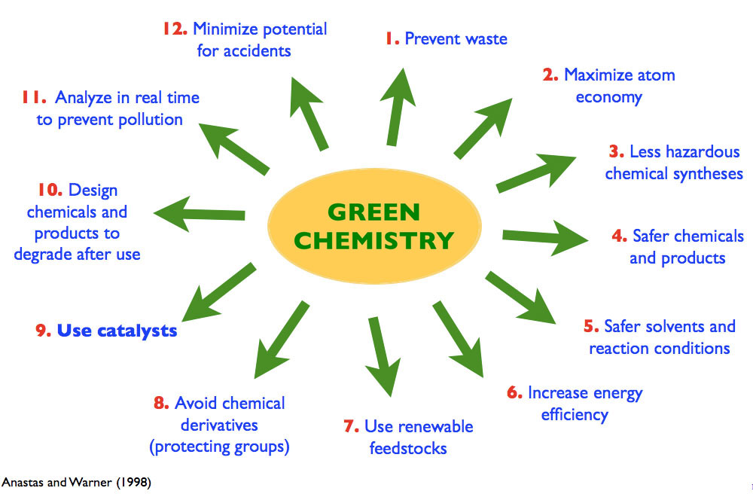
Figure 1:principle of green chemistry
Reference:minimum 5
1: Green Chemistry: Theory and Practice, ed. P. T. Anastas and J. C. Warner, Oxford University Press, Oxford, 1998.
2: Forum, Green Chem., 1999, 1, G11
3: S. L. Y. Tang, R. L. Smith and M. Poliakoff, Green Chem., 2005, 7, 761 RSC; S. Tang, R. Bourne, R. Smith and M. Poliakoff, Green Chem., 2008, 10, 268
4: B. M. Trost, Science, 1991, 254, 1471 CAS; B. M. Trost, Angew. Chem., Int. Ed. Engl., 1995, 34, 259
5: Office of Pollution Prevention and Toxics, The Presidential Green Chemistry Challenge Awards Program, Summary of 2009 Award Entries and Recipients, US Environmental Protection Agency, Washington DC, 744K09001, 2009
Biography:


Fizza Batool has completed pre-medical.she is a student,researcher and volunteer with organizations also doing marketing managing.she her expertise in evaluation and passion in improving the health and wellbeing with an opportunity to gain experience and knowledge. She has built this model after years of experience in research, evaluation,workshops,seminars and administration all are in organizations and educational institutions. she has a good talent in this pathway and has a different way of focusing she has a very goood experience to show.
Email:fizzabatool90@yahoo.com
• Full Name: Fizza Batool
• Personal Email:fizzabatool90@yahoo.com
• Mobile Number:+923475018695
• Linked In: https://www.linkedin.com/in/model-fiza-b534a5a2
• Facebook: fizzabatool90@yahoo.com
• Session Name/ number: Past and Present Research Systems on Green Chemistry
• Category: (Oral presentation/ Poster presentation)
• Date of Birth:june-25-1998
• Postal Address:Imran ali house,street no 12 near shahid general store koral Islamabad,Pakistan
Notes or Comments:
None..

