A Green Chemistry Approach to Fluorescence: Silica Nanoparticles Encapsulated Dyes
Gabor Patonay, Prof. PhD, Georgia State Univ, USA Walid Abdelwahab, Georgia State University, USA Eman Alsolmy, Georgia State University, USA Maged Henary, Prof. PhD, Georgia State Univ, USA

Abstract
Statement of the Problem: Fluorescence spectroscopic applications often require the use of extrinsic fluorophores when intrinsic fluorescence of the molecule of interest is weak or in a spectral region that is prone to interference in the matrix. Introducing extrinsic fluorophores in the molecule of interest may require chemistry that utilizes reagent that is less environmentally friendly. Fluorescence intensity of a single molecular label can be relatively weak requiring using larger amount of chemicals. All these concerns may be alleviated by encapsulating fluorophores in silica nanoparticles. Silica nanoparticles are biologically and environmentally friendly and can be designed for many applications. Covalently copolymerized dyes in silica nanoparticles are free from leaching. Even non-covalently encapsulated dyes are often virtually leach free. The outside of the silica nanoparticles can be designed for any labeling chemistry. The encapsulated dye can serve as a simple reporting label or as a sophisticated molecular probe. Due to the large number of dye molecules that can be encapsulated in a single silica nanoparticle the number of labels needed for detection is very small requiring minimal amount of chemicals. Silica nanoparticles synthesis is conducive for the introduction of covalently copolymerized fluorescent dyes by using modified TEOS reactive analogues that are widely available. The outside layer of the silica nanoparticle surface can serve as chemical reagent or sensor. For example we can change the hydrophobicity or pH sensitivity of the silica nanoparticle surface this way. This study reports how surface properties of fluorescence silica nanoparticles were modified by adding hydrophobic or hydrophilic molecules to achieve biocompatibility. Surface hydrophobicity controlled fluorescent silica nanoparticles are excellent for the detection of latent fingerprints. Surface modified silica nanoparticles can be utilized in capillary electrochromatography using amino acid-bonded silica nanoparticles as pseudostationary phases for chiral separations. Copolymerization of multiple dyes or other molecules will also be discussed.
Image
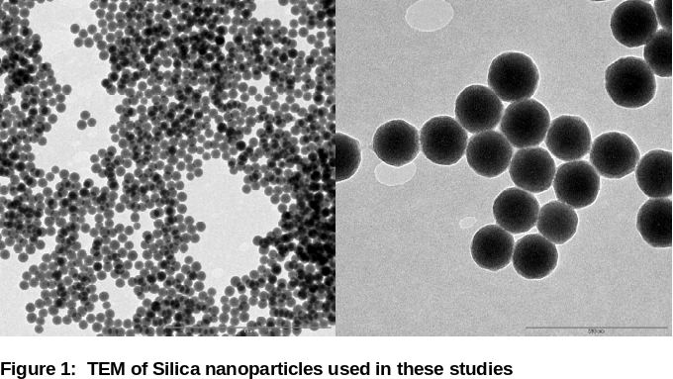
Recent Publications
- Patonay, G Beckford, G Hänninen, P UV–Vis and NIR Fluorescence Spectroscopy, in Handbook of Spectroscopy: Second, Enlarged Edition, Wiley-VCH Verlag GmbH & Co. KGaA, Published Online: 2 APR 2014, DOI: 10.1002/ 9783527654703. ch26.
- Patonay, G Chapman, G Beckford, G Henary, M Ellis, M Use of Fluorescent NIR Dyes in Silica Nanoparticles and as Enzyme Substrates in Bioanalytical Applications, Proc. SPIE. 8956, 89560U /1-89560U/11 (2014).
- Chapman, G Solomon, I Patonay, G Henary, M Synthesis and pH-Dependent Spectroscopic Behavior of 2,4,6-Trisubstituted Pyridine Derivatives, J. of Heterocyc Chem (52) 3, 861-872 (2015).
- Ebeid, WM, Salim, MM, Elkady, EF, Asmaa A, Ramzia A, El-Bagary Patonay G, Simultaneous Determination of Valsartan, Amlodipine besylate and Hydrochlorothiazide using CZE in their Combined Dosage Form, PHARMAZIE, 70, 368-373, (2015).
5. Patonay G, Henary M, Chapman G, Emer K, Crow S, Fluorescent silica nanoparticles containing covalently bound dyes for reporter, marker, and sensor applications Proc. SPIE. 97230Q; doi:10.1117/12.2217869 (2016).

Biography

Dr. Gabor Patonay is Professor of Analytical Chemistry at Department of Chemistry, Georgia State University, Atlanta, GA 30303, USA. He obtained his M.S. and Ph.D. degrees from the Technical University of Budapest, Hungary. In 1982 he left Hungary and joined Professor Isiah Warner’s group at Emory University, Atlanta, GA USA. He joined the faculty of Georgia State University (GSU) in 1987, where he is currently Professor. He spent his years at GSU focusing on NIR fluorescence related research developing new bioanalytical and biomedical applications using NIR probes and labels. His recent research interests include bioanalytical and biological applications of fluorescent silica nanoparticles. Dr. Patonay has published over 200 papers. He is the Editor-in-Chief for Analytical Chemistry Insights.
Gabor Patonay
Tel: 404-413-5556
Session Name/Number
Category: (Oral presentation)
Email: gpatonay@gsu.edu

Notes/Comments:

