From Homogeneous to Heterogeneous Catalysis towards Greener Chemistry: the Zeo-Click and Zeolite-based Organic Synthesis Approaches
Patrick Pale* H PhD, Institute of Chemistry, University of Strasbourg, France
Stefan Chassaing, PhD, ITAV, University of Toulouse France
Valérie Bénéteau, PhD, Institute of Chemistry, University of Strasbourg, France

Abstract (300 word limit)
Statement of the Problem: Organic synthesis is the art of building molecules in a controlled way, up to highly complex natural and bioactive compounds. Mostly relying on metals as reagents or catalysts, organic synthesis is facing a huge and increasing problem: metal availability and sustainability.
Sch.1: The Zeo-click concept:
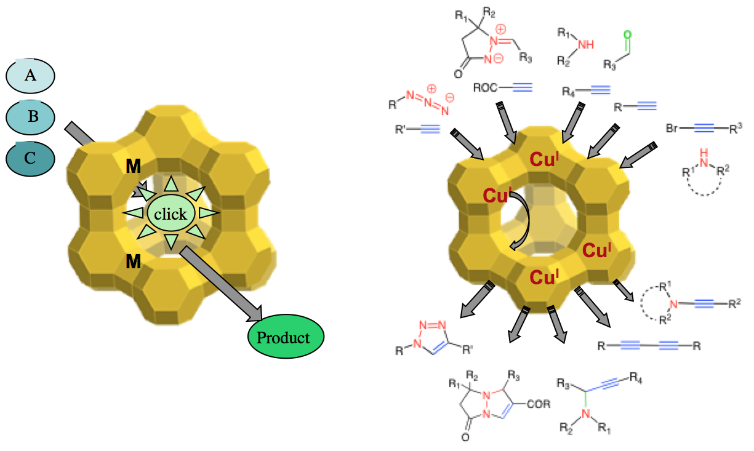
e.g. for Cu-Zeo:

Sch.2: The zeolite-based organic synthesis (ZeoBOS) approach:
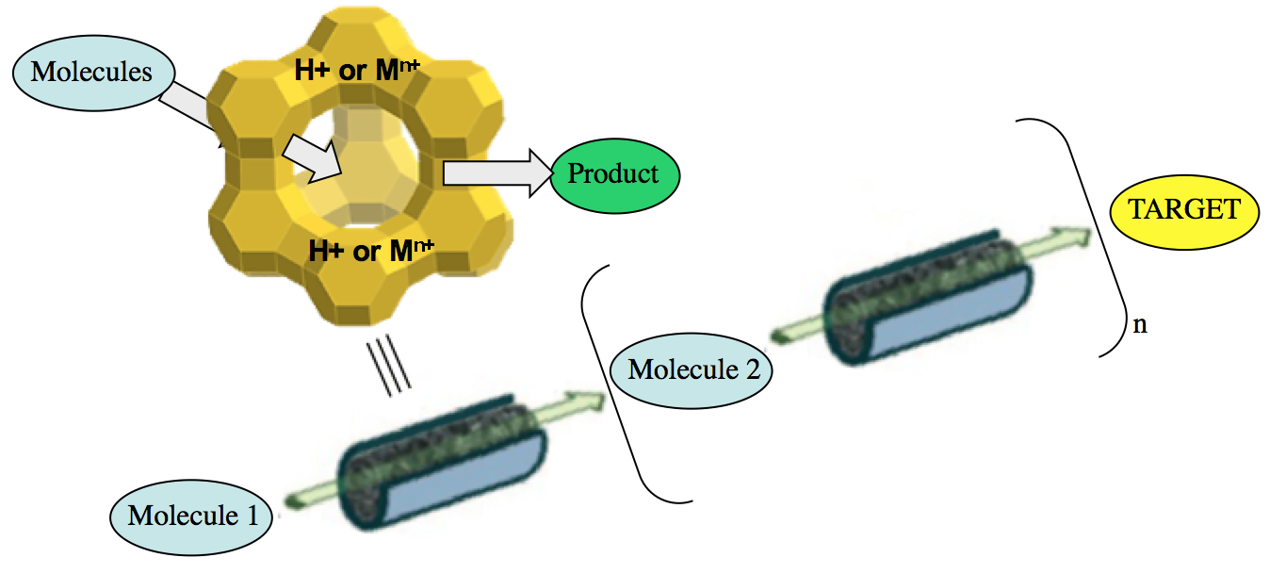
Methodology: To help solving this problem, we are combining the properties of zeolites with the catalytic properties of some metal ions, trying to develop an alternative organic chemistry that we called “ zeo-click chemistry ”. For that purpose, we are developing and using new heterogeneous catalysts based on zeolites (i) easy-to-prepare, easy-to-handle, easy-to-recover and recyclable, (ii) able to efficiently, quickly and reliably generate substances by joining appropriate units together, what we called the "zeo-click" approach. (Sch. 1 & ref 1, 3, 4). To go even further towards greener synthesis, we are currently exploring an alternative to the conventional solution- and solid-phase organic syntheses, based on such zeolite catalysts, what we called ZeoBOS: each step would be performed through a zeolite, either native or modified, catalytically converting a molecule to another one (Sch. 2 & ref 6).
Conclusion & Significance: In sharp contrast to homogeneous catalysis, a single heterogeneous catalyst can be applied to major types of organic transformations such as multi-component reactions, coupling reactions, cycloadditions, etc …(cf. Sch 1). Furthermore, metalated zeolites are efficient and reusable catalysts, and they can keep their activity in water, alcohol or without solvent. The 1st total synthesis of a natural bioactive product has been achieved based on these metalated zeolites as catalysts.
Recent Publications (minimum 5)
- Click chemistry in Cu-Zeolites : The Huisgen [3+2]-cycloaddition. Org. Lett. 2007, 9, 883-886.
- Ag-mediated reactions: Coupling and heterocyclization reactions. Chem. Rev. 2008, 108, 3149-3198.
- Silver-zeolite catalysed solvent-free synthesis of (spiro)ketals. Green Chem. 2013, 15, 1496-1500.

Image
- When CuAAC 'Click Chemistry' goes heterogeneous. Catal. Sci. Tech. (Perspective Review) 2016, 6, 923-957.
- Gold(I)-catalyzed N-desulfonylative amination versus N-to-O 1,5-sulfonyl migration: a versatile access to 1-azabicycloalkanes. Angew. Chem. I. E. 2016, 55, 9088-9092.
- Zeolite-based organic synthesis (ZeoBOS) of Acortatarin A: 1st total synthesis based on native and metal doped-zeolite-catalyzed steps. Chem. Eur. J. 2017, 23, 1484-1489.
- H-ZSM-5 zeolite model crystals: Structure-diffusion-activity relationship in methanol-to-olefins catalysis. J. Catal 2017, 345, 11-23.

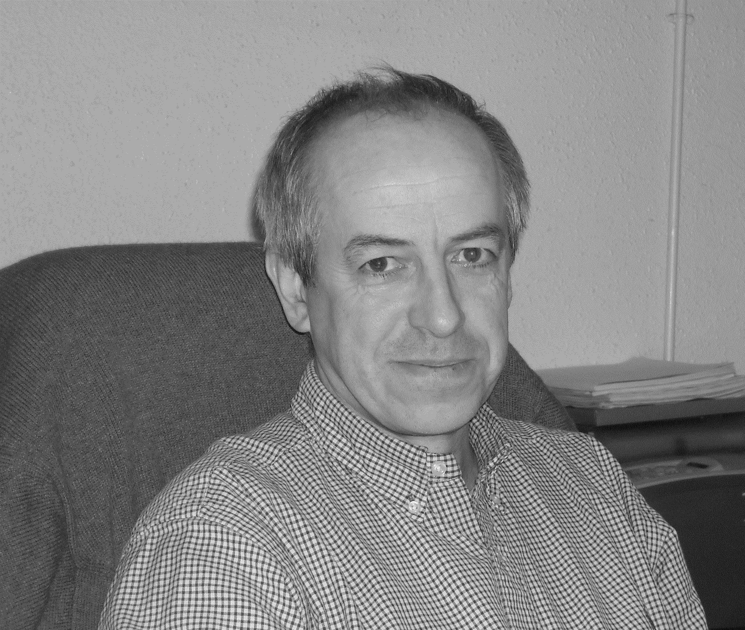Biography (150 word limit)
Patrick Pale studied at the University of Champagne in France. After an industrial stay in a pharmaceutical company, he joined the group of Prof. L. Ghosez as a postdoc in Belgium. Back to France, he got a CNRS position and then a research associate position at Harvard University in the group of Prof. G. Whitesides. In 1995, he got a full Professor position at the University of Strasbourg, France. Subsequently, he was awarded Professor at the “Institut Universitaire de France” from 1996 to 2001. His scientific interests include the (asymmetric) synthesis of bioactive compounds, organometallic chemistry, carbohydrate chemistry and enzymatic chemistry, and more recently chemistry with materials such as zeolites, MOF, POM.
PALE
Tel: +33 368 85
Session Name/Number
Category: (Oral presentation)
Email: ppale@unistra.fr

Notes/Comments:

