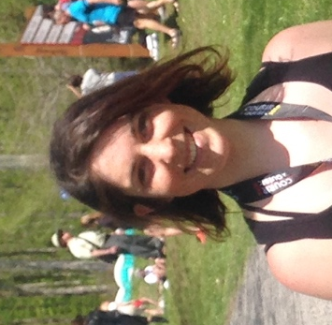
Title: Optimization of a Supercritical Fluid Extraction of Lutein and Chlorophyll from Spinach By-products using Response Surface Methodology
Names: Maëlle Derrien, Yacine Boumghar, André Gosselin, Yves Desjardins, Paul Angers
Université Laval, department of food science, Québec, QC, Canada

Abstract

Green chemistry is a major challenge of the 21st century. Industrial vegetable by-products contain high levels of valuable phytochemicals that can be used as a rich source of biomolecules. The main objective of this project was to develop an extraction process technology of two highly valuables biomolecules, lutein and chlorophyll, using spinach by-products and respecting the main principles of green chemistry. This work focused on the development and optimization of ecological processes for extraction of these phytochemicals, using supercritical CO₂ technique and response surface methodology (Box Benhken). The extraction efficiency have been compared to the total extraction of lutein and chlorophyll obtained with hexane. The effect of pressure, temperature, duration and co-solvent have been tested on the extraction of lutein and chlorophyll. The results suggested that the extraction was mostly influenced by the extraction time, pressure and ratio of co-solvant (ethanol). There is a linear and negative quadratique effect of the pressure and the extraction time on the lutein and chlorophyll whereas the co-solvant exerted a linear positive effect on the recovery of both biomolecules. The temperature did not exert a significative interaction on these molecules during the extraction procedure. The optimum extraction parameters were given by a desirability function, and were 3,6h at 490 bar, with 10% of cosolvant and at 56°C. With these parameters a yield of 65% lutein and 45% of chlorophyll, without major drawbacks were obtained.
The supercritical fluid extraction is therefore a valable method for extracting lutein and chlorophyll with respecting all the green chemistry standard.

Biography

Maëlle DERRIEN is PhD student in food science at university Laval, in Québec. She obtained a degree in biology, biochimistry from University of Rennes, France. Her research field is green chemestry, in order to valorize crops by product by an ecological extraction of their biomolecules content. For this goal, she uses innovative green chemistry techniques optimized using statistical models. She work with the supervision of Paul Angers, Researcher and Professor at the same university in food science. The project is in paternship with a Québec based nutraceutical industry , NutraCanada, and supported by NSREC (Natural Sciences and Engineering Research Council of Canada).
Presenting author details
Full name: DERRIEN Maëlle
Contact number: 418 262 3215
Session name/ number: Green Chemistry and Engineering
Category: Oral presentation

