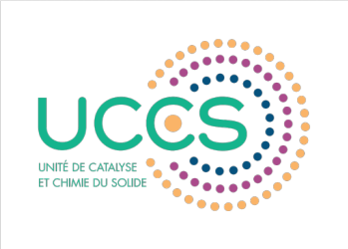


Composite nanofibers containing ruthenium nanoparticles stabilized by cyclodextrin polymers: synthesis, characterization and their application in heterogeneous catalysis
Sami Fadlallah^{1,2}, Bastien Léger², Sébastien Noël², Frédéric Cazaux¹, Nicolas Tabary¹, Eric Monflier², and Bernard Martel¹
¹ Université de Lille, CNRS, ENSCL, UMR 8207, Unité Matériaux et Transformations (UMET), F-59650 Villeneuve d’Ascq, France; ² Université d’Artois, CNRS, Centrale Lille, ENSCL, Université de Lille, UMR 8181, Unité de Catalyse et Chimie du Solide (UCCS), F-62300 Lens, France.

The synthesis of functional nanofibers containing noble metal nanoparticles (NPs) is of growing interest, notably due to their application in different fields such as catalysis, medicine and sensing (1). These systems exhibit particular characteristics and they are defined by their high surface area of stabilized active metals. However, the size and homogeneous distribution of the incorporated metal NPs should be taken into consideration in order to reach the high performance and efficiency.

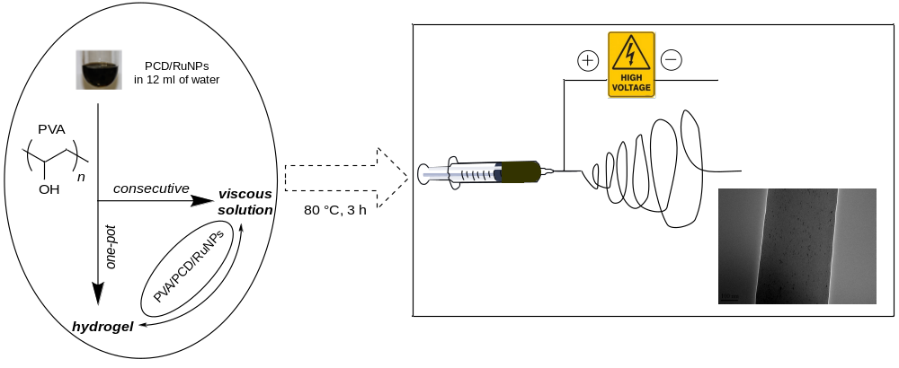
Herein, we report the synthesis of composite nanofibers of poly(vinyl alcohol) (PVA)/poly(citric acid-β-cyclodextrin) (PCD)/RuNPs. The new approach includes the preparation of a series of Ru colloidal nanosuspensions stabilized with PCD (2), then, the dissolution of PVA polymer which constituted the matrix of nanofibers during the electrospinning phase. Rheological study showed that the viscosity depends on both the molecular weight of PVA and amount of reducing agent; NaBH₄. These heterogeneous catalysts were fully characterized by TEM, SEM, TGA and DSC. Moreover, the effect of NaBH₄ (NaBO₂) as a physical crosslinking agent was studied by heat treatment of electrospun nanofibers. Furthermore, the activity of the prepared catalysts was evaluated in the catalytic hydrogenation reactions in liquid phase.

References
- J. Xue, J. Xie, W. Liu, Y. Xia. Electrospun nanofibers: new concepts, materials and applications. Accounts of Chemical Research 50 (2017) 1976-1987.
- R. Herbois, S. Noel, B. Leger, S. Tilloy, S. Menuel, A. Addad, B. Martel, A. Ponchel, E. Monflier. Ruthenium-containing β-cyclodextrin polymer globules for the catalytic hydrogenation of biomass-derived furanic compounds. Green Chemistry 17 (2017) 2444-2454.
Biography

Dr. Sami FADLALLAH has completed his PhD in Organometallic Chemistry and Homogeneous Catalysis by University of Lille-UCCS laboratory. Currently he is postdoctoral research associate in the field of polymer engineering and heterogeneous catalysis at UMET-Lille and UCCS-Artois laboratories

Presenting author details
Full name: Sami FADLALLAH
Contact number: +33(6)34216649
Email id: sami.fadlallah@hotmail.com
Linked In account: https://www.linkedin.com/in/sami-fadlallah-746482157/
Contact number: +33(6)34216649
Session name/ number: Polymer supported catalysts
Category: Oral

