Fabrication of Octahedron-like BiOI/MOF Composite Photocatalysts with Enhanced Photocatalytic Hydrogen Evolution from Water Splitting

Gang-Juan Lee, Yu-Wen Chien, and Jerry J. Wu*
Department of Environmental Engineering and Science, Feng Chia University, Taichung 407, Taiwan
*Email: jjwu@mail.fcu.edu.tw

Abstract
An octahedron-like metal-organic framework (MOF) was successfully synthesized by the ultrasound irradiation synthesis method. Meanwhile, a novel visible-light-driven BiOI/MOF composite photocatalyst was also synthesized by the microwave irradiation synthesis. MOFs, a new class of porous crystalline materials, have attracted tremendous attention considering their broad application prospect because MOF possesses the repeated crystalline structures and thereby improving the harvest of solar energy and transportation of charge carriers. In this article, the result has revealed that the appropriate modification of MOF could reach the maximum hydrogen yield under visible light irradiation. The hydrogen evolution from de-ionized water containing at pH 7 and 0.20 g L⁻¹ of BiOI/MOF composite photocatalyst had the maximum of 2,516.8 μmol h^{–1} g^{–1}. Therefore, this study has substantially demonstrated to enhance the photocatalytic efficiency of BiOI photocatalyst using MOF modified BiOI.
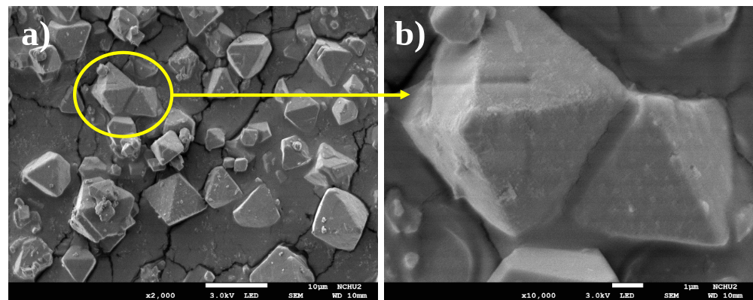
Figure 1 SEM images of a) and b) octahedron-like MOF

