Title: Large Single Crystal Graphene Manufacture
Name: James C. Sung
Affiliation: Henan Graphene Synthetic Co.,LTD., Henan, China
Co-authors: Jian She Liu, Hai Chao Wang, MIchael Sung

Abstract
Large single crystals of graphene ware made by using a solvent-catalyst of nickel metal. Both solid and liquid processes were experimented with graphene single crystals of mm demonstrated. The carbon source may be solid or gasses. For example, green house effected carbonaceous gasses could be used to strip carbon in forming large crystals of graphite that would be a source for making precious graphene.

Introduction:
Graphene has phenomenal properties, such as with 100X mechanical strength of steel, 100X of electrical conductivity of copper. However, these superb attributes belong to intact honeycomb lattice (sp2) of carbon atoms. Unfortunately, both natural and man-made graphene products are defects ridden. They are also limited by the honeycomb size (la) of carbon lattice. Hence, the graphene single crystals available are nanometers across, such bacteria sized graphene is best used as additives, such as strengthening agent for polymers, or for corrosion retardant of coatings.

Although CVD methods claim to have large areas of graphene deposition on metal foils (e.g. Cu), but the bombardment of pyrolytic carbon atoms on substrate is an irreversible (non-equilibrium) process, so most carbon atoms may land in the wrong position and incapable to move to the equilibrium sites. As a result, single crystals with defects density commensurate to silicon wafer in the order of 10 thousands per centimeter are also smaller than one micron, like that those exfoliate from natural graphite. The sublimation of SiC sigle crystal to form graphene surface suffers the non-equilibrium process in reverse. The reconstitution of remaining carbon atoms, although nearby is kinetically slow at the sublimation temperature. Consequently, the so called graphene wafer is not made, let alone to mention that SiC signle crystal wafer itself is expensive.

The problem of forming large single crystal graphene is due to the strong sp2 bonds that made graphene super strong in the first place. The bond energy of graphene is covalent plus pi bonding with a bond energy of about 6 eV. This is stronger than diamond’s sp3 bonds (band gap 5.45 eV). To break such a bond thermally, it would require >3000 ℃ that is not attainable in most vacuum furnaces. For example, carbon fibers are made by graphitization at 2600 ℃ that can most form graphene with La about 10 nm, much smaller than a virus. Consequently, it is not practical to make graphene by a thermal means.

Solvent:
However, graphene layers are bonded by van der Waals force with a bond energy less than 0.2 eV between layers in graphite. Such a force can be easily dissociated in molten iron group metals, such as Fe, Co, Ni or its alloy. In fact, this is a commercial process for making synthetic diamond from purified graphite under ultrahigh pressure^{1，2} (about 5 GPa), each year, about 2000 tons (1 ton = 5 million carats) are manufactured as superabrasives used worldwide. This process at low pressure or vacuum can be used to grow prestine graphite crystals assisted by solvent/catalyst³. Because the solute carbon atoms are easier to attach on the periphery of growing graphite with a much shorter bond length (1.42 A) than forming a new layer afar (3.35 A), the grown graphite is naturally thin and large. Incidentally, this is the process of forming kish in steel industry. But kish is to be avoided for steel making as it weaken iron, but it can be the ideal source for large single crystal graphene. However, the key is to select the carbon solvent that would not react to form carbide, hence molten iron is not a desirable kish maker. Instead, nickel does not form carbide so it is preferred. But the melting temperature of nickel is 1450 ℃, so iron may be added to lower the processing temperature. For further decrease of operating temperature, rare earth elements, such as Ce may be added.

A key consideration of making diamond or kish is the reactivity of metal atoms with carbon atoms. For 3d transition elements, this more empty 3d orbitals are present, the stronger its attraction to 2p electron of carbon. In order to avoid carbide formation or too low the solubility, empty 3d orbitals should be moderate, and hence, iron group elements have the highest carbon solubility.

Fig.1: The relative solubility of carbon in 3d period transition metals. Note that that the reactivity with carbon must be moderated, to strong (left side elements), carbide is formed; and too weak, carbon is not dissolved. Only iron group metals can allow high solubility of carbon for making making or kish.

Graphite can form diamond by displacive transition (martensitic) without breaking bonds, hence, graphite will exfoliate in molten iron group alloy, and the few layer graphene can pucker to formed diamond under high pressure.
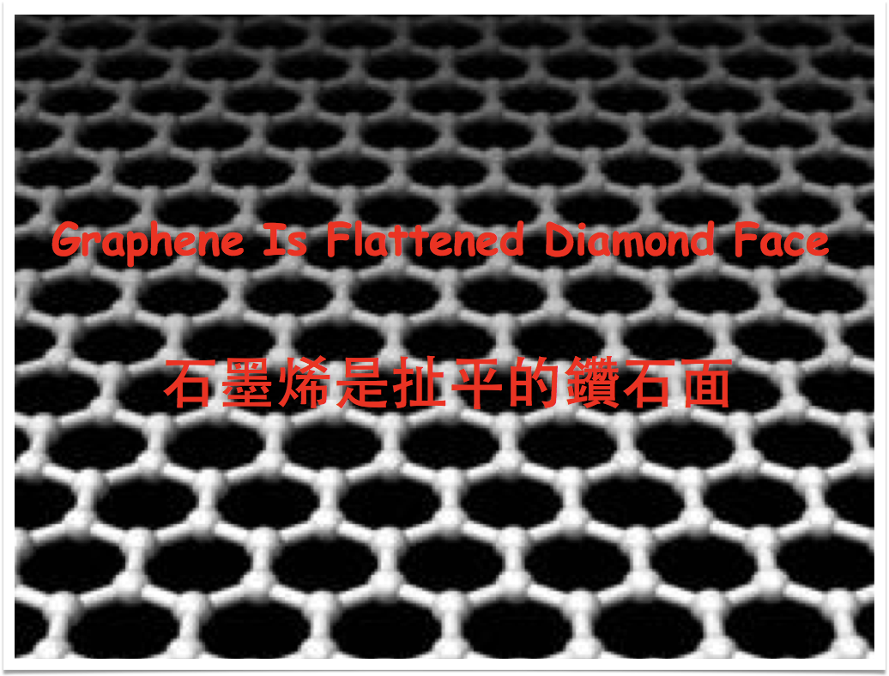
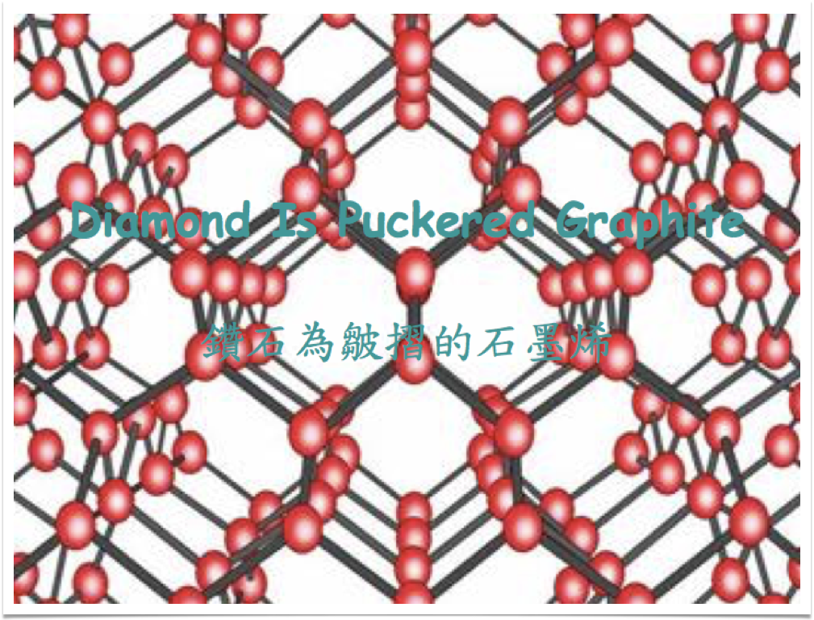
Fig.2: Graphene is a stretened octahedral plane (111) of diamond, the growth of diamond at high pressure involves puckering exfoliated graphite in molten solvent-catalyst of iron group alloy.

Template:
The dissociated few layers graphene or dissolved carbon atoms may occupy the network of psedo-octahedral voids of iron group solvent, and rearrange using the solvent psudo-lattice patern to form kish crystals.
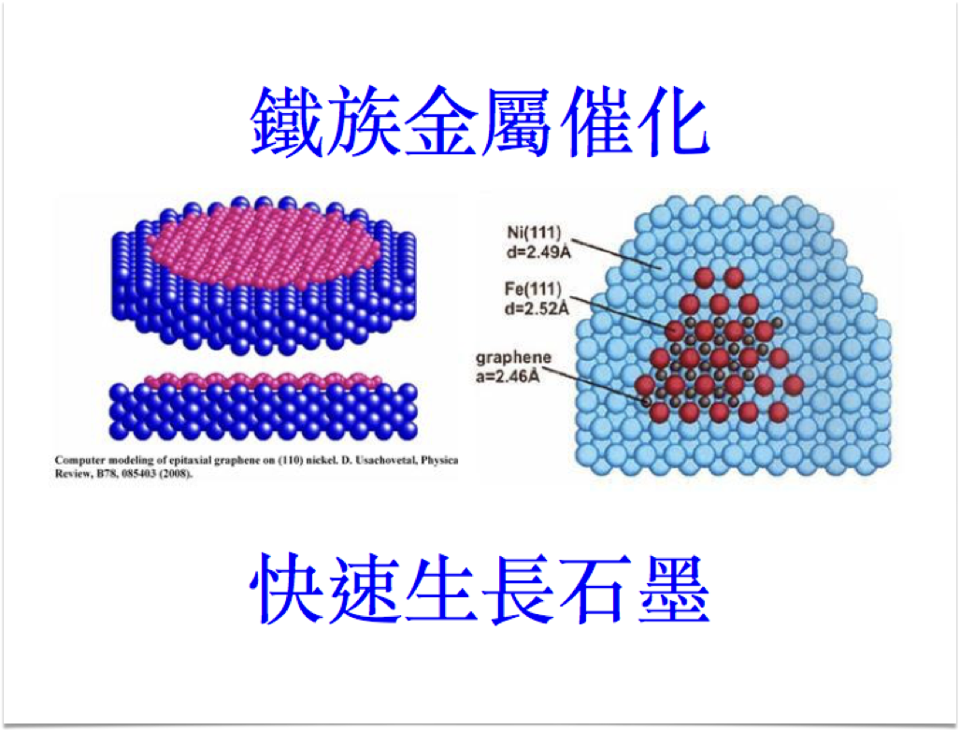
Fig.3. The molten metal acts as a template to rearrange graphene or carbon atoms into kish crystals.

The kish formation form nuclei of kish in different orientations, but with time, they may grow to form larger kish crystals due to the alignment of solvent metal atoms.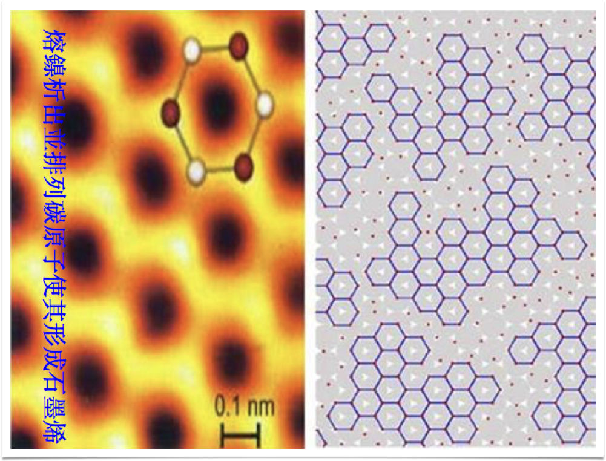
Fig.4: Pattern formation of graphene lattice due to the closest packing of solvent metal atoms.

Solid Process:
A solid state process was developed to cook graphite powder or carbon black on nickel plate under high vacuum (10^-5 torr) to 1300 ℃ and gradually decrease temperature to 1200 ℃ before furnace cooling. The result is the formation of polycrystalline kish on both sides of nickel up to 40 microns thick. The single crystals of such kish are millions time larger in area, as la was determined by XRD and Laman spectroscopy.
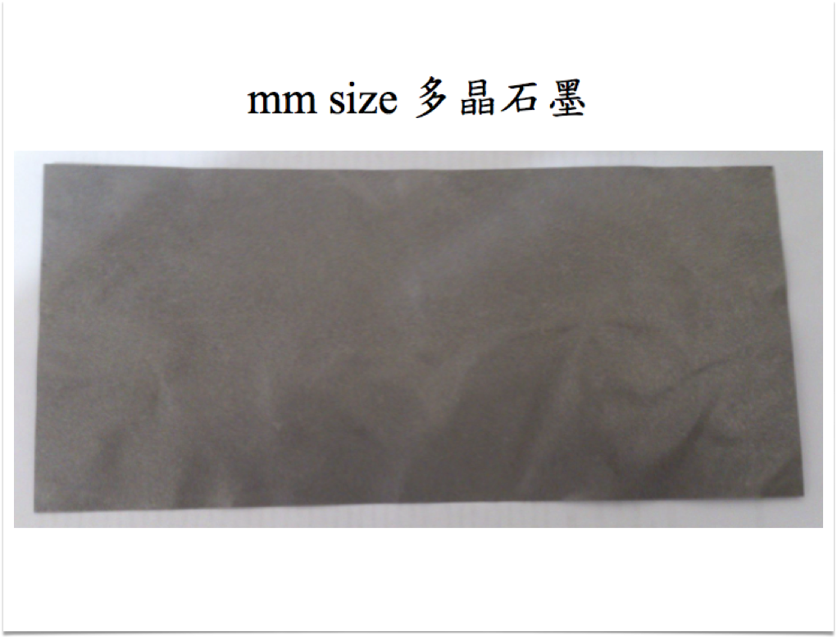
Fig.5. The appearance of polycrystalline kish formed by nickel template under vacuum.

Exfoliation:
The kish formed above was retrieved by anodizing nickel plate in acid solution. Polycrystalline kish layer was recovered and it was milled to form high crystalline graphite. Subsequently, such graphite was suspended in coupling agent NMP to make a slurry with up to 30 wt% graphite. The suspension was pressurized to 100MPa and it was squeezed between two diamond nozzles to reach sonic speed. The sudden reduction of pressure allows graphite particles to expand and exfoliate. In this way, chemical exfoliation by intercalation of acid or salt was avoided as graphene oxide (GO) formation is detrimental to physical properties of graphene, particularly, electrical conductivity. The jet exfoliation also broke the defects ridden areas so the remaining graphene contained mainly single crystals with high mechanical strength.
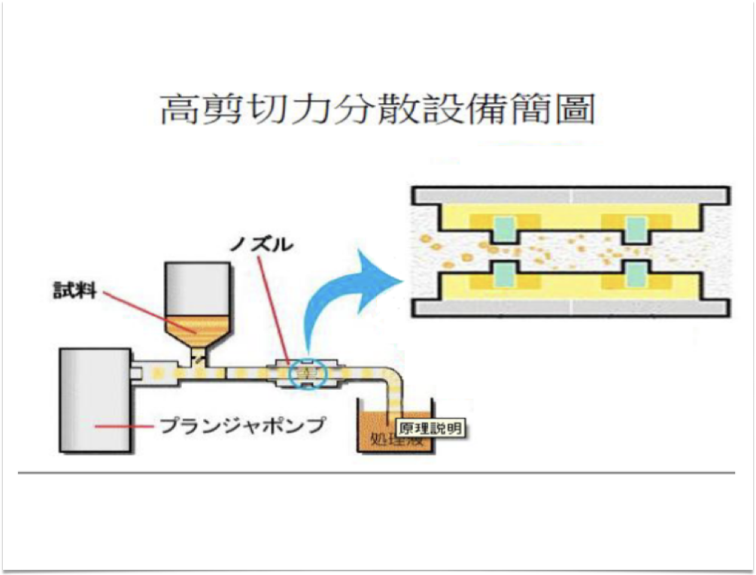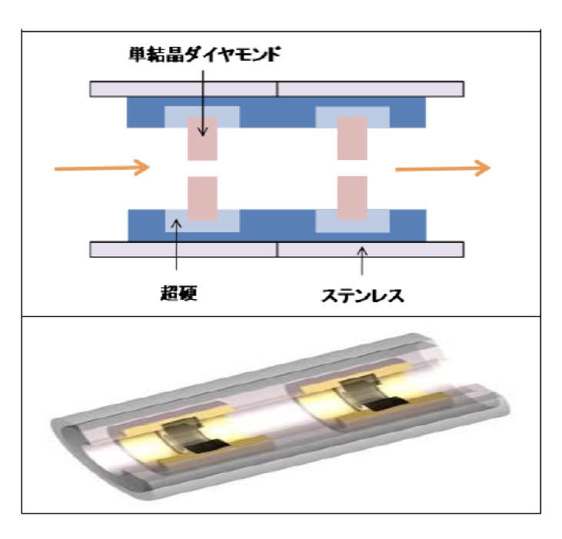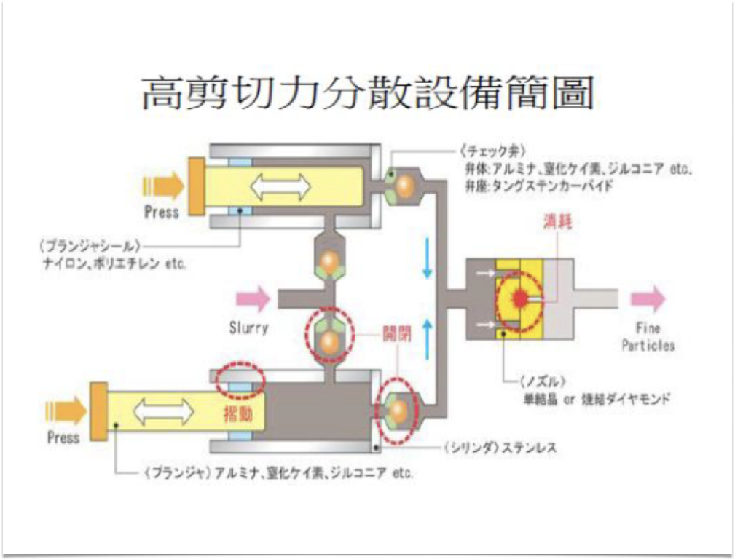
Fig.6: The continual process used to exfoliate kish graphite suspended in NMP. The process resembled the water jet with the function to explode layered graphite into graphene.

By cycling about 200 times using the above liquid jet process, about 1/3 of graphene recovered show few layers under Raman spectroscopy.
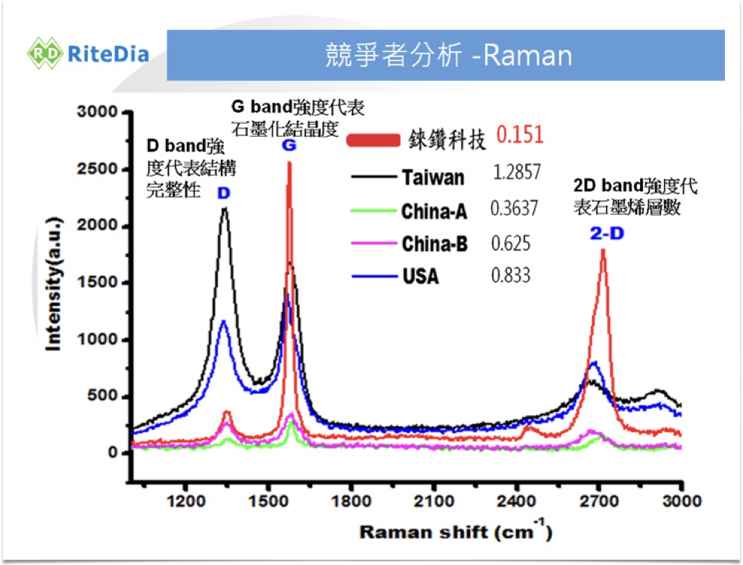
Fig.7: The few layer graphene revealed strong 2D peak and narrow G peak, indicating the high quality.

Liquid Process:
Although the above solid state process was capable to grow single crystal graphene up to mm size, but transparent conductor to replace ITO, or boundary free interconnects to replace IC would require even larger single crystals. The kinetics of solid state diffusion of carbon atoms was too slow to allow wafer sized single crystal graphite to be formed. Consequently, a liquid phase process was used to grow even larger single crystals.

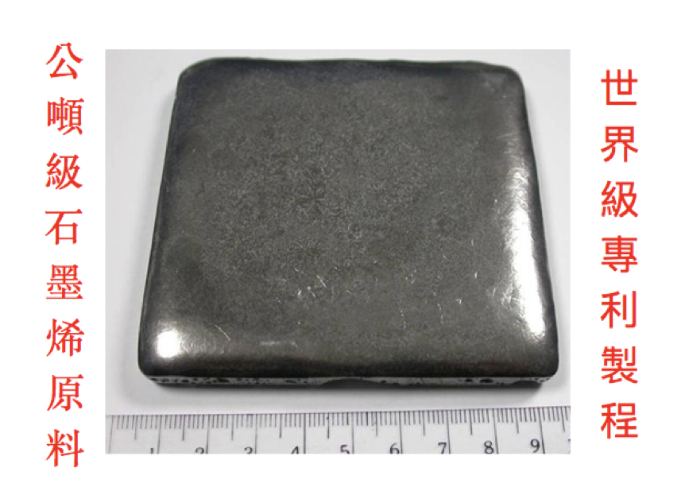
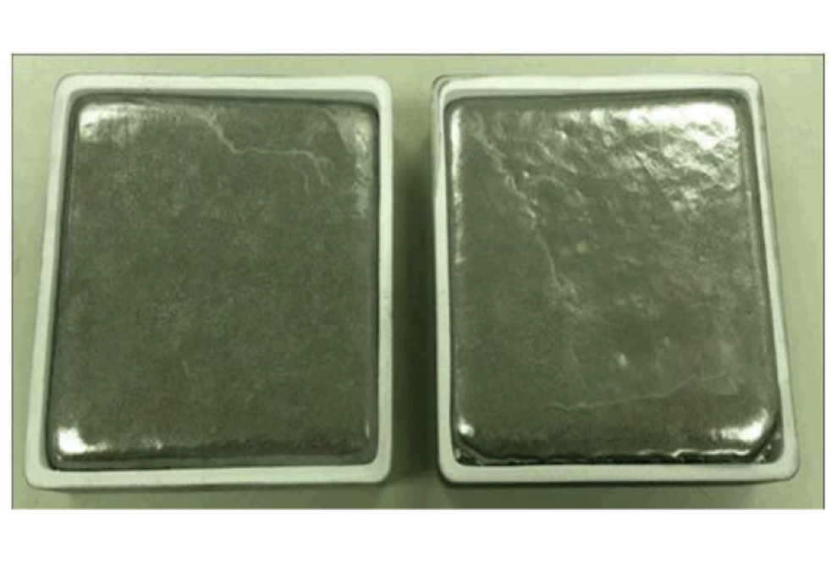
Fig.8: Regrown graphite up to 100 mm squares were formed under vacuum in a few hours.
The formation of kish in molten iron group alloy (Fe2Ni) was complete with continuous lattice of thousand layers graphene. But unfortunately, during the cooling the much faster shrinkage of molten alloys wrinkled the continuous lattice of kish formed atop.
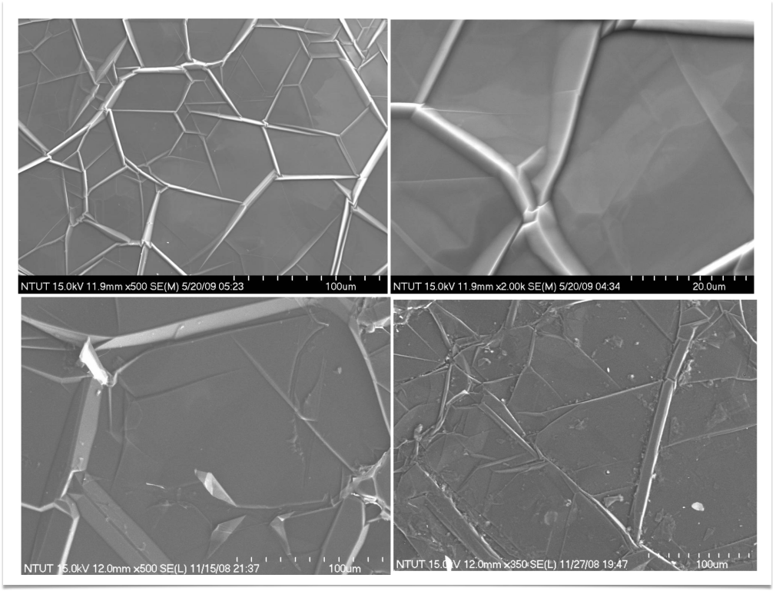
Fig.9: The SEM micrographs of kish covered metal showed shringkage wrinkles. But the graphene lattice seemed continous across.

XRD patterns revealed that the regrown graphite was rhombohedral instead of hexagonal for most normal graphite. The shaffering of AB sequence to ABC was due to the 3d orbital action of the iron group metal onto the weak van der Waals force of graphite.

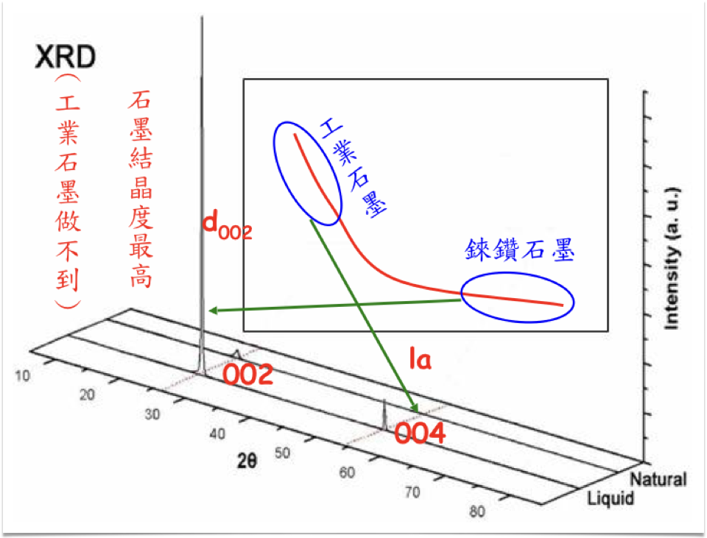
Fig.10: The large single crystal of the regrown graphite was proven by the tight d002 spacing between graphene planes, also with high diffraction intensity.

The recovered kish was exfoliated in acid to reveal cloth like behavoir that is transparent to election beam used in SEM.
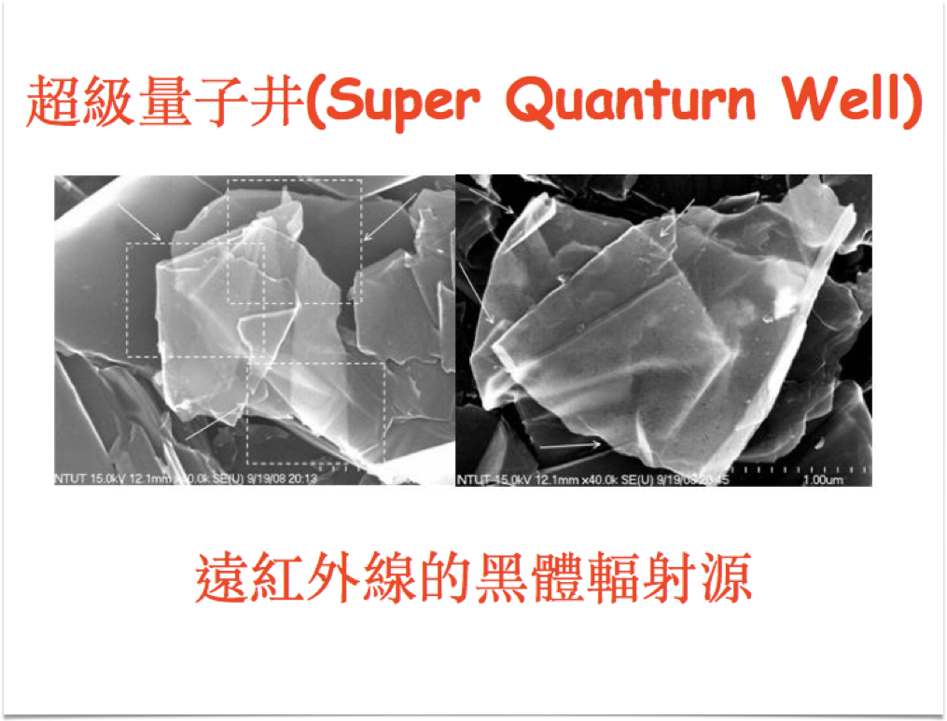
Fig.11: The cloth like graphene with sharp folding lines without breaking the lattice.

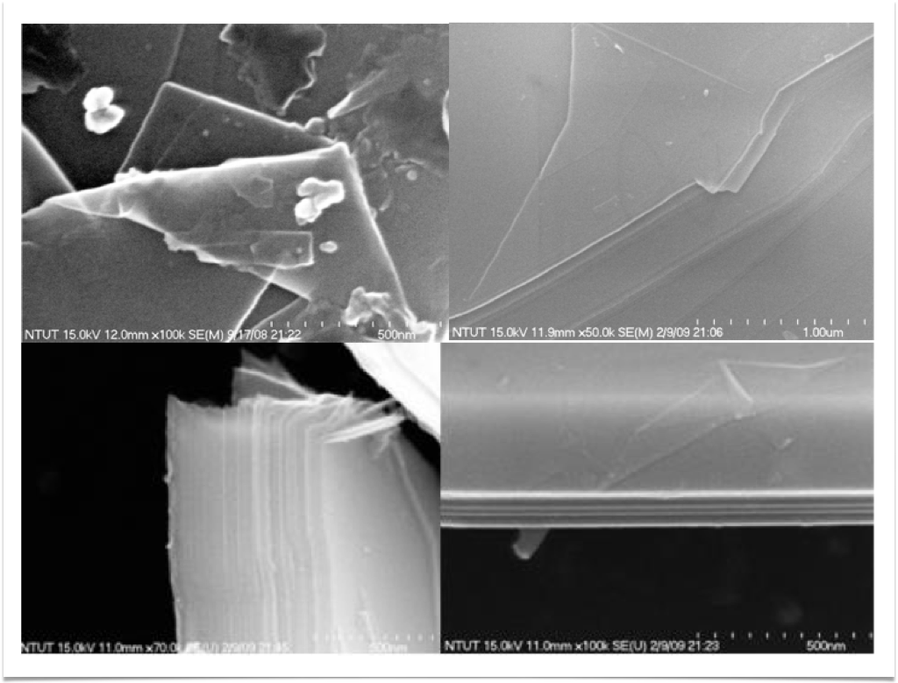
Fig.12: The booklike graphite with clear foldable graphene layers.

Steel Making Kish:
The steel making industry generates megatons kish rutinely. But due to the impurities present in the iron ore and coke used as raw materials, such kish, although may be highly crystalline, is unsuitable for the manufacture of graphene unless it is purified beforewhand.

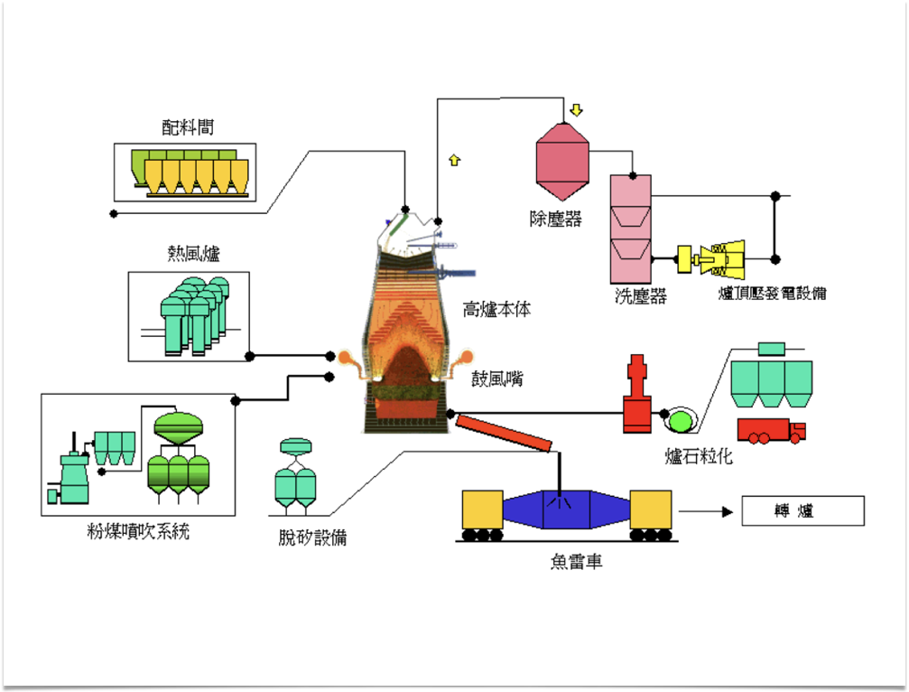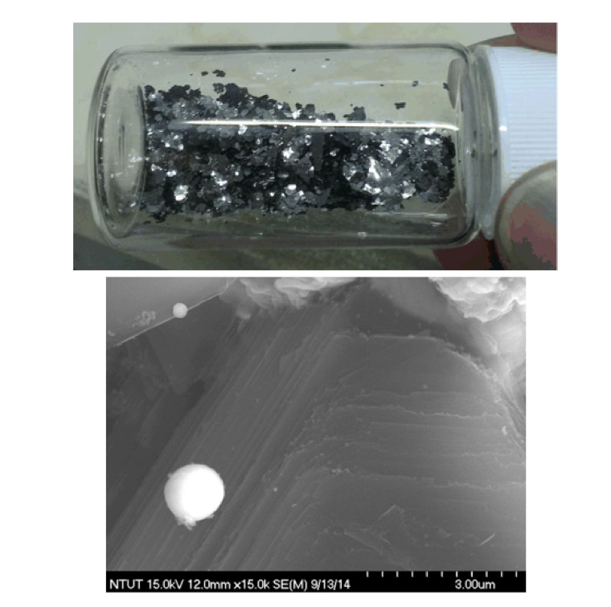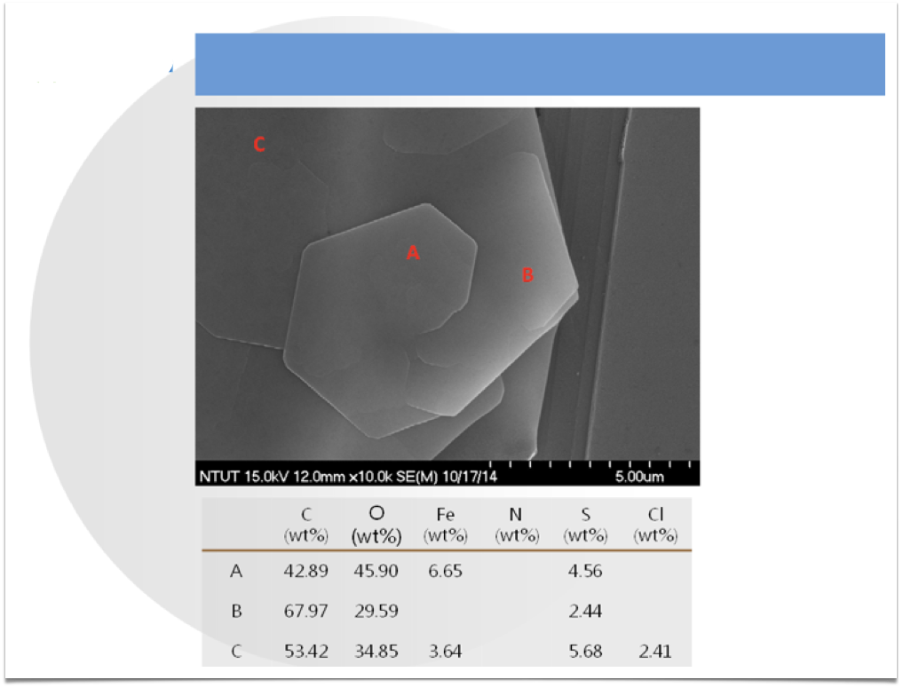
Fig.13: Blast furnaces used worldwide produce kish measured in megtons annually. Such kish has high crystallinity as indicated by the shiny basal planes of graphite, also with SEM micrographs.

Temperature Gradient Process:
To further the advancement of growing large single crystals graphite for the manufacture of graphene to be used in the future display and IC industries, a temperature gradient process under vacuum or inert atmosphere is envisaged. Moreover, by adjusting the alloy composition as discussed above, processing temperature may be greatly reduced to facilitate the commercial production.
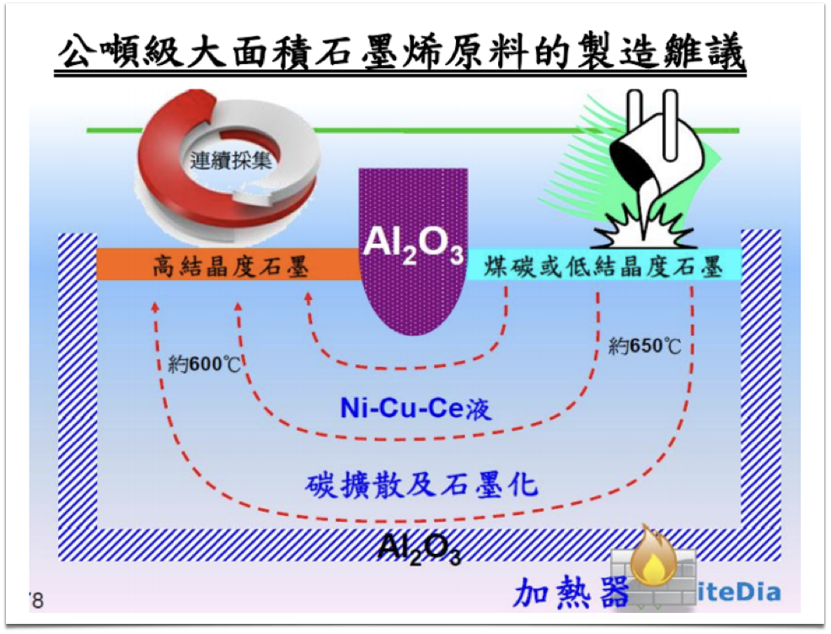
Fig.14: An example of continuous extra large single crystal graphite as manufactured at low temperature by employing a temperature gradient.

Global Warming Gasses:
Another idea to make premium graphite is to use waste gasses from oil refinery and power plant. In this case,the global warming carbonaceous gasses are combined to form harmless steam.The furnace used for this process has the precedent of Bessemer process for steel making. In this case, the blowing gasses are changed from oxygen/air to carbonaceous gasses.
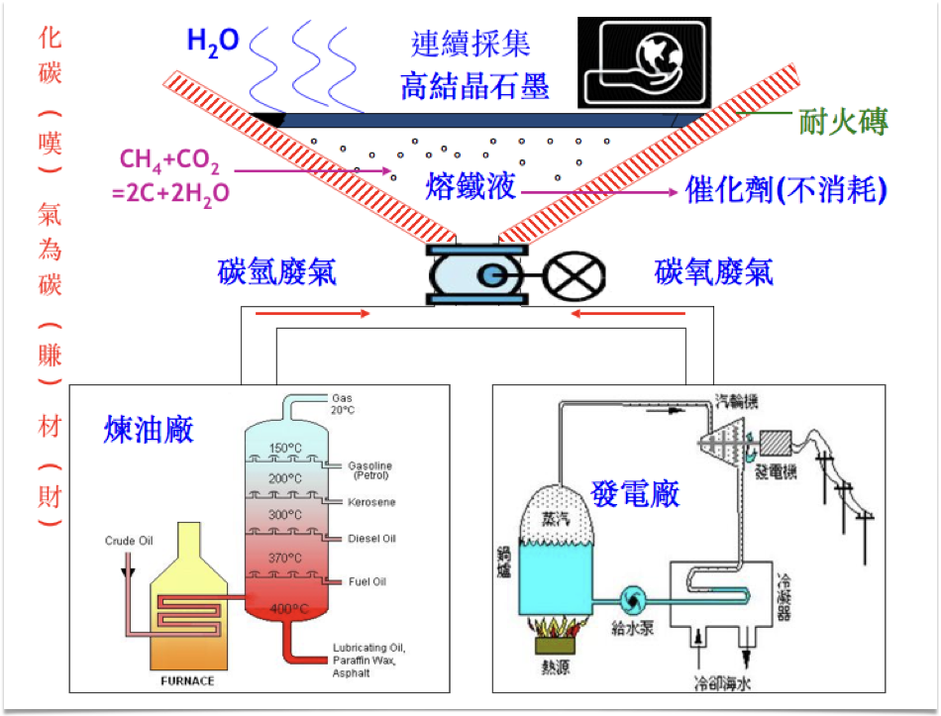
Fig.15: The illustration of using methane and carbon dioxide toxic gasses in making graphite to float above a molten alloy. Note that the endothermic reaction can be overcome by adding aluminium powder as thermite. The alumina formed will also float to sandwitch between graphite and metal.

Biography：
- Chien-Min Sung, Optimized cell design for high pressure synthesis of diamond, High Temperature s-High Pressures, 2001, Volume 33, Pages 489-501.
- James C. Sung, Michael Sung, Emily Sung, Diamond Growth In An Array Of Seeds: The Revolution Of Diamond Production, Thin Solid Film, 2006, Pages 212-219.
- James C. Sung, Jian-Ping Lin, Diamond Nanotecnology, 2010, Text Book, Pan Stanford Publishing.
This research was based on a 2008 US patent application of Dr.Chien-Min Sung (MIT), with the research data supplied by National Taipei University of Technology where Dr. Sung was a professor; and Right Diamond Company where Dr. Sung was a partner.

Email ID: jamessungad@gmail.com

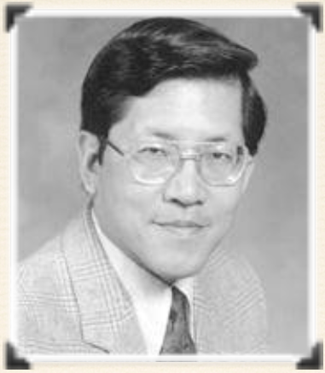
Presenter Name: James C. Sung
Type of Presentation: Speaker
Contact Number: +886 972-758-961

