Mass production of Functionalized graphene quantum dots and their application in cancer diagnosis and therapy
Chenjie Yao, Lin Ding, Chenchen Li, Yanan Huang, Minghong Wu,Yanli Wang*,
Institute of Nano-chemistry and Nano-biology, Shanghai University, Shanghai, 200444, China

Abstract

Graphene quantum dots (GQDs) have garnered increasing attention because of their various alluring physicochemical properties and a wide range of potential application. However, their large-scale applications are limited by current synthetic methods that commonly produce GQDs in small amounts. Moreover, GQDs usually exhibit polycrystalline or highly defective structures and thus poor optical properties. We established a new mass-productive synthesis method of single-crystalline GQDs via a green and low-cost alkali-mediated hydrothermal molecular fusion using an active PAH molecule as a precursor. Functionalized GQDs featured excellent optical properties, strong excitonic absorption bands extending to the visible region, large molar extinction coefficients, and long-term photo-stability.
Positively charged amino-GQDs could easily pass through cell membranes and localize in cell cytoplasm but show acute toxicity in vivo causing death of mice even after tail vein injection at low concentrations. Negatively charged sulfonic-GQDs could not pass through the cell membrane even after co-incubation for 48 h under normal culture conditions. However, specific targeting of cell nuclei was found when cells were cultured in an ultrathin film with the sulfonic-GQDs. Both subcutaneous and orthotopic mice tumor models revealed that the sulfonic-GQDs showed specific targeting performance for the tumor tissues in vivo. Confocal images of frozen tumor and normal tissue sections further demonstrated the exceptional in vivo cancer-cell-nuclear-targeting capability of the sulfonic-GQDs, which showed no cancer type specificity. Both materials showed good performance for both in vitro and in vivo imaging, however, the toxicity issues of the amino-GQDs may limit their in vivo applications. Negatively charged sulfonic-GQDs showed low toxicity both in vitro and in vivo, which indicates their good potential for clinical applications.

Image
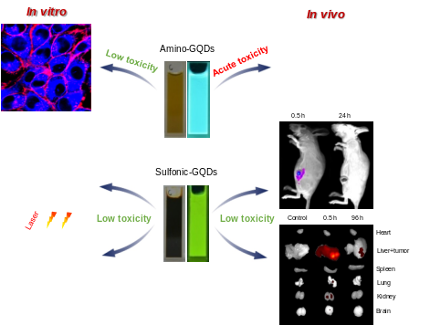

Figure1. Control the specific targeting performance by Engineering the functionalized GQDs.
Recent Publications (minimum 5)
1. Wang L †, Wang YL †, Xu T, Liao H, Yao C, Li Z, Chen Z, Liu Y, Wu M, Sun L, Pan D *(2014) Gram-scale synthesis of single-crystalline graphene quantum dots with superior optical properties, Nature communication 5:5357-5366.
2. Wang YL, Yuan L, Yao C, Ding L, Li C, Fang J, Sui K, Liu YF.*, Wu M. * (2014) Combined toxicity study of zinc oxide nanoparticles and Vitamin C in food additives, nanoscale 6: 15333-15342.
3. Wang YL *, Yao C, Li C, Ding L, Liu J, Dong P, Fang H, Lei Z, Shi G, Wu MH* (2015) Excess titanium dioxide nanoparticles on cell surface induce cytotoxicity by hindering ion exchange and disrupting exocytosis processes, Nanoscale 7:13105 – 13115.
4. Yao C, Li C, Ding L, Dong P, Wu M H, Wang YL *, Pan D * (2016) Single-crystalline graphene quantum dots as bright fluorescent probes, Nanomedicine: Nanotechnology, Biology and Medicine, 2016, DOI: 10.1016/j.nano.2015.12.302
5. Wang YL *, Li C, Yao C, Ding L, Lei Z, Wu MH * (2016) Techniques for investigating molecular toxicology of nanomaterials, J. Biomed. Nanotechnol. 12:1115-1135 (Invited review)



Biography
Dr. Yanli Wang is now working at Institute of Nanochemistry and Nanobiology of Shanghai Uni- versity as Associate Professor since 2012. She obtained her Ph.D. degree in environmental en- gineering from Shanghai University in 2010. Her research interests mainly focus on bio-effects and safety evaluation of nanomaterials and their application in bio-imaging and cancer therapy.

Email: wangyanli@staff.shu.edu.cn

