Enhancement of electrochemical performance of supercapacitors, sensors, and photocatalysts using graphene
Jae-Jin Shim, PhD, Yeungnam University, S. Korea

Abstract
Nanomaterials of metal oxides and conducting polymers have been developed for energy storage (supercapacitor), sensor, and photocatalyst applications. They have shown good electrochemical performances but are not satisfactory. Various materials such as graphene and carbon nanotubes have studied to enhance the electrochemical properties owing to their large surface area and high electrical conductivity. Synergistic effects of excellent conductivities of graphene and high electrical properties of metal oxides or polymers have improved the overall electrochemical performances tremendously.
In this study, graphene (natural or synthesized), graphene oxide, reduced graphene oxide, highly reduced graphene oxide have been tested for improving performances as a supercapacitor, sensor, and photocatalyst. Other methods have also been used such as doping of graphene with nitrogen or sulfur, using metal sulfides instead of metal oxides, and using highly porous materials as substrates. In the synthesis of these materials, a cleaner technology has been employed.

Image
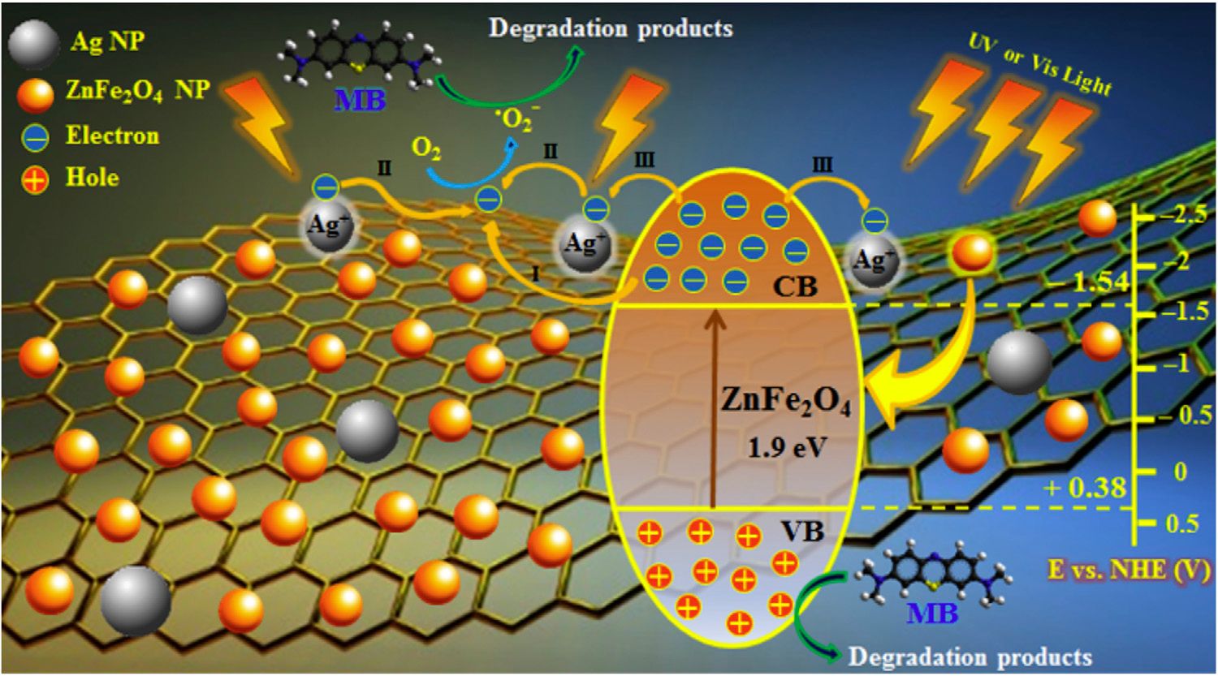
Figure 1. Schematic diagram of the MB degradation on Ag-ZnFe₂O₄ @rGO under UV- or visible-light irradiation [1].

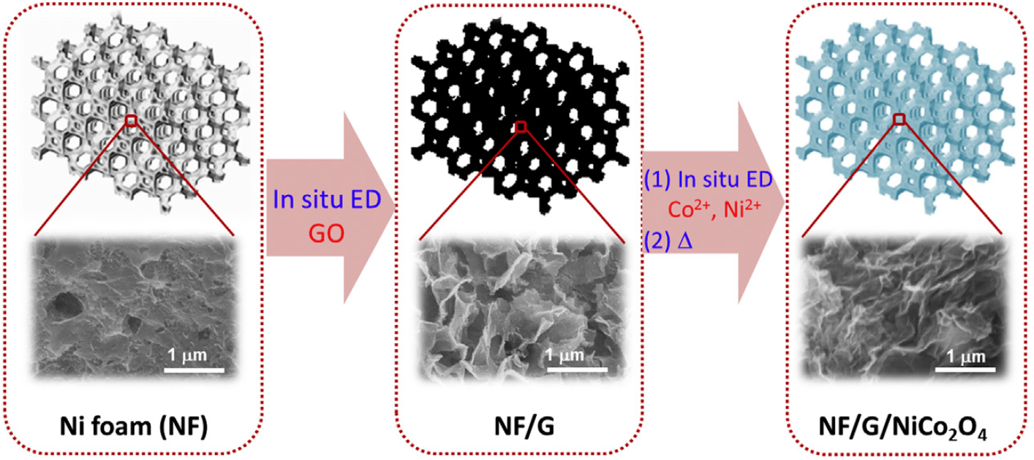
Figure 3. Schematic fabrication process for the NF/G/NiCo₂O₄ electrode [5].
Figure 2. Sensing of tetracycline in the interfering uric acid by polymelamine film on the ERGO-modified GC electrode surface [3].

Recent Publications
- Mady AH, Baynosa ML, Tuma D, Shim J-J (2017) Facile microwave-assisted green synthesis of Ag-ZnFe₂O₄@rGO nanocomposites for efficient removal of organic dyes under UV- and visible-light irradiation. Appl. Cat. B. 203: 416-427.
- Sahoo S, Shim J-J (2017) Facile synthesis of three-dimensional ternary ZnCo₂O₄/reduced graphene oxide/NiO composite film on nickel foam for next generation supercapacitor electrodes. ACS Sust. Chem. Eng. 5: 241-251.
- Kesavan S, Kumar, DR, Lee YR, Shim J-J (2017) Determination of tetracycline in the presence of major interference in human urine samples using polymelamine​/electrochemically reduced graphene oxide modified electrode. Sens. Actuat. B. 241: 455-465.
- Lamiel C, Nguyen VH, Roh C, Kang CK, Shim J-J (2016) Synthesis of mesoporous RGO@(Co,Mn)₃O₄ nanocomposite by microwave-assisted method for supercapacitor application. Electrochim. Acta. 210: 240-250.
- Nguyen VH, Shim J-J (2015) Three-dimensional nickel foam/graphene/NiCo₂O₄ as high-performance electrodes for supercapacitors. J. Power Sources. 273: 110-117.



Biography
Jae-Jin Shim received his BS degree from Seoul National University in 1980, MS degree from KAIST in 1982, PhD degree from the University of Texas at Austin in 1990. He has been a professor in Yeungnam University since 1994 and served as School Chairman and Vice-Dean of Engineering. He served as the President of the Korean Society of Clean Technology and Vice President of the Korean Society of Engineering Education. He is the Directors of the Institute of Clean Technology and the Clean Energy Priority Research Center. He has published more than 140 papers in reputed journals and served as the Chief Editor of “Clean Technology”. His current research interests are synthesis and applications of graphene(or carbon nanotube)-based nanomaterials for supercapacitors, catalysts, and sensors; syntheses of polymers and organic materials using supercritical fluids and ionic liquids; living polymerization in supercritical fluids and ionic liquids; and clean technology.
Email: jjshim@yu.ac.kr

