Bio-inspired synthesis and self-assembly of few layer graphene
Izabela Janowska PhD, Institute of Chemistry and Processes for Energy, Environment and Health (ICPEES), 7515 CNRS-UDS, Strasbourg, France

Abstract
The future development of advanced materials depends on several aspects, which are first of all linked to synthesis and then exploitation of the materials in an efficient way. This concerns also the graphene based materials and despite the huge number of efforts devoted to the synthesis of graphene and few layer graphene (FLG) there is still luck of the methods allowing their high scale production together with environment respect. Their efficient use in composites, polymers and films in order to provide or enhance graphene-related properties such as high conductivity, transparency, flexibility, mechanical resistance will depend on the way these “nano” materials are arranged in the macroscopic media. Herein, the bio-compatible, high yield production of solution processable FLG is presented together with a new approach of bio-inspired FLG self-assemblies into fractal like patterns (presently under patent application). Such FLG self-assemblies reduce the percolation threshold between FLG flakes allowing the percolation at lower amount of FLG for a given surface if compared to the random arrangement (fig. 1).¹ This can find the application in transparent conductive films (TCF), where the FLG self-assemblies patterns can be optimized in order to achieve variable transparency-conductivity properties according to the TCF final use. This interesting finding recalls the natural tendency of Matter to self-organize into functional systems. The fractal like, branched structures are commonly observed in numerous natural systems being in charge of transport function, such as river beds, trees or neural system.

Image
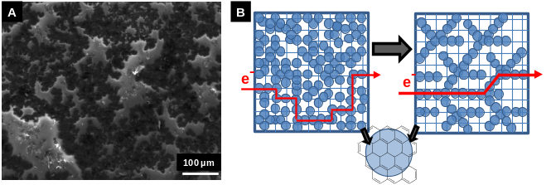
A) Self-assembled branched FLG conductive pattern by SEM, B) The conductive path improvement, from randomly to self-assembled FLG flakes (exemplary path).

Recent Publications (minimum 5)
- Janowska I (2015) Evaporation-induced self-assembling of few-layer graphene into a fractal-like conductive makro-network with a reduction of percolation threshold PhysChemChemPhys 17: 7634-7638.
- Truong-Phuoc L, Pham-Huu C, Da Costa V, Janowska I (2014) Few-layered graphene-supported palladium as a highly efficient catalyst in oxygen reduction reaction Chem. Comm. 50 (92): 14433-14435.
- Baaziz W, Melinte G, Ersen O, Pham-Huu C, Janowska I (2014) Effect of nitriding/nanostructuration of few layer graphene supported iron-based particles; Catalyst in graphene etching and carbon nanofilament growth PhysChemChemPhys 16: 15988-15993.
- Pirzado A A, Truong-Phuoc L , Papaefthimiou V, Matei Ghimbeu C, Le Normand F, Ba H, Thanh-Tung T , Pham-Huu C, Janowska I (2015) Activation of few layer graphene by µW-assisted oxidation in water via formation of nanoballs J. Colloid Interf. Sci. 451: 221-30.
- Pirzado A A, Dintzer T, Janowska I. (2016) Macronization/densification of graphenes via vibratory compaction. Powder Technology 295: 303-306.

Biography
Izabela Janowska has completed her PhD at the University of Lodz (Poland) and postdoctoral studies from the ENS Cachan (France) and University of Luis Paster (Strasbourg, France). In 2010 she joint CNRS and works at present as a researcher in carbon nanomaterials field. Her interest deals with the synthesis and tailoring of the bulk and surface structure and chemistry of (nano) carbon and (nano) metal-carbon materials mainly for energy transfer and catalytic applications. She has published around 65 papers in reputed journals.
Email: janowskai@unistra.fr

Notes/Comments:

