Good Supply Practices: Why are we still vulnerable?
Troy Fugate, Vice President, Compliance Insight, Inc.

Abstract (300 word limit)
Statement of the Problem: Toxic Cough Syrup in Panama. In 2007, when 4-year old Allan Gutierrez died, the symptoms that he displayed baffled doctors. Severe nausea, violent heart palpitations and paralysis were among the issues noted that eventually lead to at least 365 confirmed deaths.
At first, the investigation was difficult, but eventually it was discovered that the imported diethylene glycol used in the medicine was originally named “TD glycerine,” which apparently indicates that it is a glycerine substitute.

The fatal ingredient originated in China. It was shipped to a Spanish company and then on to a private company, Medicom, in Panama. Medicom resold it to the country's Social Security system, which mixed the "medicine" in its laboratory. Panamanians thought they were getting glycerin, a component of many medicines.

The poisonings seem to be a confluence of confusion over labeling and sloppy controls along the supply chain.

Why then did this event happen when we have FDA or other regulations in place along with Quality by Design concepts, Operational Excellence, Supplier Relationship Management, etc.? Thus, in 2012, a group of academia, industry and regulatory colleagues met to identify the actual problem and resolve the issues. Initially focusing on the suppliers only, it became evident that various factors were at risk across the entire supply chain including the finished manufacturers. After five years, the Xavier Health initiative has evolved to the feasibility stage and is nearing completion with adoption considerations by several regulatory bodies.

Image
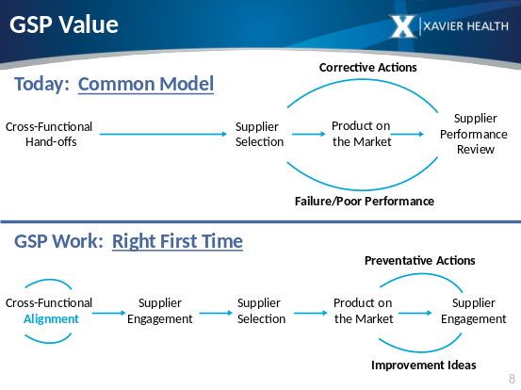
Recent Publications (minimum 5)
- Institute of GxP Compliance 2008; Pharmaceutical Cleaning: A Comprehensive Approach
- Compliance Handbook for Pharmaceuticals, Medical Devices and Biologics; CRC Press 2003; The Batch Record: A Blueprint for Quality and Compliance
- Six Mindset Shifts That Will Improve GxP Compliance, LinkedIn Publishing; 2017
- Putting the “c” Into Leadership: A cGMP Perspective, 2017
- Changing the Habit from FDA Non-Compliance to Compliance 2016

Biography (150 word limit)

As the Vice President of Compliance Insight, Inc., Troy works with companies domestically and worldwide in the pharmaceutical, biotechnology and medical device industries in the fields of Compliance and Quality Assurance. Troy’s primary strengths are Quality Assurance activities with emphasis in quality systems, risk assessment, facilities and utilities, cleaning, processes, validation and systemic audits. Professional training presentations have been conducted across the world. Troy has approximately 30 years’ experience and is a highly rated trainer bringing in his practical, hands-on experience to the attendees.
Full Name: Troy Fugate
Tel: 513-860-3512
Session Name/Number
Category: (Oral presentation)
Email: TFugate@Compliance-Insight.com

Notes/Comments:

