Crop suitability and carbon sequestration potentials of soils under different cropping systems in Cagayan Valley, Philippines
Artemio A. Martin Jr PhD, Echague, Isabela, PHILIPPINES
Melchor C. Madrid MSc, Echague, Isabela, PHILIPPINES

Abstract
A field study was conducted to examine the carbon sequestration potentials of the soils under different cropping systems. Soil analysis revealed that soil reaction in the agricultural soils of the region ranged from very strongly acidic (pH 4.5) to slightly alkaline (pH 7.4). Nitrogen in soils is very low (0.4 to 3.4 g.kg⁻¹), available P varied from very low to high (0.70 to 30.50 mg kg⁻¹) and available K from very low to very high (0.0–1.27 cmol⁺ kg⁻¹). The crops currently grown are classified as suitable which almost matched with the technical crop-soil suitability analysis. Soil organic matter and organic carbon contents (20 cm) are moderate with average values of 2.72% and 39.05 Mg ha⁻¹, respectively. SOM and SOC in upland is higher than in lowland soils attributed to differences in soil types, cropping system and agricultural management practices. The significant amount of CO₂ sequestered in upland (150 Mg CO₂ ha⁻¹) and lowland soils (126 Mg CO₂ ha⁻¹) confirms that soils in the region has the potential as sink of CO₂ and varies due to the difference in cropping systems.

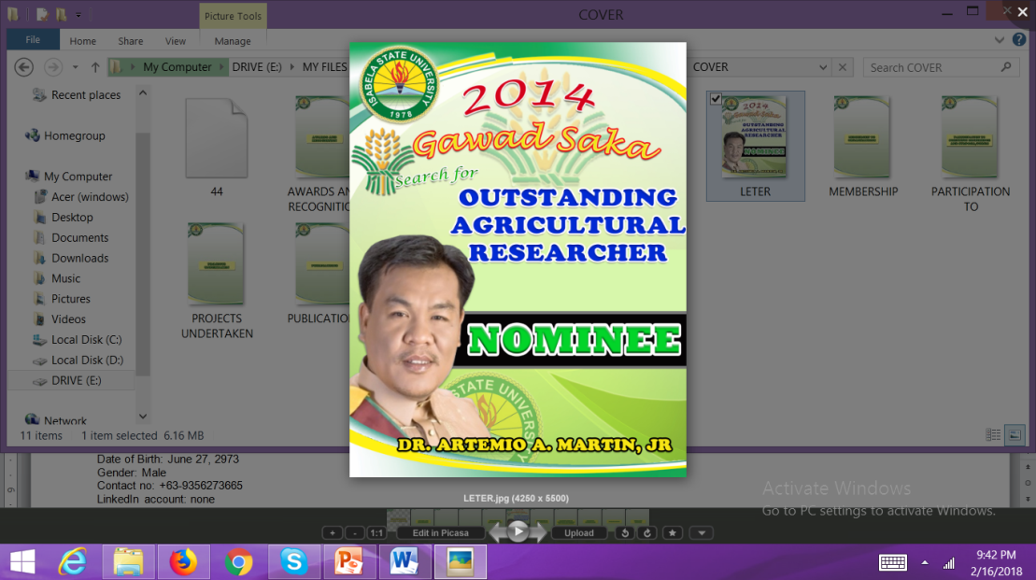
The result of this study showed that upland soils sequestered more CO₂ than the lowland soils. Nevertheless, the results do indicate that under tropical cropping systems, diversifying cropping systems in upland and lowland area is one potential option for enhancing SOC thus improving CO₂ sequestration. Current study is based on one sampled soil data from different soil series and an expansion of the area sampled is necessary to determine these potential more accurately.

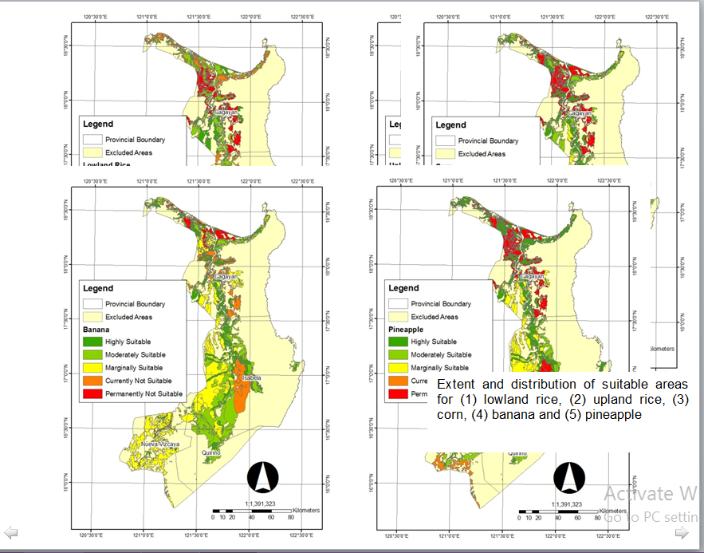

Recent Publications
Andrews, S.S., Karlen, D.L. and Cambardella, C.A. 2004. The soil management assessment framework: A quantitative soil quality evaluation method. Soil Sci.Soc. Am. J. 68:1945- 1962.

Beinat, E., Nijkamp, P., 1998. Land-use management and the path towards sustainability. In: Beinat, E., Nijkamp, P. (Eds.), Multicriteria Analysis for Land-Use Management. Kluwer Academic Publishing, Boston, MA, pp. 1– 13.

Burke, I.C., Yonker, C.M., Parton, W.J., Cole, C.V., Flach, K., Schimel, D.S. 1989. Texture, climate, and cultivation effects on soil organic matter content in U.S. grassland soils. Soil Science Society of America Journal. 53(3):800-805.

Lal, R. 2004b. Agricultural activities and the global C cycle. Nutrient Cycling in Agroecosystems. 70:103-116.

Lal, R. 2004c. Soil C sequestration impacts on global climate change and food security. Science. 304:1623-1627.

Biography
Dr. Martin is one among our active faculty members who dedicated significant of his time in conducting research, development and extension activities along Soil Science, Organic Agriculture, Environmental Management and Climate Change. With strong academic background having obtained the Academic Achievement Award- one of the highest academic awards given by the University of the Philippines, he finished strong as a SEARCA Scholar and recently a Fulbright Scholar for his Post Doctorate Research in Purdue University, Indiana, USA. His research on the influence of tillage and nitrogen fertilizer management on corn productivity and soil carbon, and impact of cover crops on greenhouse gas emissions and microbial activities on agricultural soils promote the implementation of Good Agricultural Practices (GAPS) in minimizing GHG emissions in the soil and help in curbing down the impact of climate change.

Email: jhun_6273@yahoo.com
Date of Birth: June 27, 2973
Gender: Male
Contact no: +63-9356273665
LinkedIn account: none
Category: Oral (or) Poster Oral Presentation

