Title: Coastal Pressures: Developing a framework for communities exposed to sea level rise

T Danielmeier, Otago Polytechnic, New Zealand

Abstract (300 word limit)
Coastal communities’ vulnerability in response to global conditions of climate change has major repercussions for countries with coastal settlements. The changing environmental, social, economic and political parameters around coastal regions and the genuine modesty of historic coastal settlements have put considerable pressure on the viability of these communities.
Over recent years, values placed on land, and in particular coastal locations in New Zealand, have come to be indicative of the social and economic growth and investment opportunities with demand from both local and offshore investors. Where land commodity values are less pressured, i.e., less desirable, communities have become somewhat marginalised due to the lack of economic attention placed within the development of them. New dwellings in these areas, in accordance with flood risk parameters and rising sea level predictions, are required to be made secure and transportable. At the same time, land value decreases due to the fact that insurance companies are increasingly unwilling to provide cover for houses in flood prone areas.
Using the Blueskin Bay settlement as a case study, the talk will investigate direct and indirect parameters, (outlined in Fig. 1) that influence communities affected by climate change. The talk will consider how initiated and imposed changes also leads to additional pollution due to gentrification of these communities.

Image
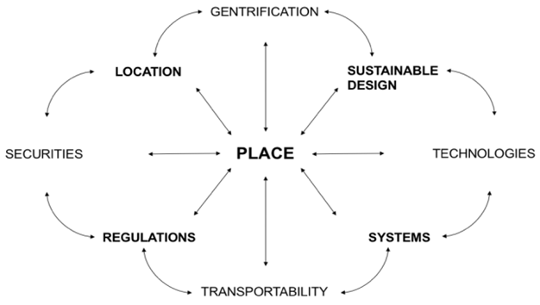

Figure 1 – Values and Pressures of sea level rise
Recent Publications (minimum 5)
- Fersterer, C., Fay, C., Danielmeier, T., Achterberg, K., & Willis, S. (2017). Climate Safe House: A Community Housing Project Tackling Catastrophic Sea Level Rise in Coastal Communities. World Academy of Science, Engineering and Technology, International Science Index 128, International Journal of Civil, Environmental, Structural, Construction and Architectural Engineering, 11(8), 1074 - 1077
- Danielmeier, T. (2016). Coffee Table Artefact in Asymmetric Labors: The Economy of Architecture in Theory and Practice. In (pp. 210-213). New York: The Architecture Lobby
- Danielmeier, T, Albrecht J. N. (2015) Architecture and Future Food and Wine Experiences. In I. Yeoman, U. McMahon-Beattie, K. Fields, J. N. Albrecht, & K. Meethan (Eds.), The Future of Food Tourism - Foodies, Experiences, Exclusivity, Visions and Political Capital (pp. 87-100). Bristol: Channel View
- Danielmeier, T. (2014). Winery Architecture: Creating a Sense of Place. In M. Harvey, L. White, & W. Frost (Eds.), Wine and Identity: Branding, Heritage and Terroir (pp. 213-229). Abingdon, New York: Routledge
5. Danielmeier, T., Kebbell, S., Donn, M., & Browning, A. (2013). Locational Drivers, Functional Clusters and Shared Amenities. Wellington: Centre for Building Performance Research



Biography (150 word limit)
Tobias Danielmeier is a New Zealand based architecture educator and practitioner. He is interested in the interplay of physical space and user expectation. As part of his dual practice, Tobias has worked on submissions to the Solar Decathlon 2011 and 2013. He has recently introduced a new Bachelor of Architectural Studies degree at Otago Polytechnic, which focuses on ecological responsibility. His research also considers aspects of performance and performativity within the built environment.
Email:tobias.danielmeier@op.ac.nz

- Full Name: Tobias Danielmeier
- Personal Email: mail@tobiasdaniemeier.de
- Mobile Number: 0064212243324
- Session Name/ number:
- Category: Oral presentation
- Date of Birth: 29.09.1978
- Postal Address: Otago Polytechnic
College of Art, Design and Architecture
Forth Street, Private
Bag 1910, Dunedin,
9054, New Zealand

Notes or Comments:

