EFFECTS OF HIGH TEMPERATURES ON THE COVER AND DISTRIBUTION
OF CORAL AT CON DAO NATIONAL PARK IN VIET NAM
Hoang Thi Thuy Duong
Vietnam – Russian Tropical center
53, Nguyen Van Huyen, Nghia Do, Cau Giay,
Ha Noi capital, Viet Nam country
E_mail: httduong_ttndvn@hotmail.com

- INTRODUCTION
In South Vietnam, coral communities experience periodic effects of temperature anomalies. In the Con Dao Islands, a marked decolouration of heat-sensitive corals and subsequent high mortality (from 10 to 100% coverage) was recorded in 1998 and 2005. (Hoang at al., Ben et al., 2004). According to NOAA data on the development of temperature anomalies (Fig. 1), in 2010, the temperature anomaly reached the second highest level with the unavoidable consequences for reef-forming corals, but so far no data on this topic have been published.
In 2016, the temperature anomaly was less pronounced, but sporadic coral bleaching was noted by workers of the national park.
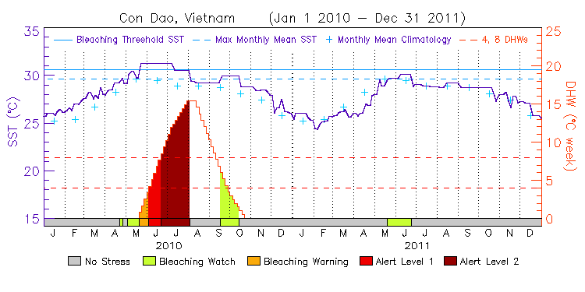
Fig. 1. Temperature dynamics for the anomalous 2010 on the islands of Con Dao. A significant excess of the temperature threshold of coral bleaching in the summer months of 2010 is shown.

- MATERIAL AND METHODS
In the water area of ​​the Con Dao archipelago, 9 hydrobiological stations were made (Figure 2, Table 1), where the assessment of the coral cover and the density of functional groups of invertebrates on the registration sites of 4 × 100 m² was made. The material was collected using diving equipment at depths of 2-6 meters with the largest formation of reef-forming corals. The estimation of the coral cover was carried out by the method of photocouples (area 0.25 m²) along four 25th transect, 20 photocouples per transect. Quantification of projective coverage of corals, macroalgae and inanimate substrate was carried out using the CPCe program (Kohler, Gill, 2006) at 25 points in the field of each square. The registration of key invertebrates (according to the ReefCheck protocol) was performed visually on the same four sites (belt transects 4 × 25 m each).
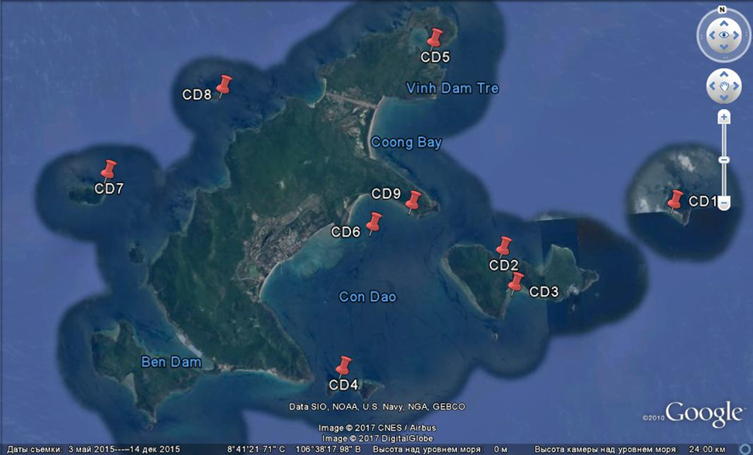
Fig. 2. Location of stations in the waters of the Con Dao Islands
Table 1. Coordinates, date, depth and temperature for each station in Con Dao
№ Station | Data | Coordinates | Depth | The temperature (° C) at the surface (s) and at the bottom (b)
1 | 17.04.2017 | 8°41’12” N  106°44’10”E | 4-6 м | (s) 29  (b) 29
2 | 17.04.2017 | 8°40’32” N  106°40’40”E | 3-5 м | (s) 29  (b) 29
3 | 19.04.2017 | 8°39’49” N  106°40’51”E | 3-5 м | (s) 29  (b) 29
4 | 19.04.2017 | 8°38’24” N  106°37’18”E | 5-6 м | (s) 29  (b) 29
5 | 21.04.2017 | 8°44’44” N  106°39’36”E | 3-5 м | (s) 29  (b) 29
6 | 21.04.2017 | 8°41’12” N  106°38’7”E | 2-4 м | (s) 31  (b) 29
7 | 23.04.2017 | 8°42’37” N  106°32’54”E | 4-6 м | (s) 30  (b) 30
8 | 23.04.2017 | 8°44’8” N  106°35’19”E | 4-5 м | (s) 30  (b) 30
9 | 25.04.2017 | 8°41’34” N  106°38’56”E | 2-4 м | (s) 31  (b) 31

- RESULTS
For the coral communities, the histogram shows that, in general, a high coral cover is preserved in the archipelago water area with a variation from 62 to 98% of the bottom cover by reef-forming calcareous corals (average 80.7%, n = 9). The number of active coralphage - starfish Acanthaster planci does not cause alarm - for all 9 stations there are only 2 starfishs.
Station 1 is a rich structureless coral reef with a weakly pronounced rifle and reef slope up to 9 m. The main structural element of the reef is the branched acropores Acropora formosa and A. nobilis with a bottom covering up to 80% (Fig. 3).
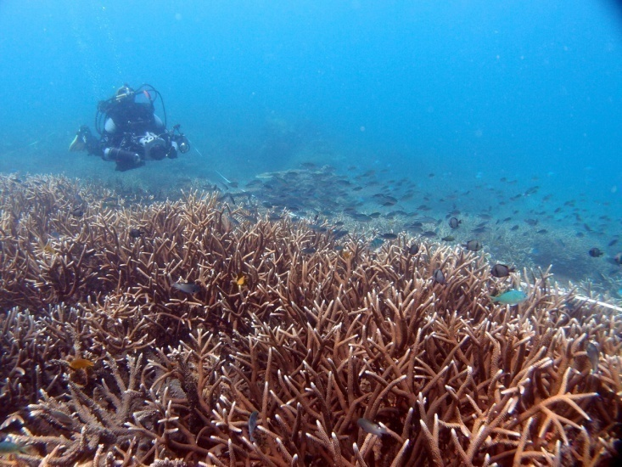
Fig. 3. The proportion of scleractinia in the bottom cover and the general appearance of the reef at station 1
The coral reef at station 2 was located in the bay on the northern side of the island of Hon Bay Canh. It is also an unstructured reef with a chaotic distribution of reef formations - elevations, spurs and poritid "coral heads" of large size, in particular, the measured diameter of one of the largest colonies of Porites lobata was 12.5 m. Considering the rate of radial growth of such colony on average 1 cm in year, the age of this colony is more than 200 years. The reef was distinguished by a high species diversity of corals, the major part of which was 8 genera of scleractinia (Figure 4), among which were prominent branched and lamellar Acropora, cortical Montipora and massive Porites.

Fig. 4. The share of scleractinia in the bottom cover and general reef species at station 2
Station 2 shows a high abundance of fish-phytophages, in particular, scaridae, where the size of the flock was 140-150 individuals measuring 15-20 cm. This family plays a key role in maintaining the dominance of scleractinia over macroalgae.
Station 3 was located on the opposite, southern side of the island of Hon Bay Canh. The shallow-water reef (up to 7 m) is structureless with a shallow slope. Primarily formed by branched and lamellar Acropora and foliar Montipora aquetuberculata (Figure 5). The largest proportion of coral debris at this station indicates that the reef is in a recovery phase after a massive extinction of corals, probably associated with the 2010 temperature anomaly.

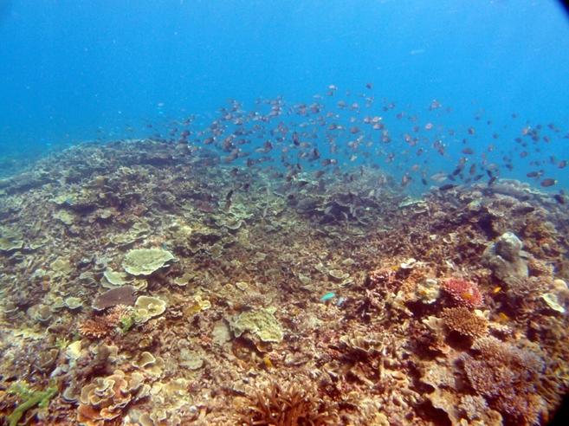
Fig. 5. The proportion of scleractinia in the bottom cover and the general appearance of the reef at station 3
The high abundance of scuba fish at this station also contributes to the process of coral restoration.
Station 4 was a reef off, the basis of the coral covering was acropores (Figure 6).

At the station 5, in view of its geographically semi-closed position, open to the winds of only eastern rumbles, is in fact completely enclosed by a powerful coral frame with a pronounced riff-flute and slope. Repeating the shape of the bay, the reef slopes form here a long narrow tongue with a sandy base at a depth of 6-8 m. At the entrance to the bay, the reef is formed by powerful acroporic settlements with perennial colonies of plate coral Acropora hyacinthus and high species richness. However, closer to the shallow lagoon, located in the dense part of the bay, with which its outer part is connected by a shallow isthmus, the abundance of macroalgae of the genus Sargassum increases on the reef. The shores of the lagoon with muddy-sandy bottom are covered by dense settlements of mangrove thickets. Apparently, eutrophication of the lagoon, due to its closed nature and weak water, promotes the growth of macroalgae on the inner part of the coral reef. In general, coral coverage on the reef is high (81%), and the main part is made up by branched and lamellar Acropora, massive and submissive Porites, foliar and cortical Montipora (Fig. 8). Thus, the station 5 is a unique semi-enclosed ecosystem in the Con Dao Island with a well-developed coral reef and mangrove forest. The plan for the construction of a large tourist complex in this bay (Figure 9) will inevitably lead to complete degradation of both ecosystems. First of all, the development of the coastline and the dumping of soil along the banks and into the bay will lead to destruction. Therefore, when constructing such complexes, a comprehensive assessment of possible negative consequences for marine ecosystems is necessary, so that serious damage.

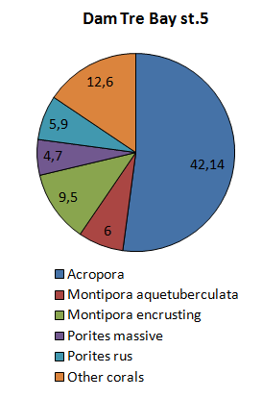
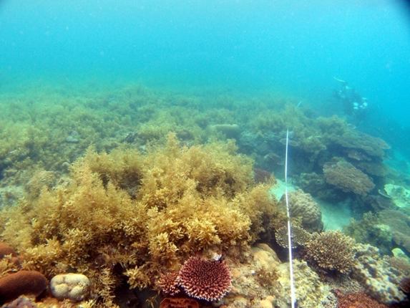
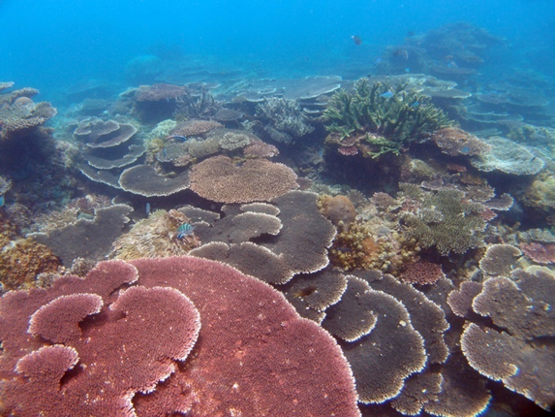
Fig. 7. The proportion of scleractinia in the bottom cover and the general appearance of the reef at station 5
Station 6 was located in a shallow-water patch reef (coral bank) in the main bay of the island of Kondao at depths of 2-4 m. The results show that this reef experienced the highest mortality rate of corals during the temperature anomaly of 2010. The share of dead corals, Large colonies of lamellar acropora on this reef were maximum - 30.6% coverage. Nevertheless, the restoration of this reef is rapid due to a large proportion of surviving large colonies and a large proportion of young - up to 14 colonies of juveniles per 1 m². In general, the coral coverage on this reef was low relative to other stations, but high enough to consider this reef in a healthy status. Acropolis was the only mass genus of scleractinia forming this reef (Figure 8).

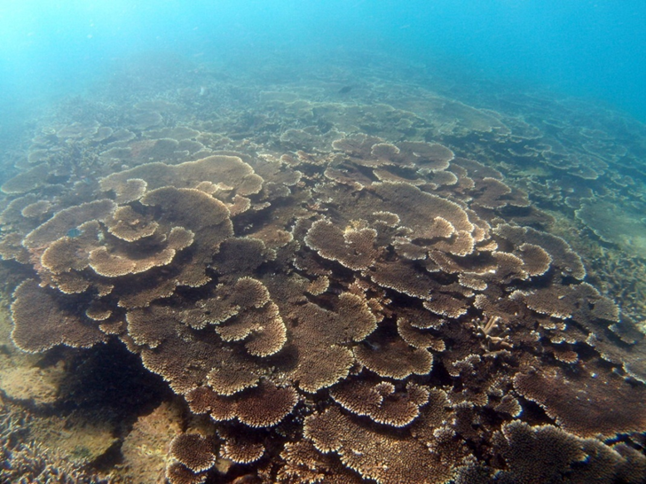
Fig. 8. The proportion of scleractinia in the bottom cover and the general appearance of the reef at station 6
The reef from the northern side of the island of Cheon Lon had the highest coverage of coral, mainly from the genus Acropora - 98.6% (Fig. in fact, this reef represented a continuous coral cover of the seabed. The reef is structureless, with a slightly pronounced slope with an inclination angle of 15-20º.
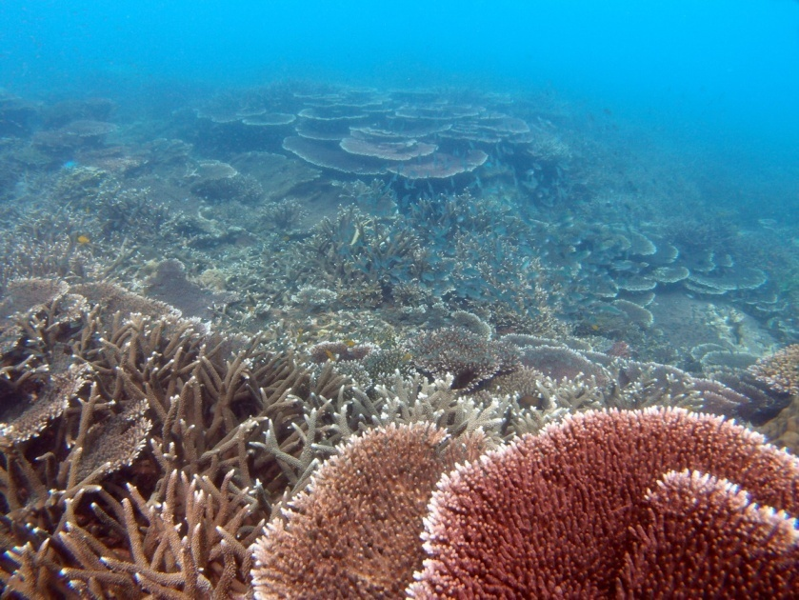
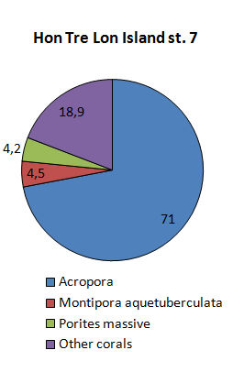
Fig. 9. The share of scleractinia in the bottom cover and the general appearance of the reef at station 7

The coral community in the area of ​​Station 8 was cortical, with a relatively low coverage by coral boulder-block collapse. Nevertheless, in this community, most of the scleractinia were also formed (Figure 10).

Fig. 10. The proportion of scleractinia in the bottom cover and the general appearance of the reef at station 8
Station 9 was located on a shallow fringing coral reef (depth 2-4 m) from the interior of the northern cape of the central bay of the island of Con Dao. The community was predominantly the dominant genus Acropora (Figure 11), accounting for almost 98% of the total high coverage by scleractinia.
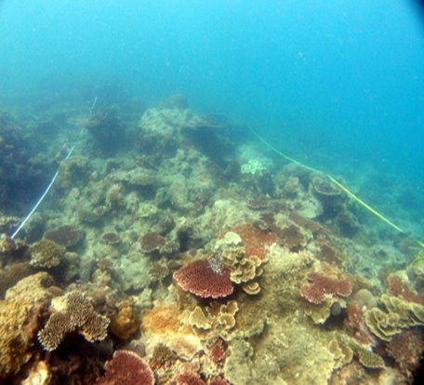
Fig. 11. The share of scleractinia in the bottom cover and the general appearance of the reef at station 9
Thus, coral communities on the islands of Con Dao retain a healthy status with a high coral covering and a predominance of thermosensitive genera of corals. Despite the leading role in the structure of heat-sensitive genera, the coral communities of the archipelago show a high resistance to temperature anomalies and a pronounced positive dynamics of recovery after climatic shifts in the example of the two reefs studied.

Literature
- Ben-Haim Rozenblat, Y. and Rosenberg, E. (2004). Temperature-regulated bleaching and tissue lysis of Pocillopora damicornis by the novel pathogen Vibrio coralliilyticus. In Coral Health and Disease (ed. E. Rosenberg and Y. Loya), pp. 301- 324.
- Britayev, T.A., Pavlov, D.S. (Eds). Benthic fauna of the Bay of Nhatrang, South Vietnam.V.2, Moscow, KMK.346 p.\
- Brown B.E., Cossins A.R. (2011) The potential for temperature acclimatization of reef corals in the face of climate change. In: Dubinsky Z., Stambler R. (Eds), Coral Reefs: an Ecosystem in Transition. Springer, New York: 421–433.
- Hoàng Xuân Bền, Võ Sỹ Tuấn và Phan Kim Hoàng (2005). Nghiên cứu hiện tượng san hô chết hàng loạt ở Côn Đảo. Tạp chí khoa học công nghệ biển T8 (2008). Số 3. Tr 59-70.
- Kohler K.E., Gill S.M. (2006) Coral Point Count with Excel extension (CPCe): A Visual Basic program for determination of coral and substrate coverage using random point count methodology // Comput & Geosci 32: 1259-1269.
- Латыпов Ю.Я., Даутова Т.Н. 2005. Видовой состав кораллов на заиленном мелководье архипелага Байтылонг (Тонкинский залив, Южно-Китайское море). Биология моря.31(5), 311-318.
- Marshall P.A., Baird A.H., (2000). Bleaching of corals on the Great Barrier Reef: differential susceptibility among taxa. Coral Reefs 19, 155–163.
- Stimpson J. (1985). The effect of shading by the table coral Acropora hyacinthus on understory corals. Ecology 66, 40–53.
- Tkachenko KS., Britayev TA, Huan N., Pereladov MV., Latypov Y., 2016. Influence of anthropogenic pressure and seasonal upwelling on coral reefs in Nha Trang Bay (Central Vietnam). Marine Ecology 37, 1131-1146.
- Ткаченко К.С. (2015) Экологический статус коралловых сообществ островной акватории залива Нячанг (Вьетнам) // Экология. 5: 367-373.

