THE PATH TO REACHING ECOLOGICAL CIVILIZATION AS A DEVELOPING NATION THROUGH THE KNOWLEDGE OF ECOLOGICAL FOOTPRINT. Gbujie Daniel Chidubem*, Uchegbu Ngozi and Ezioma Onyinye Gbujie
*ALL CORRESPONDENCE SHOULD BE SENT TO: 13703, Ruther Avenue Southgate California USA Email: gbujiedan2@yahoo.com Tel: +234 8033041426, +1 817 8812436
ABSTRACT:
Statement of the Problem: The Ecological Footprint measures the cumulative effect of the impact of human activities on the environment; its increase has become an environmental threat to mankind. It is expressed as the amount of land required to sustain human use of natural resources influenced by the human population, consumption per person, global natural resources and water intensity. The aim of this paper is to provide a comprehensive review on Ecological Footprint in developing nations in other actions and how they can sustain and attain ecological civilization. Methodology: This article, reviewed papers and data discussing Ecological Footprint and related environmental topic, from online search engines, journals, and reports of the United Nations and her department responsible for Environment and Development, reports of international agencies with effort from few governments. The Anthesis Ecological Footprint calculation model was used to determine the Ecological Footprint of a developing nation used as a case study. The relationship between Ecological Footprint and other sustainability measuring scales were reviewed and compared with values of the Ecological Footprint of nations. Findings: Reveals that, most developing nations are experiencing varying degrees of ecological deficit with depleting reserves and these poor countries are worse hit by the ecological impact, many of them are yet to fully initiated their nations' plans, and with their respective economies heavily relying on high carbon emission growth model, it has resulted in worsening environmental degradation and extremes of weather conditions, hence the need to urgently intervene globally and nationally. Conclusion & Significance: The article advocates for changes in every aspect of human lives, and also advocate for international collaborations with financial incentives and aid for these poor developing nations will ensure they eventually shift away to more eco-friendly energy efficient system. Recommendations were made to that could help mankind attain ecological civilization.
Keywords; Ecological Footprint, Ecological Civilization, International Collaboration, Sustainable Development Goals, Developing Nations

THE PATH TO REACHING ECOLOGICAL CIVILIZATION AS A DEVELOPING NATION THROUGH THE KNOWLEDGE OF ECOLOGICAL FOOTPRINT. Gbujie Daniel Chidubem*, Uchegbu Ngozi and Ezioma Onyinye Gbujie
*ALL CORRESPONDENCE SHOULD BE SENT TO: 13703, Ruther Avenue Southgate California USA Email: gbujiedan2@yahoo.com Tel: +234 8033041426, +1 817 8812436

INTRODUCTION
As mankind continues to devour and daily consume natural resources through destructive activities of humans and other species, there is tremendous pressure on the ecological space. With centuries of continuous active globalization, mankind may have met its match with a depleting natural reserves and a slow regenerating capacity of the earth. (1, 2) Unfortunately, mankind cannot continue to exist comfortably without natural resources and with the current appetite for economic empowerment driven by the high carbon emission growth model a sustainable way of life on earth may become an unachievable goal.(3) A recent report published by the World Wild Fund for Nature (WWF), it reveals that sea creatures like fish, land animals and birds have their population dwindling by almost 58% between 1970 and 2012. Furthermore, the report specifically revealed a continuous reduction of freshwater ecosystem species by around 81% decline in the last half a century. (4) With the near extinction of some of these species and natural resources, humans are at risk, if an urgent intervention is not made, it may lead to the planet and its ecosystems becoming much less hospitable and supportive of living things. (5,6) Current research reveals that human demands on our planet’s systems are increasing exponentially and may have possibly surpassed sustainable environment limits. Hence the need for interested stakeholders involved with ecological system and the environment, to proffer and determine how to measure how much of the lands can support the human consumption of natural resources with what is required to sustain the environment. (7) Therefore, mankind may need to completely change lifestyle from what humans are presently exhibiting to a more humane and sustainable ways. This is what the measurement of Ecological Footprint tries to evaluate. (8) Hence, the reason why Ecological Footprint is listed as one of the top indicator for estimating global sustainability and an indicator of environmental sustainability.(9) Consequently, Ecological Footprint is defined as an effective communicative and accounting tool for measuring the pressure imposed by a given population on the ecosphere. It is not only the countries footprint that can be measured, institutional and individual footprint can also be assessed within an ecological area this is possible by quantifying and calculating, the amount of land and marine area required to sustain mankind or the total bio-productive area needed to produce the resources humans consume and assimilate the wastes mankind generates. (10)

The global average Ecological Footprint per person is 2.6 global hectares, with the value for the United States of America standing at approximately 10 hectares. It translates that 5 planets are required if the mankind consumption rate is as those of the Americans while if its Nigeria with 3.3 hectares than about 1.5 Planets will be required.(11)

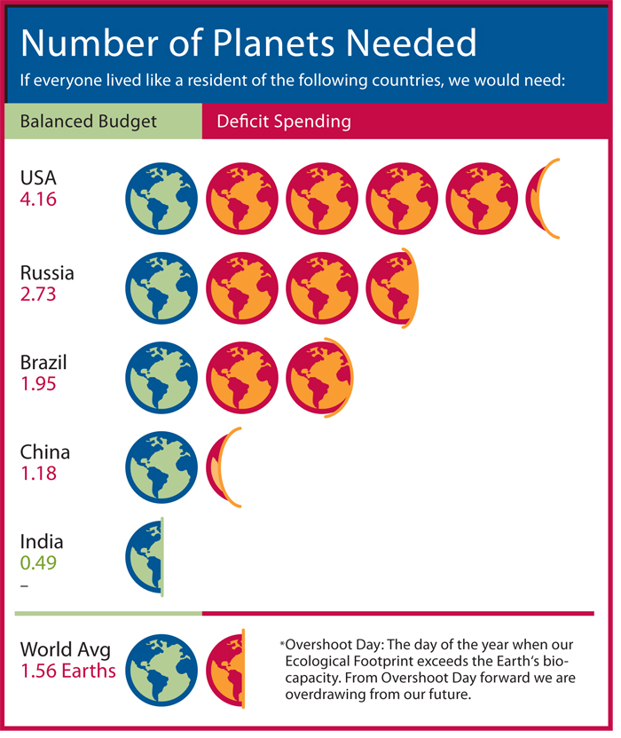 Source: Footprint Network News; Humanity now demanding 1.4 Earth, 2006
With all these data and reports on Ecological Footprint and the environmental impact, nations should urgently place a high priority on taking care of the environment while incorporating ways to change or modify their respective citizens economic, cultural, and social life to reduce the Ecological Footprint. If the entire above are achieved, then sustainable development will become a reality, with the application of eco-conservative initiatives and environmental protection policies, the world may well be on her way to an era of ecological civilization.(12) The summary of human existence on earth, following the current alarm been raised about the impact of climate change will be based on how humans alter their lifestyle and habits.(13) Exploring the options for sustainable living which entail applying conservative policy on natural resources, and the acceptance of renewable energy model as a means to reducing the Ecological Footprints that humans generate may be a way to sustainable living, further to this, it can reduce carbon emission by a factor of two and create doubling effect on wealth, without jeopardizing the quality of life and helping simultaneous to solve the climate change crises.(14)
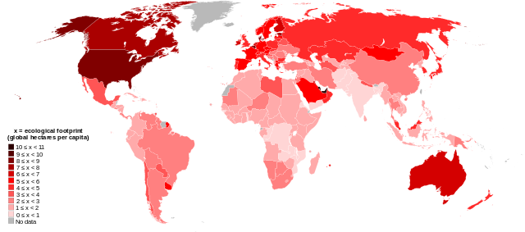
Source-Wikipedia; World map of countries by Ecological Footprint, 2007
METHODOLOGY This article sourced for information on ecological footprint and relevant linking parameter from data collected by international, private organizations and few countries. Details were retrieved from online search engines, books, Newspapers, working papers, Journals, and few television reports. However the data from United Nations and her partners were the main focus of this paper. Though, reports from recognized International Non-Governmental Organization working on Ecological Footprint with effort from few Governments working on related parameters were also acknowledged.
Graph showing Ecological Footprint within regions
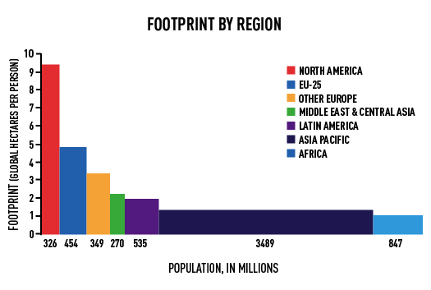

Top of Form
CALCULATING ECOLOGICAL FOOTPRINT (EF) EF takes into account every single human activity done; from the food we eat, to the vehicles we drive and other consumption habits humans engage in on a daily basis. EF is a very complex calculation that measures the amount of biologically productive land and marine area an individual, a city, corporations, and country can consume, or all of what humanity consumes and absorb, to the waste it generates with the current technology and resource management it practices. The expression of the size of our individual or collective footprint is usually then converted into a standardized measure of land area which is called 'global hectares' (gha).

EF = Population X Consumption per Person X Natural Resources/Water intensity
There is an Ecological Footprint calculation standard was put forth in 2006 but was reviewed in 2009. It was developed through a consensus from representatives of academia, government, United Nations, Non-Governmental Organizations and consulting firms. This standard was reviewed and guidelines on the use of sourced data, derivation of conversion factors, the establishment of study boundaries, and communication of findings all complied with the Standard-Setting Code of Ethics and Good Practice. This new standard review, in itself, is not perfect, but it has succeeded in shedding more light on how the marine area should be counted, how to account for fossil fuels, how to account for nuclear power and, how space for biodiversity should be included.(15)

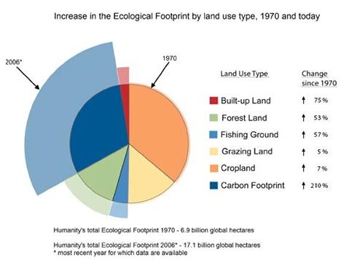

The ecological footprint calculation standards really can't consider the entire ecological variable on earth. For example, women in rural area in Nigeria, a developing nation use charcoal and firewood to cook, and regularly pour petroleum product called ‘kerosene’ into their lanterns which they use as a light source on a daily basis than their counterpart in the cities, so they consume more natural resources than those in the cities. Similarly, farmers in rural and countryside involved in mechanized agriculture can easily consume more resources than those developing urban areas. (16) Proper calculation and knowledge of Ecological Footprint is also an educative tool which can help alter personal behaviour to a more sustainable form and also influencing better government environmental policy.

Carbon Emissions is the major Portion of Ecological Footprint
With the carbon emissions being the largest component of Ecological Footprint, the graph below shows, that EF has been increasing exponentially since 1970, using the Global footprint Network 2006 statistics. Therefore, increasing carbon emissions are from increased energy generated from fossil fuels, increase in consumption of food, deforestation, and Mobility and urban transportation driven by fossil fuels.
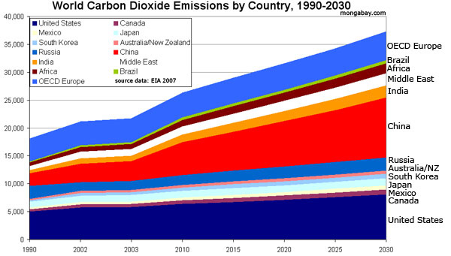

Activities that cause Ecological Footprint to rise; Humans consume more natural resources per year than what Earth can produce in the same timeframe. Data reveals that it takes the globe about a year and a half to regenerate all depleted natural resources consumed in a year period. (17)
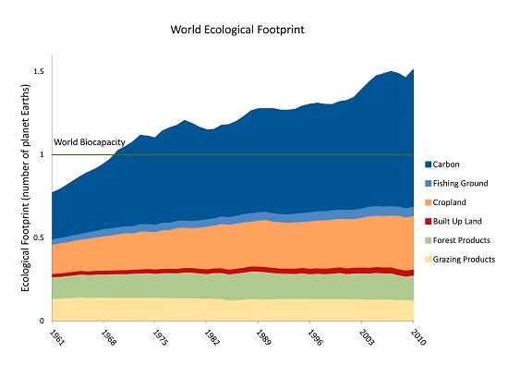
These are caused by the following activities humans actively engage in; 1. Mobility/ Transportation The use of Cars, Light Trucks and other forms of vehicles cause a considerable rise in Ecological footprint and lead to air pollution and global warming. 2. Consumption of Meat and dairy products Meat and poultry production requires large amounts of water and causes water pollution. It also uses a significant share of the nation's land--800 million acres of grazing livestock and an additional 60 million acres to grow animal feed. Irrigated crops grown to meet consumer demand use an enormous quantity of water. pesticides and fertilizers cause 5 percent of consumer-related toxic water pollution. Food crops also use substantial amounts of land. (18, 19) 3. Household lighting and other Appliances Electricity seem clean and nonpolluting when it's used in the home, but most of it is generated by burning polluting fossil fuels, especially coal. Appliances and lighting are responsible for the greenhouse-gas emissions related to consumer expenditures. Other appliances like Cooling and heating machines have an impact on ecological footprint because these appliances depend on electricity or fossil fuel contribute heavily to rising ecological footprint. Most fireplaces and wood stoves in rural area are especially high air polluters. 4. Home Construction The land and wood used for new homes are responsible for about a quarter of consumers' impact on wildlife and natural ecosystems. Six percent of consumer-related water pollution comes from manufacturing the materials for new homes and disturbing the soil during construction. 5. Industrialization and extraction of fossil fuel; Responsible for the major harmful carbon dioxide and greenhouse gas emission
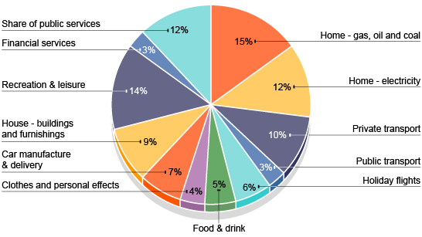

ECOLOGICAL FOOTPRINT OF FEW ADVANCED AND DEVELOPING AND POOR COUNTRIES
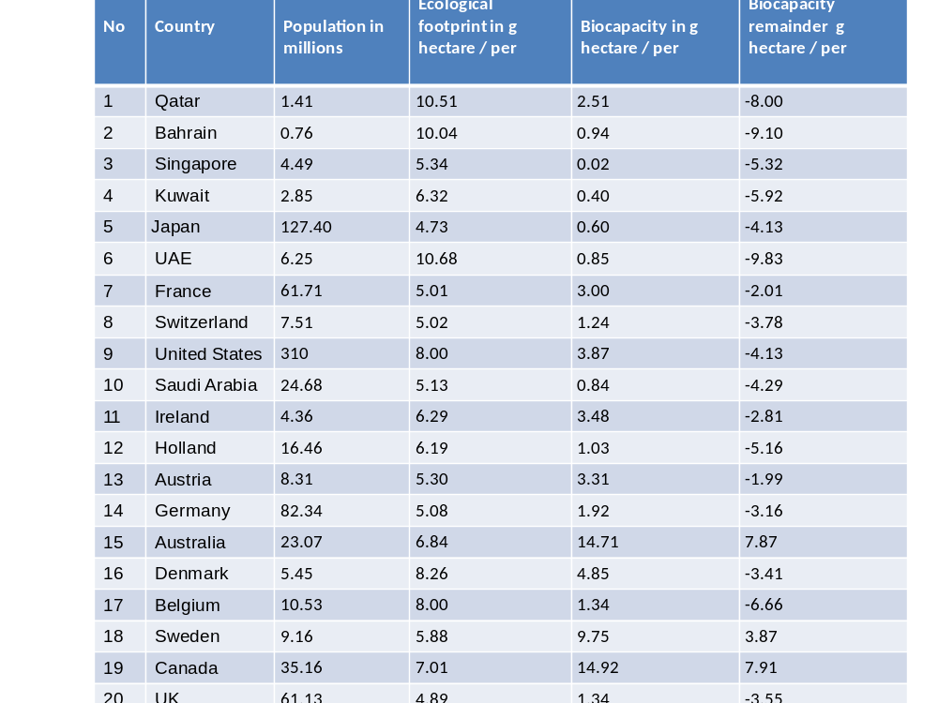
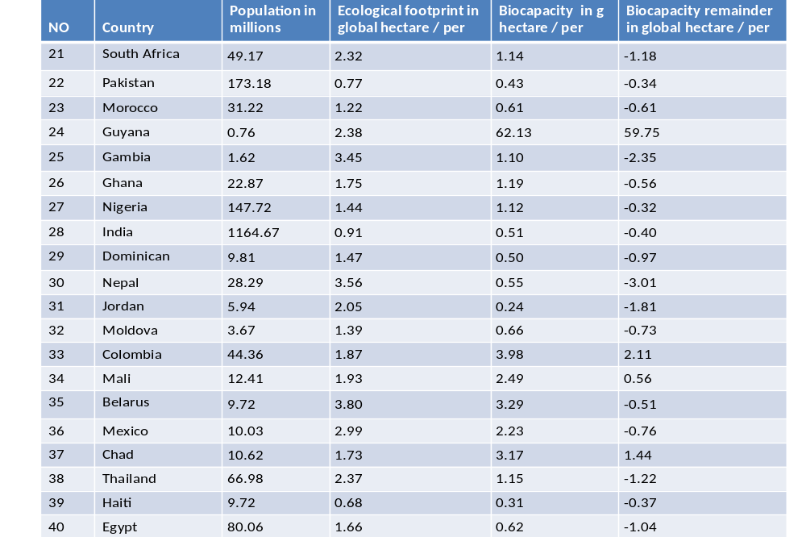 Ecological Footprint Atlas 2010- Global Footprint Network
FACTORS THAT AFFECT ECOLOGICAL FOOTPRINT (EF) Ecological Footprint is the product of population, consumption per person and natural resources on land and marine area. It is believed that these parameters will expand the human impact on the environment by over one-third. Though environmentalists have also identified the common factors that affect Ecological Footprint, they are: a growing population, urbanization and increased mobility through transportation (high level of importation) also have great environmental impacts. (20) Another factor that has greatly attracted attention is the increasing food consumption rate, especially for meat. There seems to be a growing global demand for meat consumption in the last 50years, its impact has depleted resources on land and is causing some strains on marine area, this consumption is responsible for the increasing deforestation and environmental degradation going on in some developing nations in Latin America, Africa and Asia. It is estimated that 40% of all the rainforests may have been cleared or burnt down in the past half a century, solely to give way for cattle pasture or its products; they are subsequently exported to the international market in majorly fast food brands and companies majorly in the USA and western nations. (21) (22)

These consumptions have caused some government in collaboration with few greed corporate entities devise means to grab land from indigent residents and often few country are manipulated to make sudden change in land ownership policies which favor the highest international bidders who are based in the cities of western nations. This usually leads to rise in hunger and loss of employment opportunity in rural areas, the combination of this effect further worsens and increases the urban migration as people move to the urban area to survive .(23) . In the process, natural ecosystems are destroyed by the quest to get or acquire land, even the meat produced as an end product of this ventures are too expensive for the indigent people who are predominately poor to buy and consume. This systematic action, of government and corporate bodies have forced out indigenous people or the inhabitants from farmlands to now search for land (24)
Environmentalists say, a control over consumption will be the game changer; however they acknowledge, it may be difficult to suddenly change human consumption patterns , because much of the way consumption are formed are strongly associated with mankind socio-cultural ways which have become part of man’s lifestyles, so altering this pattern will mean a collapse of existing cultural belief. There is also the economic consideration that must be considered because it will negatively affect the demand and supply for products and goods. It is believed that a scenario like this will cause unemployment and unimaginable financial crisis (25)
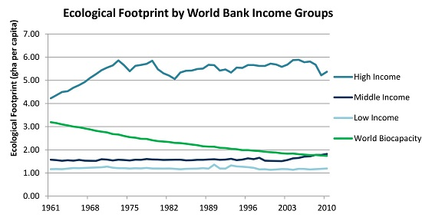

Other factors that may have some relative impact on Ecological Footprint are; the continued reliance on fossil fuel with its product and large emission of carbon waste. Similarly, a factor that may not have been previously observed but may have been noticed in this article and supported by very few experts is geopolitical interest of some advanced countries, this observation and the environmental degradation caused by high consumption of resources is as a result of geopolitical and corporate interest of western nations who need to feed their respective population. (26, 27, 28)

Reduction of Ecological Footprints It is a collective effort that involves but individual, national and global collaboration(29) On the individual part; lifestyle changes can reduce the size of a person Ecological Footprint, an attitude change of an individual can spur others and eventually help the community build sustainable methods of attaining development. Other effective changes that individual can make are in the area of energy usage and conservation in the home, mobility (Advocating for public transportation instead of private cars), buying locally grown foods in order to prevent the transportation of food products which will help increase EF and purchasing socially and environmentally responsible products.
Other efforts that individuals can do are; 1.Construct green buildings and protect green spaces, the individual homes should be Eco-friendly in design and individual should Support planting of trees, and protect open gardens and space. 2. Encouraging and practicing proper separation of waste generated in the home.
On the part of the country reduction of Ecological Footprint; 1.Reduction or complete stoppage of fossil fuel extractions or production. 2. Recycling and reuse of manufactured products and extracted natural resource. 3. Protection of remaining ecologically productive area. 4. Encourage divestment to renewable energy by promoting innovative ways of conserving, storing and generation renewable energy. 5. Regulating national population 6.Use of technology to increase carrying capacity and efficiency of the use of the remaining available land 7.Country should support green initiatives concepts.
Relationship between Ecological Footprint and Sustainable Development Ecological Footprint can be large or small, it is large if these activities are increased over a period of time and can be small if mankind do not overburden the environment i.e. they don't require a lot from the natural resources by trying to consume less, applying recycling ways and cutting down on private transportation through biking or walking. (30) Sustainable Development globally has tents on which it operates; they are environmental, economic and social tenet. This was why in 2002 at a world summit in South Africa, global leaders agreed that there was need for a global responsibility to environmental development and protection and another tent like economic development and social development with a need to advance and strengthen the interdependent of all these tents at local, national, regional and global levels. (31, 32) Sustainably then means, meeting the needs of mankind without compromising the needs of future generations to meet their needs, The challenge of sustainability is to find ways to create fulfilling lives while reducing our impact on the environment here on earth. (33,34) So the relationship between Sustainable development and EF rest on the amount of Ecological Footprint generated, if large it is not sustainable, and will greatly affect and hurt the future generations needs but Earth becomes progressively sustainable when EF is small or reduced .(35)
Therefore for Earth to achieve sustainable development in the environment, the planet must be a place where EF considerations and regulations must be considered including the positive modification of behavior of citizens, Government and corporate policies and with an urgent action to address the underlying causes of Biocapacity loss and the integration of environmentally sustainable development policies at all levels life can be sustainable. (36)
There is the urgent need to mobilize and coordinate mutual actions from diverse stakeholders around the globe to achieve multiple reductions of Ecological Footprints while enacting a vision of a better planet, where mankind needs are met without destroying or irrevocably degrading environmental resources that we all depend on to survive. (37)
DISCUSSION The recent downturn in the global economy and instability is a stark reminder of the consequences of living beyond our means this was the comment by James Leape, WWF International's director general. Mankind live in a time, in the history of nations when there is greater need than ever for coordinated mutual political action to salvage our planet, as we head for a possible ecological disaster far worse than the economic crisis the world is currently experiencing this is so because mankind is depleting earth’s biodiverse natural resources at a rate so fast that it threatens to our earthly existence may push us likely to extinction.(38).
By calculation, it is estimated that humans are using 20-30% more resources than the Earth can replenish each year, leading to loss of forest reserves, environment degradation, increased pollution of air and marine ecosystem. (39) Sadly the challenge is getting worse with a growing population and increase in human consumption which is faster than the current technology ways of solving the problem and meeting the needs of humanity. It is predicted by 2030, if this trend continues with no shift in the consumption or population factor, Mankind may need to start looking for a two new planets to sustain its lifestyle. (40) Humans thought that the right to use the natural resources of the earth to serve our human growth was the ideal way to toe, this was because human-centered ethics held that the earth's natural resources were infinite with the human ability to grow and increase was infinite this opinion may no longer acceptable, since there now seem to be a shift toward Environmental centered ethics , that believes that the Protection of the resources in the environment takes priorities before the needs and rights of the human population, the new ethics reveals that earth is finite, built on the environmental principle of preserving and sustaining the earth's system of living things. (41)
The unfortunate victims of earthly loss of the natural resources are usually the lower animals and or indigent citizens of developing nations because the consequence of this loss is the absence of clean water, pollution of air and degradation of the arable land.

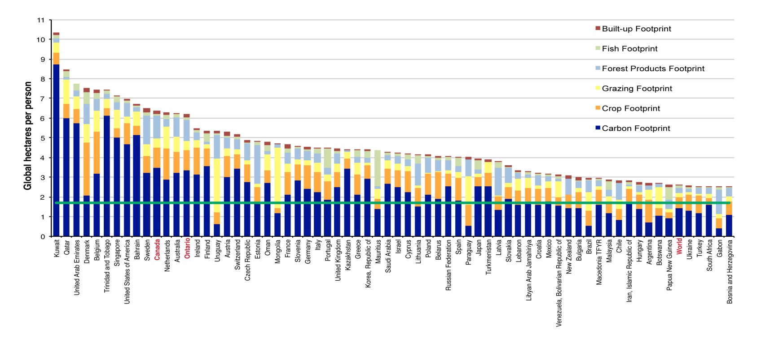This graph State of Ontario's Biodiversity 2010 Ecological Footprint per capita for 66 countries with the highest Ecological Footprint, compared with Ontario (Horizontal green line represents average )

ANALYSIS OF ECOLOGICAL FOOTPRINT There are related terms that need to be discussed to fully understanding EF, hence the need to define them; 1.Ecological Overshoot; Occurs when a population's demand on an ecological space exceeds the capacity of that ecosystem to regenerate the resources it consumes and to absorb its carbon dioxide emissions. This carbon emissions are the fastest growing contributor to ecological overshoot, the date of the ecological Overshoot for the year 2016, was August 8, 2016. (42) A figure of 13.5 billion global hectares or 2.2 hectares per person is documented to have been used translating to more than a 20% overshoot. The total human ecological footprint globally is 2.6 global hectares per capita (gha/ cap) compared with a total worldwide Biocapacity of only 1.8 gha/cap .Ecological overshoot means that mankind is currently using 1.4 times as many natural resources as are sustainably available, which in the long run is unsustainable. (43)
Ecological Overshoot (gha/cap) = Ecological Footprint (gha/cap) – Biocapacity (gha/cap)

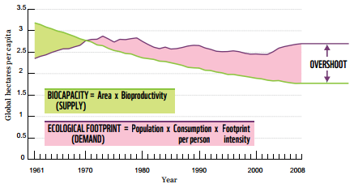
Source:WWF: Living planet report 2012: biodiversity, biocapacity and better choices
The overshoot for high income countries is much more extreme than the overall average. Thus we would already need 1.5 Planets (i.e. 3.3/1.8) to support the total world population of 6.8 billion if everyone was to live like a Nigerian on earth. This low Overshoot is from a developing nation and is relatively low compared to United States of America, an advanced nation, with a very high overshoot that required about 5planets supporting the same population and is higher than even the world average.(44)
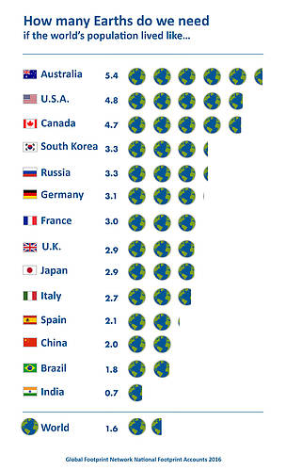

Ecological footprint shows that human activities have overshoot for nearly 30years, and the level is still rising over time with EF measurement accounting only for per capita consumption in the human population excluding the Biocapacity needed for the survival of other animals and species. This has highlighted a shortcoming of EF calculation, as not being able to get the exact estimate of total EF, since other animals and species are not factored in the original calculation of EF. It implies that ecological overshoot will be far greater than previously calculated. (45)
Steps to address Ecological Overshoot; 1. Adjusting expectations of what is considered a normal level of resource consumption in the developed world. 2. Reassessing how much stuff we believe is required for our happiness . Others ways include; 3. Using of technology to address eco-friendly energy-efficient housing designs. 4. Governmental ecological tax reform with total removal of resource subsidies. 5. Population regulation through safe and affordable family planning. 6. Total change of current life-cycle of consumptions.

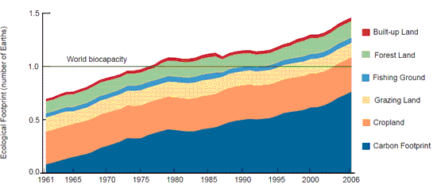

The graph shows human demand over the last 40 years as compared with the earth's ecological capacity for each year. One vertical unit in the graph corresponds to the entire regenerative capacity of the earth in a given year. Human demand exceeds nature's total supply from the 1980s onwards, overshooting it by 20% in 1999.

2. Biocapacity: refers to the capacity of a given biologically productive area to generate an on-going supply of renewable resources and to absorb its spillover wastes within a certain area (e.g. of arable land, pasture, forest, productive sea). unsustainability occurs if the area's ecological footprint exceeds its biocapacity. It is measured in global hectares.
Biocapacity and EF are closely related in Economics to the concepts of demand, which represent (Ecological Footprint) and Supply (Biocapacity). When the EF is larger than the Biocapacity the renewable resource results in a deficit. A deficit occurs when the total natural resources extraction and waste generation, exceed an ecological system’s ability to replenish the natural resources and to absorb the generated waste. It is estimated that more that 85% (5 billion) of the global population live in nations that are running ecological deficits. (46)
Therefore, the situation is ecologically unsustainable. A national ecological deficit can be compensated through trade with nations that process, ecological reserves or through liquidation of national ecological assets. In contrast, the global ecological deficit cannot be compensated through trade, and is, therefore, equal to overshoot and a nation with ecological reserves can still experience a local deficit (Global Footprint Network 2006) ,but if the Ecological footprint is smaller than the Biocapacity i.e. Biocapacity of a region exceeds its population's EF, the result is Ecological reserve. (47, 48)
The consequences of ecological deficit, in some nation, mostly developing, have been devastating, leading to ecosystem collapse, debt, poverty, famine and even war, with the world populations projected to increase exponentially, further rise of ecological deficit is certain, unless individuals, governments and stakeholders start to take serious precaution and adjustment in their ways of life and keep a regular attention to ecological footprint. (49,50 )

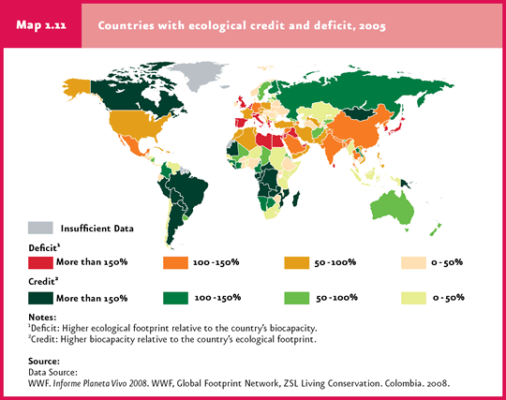

The 2003 report from United Nations, Department of Economic and Social Affairs (UNDESA) state that an increase in the natural resource consumption, populations and global emissions is affecting the environment. The report shows that 20% of the world population who reside in wealthy nations, actually consume 86% of the global natural resources and actively generate 53% of the world CO2 emissions of carbon waste, while the remaining 80% of the population from majorly poor countries and developing nations estimated to be about 5 billion people consume and live on the remaining 14% natural resources and in the poorest nation generating about 3% of CO2 emission.
Hence the need to act urgently, especially for advanced nation to take the lead in ensuring that incentives and transfer of adequate sustainable innovation are made possible for this poor countries and the remaining emerging and developing economies. (51)

OTHER SUSTAINABLE DEVELOPMENT SCALE AND ITS IMPLICATION IN ECOLOGICAL FOOTPRINT
The successful adoption of the 2030 Agenda for Sustainable Development and the first universally binding climate change agreement signed in Paris in 2015, renewed hope for a bold transition towards a zero-carbon driven economy and an inclusive green economic growth that are sustainable. Signs of progress will come when nations act accordingly to implement all the adopted Sustainable Development Goals (SDG) of UN while considering the peculiarity of their locality.
The principle behind the framework of all the SDG goals requires political willingness on the part of the various governments, adjustment in the lifestyle of every citizen within the country to activities that are more eco-friendly and equitable distributions of wealth.
This article raises awareness of the urgency to act in order to mitigate the dangerous consequences that may befall mankind. If we must hope to be able to achieve the commitment of the 2030 Agenda and its SDG, we must be ready to use the various Ecological footprint data and other sustainable development scales such as like Human Development Index (HDI) to the benefit of our environment. (52)
Human Development Index (HDI) is a measure of average achievement in 3 key areas of human development: income, health, and education. It is the geometric mean of normalized indices for each of the three area of human development. The health component is assessed by life expectancy at birth; the education component is measured by mean of years of schooling for adults from 25 years upwards and expected years of schooling for children of school entering the age. The standard of living or income component is measured by gross national income per capita. It is one of the indicators for sustainability. The challenge for globally is to define suitable indicators that represent progress towards a new goal based on human aspirations. HDI fits this description; it assists in understanding the relationship between the natural wealth to raise human well-being and the need for an intact planet to maintain it. Tracking the eco-efficiency of various societies and linking the Ecological Footprint Accounts with HDI will help the sustainable living. (53)

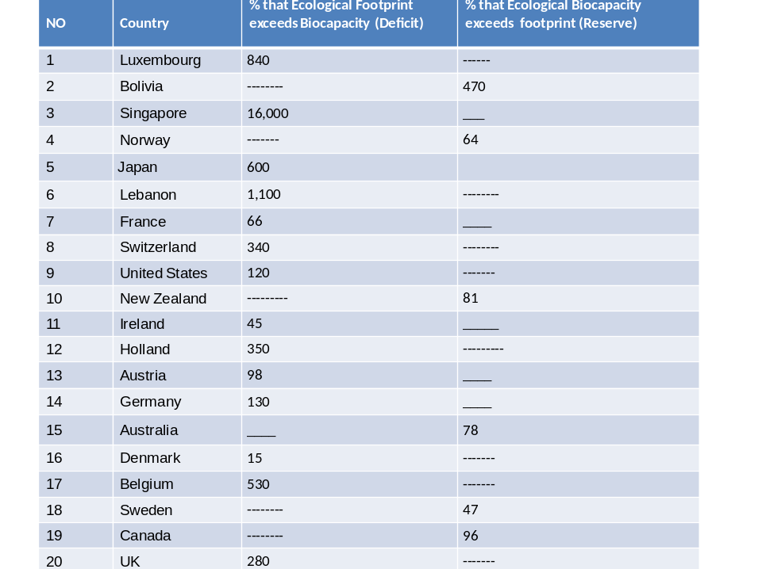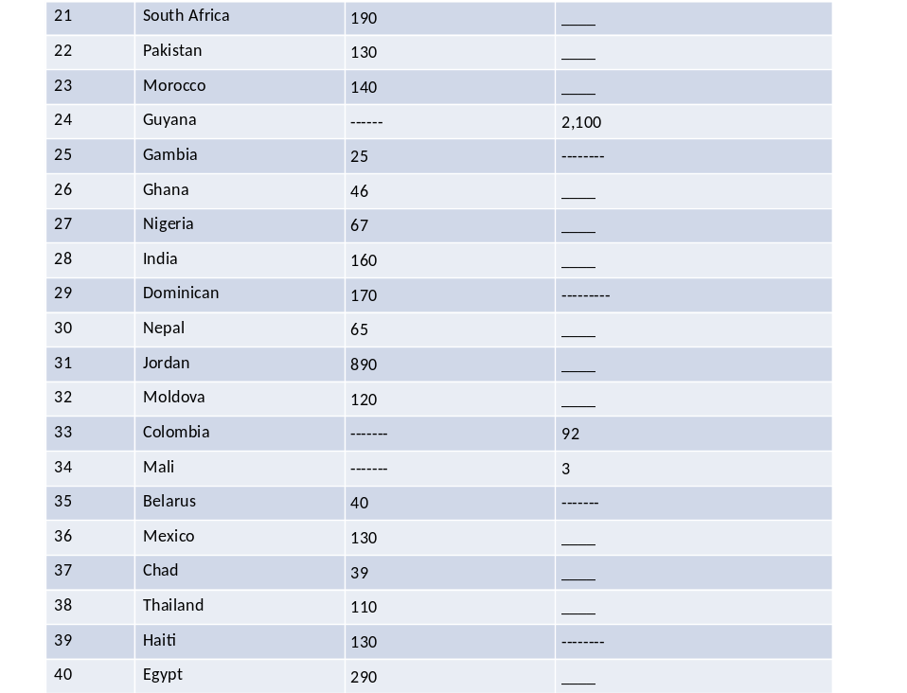

However, to better understand the Ecological Footprint distribution globally, analyzing the demand generated across income groups are one of the ways. The Ecological Footprint of these Income Groups, of a country provides a preliminary overview of the nations human demand on nature. It gains insight into the relationship between income level, changes in population, changes in consumption, and available Biocapacity over time (54)
Using the World Bank classifications; For the current 2016 fiscal year using the World Bank Atlas method; 1.High-income Countries are defined as having a per person Gross National Income (GNI) of $12,736; 2.Middle-income Countries are defined as having GNI per capita of more than $1,045 but less than $12,736; 3.Low-income Countries are economies with a GNI per capita of $1,045 or less.

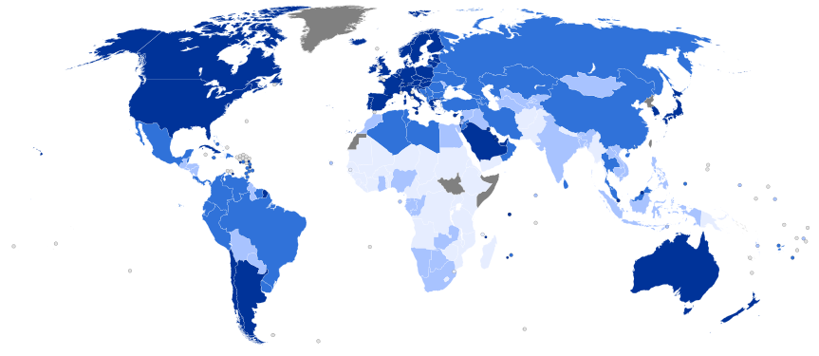
Human Development Index (HDI) rankings for 2014 showing the World map indicating the categories of Human Development Index by country published by UN.
The categories are shown by the following colors; Very high human development High Medium Low Unavailable Data

While High-income countries usually are characterized by high per-person consumption so they will get high Ecological Footprint per-person even with relatively small populations, unlike Low-income countries that have small consumption and a small Ecological Footprint per-person, but with a larger growing population. It is clear that income or economic growth have a remarkable impact on EF and must be taken seriously if sustainable development is to be achieved.
The graphs to the show how affluence relationship between the Ecological Footprint values and countries with low-, middle-, and high-income groups.
Therefore, countries progress toward sustainable development can be assessed Human Development Index (HDI) as an indicator of well-being, and the ecological footprint as a measure of demand on the biosphere. (55) The Ecological Footprint of the top five countries makes up about half the global total. Analysis of the 2014 National Footprint Accounts reveals that just two countries generated 31 percent of the world’s total carbon Footprint: China (16 percent) and the USA (15 percent).

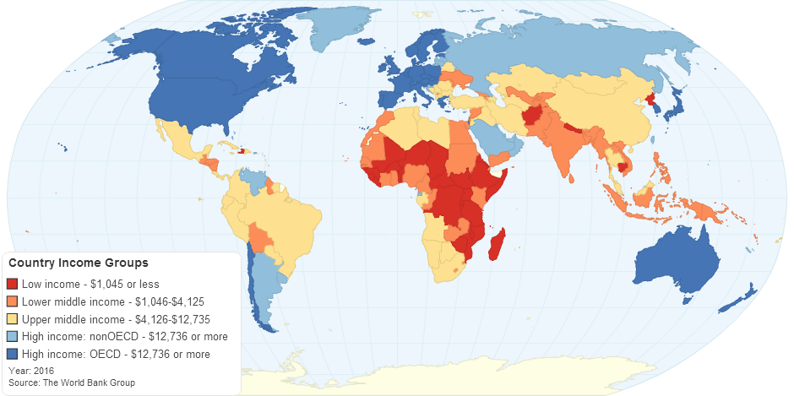
This map classifies all World Bank member economies and economies are divided among income groups according to 2015 gross national income (GNI) per capita, calculated using the World Bank Atlas method.

HDI SCORE SCALE
The United Nations, Human Development Index is expressed as a value between 0 and 1, from less to most developed countries. HDI index less than 0.5 is said to be indicative of a low level of development and an HDI of greater than 0.7 is considered to be a high level of development the HDI in the range of 0.5-0.7 indicates a middle level of development.
UN considers a nation with an HDI that is within the top quartile i.e. Percentiles 76-100 is seen as “very high human development “; an HDI in the 51-75 is regarded as “high human development”; HDI in the 26-50 is grouped as” medium development” and percentiles less than 26 which is the bottom quartile is said to be” low human development “. However, the threshold of HDI 0.7 is the critical threshold value needed to achieve high development. (56)
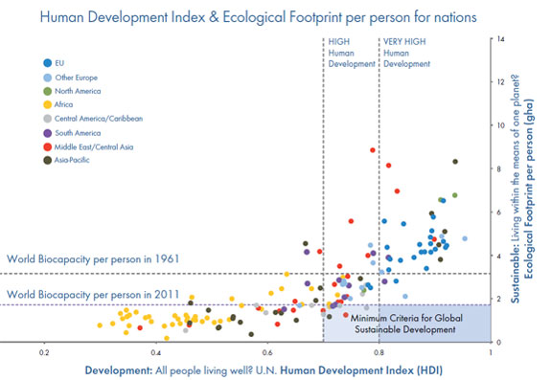

SHORTCOMING OF ECOLOGICAL FOOTPRINT 1.The Ecological Footprint does not evaluate the social and economic dimension of sustainability. 2.Ecological Footprint only captures overall demand on the biosphere from humans; it does not pinpoint specific biodiversity pressures caused by other species. 3.The Ecological Footprint should also cater for non-renewable resources like fossil fuels and other earthly minerals extracted since their use put a demand on Biocapacity. In all some demands are difficult to calculate and though not added to the original calculation of EF. It means that EF values are underestimated dependency hence shortcoming.

To discuss a developing nation specifically, Nigeria an African country will be selected;
INTRODUCTION Currently Nigeria is Africa most populous nation with an estimated population of 182,201,962 inhabitants as at 2015 using the annual growth rate of 2.7% estimated to be 4,555,444. (57) The country population is divided among over 475 different ethnic groups; 145,761,570 of the total Nigerian population are from the following ethnic groups, ten (Hausa, Fulani, Yoruba, Ibo, Kanuri, Tiv, Edo, Nupe, Ibibio and Ijaw) which is approximately 80% of Nigeria population. Nigeria population density is 199.9 people per square kilometer as of December 2016 and a total land area of about 923 770 km2 according to the United Nations Statistics Division with 25% of the population in the Western Region covering 12% of area, 21% in the Eastern Region covering 9% of area, and 53% in the Northern Region covering 79% of area.
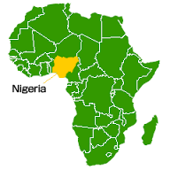
The Federal Ministry of Environment of Nigeria in 2001 estimation of irrigated land is 9 570 km2 and arable land representing about 35 %; 15 % pasture; 10 % forest reserve; 10 % for settlements and the remaining 30 % considered uncultivable for one reason or the other. (58) with a total surface area of 91.07 million hectares, 57 % of which is believed to be either under crops or pastures while the remaining 43 % is divided amongst the forest, water bodies and other uses. (59, 60)
Nigeria is a country of marked ecological diversity and climatic contrasts, as a country trying to industrialize and having one of the largest oil and gas reserves in the world, active extraction of fossils fuel to the detriments of the environment happens regularly. These detriments impact, usually are said to be caused by vandals within the region or as the resident of the area say, the irresponsible activities of multinational companies. Violent disputes within the oil-rich area are common, especially in the southern part of the country and have started spreading to another area not known for violence.
The aftermaths are the constant kidnapping of company workers, armed conflict, occupations of oil installations across the country and sabotage both by the people and the multinational companies. With the frustration of indigenous member of the community, not having anything to show for the nearly 50years of active exploration of oil from their tribal lands only extreme poverty and environment degradation has further fueled all these disputes causing several deaths.

Diagram (i) and (ii) show the EF % of an Average Nigerian and the total individual Ecological Footprint in Nigeria.
Diagram (i);
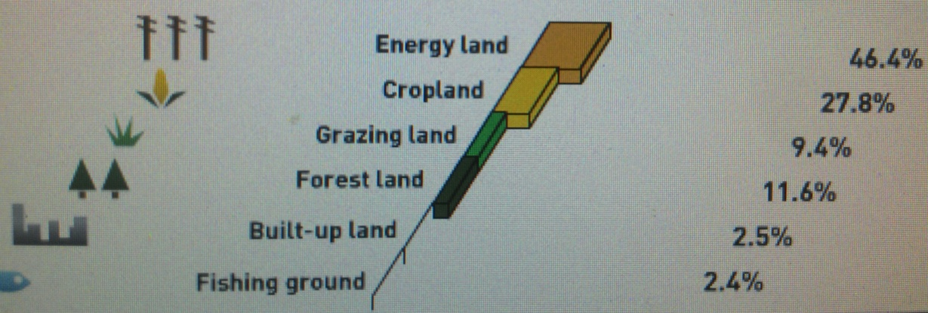
Diagram (ii);
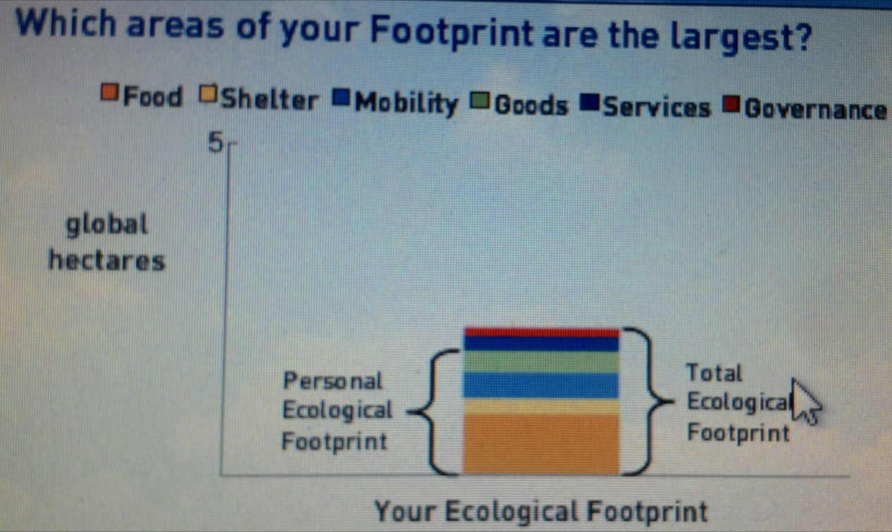
The nation indeed is facing severe environmental and resource challenges, especially with a fast growing population. All these have led to the rise of ecological footprint in the country. Corrupt multinationals and national government receive and loot the money received as the share of oil revenues meant to develop and empower the people from the region and another citizen in other regions but they never get to do so. Hence the violent protest.(61)
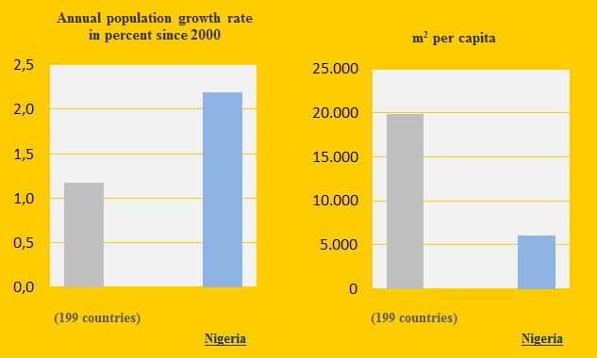
It is being projected that Nigeria and Ethiopia will be among the top 5 contributors to the ecological footprint solely due to the projected population growth increase between now and 2050. As the world's population continue to rise it is believed by UN and other related agencies that much of the world's population growth over the half a century will happen in developing nations, which will only worsen the increasing ecological damage we will continue to inflict on the planet as our footprint expands. (62)
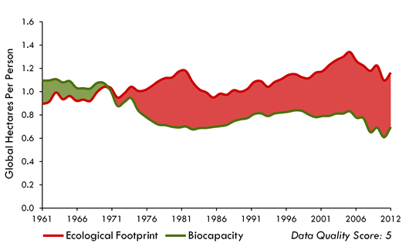 This graph tracks the per-person Ecological Footprint and biocapacity in Nigeria since 1961 till 2012. It shows that there is ecological deficit, the Footprint accounts come from UN statistical sources.
Unfortunately, Oil-rich Nigeria should be wealthy, but it’s not with most of her citizens lacking running water, electricity, adequate education and health care, but multinationals like Shell Corp. have extracted more than $100 billion in oil from Nigeria since 1958 and with an exploding population growth, massive corruption within the government and a dwindling natural resources with environmental degradation, it makes it much more difficult for the country to improve the prosperity and health of her citizen not to talk about maintaining sustainable development. A researcher Prof. Eugene A. Rosa from the Washington State University and her fellow researchers assessed anthropogenic factors that cause environmental impacts using the ‘Ecological Footprint’ for the year 2015, for all countries that having at least one million people, they found that “increases in population and affluence will expand mankind’s impact on the environment by over one-third.” They suggested that in order to mitigate this impact, nations would need to adequately manage their natural resources efficiently and furthermore country must determine the technical efficiency rate value each nation which is the value required to be able to offset their ecological footprint, and examples, they gave were that of China that would need to improve its technical efficiency at a rate of about 2.9 percent per year, and India by about 2.2 percent per year to offset the projected growth of their ecological footprints. If not the ecological footprint of each of these nations will exponentially rise as projected. Therefore for these nations and any other nation, ecological protective strategies and policies will be needed if they must achieve sustainable development.

Population size and affluence are driving environmental degradation according to a new study published in the current edition of the journal Frontiers in Ecology. These experts concluded that urbanization, economic structure, age distribution may just have a relatively little impact and observed that improved education and life expectancy can enhance human well-being. (63) Human alterations of the natural landscape exert significant direct and indirect impacts on natural resources like river and wetland processes. Wetlands and rivers are important sources of commercial fishing providing fish proteins for local communities, agriculture, seasonal livestock grazing, wood collection and ecotourism. A shared understanding of the link between humanity and nature is essential to making profound changes that will allow all life to thrive for generations to come (64, 65)

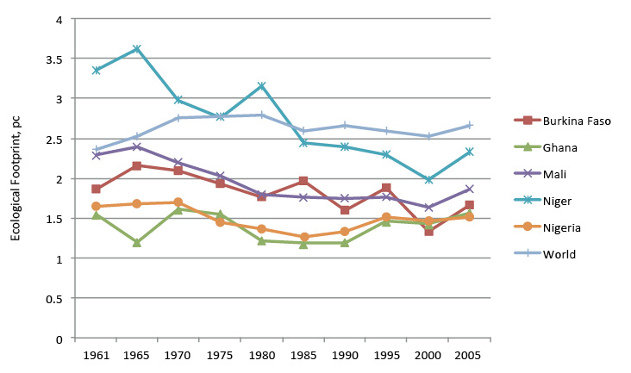 Graph showing ecological footprints of 5 African country and the world average from 1961-2005
The Nigerian Governments using the Ecological Footprint will be able to: 1. Assess the value of their country’s ecological assets. 2. Monitor and manage their assets. 3. Identify the risks associated with ecological deficits. 4. Set policy that is informed by ecological reality and makes safeguarding resources a top priority. 5. Government should establish system to hold people accountable and be able to measure progress toward reach the sustainable development goals

MAJOR THREAT IN NIGERIA INCLUDE THE FOLLOWING; 1. Environmental Degradation; Habitat loss and degradation are the most common threat to animals on the decline. Everything from unsustainable agriculture to residential or commercial development to energy production can damage vital areas for wildlife. 2.Food Systems; the country have been greatly affected by no fertile land to farm due to ecological degradations, flooding, erosion, climate change impacts etc. there is, therefore, need to push for ways to provide nutritious food for the growing population while mitigating the ecological impact. Fossil fuel impact and climate change work hand in hand and failure to resolve one will lead to failure to resolve in the other.

It is recommended that sustainable development model will be needed while recognizing planetary boundaries including climatic limits. Hence, the Call for urgent action to reduce the country Ecological Footprint and create policies for a Green Economy and will assist in repositioning the country, to achieving appreciable sustainable development. (66)

CALCULATING NIGERIA ECOLOGICAL FOOTPRINT; this was done using the Anthesis model of computation, Anthesis is a global sustainability consultancy firm that provides environmental, social and commercial sustainability strategies and solutions. Individual footprint and country footprint can be calculated with this model.

For calculating individual footprint; Identification of the location in the world such individual lives or resides, in this case, it was Nigeria, noting if the individual lives in a large house or small apartment or whether the individual share with others or live alone. This model used to determine the country EF, also consider if social amenities’ like light and electricity, whether they used renewable products or not, household appliances especially electric bills and other expense whether they are high, average or low. The nature of food consumption was also considered in the calculation, especially what the individual consume whether it's fresh foods or convenience foods or mixtures of both, or whether one is a meat-eater or vegetarian. Mobility in terms of transportation was considered, because air transport and car travel is factored heavily into an Ecological Footprint analysis, because they produce carbon dioxide that adds to carbon emission which hurts the environment; hence the reason why it is factored into the calculation of EF; especially if uses car is either average or heavy, or whether individual uses public transportation and if travelling on vacation or holiday on flights long or short distance.

Finally the amount of waste generated and whether it is recycled or not was determined, with all these data answered in a questionnaire format fitted into the company model system plus the total population of each country known from the UN records, the ecological footprint of an individual was then determined as well as those of the entire nation, with this model format the average of Nigerian citizen was ecological footprint was 3.03 global hectares and if everyone lives like us, we would need over 1.5 planets to support global consumption . About 10% ecological footprints on land attach to other species on water and land.

RECOMMENDATIONS FOR NIGERIA The way forward should be an all-inclusive effort to reduce all sources of Ecological Footprint generated, working with numerous organizations to educate the citizens to the green philosophy of; ‘reduce, reuse, recycle' that are core concept which can help mankind to conserve natural resources and are key to drive sustainable development. Therefore, it is recommended that developing nations start to take seriously the ecological footprint they generate and its impact on the environment. There is no doubt , Advanced economies must try to change their consumption rate to reduce ecological footprint, but this equally is a call for Nigeria and other developing nations to equally embrace sustainable ways of living, as the ecological resources within their locality are depleting with a rising population growth. (67) Furthermore, it is recommended that countries, especially developing nations should liaise with established organizations involved in calculating Ecological footprints, in order to get the accurate data calculation of their respective Ecological Footprint

OVERALL THE GLOBAL RECOMMENDATION This article holds the view that humans globally should work to promote and encourage various ecologically sustainable ways of reducing our dependence on fossil fuel, and reduction of Ecological Footprint. Achieving a global outcome can only be through coordinated collaboration among countries. Carbon Emission and climate change are both threat to sustainable development and the fight against poverty. Unless the world takes bold action now, prosperity may be out of the reach of millions. Now more than ever, awareness is growing that a lack of action and commitment to reduction or near eradication of fossil fuel and the worsening climate change are currently the biggest threat to development and poverty elimination. Hence the UN resolution on the environment and climate change are clear, nations are to place a higher priority on the protection of the environment, approach to mitigate and adapt to climate change, especially the health impact while proffering innovative strategies to create a healthy ecological biosphere.

The mandate to achieve a 1.5 ºC reduction in temperature by 2030, can only be realized, if carbon emissions and fossil fuel extraction are phased out as agreed by more than 100 countries who are now vulnerable to the impacts and are advocating for a 1.5C limit goal by 2030 at UN negotiations in Paris.(68) Some reasons for the urgent need to take action towards reduction is that many island nations like Fiji regarded as low-lying islands are on the threat of almost being submerged by the ever-rising oceans and farmers in the continent of Africa are facing extreme drought and food shortages, hence the call for a total phase-out of fossil fuel use worldwide by 2030.(69, 70)

To achieve full decarbonization in a way that can achieve wider sustainable development, each country must develop a strategic national plan to shift and completely move from a high-carbon economic growth model.(71) The current global economic difficulties faced by many countries have made it harder for a lot of countries to fully mobilize local or global financial commitments to a long-term challenge like the reduction of carbon emission and climate change.

However, it is expedient that we begin to make the sacrifice if we intend to continue to live on earth for another century. Nations must begin to step up their respective efforts to pursue low-carbon development and adaptation, following the recent international agreement.

Globally, stakeholders need to host regular workshops and roundtables to reappraisal status of Sustainable Development Goals (SDGs) to review their current status. Researchers say that renewable energy and technological innovations will, improve better farming practices to enable farmers to be more resilient, cut air pollution dramatically as well as reduce emissions. (72, 73) Zero-carbon emission strategies or policies are the way forward for sustainable living here on earth, the important component of this concept are climate protection and sustainable development; the principle idea behind this policy is for future development model to imbibe a near complete zero-carbon emission, efficiency and renewable energy innovations which can reduce fossil fuel emissions and create wealth by reducing poverty especially developing countries within the continent of Africa, Asia, and Latin America be encouraged, because the new wave of population growth and consumption will arise from these regions. (74, 75) This article is equally proposing a financial initiative, which is in a form of an incentive; the aim is to generate commitment from the various national governments to ensure a reduction in carbon emissions. Currently, most developing nations are having serious economic, humanitarian, legislative difficulties, with these known facts; it makes it extremely difficult for developing nations to mobilize substantial financial commitments for a long-term plan for a reduction of emission and climate change financing.

Furthermore, corrupt leaders from these developing nations often explore the blame game on fossil fuel effect on the environment and the human activities on the climate. The initiative is indeed a financial incentive; that will give a proposed 5% of the total amount of the country budget to the developing nation as a financial aid to help them facilitate the transformational process towards a near-zero-carbon emission, a climate resilient future and explore the renewable energy innovation though recently have undergone a sharp price reduction, creating new opportunities and expanding access to efficient energy. Nations are required to meet all the criteria set up to be able to get the funds, which may be accessed from the Adaption Fund, already promised by UN member nations during COP 21 and COP 22 agreement in Paris, France and Marrakesh, Morocco respectively. The important criteria countries must comply with are; Nations must show and present their annual national commitment plan or strategy and they should have legislative backing for a complete transition to better forms of energy more efficient and renewable within the country.

However, for the above to work in developing nations the following are equally recommended;

1.There should be a stoppage of the international or national financing and subsidies’ of fossil fuel products including coal and related infrastructures that are not eco-friendly.

2. Mobilization of both national, local financial sources from the respective nations via Tax can help and help accelerate efforts to end fossil fuels in no distant time. This process has to be strengthened and expanded by providing a favorable political framework.

This incentive will significantly strengthen and promotes capacity building in the area of technological innovation while compelling all advanced nations to make a meaningful commitment and assist in the technology transfer and investments in renewable energies and energy efficiency to developing nations. Though it may look as a slow path, but in principle, it is an all-inclusive collaborative effort which should be at a pace the various nations can reasonably act.

However, the role that individual citizen play can’t be overemphasized; 1.Individual must ensure energy conservation through measures such as replacing light bulbs with compact fluorescents, Unplugging electronics when not in use, drying clothes outside whenever possible and run laundry machine only when full and Defrost refrigerator and freezer regularly. 2.Design sustainable new homes that are eco-friendly and using renewable source of energy like solar for home appliance, which can help to drop your energy bill. 3.Proper sanitation and waste management should be done at home and in public places like schools, having recycled bins around are helpful. 4.Drive cleaner this is by using a bike, or walking or take public transport whenever possible, instead of private cars and long flight via air. And if private cars are to be used Small-engine cars are usually energy efficient than larger ones. 5. Citizen should purchase less refined food, and more of fresh food

CONCLUSION This article tries to raise awareness about the individual, national and global ecological footprint impact on the environment and other aspects of life like the economic, political, cultural, and social ways of the citizenry, and with effective knowledge or understanding of the Ecological Footprint, respective countries can have adequate information to assist them make better environmental and economic policymaking, while ensuring a rapid shift to ecological civilization. With the manifestation of ecological problems the windows of opportunity are closing fast.

The actions that humans collectively take or fail to take will determine whether the future is hopeful or bleak. Ecological Footprint as an indicator of sustainability for development has proven to be effective alongside other sustainable development scales or indices. Clearly, there should be a global annual regular review of where we are may need to be done at a global, nation and local level so that we can understand and know how far we have come in reducing Ecological Footprint and possibly know how far we still have to get to a sustainable acceptable level of existence . Therefore, there must be a renewed effort to create a new ecological civilize generation, especially with the shared knowledge that the planet is our responsibility and we must ensure that we leave her as green as possible and the current search for another planet to live on as being proposed by an advanced nation the USA may be just wishful thinking and a wasteful venture since such funds can be better put into initiatives and innovation that can ensure universal sustainability.

The article believes that this may be the best possible way to achieve sustainable development and may be an excellent response to even mitigating climate change impact on our planet. Since it appears to be a more realistic strategic solution for developing nations, especially moving forward from where they are currently rooted. The international collaboration from all countries still remains one of our greatest strengths to reaching a sustainable development and ecological civilization. Finally, this article lends and supports thousand of actions, campaigns and voices to the reduction of fossil fuel emissions, climate changes and the need to globally mobilize resources with political will globally, nationally, and more importantly locally to meet the current challenge.

ACKNOWLEDGEMENTS; This article could not have been written without the steadfast support and forbearance of my co-authors Dr Ezioma Onyinye Gbujie and Dr Uchegbu Ngozi. I am sincerely indebted to Theophane and Dr Ijendu Korie for providing a constant source of support and guidance. I have also been fortunate to have attended the COP22 convention in Marrakesh, Morocco which equally helps me to develop some aspects of the discussion in this article. Authors appreciate helpful input and reviews from all the materials used which were majorly from the United Nations, and their partners really help to deepen my knowledge of the topic and other related issues their various areas of expertise have been invaluable.

REFERENCE

1.Wackernagel M., Schulz , N., Deumling, D., et al. (2002).Tracking the ecological overshoot of the human economy. Proceedings of the National Academy of Sciences (PNAS). Vol. 99(14), 9266-9271-Retrieved from http://www.pnas.org/cgi/content/abstract/142033699v1 2.Jowit, J., (2008,October 29).World is facing a natural resources crisis worse than financial crunch. The Guardian . Retrieved from https://www.theguardian.com/environment/2008/oct/29/climatechange-endangeredhabitats 3.Martin, B., (2005). New Leaf or Fig Leaf?-The challenge of the New Washington Consensus. Retrieved from http://www.publicworld.org/files/newleaf.pdf 4.World Wide Fund For Nature (2016). The Living Planet Report 2016. Retrieved from http://assets.worldwildlife.org/publications/964/files/original/lpr_living_planet_report_2016.pdf?1477582118&_ga=1.52750187.23605437.1481492977 5.Smith J.W., (1994) The World's Wasted Wealth 2, Institute for Economic Democracy (1st ed.).Retrieved from htpps://www.amazon.com/Worlds-Wasted-Wealth-Save-Environment/dp/0962442321 6.Secretariat of the Convention on Biological Diversity (2010) Global Biodiversity Outlook 3. Montréal. Retrieved from https://www.cbd.int/doc/publications/gbo/gbo3-final-en 7.Rockström, J., et al. (2009) A safe operating space for humanity. Retrieved from Nature 461, 472-475 (24 September 2009) | doi :10.1038/461472a 8. Speth G.J,. (2005). Red Sky at Morning: America and the Crisis of the Global Environment. (Kindle Version) Yale University Press. Retrieved from htpps://www.amazon.com 9.Meadows, D., (1998). Indicators and Information Systems for Sustainable. Retrieved from International Institute for Sustainable Development (IISD) website: http://www.iisd.org/pdf/s_ind_2.pdf 10.Wackernagel, M., Onisto, L., Bello, P. et al. (1999); National natural capital accounting with the Ecological Footprint concept. Ecological Economics. 29, 375–390. Retrieved from http://metagraphies.org/Sir-Patrick-Geddes/ecology/Wackernagel_National.pdf 11.Galli,A.,D,Lin.,Wackernagel,M.,et al.,(2015). Humanity’s growing Ecological Footprint: sustainable development implications. Retrieved from https://sustainabledevelopment.un.org/content/documents/5686humanitysgrowingecologicalfootprint.pdf 12.Kibert, C., Thiele, L., et al. (2012). The Ethics of Sustainability. Retrieved from http://rio20.net/wp-content/uploads/2012/01/Ethics-of-Sustainability-Textbook.pdf 13.Best S, Nocella A., (2006). Igniting a revolution voices in defense of the earth. Retrieved from https://libcom.org/files/Best%20S%20and%20Nocella,%20III%20(Eds.)%20-%20Igniting%20a%20Revolution%20-%20Voices%20in%20Defense%20of%20the%20Earth.pdf 14.Ernst Ulrich von Weizsacker , Hargroves C., et al.(2009) . Factor Five: Transforming the Global Economy through Improvements in Resource Productivity. (Kindle Version) Retrieved from htpps://www.amazon.com amazon.com 15.Global Footprint Network,(2009).Ecological Footprint Standard. Retrieved from http://www.footprintnetwork.org/images/uploads/Ecological_Footprint_Standards_2009.pdf 16.Dunn C. (2008, Feburary, 7). Your ecological footprint: defining, calculating and reducing your environmental footprint. Retrieved from http://www.treehugger.com/culture/your-ecological-footprint-defining-calculating-and-reducing-your-environmental-footprint.html 17.Sodhi, N.S., Paul R. Ehrlich., P.R., (2010). Conservation biology for all. Retrieved from https://conbio.org/images/content_publications/ConservationBiologyforAll_reducedsize.pdf 18.Gerber, P., Opio C. and Steinfeld H (2007).Poultry production and the environment – a review Retrieved from http://www.fao.org/ag/againfo/home/events/bangkok2007/docs/part2/2_2.pdf

19.Ball, K., (2011). Mass poultry production causes water pollution . Retrieved from http://www.earthtimes.org/pollution/mass-poultry-production-causes-water-pollution/1185/ 20.Coyle, D., Simmons, A.,(2014). Understanding the Global Energy Crisis. Purdue University Press. (Knowledge Unlatched Open Access Edition.) Purdue University press. Retrieved from http://docs.lib.purdue.edu/cgi/viewcontent.cgi?article=1028&context=purduepress_ebooks 21.Thornton,P.,(2010).Livestock production: recent trends, future prospects. Retrieved from Philos Trans R Soc Lond B Biol Sci. 2010 Sep 27; 365(1554): 2853–2867..doi:10.1098/rstb.2010.0134 22.Nierenberg, D.(2005); Happier Meals: Rethinking the Global Meat industry. Retrieved from http://www.worldwatch.org/system/files/WP171.pdf-World Watch Institute 2005 23.World Bank,. (1999).World development report 1999/2000; Entering the 21th century. Retrieved from https://openknowledge.worldbank.org/handle/10986/5982 24.Chakravarty, S., S. K. Ghosh,S., Suresh, P., Dey,A.,Shukla G.(2012).Deforestation: Causes, Effects and Control Strategies Retrieved from http://cdn.intechopen.com/pdfs/36125.pdf 25.Robbins, R.,(2005).Global Problems and the Culture of Capitalism (5th Edition). Retrieved from https://www.amazon.com/Global-Problems-Culture-Capitalism-5th/dp/0205801056 26.Diamond, J. (2011). Collapse: How Societies Choose to Fail or Succeed. Retrieved from https://www.amazon.com/Collapse-Societies-Choose-Succeed-Revised/dp/0143117009 27.Ritzer ,G., Malden, M.A (2006).The Blackwell Companion to Globalization. Blackwell Publishers . Retrieved from http://www.academia.edu/8074687/The_Blackwell_Companion_to_Globalization_The_Blackwell_Companion_to_Globalization 28.Shah , A., (2001).Stress on the environment, society and resources? .retrieved from Global Issues http://www.globalissues.org/article/214/stress-on-the-environment-society-and-resources 29.Brower ,M., Leon, W.,(1999). The Consumer's Guide to Effective Environmental Choices. Retrieved fromhttps://www.amazon.com/Consumers-Guide-Effective-Environmental-Choices/dp/060980281X 30.Ian Moffatt (2000); Ecological footprints and sustainable development. Retrieved from Ecological Economics.vol 32 359–362 31.Johannesburg Declaration on Sustainable Development. (2002), www.housing.gov.az 32.Martinet V.,(2012) Economic theory and sustainable development: what can we preserve for future generations?. Retrieved from https://ebookbestdeal.us/index.php?q=economic-theory-and-sustainable-development-what-can-we-preserve-for-future-generations-routledge-studies-in 33.World Commission on Environment and Development,(1987). Our Common Future retrieved from https://global.oup.com/academic/product/our-common-future-9780192820808?cc=us&lang=en& 34.United Nations Development Programme (UNDP). (2014); Human development report 2014: Sustaining human progress: Reducing vulnerabilities and building resilience. Retrieved from http://hdr.undp.org/sites/default/files/hdr14-report-en-1.pdf 35.Bastianoni, S.,(2010).The State of the Art in Ecological Footprint Theory and Applications. Retrieved from http://www.footprintnetwork.org/images/uploads/Academic_Conference_Book_of_Abastracts.pdf 36.Patrick ten Brink.,(2011).The Economics of Ecosystems and Biodiversity (TEEB) in National and international policy making. Retrieved from http://www.teebweb.org/publication/teeb-in-national-and-international-policy-making/ 37.Kates W.R, Parris,T.M., Leiserowitz A.A., (2005).What Is Sustainable Development? Goals, Indicators, Values, and Practice. Environment: Science and Policy for Sustainable Development, Volume 47, Number 3, pages 8–21. Retrieved from www.enivronmentmagazine.org/editorials/kates-apr05-full. 38.Smith, R., (2015).China's Communist-Capitalist Ecological Apocalypse. Retrieved from the institute for policy research and development, London website- http://www.paecon.net/PAEReview/issue71/Smith71.pdf 39.Pimm, S.L., Jenkins, C.N., Abell R., Brooks,T.M( 2014). The biodiversity of species and their rates of extinction, distribution, and protection. Retrieved fromhttp://science.sciencemag.org/content/344/6187/1246752

40.United Nations Educational, Scientific and Cultural Organization. (1997) . Educating for a sustainable future; a transdisciplinary vision for concerted action. Retrieved from http://www.unesco.org/education/tlsf/mods/theme_a/popups/mod01t05s01.html 41.Olen D.R.,(2008,June,8). A Shift to a New Ethics?.Milwaukee Journal Sentinel. Retrieved from www.jsonline.com 42.Pandey, A., (2016, August,8).Earth Overshoot Day: Human have used up their yearly supply of planet’s resources in less than 8 months. From retrieved http://www.ibtimes.com/earth-overshoot-day-2016-humans-have-used-their-yearly-supply-planets-resources-less-2398626 43.Global Footprint Network,(2009). Ecological Footprint Atlas 2009. Retrieved from https://issuu.com/globalfootprintnetwork/docs/ecological_footprint_atlas_2009/18 44.Monfreda, C.,Wackernagel , M. , Deumling, D., (2004). Establishing national natural capital accounts based on detailed Ecological Footprint and biological capacity assessments. - Land Use Policy 21 (2004) 231–246. Retrieved from http://www.bioinfo.rpi.edu/bystrc/courses/biol4961/monfreda.pdf 45.Lenzen ,M., Dey, C., Lundie S., (2006). A comparative study of some environmental impacts of conventional and organic farming in Australia. Agricultural Systems 89 (2006) 324–348 retrieved from http://citeseerx.ist.psu.edu/viewdoc/download?doi=10.1.1.471.9579&rep=rep1&type=pdf 46.World Bank.(2016).World Development Indicators 2016.Washington, DC. World Bank. Retrived from https://openknowledge.worldbank.org/handle/10986/23969 47. Florian Schaefer, Ute Luksch, et al (2006); Ecological Footprint and biocapacity. -Eurostat . Retrieved from http://ec.europa.eu/eurostat/documents/3888793/5835641/KS-AU-06-001-EN.PDF 48.Borucke, M. , Galli, A., Iha,K.,Lazarus,E.,Mattoon,S.,Morales J.C, Poblete,P., Wackernagel, M., (2013). Global Footprint Network, 2013. The National Footprint Accounts, 2012 edition. Global Footprint Network. Retrieved from http://www.footprintnetwork.org/images/article_uploads/National_Footprint_Accounts_2012_Edition_Report.pdf 49.United Nations, Department of Economic and Social Affairs, Population Division (2015).World Population Prospects: The 2015 Revision,Volume II: Demographic Profiles. Retrieved from https://esa.un.org/unpd/wpp/publications/Files/WPP2015_Volume-II-Demographic-Profiles.pdf 50.Alkema, L, Raftery A.E, Gerland, P, Samuel J. Clark, S.J., Pelletier, F., Buettner,T., Heilig,G.K. (2011).Probabilistic Projections of the Total Fertility Rate for All Countries. Demography. 2011 Aug; 48(3): 815–839. doi: 10.1007/s13524-011-0040-5. Retrieved from https://www.ncbi.nlm.nih.gov/pmc/articles/PMC3367999/ 51.Food and Agriculture Organization of the United Nations.(2003).The State of Food Insecurity in the World (SOFI). Retrieved from ftp://ftp.fao.org/docrep/fao/006/j0083e/j0083e00.pdf 52.United Nations Development Programme (2014). Human Development Report 2014; Sustaining Human Progress: Reducing Vulnerabilities and Building Resilience. Retrieved from http://hdr.undp.org/sites/default/files/hdr14-report-en-1.pdf 53.Kovacevic, M., (2011).Review of HDI Critiques and Potential Improvements. Retrieve from http://www.hdr.undp.org/sites/default/files/hdrp_2010_33.pdf 54.World Bank (2011).Country Income Groups (World Bank Classification) .Retrieved from http://chartsbin.com/view/2438 55.McGillivray,M., Clarke M.,(2006).Understanding Human Well-being, pp. 217-238, United Nations University Press, India. Retrieved from http://i.unu.edu/media/unu.edu/publication/2394/1130-understandinghumanwell-being.pdf 56.United Nations Development Programme (2010)- Human Development Report 2010 . Retrieved fromhttp://hdr.undp.org/sites/default/files/reports/270/hdr_2010_en_complete_reprint.pdf 57.Knoema,(2015).World Data Atlas-Nigeria. Retrieved from https://knoema.com/atlas/Nigeria/Population 58.Federal Ministry of Environment of Nigeria(2001); National Action Programme to combat desertification. Retrieved from http://www.uncd.int/action programmes/Africa/national/2001/Nigeria-eng.pdf. 59.Cleaver, M., Schreiber, A.,(1994).Reversing the spiral: the population, agriculture, and environmental nexus in sub-Saharan Africa. Retrived from http://www.popline.org/node/287708 60.Food and Agriculture Organization of the United Nations- FAO Bulletin of Statistics, 2001. Retrieved from http://www.fao.org/statistics/en/ 61.Reuter.(2016,August,14).Militants blow up Nigeria pipeline, Chevron protest goes on. Retrieved from http://www.reuters.com/article/us-nigeria-oil-idUSKCN10M10Y 62.Chefurka P.,(2009).Population, Consumption And Our Ecological Footprint.–PlanetThoughts. Retrieved from http://www.planetthoughts.org/?pg=pt/Whole&qid=3086 63.Dietz, T., Rosa. E.,Richard York, R.,(2007) Driving the human ecological footprint. Front Ecol Environ 2007; 5(1): 13–18. Retrieved from http://noss.cos.ucf.edu/papers/Dietz%20et%20al%202007.pdf 64.Da Silva, C.J.,Jane Simoni, J.(2012).Waters, Biodiversity and Culture in the Pantanal - Ecological and Ethnobiological Studies in the Chacororé Bay System. Retrieved from https://carliniecaniatoeditorial.wordpress.com/page/5/ 65.Gleason, Robert A., "Prairie Pothole Regional Studies" (2008). USGS Northern Prairie Wildlife Research Center. Paper 184. Retrieved from http://digitalcommons.unl.edu/usgsnpwrc/184 66.Adejumo, A., Adejumo O.,(2014). Prospects for Achieving Sustainable Development Through the Millennium Development Goals in Nigeria. European Journal of Sustainable Development (2014), 3, 1, 33-46 ISSN: 2239-5938 Doi: 10.14207/ejsd.2014.v3n1p33.Retrieved from http://www.ecsdev.org/images/V3N1/adejumo%2033-46.pdf 67.United Nations Development Programme(1998).Human Development Report 1998.Retrieved from http://hdr.undp.org/sites/default/files/reports/259/hdr_1998_en_complete_nostats.pdf 68.Hassol,S., (2011).Emissions Reductions Needed to Stabilize Climate.- Presidential Climate Action Project. Retrieved from https://www.climatecommunication.org/wp-content/uploads/2011/08/presidentialaction.pdf 69.Dabar, M. (2015, December 7). Scientists: 1.5C warming limit means fossil fuel phase-out by 2030. http://www.climatechangenews.com/2015/12/07/scientists-1-5c-warming-limit-means-fossil-fuel-phase-out-by-2030/ 70.United Nations Environment Programme (UNEP), (2014). The Emissions Gap Report 2014. United Nations Environment Programme, Nairobi. Retrieved from http://www.unep.org/publications/ebooks/emissionsgapreport2014/portals/50268/pdf/EGR2014_LOWRES.pdf 71.Zaelke,D.,Borgford-Parnell,N.,Andersen,S.,(2016).Recent study- Institute for Governance & Sustainable Development. Retrieved from http://www.igsd.org/wp-content/uploads/2016/09/HFC-Primer-12Sept2016.pdf 72.Gewin,V., Monahan,P.,(2016,May,19).As U.S. moves to cut greenhouse emissions from farms, new study finds big global challenge. Retrieved from http://www.sciencemag.org/news/2016/05/us-moves-cut-greenhouse-emissions-farms-new-study-finds-big-global-challenge 73.Eva Wollenberg., (2016). Reducing emissions from agriculture to meet the 2 °C target. - Glob Chang Biol. 2016 Dec;22(12):3859-3864. doi: 10.1111/gcb.13340. Retrieve from https://www.ncbi.nlm.nih.gov/pubmed/27185416 74.Soltau F., (2008). Fairness and Equity in Climate Change. (2008) Retrieve from http://digitalcommons.pace.edu/lawdissertations/4 75.Independent Commission on Multilateralism. (2016). The 2030 Agenda for Sustainable Development and Addressing Climate Change. Retrieved from- https://www.icm2016.org/IMG/pdf/executive_summary_02_19.pdf

