Title: Women, trauma and alcohol dependency: Connections and disconnections in alcohol treatment for women
Deanna L Mulvihill, RN PhD, TLI Foundation, USA

Abstract (300 word limit)
Based on the investigation in waters around Nanri Island in spring and autumn of 2011, we analyzed spatial and temporal changes in species, abundance and diversity index of phytoplankton, and explored the relation between phytoplankton community structure and environment. The result showed that 106 species of phytoplankton, in 48 genera were identified, wherein diatom was the dominant species in abundance. Abundance in spring was significantly higher than that in autumn, ecological groups feature eurythermal and warm water species. Investigation showed that the heterogeneity of the marine environment of was high, and phytoplankton species diversity was low. Salinity and nutrients, as two major factors that influenced temporal and spatial variation of phytoplankton distribution abundance, were significantly correlated with phytoplankton abundance in spring. Compared to islands survey data during 1990-1991, dominant species were mainly few species, which succeed from domination of both dinoflagellate and diatom to domination of diatom.
Image
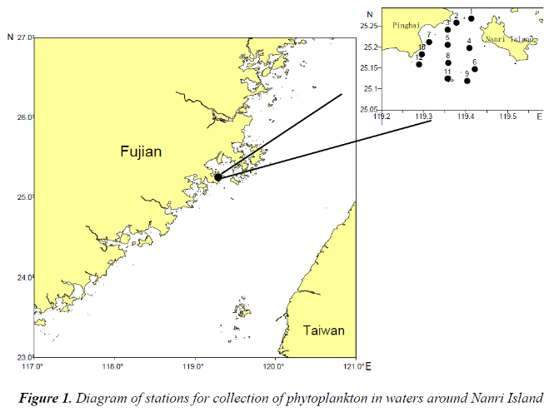
Recent Publications (minimum 5)
- Application of a Load Duration Curve for Establishing TMDL Programs Upstream of the Tiaoxi River within the Taihu Watershed, China
Luo Y and Zhang JY

- Relation between diversity of phytoplankton and environmental factors in waters around Nanri Island
Ye YY , Luo Y, Wang Y, Lin M, Xiang P, Ashraf MA.

- Water Quality Comparison and Ecological Environment Assessment in Offshore Area of Fujian Province
Luo Y, Ni WM, Cai L, Huang HN

- Marine water quality assessment and comparison during major and minor tides in near sea area of Fujian Province
Luo Y, Ni WM, Cai L, Huang HN

- Microcystin accumulation in bighead carp (Aristichthys nobilis) during a Micro –cystis-dominated bloom and risk assessment of the dietary intake in a fish pond in China
Ni WM ; Zhang, JY ; Luo, Y
- Response of freshwater algae to water quality in Qinshan Lake within Taihu watershed, China
Zhang JY, Ni WM, Luo Y, Stevenson RJ, Qi JG


Biography (150 word limit)
Yang Luo has completed his PhD from Ocean University of China. He was employed by Third Institute of Oceanography (TIO) affiliate to State Oceanic Administration of China (SOA) as an associate professor since 2010. He is interested in water quality assessment and eutrophication in estuary and coastal area. He has published more than 10 papers in reputed journals and two chinese monographs.
Email: luoyang@tio.org.cn
- Full Name: Yang Luo
- Personal Email: luoyang@tio.org.cn
- Mobile Number: +86 592 2195510
- Linked In:
- Facebook:
- Session Name/ number: Marine Biology
- Category: (Oral presentation/ Poster presentation): Oral presentation
- Date of Birth: 5/5/1984
- Postal Address: 178 Daxue road, Siming district, Xiamen city, Fujian province, Chin

