Antibiotic residues in waste impacted surface waters from Lagos, Nigeria.
Oluwatosin Olarinmoye¹,
Adekunle A. Bakare²,
Obih A. Ugwumba².
Abstract

In the past few decades, there has been increasing interest and concern, in and about the environmental presence of human and veterinary pharmaceutically active chemicals (PHACs) in environmental matrices, especially in water, and the implication of such presences on ecosystem health at orgarnismal and population levels. The development of increasingly accurate and specific analytic methods for the detection of such micropollutant residues has enhanced the determination of presence, and environmental concentrations. A study detailing the presence and concentrations of antibiotic residues and degradates in surface water specimens taken from six locations in the city of Lagos in Nigeria is presented in this paper. The specimens were analysed using SPE coupled with tandem LC/MS. Six antibiotics were detected out of thirteen screened for at environmentally significant concentrations in specimens from five of the six study locations. Seven were not detectable as they were below the limits of detection of the protocols used. The highest concentrations measured were detected in the sample ISOLO for Sulfamethoxazole (1.5 µg/l) and Erythromycin (1.0 µg/l). The obtained concentrations for antibiotic residues during this study, which is the first detailing the environmental presence and quantities of detection of antibiotics in Nigerian urban surface waters, are within range of several extant reports. The ubiquity of presence and the high locational detectability could be attributable to direct municipal domestic wastewater impaction on surface water bodies, due to an almost total lack of concerted sewage treatment of such wastewater streams which consequently become influents into surrounding waters, and the environmental pseudo-persistence of antibiotics. Implications for non-target aquatic fauna and ecosystems are discussed.
Keywords: Lagos, Antibiotics, Surface waters, LC/MS, Ecotoxicology, Non target species.

Recent Publications (minimum 5)

- Olarinmoye, O.M., Fashina-Bombata, H.A., Clarke, E.O., Anosa, V.A. and Ahabue, E.I. 2006. Pigmented macrophage aggregations and ovarian haemosiderosis in silver catfish Chrysichthys nigrodigitatus from Lagos lagoon, south western Nigeria. Afr. J. Environ. Pollut. Health 5(2): 16-20. Calabar, Nigeria.
- Olarinmoye, O.M., Clarke, E.O., Kumolu Johnson, C. A., and, Aderinola, O.J. 2008. A preliminary assessment of the health status of feral populations of Chrysichthys nigrodigitatus in Lagos lagoon complex, Nigeria, using a modified health assessment index protocol. Afr. J. of Aquat. Sci. 33(1) 77-82. South Africa.
- Olarinmoye, O.M, Fashina-Bombata, H.A, Aderinola, O.J., Clarke, E.O., and Adeboyejo, A.O. (2015). Hematologic metrics of Wesafu, a cichlid from Lagos, Nigeria. Journal of Basic and Applied Research International. 13(3). 193-198. Abstract available online at: http://www.ikpress.org/abstract/4819#.VwtbEPkrLrc
- Olarinmoye, O.M. (2016). Characterization of pharmaceutical pollution in the aquatic environment of Lagos Nigeria and potential ecotoxicological effects. Technical report commissioned by the UNESCO International Hydrological Programme.http://en.unesco.org/emergingpollutants/strengthening-scientific-research-and-policy/case-studies
- Olarinmoye, O. M., Bakare, A. A., Ugwumba, O. A., and Hein, A. (2016). Quantification of pharmaceutical residues in wastewater impacted surface waters and sewage sludge from Lagos, Nigeria. Journal of environmental contamination and ecotoxicology. 8(3). 14-24. http://www.academicjournals.org/journal/JECE/article-full-text-pdf/083D7EF57805

Olarinmoye O.M., and Ugwumba, O.A. and Awe, F.A. (2017). The Niger delta: ecology of oil, depredation, and conflict. In: the Political Ecology of Oil and gas activities in the Nigerian aquatic ecosystem. Elsevier. The Netherlands.

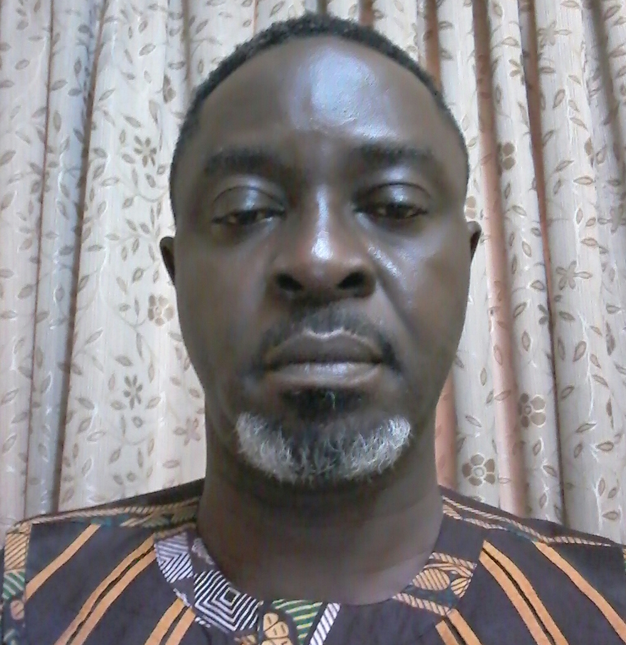

Biography (150 word limit)
Tosin Olarinmoye is a lecturer and researcher (fish pathology) in the department of fisheries of the Lagos State University. His areas of special focus are the effects of anthropogenic inputs on non-target species in the aquatic environment (aquatic toxicology) and environmental risk assessments.
Email: pisxs22@gmail.com

Notes/Comments: Complete publication lists available on demand.

Presenting author details
Full name: OLARINMOYE Oluwatosin Modupe
University/Industry/Organization name: Lagos State University
Designation (Director/Prof/Assistant or Associate prof/Researcher/Student): Lecturer I
Country: Nigeria
Telephone: 234 (0)9058331627
Email: pisxs22@gmail.com
Track name: Tosin Olarinmoye
Category (Oral presentation/ Poster presentation/Young researcher forum/E-poster): Oral
Research interest: Aquatic toxicology, ecotoxicology
Linked In account: Tosin Olarinmoye

Note: Please fill up the Red mark fields so that it would be easier for us to cite your details in the conference particulars. (Please do not forget to fix your photo above the title)

