Direct acting anti-viral drugs improve Health-related quality of life in patients' with hepatitis C.
Authors:
Wesam Morad MD1 Esam Elshimi MD 2, Nashwa Shebl MD2 and Warda Othman MD2
Institution:
1- Epidemiology and Preventive Medicine Department, National Liver Institute, Menoufia University. Egypt
2-Hepatology Department, National Liver Institute, Menoufia University-Egypt
Running heading: HRQL and Direct acting anti-viral drugs in patients with HCV
Corresponding author and reprint:
Name: Dr. Wesam Saber Morad
Telephone: +2-01004745371
E -mail address: wesammorad@gmail.com
Address: Department of Epidemiology and Preventive Medicine, National Liver Institute, Menoufia University, Yassin Abdelghaffar street, Shebin Al-Kom, Menoufia, Egypt.
Zip Code: 39111.
Financial support: None
Conflict of Interest: “None”
Abstract word count: 231
Paper word count: 2774
Key words: HCV, DAA drugs, Liver cirrhosis, quality of life.
Abstract:
Background: Chronic hepatitis C virus (HCV) causes significant decline in the health related quality of life (HRQL). Recently, direct acting anti-viral drugs (DAA) have been endorsed as standard of care for treatment for HCV. Objectives: to study the HRQL in patients with HCV and cirrhosis before and after DAA. Study design: Prospective cohort hospital based study. Methods: We included 500 patients with HCV and cirrhosis fulfilled all eligibility criteria for treatment and completed the survey of HRQL using (SF-36 and CLDQ questioners) before and after treatment. Patients were treated by combination of one of the following regimens: a) Sofosbuvir (SOF) plus Daclatasvir (DAC) ± ribavirin (RBV) in 2 divided doses or b) SOF plus Simeprevir (SIM) ± RBV or c) SOF plus RBV. Results: On treatment, 35.2% of the patients had a poor physical function and half of them had poor role-emotional, while 45.7% patients’ had excellent role-emotional, 49% noticed change in their mode, evaluation of HRQL before and after treatment through SF-36 and CLDQ showed an improvement in different domains. (p<0.05). The overall sustained virological response (SVR) was (89.6%). Conclusions: Results from the current study suggest that HRQL decreased on treatment and significantly increased after treatment. We recommend addressing the patients’ quality of life into consideration as a part of the evaluation protocol before the initiation of DAA drugs and after cure to improve this particular aspect of patients’ life.

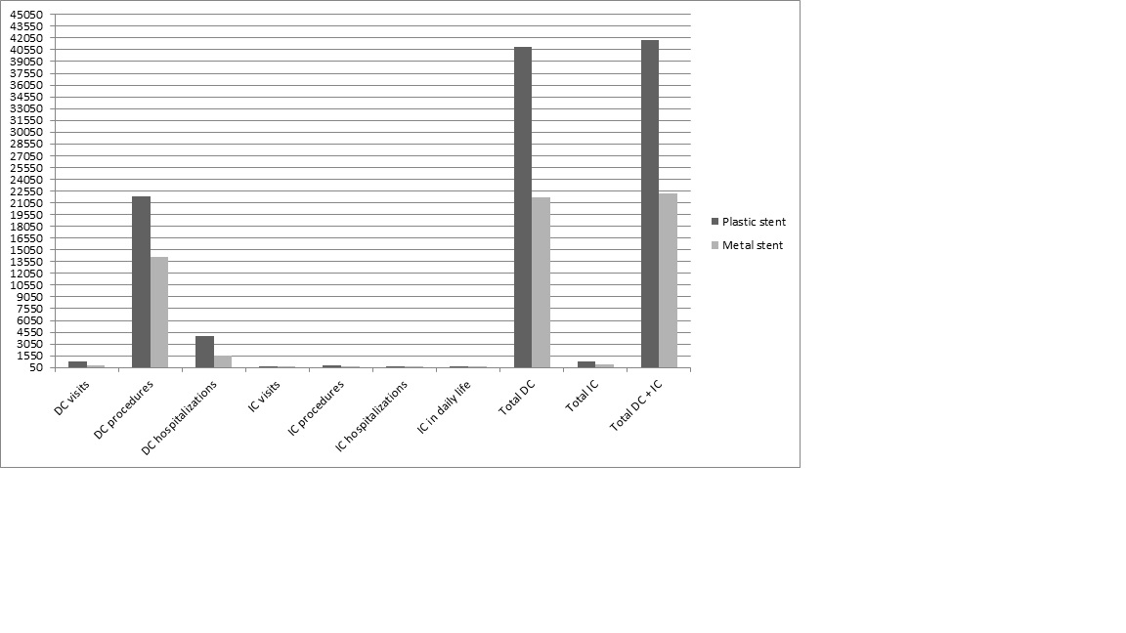Figure 1: Distribution of patients consulted the doctor about annoying side effects (N=500), 54% of patients consulted the doctor about annoying side effects.

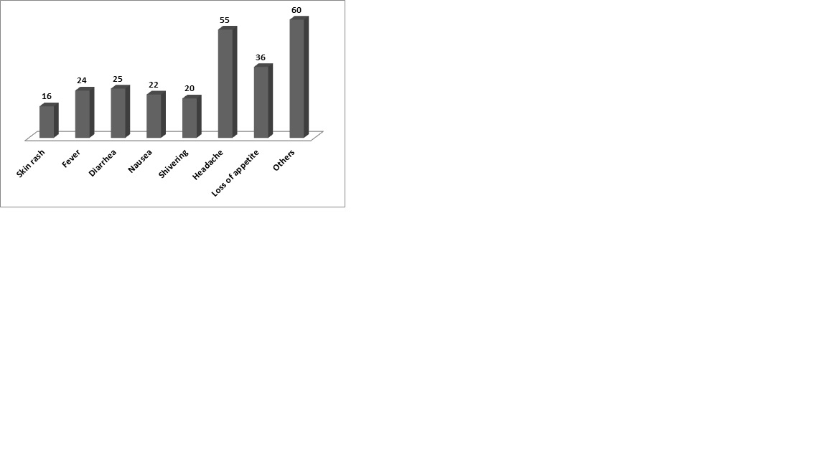
Figure 2: Distribution of common short-term side effects among patients attending National Liver Institute Hospital (N=500). Headache was the most common short-term side effect (55%) followed by others as (joint pain–decreasing sexual function-decreasing appetite).

