Open access literature databases for mandatory drug safety literature screening during clinical development and post market – equal access to new science for pharmaceutical companies.
Steen Ottosen MD, Steen Ottosen ApS, Denmark

Abstract
Statement of the Problem:
It is difficult and expensive to meet the regulatory requirements in Europe and USA using existing commercial providers. Regulatory agencies mandate frequent often weekly literature searches using widely used reference databases. In addition, the European Union require literature searches in local language in member states. For many small or midsize pharmaceutical companies, the current costs for access to commercial reference databases and articles is prohibitive.
Methodology & Theoretical Orientation:
To conduct the required literature searches normally a subscription is required to access to commercial databases where the cost can run tens of thousands annually. Access to the full text articles must be paid separately which typically cost between $20-100 to access pr. article. Most existing library databases are not designed to support the specialized type of search that is required for drug safety to produce expedited single case reports and aggregate reports where searches are in date sequence and articles should be presented in a tabular format to quickly review the relevance of the article and access the full text as needed.
One newer open access database is Europe PMC is built on PubMeds 36 million indexed articles and supplemented with additional 5 million mostly European articles. Europe PMC has full text article search capability and they are working actively to make more full text articles freely available for reading. In Europe PMC there are currently almost 9 million full text articles free to read.
Europe PMC is partnering with specialists in drug safety and pharmacovigilance to provide open search tools like RxReg.com designed to support specialized drug safety searches and minimize the time to search and document findings.
Conclusion & Significance:
The recent trend towards open access and public domain information services represent a new opportunity for small and midsize pharmaceutical companies to ensure equal access to compliant and comprehensive searches for new safety information simpler and at a much lower cost.

Image
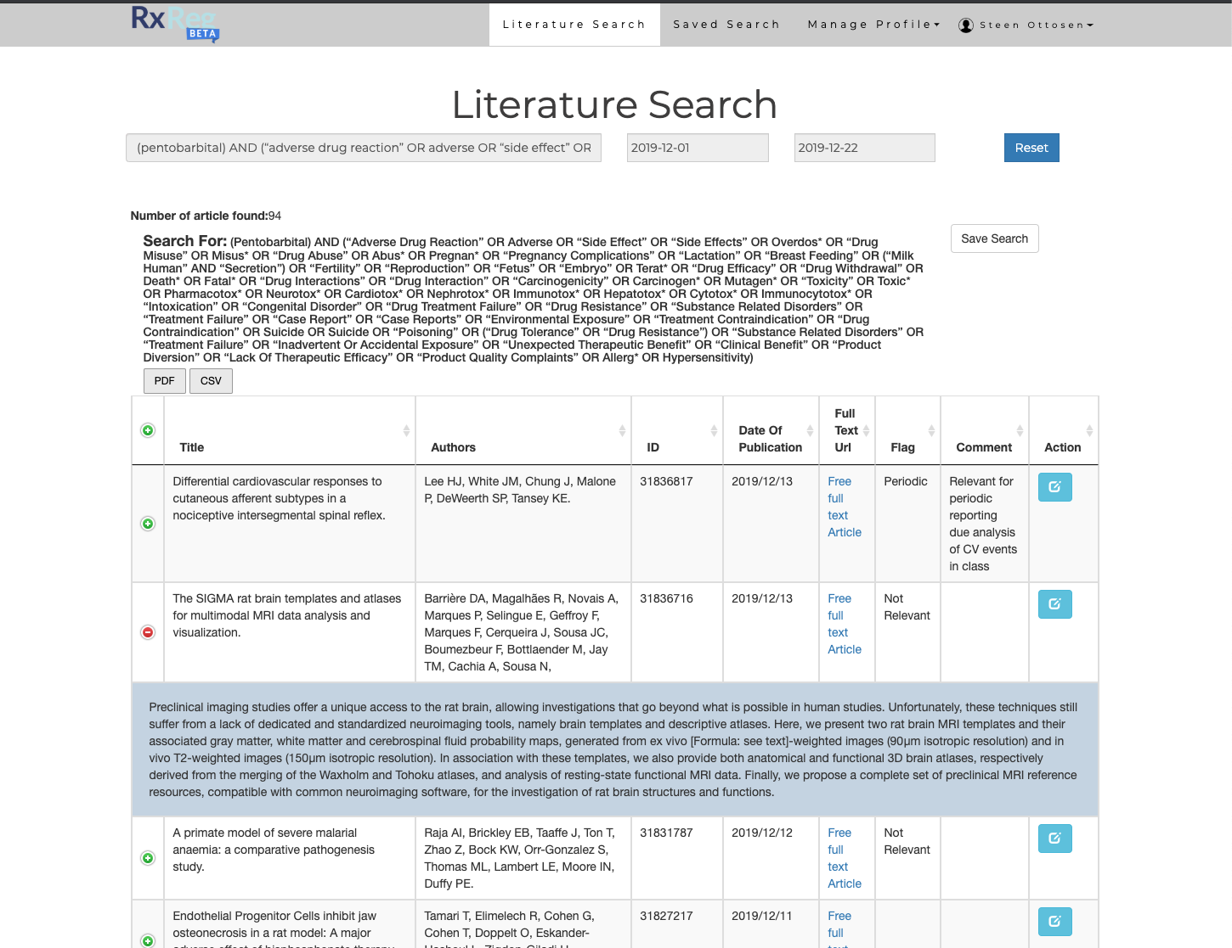
Recent Publications
- FDA Draft Guidance for Industry: Postmarketing Safety Reporting for Human Drug and Biological Products Including Vaccines
- EMA Guideline on good pharmacovigilance practices (GVP) Module VI – Management and reporting of adverse reactions to medicinal products
- CIOMS V: Current Challenges in Pharmacovigilance: A Pragmatic Approach
- ICH E2D: Post-approval safety data management
- ICH E2A: Clinical Safety Data Management: Definitions and Standards for Expedited Reporting

 Steen Ottosen Biography
Dr Steen Ottosen is a physician with a medical degree from the University of Southern Denmark and clinical experience from general surgery as well as family medicine and specialization in public health medicine from the University of Oslo, Norway. He has 20 years of experience in drug safety, medical and regulatory affairs and quality management. He is founder of the drug safety consultancy company Steen Ottosen ApS with consultants and clients in the US and Europe. Previously he has been leading a number of drug safety organizations as well as serving as Qualified Person for Pharmacovigilance around the world including companies like La Jolla Pharmaceutical, Arena Pharmaceuticals, Amgen, PRA International, Pharmion, Genmab and Lundbeck. Dr Ottosen is a physician with a medical degree from the University of Southern Denmark and clinical experience as general surgeon and family medicine. Specialization in public health medicine from University of Oslo, Norway.
Email: sto@ottosen.com

Notes/Comments:

