The effectiveness of antibiotic-loaded bone cement for preventing postoperative infection in patients undergoing total knee arthroplasty
Shu-Hui Wen, PhD, Tzu-Chi University, Taiwan

Abstract (300 word limit)
The study question focuses on the effectiveness of antibiotic-loaded bone cement (ALBC) for preventing postoperative infection in patients undergoing total knee arthroplasty (TKA). Infection has remained being a rare but serious complication after TKA. However, the use of ALBC for reducing the occurrence of infection is debated. We used the National Inpatient Database, which was provided by National Health Research Institutes. We included 16,108 TKA adult patients between January and November, 2012. There were 5,605 patients (34.8%) using ALBC. The postoperative 30-day infection and acute renal failure were compared. We adopted multi-level logistic regression models to adjust for potential confounding factors with consideration of hospital levels (including medical centers, metropolitam hospitals, and local communitiy hospitals). The odds ratio (OR) of infection in ALBC use group and 95% confidence interval (CI) were estimated. The main compositions of ALBC were vancomycin (71.7%), followed by gentamicin (30.7%), and cefuroxime (12.4%). Among patients with ALBC use, 83.8% patient had one type of antibiotics, nevertheless 16.0% patients had two combided antibiotics. We found that the use of ALBC could not reduce the postoperative 30-day infection. When conducting multi-level logistic regression model, there remained no favorable effect of ALBC in reducing postopeartive infection(OR= 0.80, 95% CI: 0.50-1.26, p= 0.329). For risk of acute renal failure for ALBC users, the sample size (n=7) is too small to evaluate. In conclusion, there was no significant benefit of ALBC in reducing postoperative 30-day infection in patients undergoing TKA.

Image
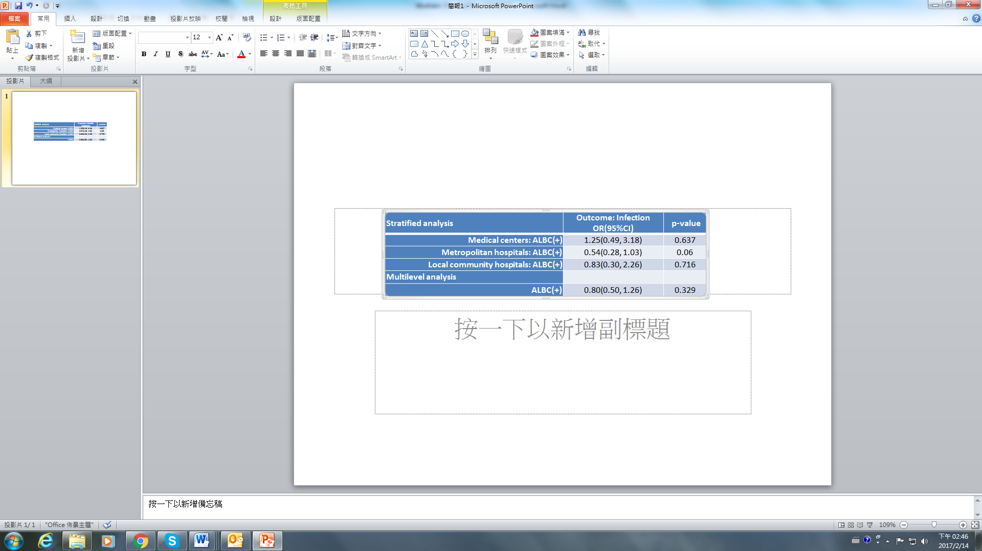
Recent publications (minimum 5)
- K.L. Liu, I.H. Chen, S.H. Wen* (2017) Low dose tranexamic acid reduces blood transfusion rate after total knee arthroplasty: A population-based study in Taiwan. Journal of the Formosan Medical Association Volume 116(1):24–31
- C.S. Hsu, S.H. Wen, J.S. Hung, T.T. Liu, C.H. Yi, W.Y. Lei, F Pace, C.L. Chen* (2017) Overlap of Dyspepsia in Patients with Gastroesophageal Reflux Disease: Impact of Clinical, Metabolic, and Psychosocial Characteristics. Digestive Diseases and Sciences doi:10.1007/s10620-017-4455-8
- C.L. Wu, S.H. Wen* (2016) A 10-year follow-up study of the association between calcium channel blocker use and the risk of dementia in elderly hypertensive patients, Medicine 95:32 e4593
- K. L. Liu, W.T. Wu, J.H. Wang, T.C. Yu, S.H. Wen*, I.H. Chen* (2016) When and how do prosthetic hips fail after total hip arthroplasties? – A retrospective study. Journal of the Formosan Medical Association 115:786-793.
- H.C. Wu, S.H. Wen, J.S. Hwang, S.C. Huang (2015) Validation of the traditional Chinese version of the Menopausal Rating Scale with WHOQOL-BREF. Climacteric. 2015 1:1-20.

Biography (150 word limit)
Shu-Hui Wen has completed her PhD at the age of 28 years from National Taiwan University, Taiwan. She is an associate professor of department of public health, Tzu-Chi University in Taiwan. Recently, her research focuses on the application of statistical techniques to the design, analysis and interpretation of secondary database arising from public health or clinical studies. Together with her students and collaborators, she have been working on different areas of surgical approaches, Chinese medicine and antihypertensive medicines. Currently this has led her to focus on pharmaco-epidemiology research. She has published more than 30 papers in reputed journals.
Email: shwen@gms.tcu.edu.tw

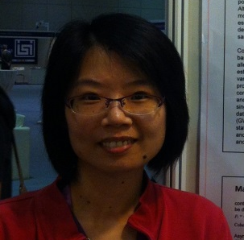

Notes/Comments:

