TITLE: Primary ovarian carcinoid tumour arising in a mature cystic teratoma: A rare case report.

Mahtab Farzin ¹, Parin Tanzifi ¹, Raghwa Sharma ²
¹ NSW Health Pathology, Department of anatomical pathology, Orange Hospital, Orange, NSW, Australia
² NSW Health Pathology, Department of anatomical pathology, Westmead Hospital, Westmead, NSW, Australia

- ABSTRACT BODY
Ovarian mature cystic teratomas represent 20% of ovarian neoplasms with malignant tumours arising within them including adenocarcinoma, thyroid carcinoma, and malignant melanoma¹. Primary ovarian carcinoid tumours (Neuroendocrine Tumours Grade 1) arising from a mature cystic teratoma is very rare with small number of published cases. These neoplasms constitute 0.1% to 0.3% of all ovarian carcinomas and less than 1% of all carcinoid tumours ^{2,3}. These lesions occur mainly in association with mature cystic teratomas. Most patients are postmenopausal and the lesion is invariably unilateral.
We report a 69-year-old lady with a right ovarian cyst on ultrasound and subsequent bilateral salpingo-oophorectomy.
On macroscopic examination (Figure 1) the right ovary included a 75mm mass.
Histology revealed a grade 1 neuroendocrine tumour (carcinoid tumour) arising within a mature cystic teratoma with 60% and 40% of the mass respectively (Figure 2). The neuroendocrine tumour showed insular and nested pattern of polygonal cells with oval nuclei and 1/10 HPF mitoses. Immunohistochemistry (Figure 3) showed positive neuroendocrine markers in the carcinoid component with a low Ki67 proliferation index (1%). This is usually observed in a primary ovarian carcinoid tumour as to metastatic carcinoid tumours with a higher Ki67 proliferation index ³.
Amongst unfavourable prognostic factors are cyst wall invasion, intraoperative rupture of the mass and adhesions ⁴.
This phenomenon is an infrequent pathology and lacks evidence-based guidelines for therapy. Hence worth mentioning as the optimal therapeutic strategy remains the main challenge.
We believe these cases are notable and reportable due to the rarity of the occurrence.

- Images

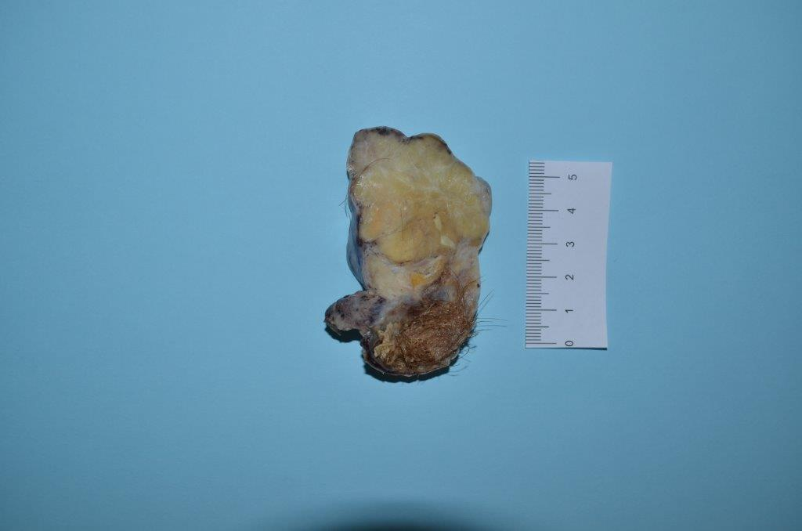

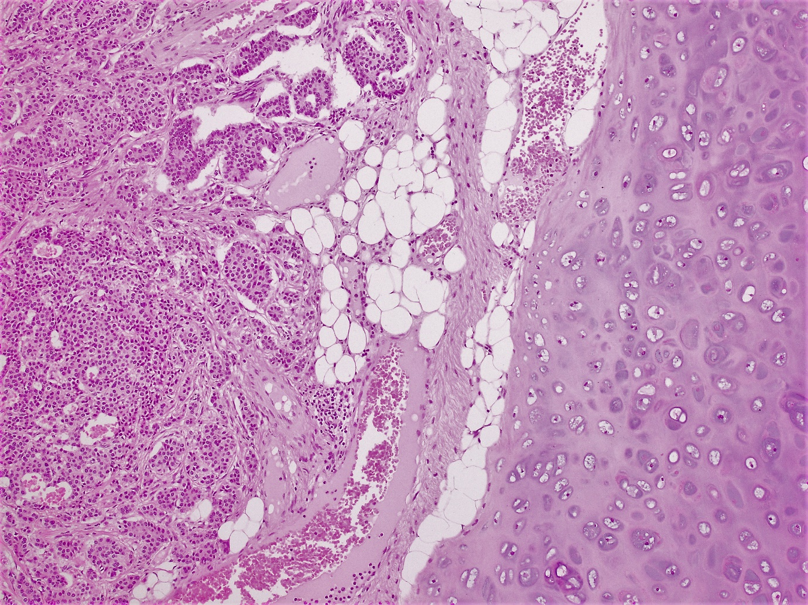
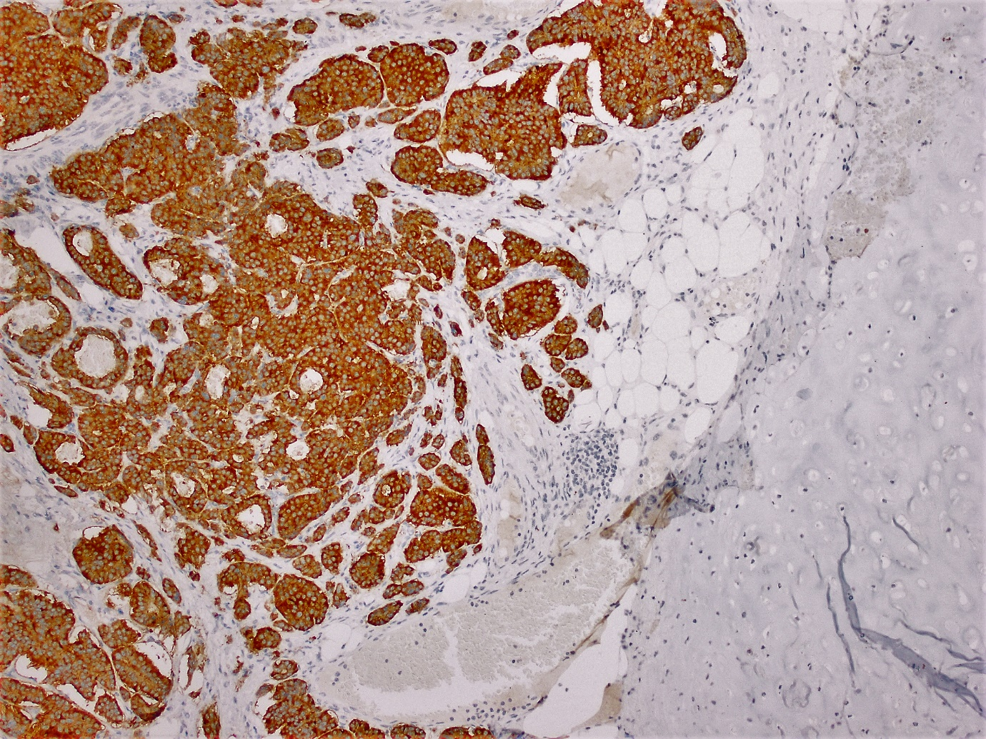

- References

- Petousis S. et al. Case reports in Obstetrics and Gynecology 2013, Article ID 108582, 3 pages.
- Zhang X, Jones A, Jenkins S, Huang Y. ki67 proliferative index in carcinoid tumours involving ovary. Endocrine Pathology Journal 2018; 29:43-48.
- Gonzalez M, et al. Primary ovarian carcinoid tumour arising within a mature cystic teratoma in a 32-years-old patient. Gynecol Reproduct Endocrinol- UK 2018; Volume 2 Issue 1.
- Arora D. S., Haldane S. Carcinosarcoma arising in a dermoid cyst of the ovary. Journal of Clinical Pathology 1996; Volume 49, no. 6, pp. 519-521.

- Biography
Dr M. Farzin has completed MD degree in 2005 and joined the Royal College of Pathologists of Australasia in Sydney, Australia (RCPA) in 2010. She graduated and gained her fellowship (FRCPA) in 2016. She has number of publications, national and international poster presentations during her career.

- Presenting author details

Full Name: Mahtab Farzin
Contact number: 0421177697 (Australia)
Twitter account: Mattie Farzin MD FRCPA @MattieFarzin
Linked In account: Mahtab Farzin
Category: Poster presentation

