Role of IV Immunoglobulin in Indian Children With Guillain-Barré Syndrome
Authors
Mritunjai Kumar, All India Institute of Medical Sciences, Rishikesh, India
Jayantee Kalita, Sanjay Gandhi PGI, Lucknow, India
U K Misra, Sanjay Gandhi PGI, Lucknow, India

Abstract (300 word limit)

Objectives:
To evaluate the outcome of Indian children with Guillain-Barré syndrome who received IV immunoglobulin compared with those who did not receive any specific therapy.

Design:
Single center, prospective cross-sectional study.

Setting:
Tertiary care neurology teaching hospital.

Patients:
Children (≤ 18 yr old) with Guillain-Barré syndrome were included from a prospectively maintained Guillain-Barré syndrome registry from January 2008 to April 2017. Children were classified into acute inflammatory demyelinating polyradiculoneuropathy, acute motor axonal neuropathy, acute motor-sensory axonal neuropathy, and inexcitable motor nerves based on nerve conduction study.

Interventions:
Out of 138 pediatric Guillain-Barré syndrome, 50 received IV immunoglobulin and another 50 age and peak disability matched controls (who did not receive IV immunoglobulin or plasmapheresis) were selected from the same registry for comparison.

Measurements and Main Results:
Outcome at 3 and 6 months was defined on the basis of a 0–10 Clinical Grading Scale into complete (Clinical Grading Scale < 3), partial (Clinical Grading Scale 3–5), and poor (Clinical Grading Scale > 5) recovery. The primary outcome was proportion of patients with complete recovery at 3 and 6 months in IV immunoglobulin and non-IV immunoglobulin groups. Secondary outcomes included in-hospital deaths, duration of mechanical ventilation, and hospital stay. Subgroup analysis was done in acute motor axonal neuropathy and acute inflammatory demyelinating polyradiculoneuropathy groups. The baseline characteristics were similar except for shorter duration of illness and higher proportion of facial palsy in IV immunoglobulin group. Hospital deaths, duration of mechanical ventilation, hospital stay, and outcome at 3 and 6 months were not different between the two groups. Children with acute motor axonal neuropathy had better recovery at 6 months on IV immunoglobulin (58.3% vs 11.1%; p = 0.03), but not those with acute inflammatory demyelinating polyradiculoneuropathy (58.3% vs 72.2%; p = 0.22). In nonambulatory Guillain-Barré syndrome children, complete recovery at 6 months was similar in IV immunoglobulin and non-IV immunoglobulin group (57.4% vs 57.1%; p = 0.98).

Conclusions:
In Indian children with Guillain-Barré syndrome, the outcome at 6 months in IV immunoglobulin treated group was similar to non-IV immunoglobulin group. Children with acute motor axonal neuropathy responded better to IV immunoglobulin.

Image
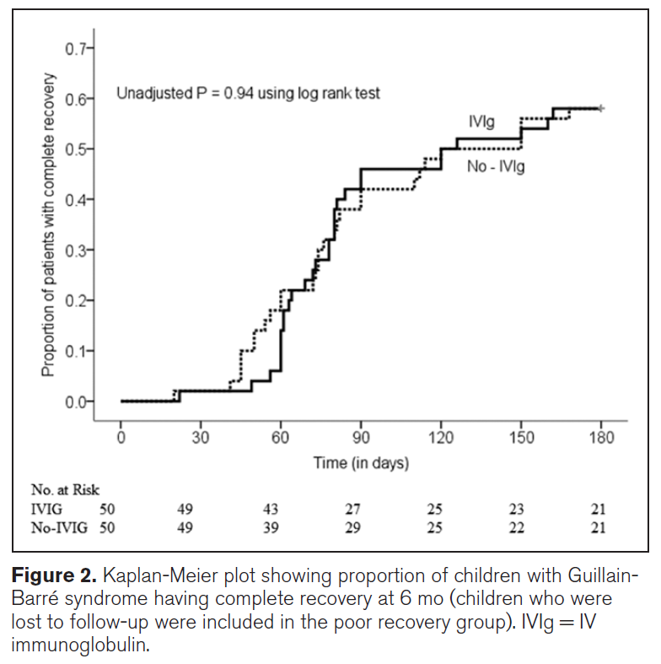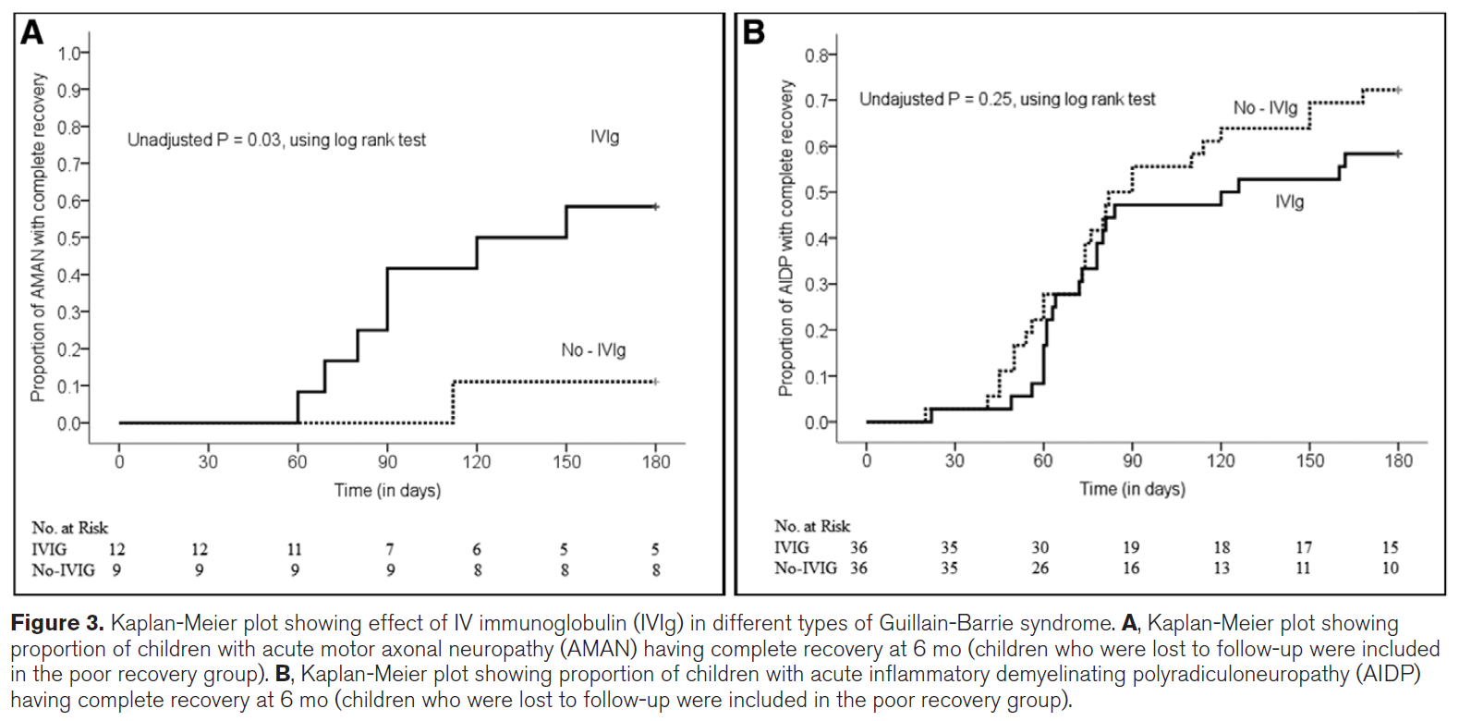

 Recent publications
- Misra UK, Kumar M, Kalita J. Standard versus sequential anti-tubercular treatment in patients with tuberculous meningitis: a randomized controlled trial. Trans R Soc Trop Med Hyg. 2021 Jan 7;115(1):94-102.
- Kumar M, Dhar N, Tiwari A, Siddiqui MS. Comparison of patterns of infarction in TB and cryptococcal meningitis. Trans R Soc Trop Med Hyg. 2021 May 7:trab070.
- Kalita J, Misra UK, Kumar M, Bansal R, Uniyal R. Is Palinopsia in Migraineurs a Phenomenon of Impaired Habituation of Visual Cortical Neurons? Clin EEG Neurosci. 2021 Mar 1:1550059421991707.
- Manchanda R, Dhar N, Kumar M, Kumar N, Tiwari A. Thickened sural nerve in Hansen's disease. QJM. 2021 May 19;114(3):202-203.
- Kumar R, Kataria N, Kumar N, Kumar M. Poststroke depression among stroke survivors in sub-Himalayan region. J Family Med Prim Care (accepted, march).

Biography (150 word limit)
Dr Mritunjai Singh is currently working as an assistant Professor of neurology, AIIMS, Rishikesh, He has special interest in tropical neurology, nerve muscle disorders, stroke, neuro-electrophysiology and critical care neurology. He has published 23 scientific articles in peer reviewed international and national journals in the field of tuberculous meningitis, stroke, Guillian Barre syndrome.
Email: mritunjaikumar@gmail.com

Notes/Comments:

