Nutrition for cancer patients during treatment. New online resources.

Zamora-Ros R^{1*}, Tresserra-Rimbau A^{2,3}
1Unit of Nutrition and Cancer, Cancer Epidemiology Research Program, Catalan Institute of Oncology (ICO), Bellvitge Biomedical Research Institute (IDIBELL), Barcelona, Spain
2Department of Nutrition, Food Sciences and Gastronomy, School of Pharmacy and Food Sciences , University of Barcelona , Barcelona , Spain.
3CIBER Physiopathology of Obesity and Nutrition (CIBEROBN), Institute of Health Carlos III , Madrid, Spain.
*Email: rzamora@idibell.cat
Tel: +34 932607401

Abstract.
Cancer patients and survivors are at risk of poor clinically outcomes due to poor nutritional intake throughout cancer continuum period. Cancer‐related malnutrition is associated with serious adverse consequences, including reduced survival and ability to complete treatment, poorer quality of life and higher costs to the health care system. In general, the goal of nutrition intervention during cancer is to ensure the adequate intake of calories and proteins to preserve muscle mass and to address treatment-related toxicities that affect the ability to eat. Lack of knowledge and health promotion programs are among the reasons for cancer patients not following diet recommendations. Effectively addressing nutrition issues with cancer patients often requires going beyond simply providing 1-time written or brief information to patients and instead can requires continuous supporting with a series of strategies to address patients’ complex needs. Several theory-based programs that includes nutrition education and hands-on cooking classes are showing significant improvements of cancer outcomes.
“Què i com menjar durant el cancer”, “What and how to eat during cancer”, (https://menjardurantelcancer.cat/) provides simple and practical guidelines in English, Spanish and Catalan languages to help cancer patients with the daily management of nutrition during the disease. The project has been developed by researchers, dietitians, nutritionist, chefs, journalists, and TV producers from local institutes in Catalonia, Spain. In the free-access website cancer patients can find audio-visual materials such as recipes designed to alleviate the most common side effects that appear with the disease, explanation of the main side effects, content that helps dispel nutrition and cancer myths, general advices, and first-person reporting.

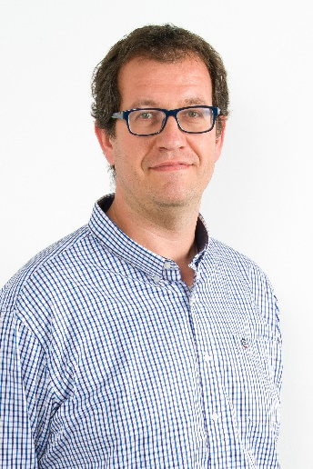
Biography.
Raul Zamora-Ros, PhD, Principal investigator.
ORCID: orcid.org/0000-0002-6236-6804
Raul Zamora-Ros qualified in both Nutrition and Food Science and also obtained a master on Statistics and Epidemiology. He earned his PhD from the University of Barcelona in 2008. He did his PostDoc at the IDIBELL (Barcelona-Spain), International Agency for Research on Cancer (IARC, Lyon-France) and the University of Cambridge (UK), before joining his current position as principal investigator at the Unit of Nutrition and Cancer at IDIBELL. He is interested in whether dietary factors, particularly polyphenols and polyphenol-rich foods, are causally associated with the development and prognosis of chronic diseases, especially cancer. He has published over 100 peer-review articles and above 10 book chapters in his area. His current h-index is 40.

