Prenatal serum ferritin level and its association with Infants’ weight at birth: A Prospective Cohort Study
Dr MBF, PhD, Wollega University, Ethiopia
Dr LO, PhD, Haramya University, Ethiopia
Dr AKT, PhD, Haramya University, Ethiopia
Dr TAY, PhD, Haramya University, Ethiopia
Dr KTR, PhD, Haramya University, Ethiopia

Abstract
Statement of the Problem:: Globally,15 to 20% of all live births each year are of low birth weight (LBW).In humans overly, neonate from iron deficient (ID) mothers at birth were found to have low iron stores, showing there is a restricted capacity for the fetus to store iron from mothers with low accumulation.Although several studies have evaluated the associations between maternal iron status and fetal iron status and growth, the findings remain inconsistent. To our knowledge, this is the first report to examine the association between iron status and birthweight in Eastern Africa, particularly in Ethiopian pregnant women. The aim of this study was to assess the level of maternal ferritin concentration, and the association between prenatal iron status and infants’ weight at birth in Ethiopia. Methodology: A community based prospective cohort study design was conducted. About 427 pregnant women in their second or third gestational trimester were randomly selected and their serum ferritin and concentration was determined at National Clinical Chemistry Reference Laboratory, Ethiopian Public Health Institute. A Poisson regression model with robust variance estimation regression analysis was used to investigate the independent variables association with birthweight. An adjusted prevalence ratio (APR) with 95% confidence interval was reported to show association at p <0.05. Findings: The level of ID based on ferritin
measures was 45.96%. The prevalence was significantly higher among those women who had low diversified diet and lower among those who had antenatal care follow-up. On-the other hand, we found that 20.2% of babies were born with LBW. From our results,prenatal iron deficiency was found to have negative effect on birthweight. Also we observed that, LBW was more likely higher among husbands who were daily labour, women who were undernourished, and women were stunted.However,LBW was less likely lower among females babies.Conclusion & Significance. Prenatal iron deficiency and LBW were frequent in Ethiopia.We recommend it is essential to employ more prospective multicenter studies with larger population using all the available iron biomarkers to elucidate the potential risk factors of prenatal ID and examine its relationship with birthweight.


Photograph
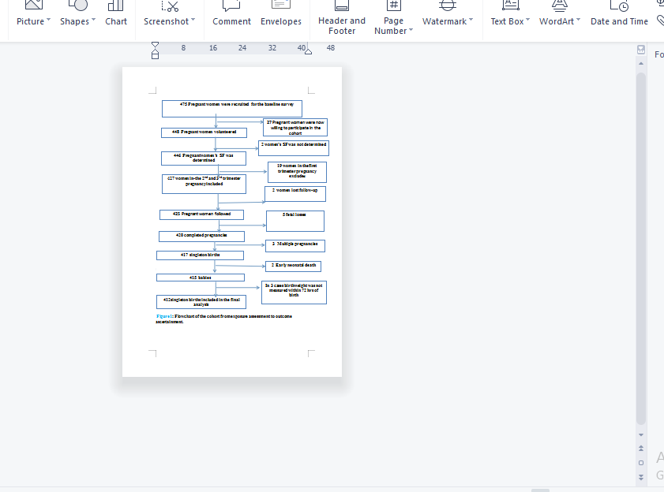
Image

Recent Publications (minimum 5)
- Fite MB, Roba KT, Merga BT, Tefera BN, Beha GA, Gurmessa TT (2021) Factors associated with enrollment for community-based health insurance scheme in Western Ethiopia: Casecontrol study. PLoS ONE 16(6): e0252303. https://
- Fite MB, Roba KT, Oljira L, Tura AK, Yadeta TA (2021) Compliance with Iron and Folic Acid Supplementation (IFAS) and associated factors among pregnant women in Sub-Saharan Africa: A systematic review and meta-analysis. PLoS ONE 16(4): e0249789. https
- Fite MB, Denio AD, Muyhe A, Merdassa E, Desalegn M, Gurmesa TT. Compliance with iron and folic acid supplementation and associated factors among pregnant women in Ethiopia: a systematic review and meta analysis. Int J Sci Rep. 2020 Dec;6(12):514-522 http://www.sci-rep.com doi.org/10.1371/journal.pone.0252303
- Ejeta A, Abdosh T, Hawulte B, Lamessa A, Belete Fite M, Fekadu G. Diabetes Concordant Comorbidities and Associated Factors Among Adult Diabetic Out-Patients at Hiwot Fana Specialized University Hospital, Harar, Eastern Ethiopia: a Cross-Sectional Study. Diabetes Metab Syndr Obes. 2021 May 21;14:2281-2289. doi: 10.2147/DMSO.S308553. PMID: 34045877; PMCID: PMC8149283.
- Babure ZK, Ahmed YM, Likasa ST, Jiru FA, Weldemarium TD, Fite MB (2021) Trend Analysis of Malaria Prevalence in East Wollega Zone, Oromia Regional State, Western Ethiopia, 2020: A retrospective study.. J Women's Health Care 10:515. doi:10.35248/2167 0420.21.10.515.
- Mekonnen R, Admasu D, Belete M (2018) Sero-Prevalence of Hepatitis B Virus and Associated Factors Among Pregnant Mothers Attending Antenatal Care in Public Health Facilities, Dire Dawa. J Med Microb Diagn 7: 281. doi10.4172/2161-0703. 100028
Biography (150 word limit)
Dr.Meseret Belete Fite has his expertise in academic research and teaching in improving the health and wellbeing. He,currently works at the Institute of Health Sciences,Wollega University. He is Public health expert. Meseret is interested to do research on public health Nutrition like Dietary practice, Under-nutrition,Anemia, micro-nutrient deficiency, food consumption effect of micronutrient in birth outcome in Ethiopia and Compliance of IFAS in Sub-Saharan Africa Email: meseretphd2014@gmail.

