Increase Rate of Discharge Before Noon: Improving Patient Throughput
Valerie D. Shaw
Abstract

Abstract
Purpose: The aim of the study was to examine the effect of a standardized discharge checklist and protocol on discharge times and patient throughput in an acute care facility with the primary goal to increase the rate of discharge before noon.
Background: Late afternoon discharges significantly contribute to admission bottlenecks, overcrowding in Emergency Departments (ED), and in inpatient units. Ryckman et al. (2007) cited a lack of improvement in patient throughput has negatively impacted hospital financial performance, disrupt patient flow, negatively impact patient satisfaction, staff retention, referrals, patient safety and reimbursement
Method: A quasi-experimental pretest-posttest design was used for the nurses’ perception of their role in discharge planning utilizing the evidence-based tool, Role Perception of Hospital Nurse Questionnaire. An evidence-based discharge checklist was adopted and used for this project. Statistical analysis utilized a 2-way repeated measures ANOVA and Sidak’s comparisons to compare the data of the pre-test and follow-up survey results.
Sample: Participants n = 26 (n= 24 female and n=2 male).
Results: Survey pre and post results did not show a main effect for the intervention (F(1,12) = 1.55, p = .2369). There was a main effect for discharge time (F(2,24) = 114.69, p < .0001), signifying that differences in the percentage of discharge across time epochs accounted for 86.97% of the variance, with greater amounts of patients being discharged during later time-epochs.
An interaction between the two variables (F(2,24) = 3.62, p < .0422) was also observed (2.75% of the variance), signifying that greater amounts of patients were discharged across time-blocks due to the intervention.
Sidak’s multiple comparisons tests revealed an increased percentage of discharge before noon (t (36) = 2.833, p =.0023
Conclusion: Discharging patients before noon helped to enhance throughput and eliminate a bottleneck in the system. With a successful and sustainable DBN program, the implication at the macro-system level will be large by impacting the patient experience of care, staff satisfaction, decrease the loss of revenue and minimize the number of patients being discharged home on the night shift.
Biography
Valerie Shaw is a healthcare administrator with more than 25 years of proven leadership, management, negotiation, and mentoring experience. Her expertise in patient throughput and flow was the impetus for this line of study. Prior researchers have identified late patient throughput as a aligned practice and decision making with unit and organizational goals. Her technical, analytical and organizational skills, help to facilitate her ability in effectively manage in many levels of healthcare environment, not only in-patient throughput and flow, but in including budget management, cost containment, supply chain management, regulatory compliance management, human resource management, and customer satisfaction initiatives. Proficient in setting goals and mentoring staff to create a high-performance environment. This nurse leader has completed her DNP from Chamberlain University and an MBA from Rutgers University School of Business and her MSN degree from Rutgers University School of Nursing.

PUBLICATIONS
- “Comfort Care in the Previable Neonates,” Neonatal Network, Stringer, M., Shaw, V. and Savani, R., 2004.
- “Normal Newborn Care,” Manual of Neonatal Care, In Dunn, P. (ed.), Price-Douglas, W. & Shaw, V., Little Brown and Company (1998).
- “Common Newborn Concerns,” Manual of Neonatal Care, In Dunn, P. (ed.), Price-Douglas, W. & Shaw, V., Little Brown and Company (1998).
- “Identification of the At Risk Newborn,” March of Dimes Birth Defect Foundation, Bakewell-Sach, S., Shaw, V. & Tashman, A. (October 1997).
- “Dietary Practices and Pregnancy Discomforts Among Urban Blacks,” Journal of Perinatology, Vol. IV, No. 3, 271-280, Gulick, E.E., Shaw, V., Allison, M., 1989.

References
Ryckman, F.C., Adler, E., Anneken, A.M., Bedinghaus, C.A., Clayton, P.J., Hays, K.R., Lee, B.,
Morillo-Deleme, J.W., Schoettker, P.J., Yeton, P.A. & Kotagal, U.R. (2007). Cincinnati children hospital medical center: Redesigning perioperative flow using operations management tools to improve access and safety. In Lituak (2nd edition), Managing Patient Flow in Hospitals: Strategies and Solutions. Pp 97-111. Joint Commission Resources.

Figure 4
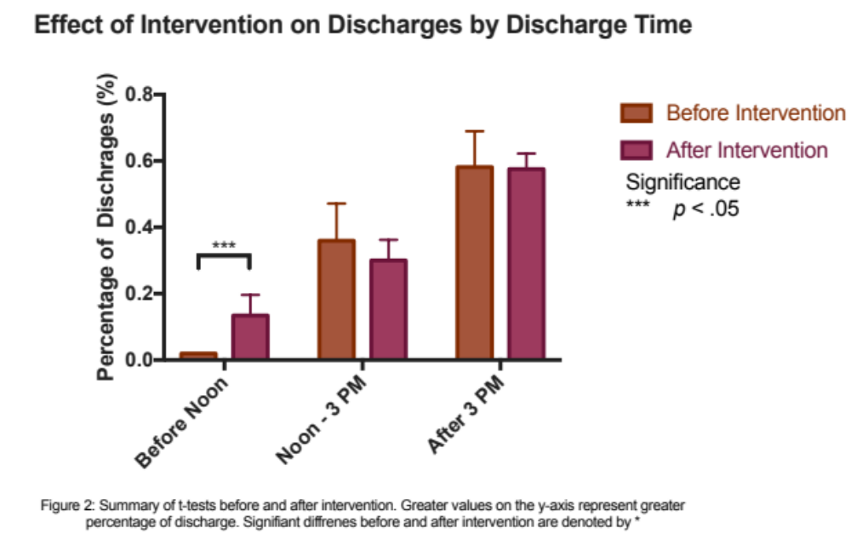
Sidak’s multiple comparisons tests revealed an increased percentage of discharge before noon (t (36) = 2.833, p = .0023).

 | Before Noon | Between 12p-3p | After 3:01p
Before Intervention | 2.00% | 36.00% | 58.19%
After Intervention | 13.44% | 30.53% | 57.55%

