Using space technology as a remedy for diseases caused by environmental factors
Funmilola A Oluwafemi,
National Space Research and Development Agency (NASRDA), Abuja, Nigeria.

Abstract (300 word limit)
Problem Statement:Patients with community/environmental-acquired diseases (e.g. pneumonia, cellulitis, urinary-tract infection) may be treated in hospital or as outpatients, depending on severity. Modern-tool like telemedicine/telehealth, using space-technology have now come-in handy to address issues of disease-surveillance, control-checking, and evaluation.Methodological&Theoretical orientation:Telemedicine at home is used to monitor patients who would normally be hospitalized, and its potential to positively-influence the environment on a worldwide-scale is becoming a reality reaching those never benefited from modern-healthcare practices. Telemedicine is useable as vector-control strategy and surveillance, perspectives on diagnosis, treatment and control of diseases caused by environmental-factor. It’s possible through satellite-remote-sensing technique/Geographic-Information-System enabling surveillance of environmental-conditions for vector-development and disease-transmission; providing information on epidemiology of a region. Such applications in the environmental-factor disease elimination program also have the potential to lessen geographical-disparities, to simplify access to resources, diagnosis, and the knowledge of scarce-specialists; synergizing health centers at local, national and international-levels; and integrating multifaceted intervention and personnel.Findings:Patients treated with telemedicine have satisfactory clinical-outcomes; recovery appearing more-rapid; and resulting in considerable-savings by averting/shortening hospitals stays. Of primary-concern to environmentalists is the greenhouse gases (GHG) emission eliminated in relation to healthcare prevented in patient-travel, hospital-visitors, ambulances, laboratory-delivery, pick-up etc. Traveling to the emergency-room, rehabilitation-facilities, or doctor’s-office for follow-up; environmental-diseases from GHG; and all the cumulative-energy all avoidable. Telemedicine linking the patient and doctor, makes: fewer-buildings required, more efficient-use of hospital space, smaller waiting-rooms, fewer examination-rooms, eliminate travel-costs, reduce accidents while traveling etc.Conclusion&Significance:With environmental-management, disease causing vectors could be greatly reduced/eradicated. Telemedicine-technology: can help co-ordinate strategies to bridge the gap between people and programmer (tele-education, tele-training), especially through video-conferencing; and offers environmental-education and protection to rural people which can aid in destroying disease-vectors habitats. Telemedicine benefits are no longer confined to increasing-access and improving patient-outcomes but a prominent-contributor towards conserving the environment, lowering the carbon-footprint of the health-industry against climate-change.

Image

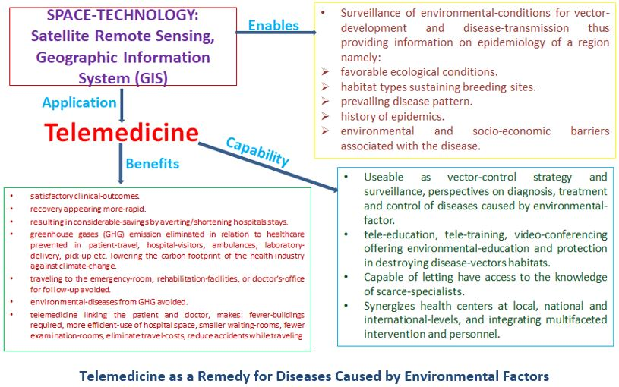
Recent Publications (minimum 5)
- Oluwafemi FA, Abdelbaki R, Lai JCY, Mora-Almanza JG, Afolayan EM (2021) A review of astronaut mental health in manned missions: Potential interventions for cognitive and mental health challenges. Life Sciences in Space Research 28: 26-31. ISSN: 2214-5524. https://doi.org/10.1016/j.lssr.2020.12.002. http://www.sciencedirect.com/science/article/pii/S2214552420300870.
- Jaiyeola OP, Ayegba A, Oluwafunmi FA, Benibo I (2020) Impact of climate change on schizophrenia patients with sex stratifications: Variability of temperature and relative humidity effect. International Journal of Scientific and Research Publications 10: 11. ISSN 2250-3153. Doi: 10.29322/IJSRP.10.11.2020.p10763 http://dx.doi.org/10.29322/IJSRP.10.11.2020.p10763.
- Abdulrashid FA, Oluwafemi FA, Hussaini SJ, Daniel IB, Isah B, Ademu A, Otum AO, Polok AC, Dumbiri CO (2020) Possible solutions to the effects of space environment on astronauts’ physiology. London Journals Press. London Journal of Engineering Research (LJER) 20:5, Compilation 1.0, Print ISSN: 2631-8474 Online ISSN: 2631-8482.
- Enemali JO, Oluwafemi FA, Hussaini SJ, Daniel IB, Ameh O, Adamu A, Agboola OA (2020) Microgravity: A tool for protein drug development. International Journal of Pharmaceutical Sciences Review and Research 64: 2, 14, 82-86. ISSN 0976 – 044X. Doi: 10.47583/ijpsrr.2020.v64i02.014.
- Oluwafemi FA, Ibraheem O, Fatoki TH (2020) Clinostat microgravity impact on root morphology of selected nutritional and economic crops. Plant Cell Biotechnology and Molecular Biology 21(43&44):92-104. ISSN: 0972-2025.
- Jaiyeola PO, Oluwafemi FA, Otum AO, Tomori OS, Bemibo IE, Ayegba A (2020) Impact of microgravity environment on body mass: Case study of lizards. International Journal of Engineering and Applied Sciences (IJEAS) 7: 8. ISSN: 2394-3661.
- Jaiyeola OP, Ayegba AS, Oluwafemi FA, Ulaetor ES (2020) Impact of climate change on epileptic patients with sex stratifications: Variability of temperature and relative humidity effects. International Journal of Trend in Research and Development (IJTRD) 7: 1. ISSN: 2394-9333. http://www.ijtrd.com/papers/IJTRD21979.pdf
- Oluwafemi FA (2020) Using space technology to combat the role of microplastics in climate change. United Nations/Austria Symposium: “Space Applications for Sustainable Development Goal 13: Climate Action” (Virtual), 1-3 September, 2020.
- Afolayan EM, Oluwafemi FA, Jeff-Agboola EO, Oluwasegun T, Ayankale JO (2019) Socio-economic benefits of microgravity research. Arid Zone Journal of Engineering, Technology and Environment (AZOJETE). Centre for Satellite Technology Development Special Issue: Space Science and Technology for Sustainable Development 15(SP.i2): 57-74. Print ISSN: 1596-2490, Electron vic ISSN: 2545-5818.
- Oluwafemi FA, Olubiyi RA (2019) Space technology applications for water quality in sustainable development. Arid Zone Journal of Engineering, Technology and Environment (AZOJETE). Centre for Satellite Technology Development Special Issue: Space Science and Technology for Sustainable Development 15(SP.i2): 100-109. Print ISSN: 1596-2490, Electronic ISSN: 2545-5818.
- Oluwafemi FA, Olubiyi RA (2019) Investigation of corn seeds growth under simulated microgravity. Arid Zone Journal of Engineering, Technology and Environment (AZOJETE). Centre for Satellite Technology Development Special Issue: Space Science and Technology for Sustainable Development 15(SP.i2): 110-115. Print ISSN: 1596-2490, Electronic ISSN: 2545-5818.
- Jaiyeola OP, Oluwafemi FA, Ayegba AS (2019) Microgravity and infertility. International Journal of Trend in Scientific Research and Development (IJTSRD) 3(6):190-195. ISSN: 2456-6470. https://www.ijtsrd.com/papers/ijtsrd29408.pdf.
- Jaiyeola OP, Oluwafemi FA, Ayegba AS (2019) Effects of microgravity on sexual organs. International Journal of Trend in Scientific Research and Development (IJTSRD), 3(6):182-189. ISSN: 2456-6470. https://www.ijtsrd.com/papers/ijtsrd29407.pdf.
- Oluwafemi F, Olubiyi R, Ibraheem O (2019) Space environment: A classical study for all research fields (Poster). United Nations /Austria World Space Forum: ‘Access to Space for All’, Vienna, Austria, 18-22 November, 2019.
- Oluwafemi FA, De La Torre A, Afolayan EM, Olalekan-Ajayi BM, Dhital B, Mora-Almanza JG, Potrivitu G, Creech J, Rivolta A (2018) Space food and nutrition in a long-term manned mission. Springer: Advances in Astronautics Science and Technology 1: 1-21. https://doi.org/10.1007/s42423-018-0016-2. https://rdcu.be/bPumi.
- Oluwafemi FA, Olubiyi RA (2018). Space technologies application micros studies in global health for sustainable development: Microgravity, microplastics, microbiology. Proceedings of United Nations / Germany High Level Forum: The way forward after UNISPACE+50 and on Space2030, Bonn, Germany, 13-16 November, 2018.
- Oluwafemi FA, Dhital B, Afolayan EM, Abdelbaki R, De La Torre A, Olalekan-Ajayi BM, Mora-Almanza JG (2018) Astronautical hygiene: A communal discipline to space medicine and a preventive measure to space diseases. IAC-18,A1,3,16,x44086, Proceedings of the 69th International Astronautical Congress (IAC), Bremen, Germany, 1-5 October, 2018.
- Oluwafemi FA, Olubiyi RA (2018) Microplastics as environmental stressor and threat to human and sea life. Proceedings of United Nations/Pakistan Conference on Space Technology for Water Management, Islamabad, Pakistan, 26 February-2 March, 2018.
- Oluwafemi F (2017) Microgravity research and applications: Roles in economic prosperity and poverty reduction. Proceedings of United Nations/United Arab Emirates, High Level Forum “Space as a Driver for Socio-Economic Sustainable Development”, Dubai, United Arab Emirates, 6-9 November, 2017.
- Oluwafemi FA (2016) Investigation of growth and biological processes of some Nigerian indigenous plants in a microgravity environment using a clinostat. Proceedings of the 4th Biennial International Conference and Exhibition on Environmental Issues (ICEI4), Abuja, Nigeria, 17-20 April, 2016.


Biography (150 word limit)
Funmilola Oluwafemi is a Space Bio-Scientist, the Astrobiology Unit Head and the Leading Expert of Microgravity Research at the Space Agency of Nigeria – National Space Research and Development Agency (NASRDA), Abuja, Nigeria. She is an educationist, researcher, teacher, writer, and counsellor on space matters, who’s also a winner of several moral and academic awards with publications in several reputable journals and magazines.
Email: oluwafemifunmilola@gmail.com

Notes/Comments:

