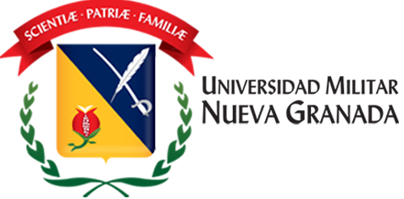
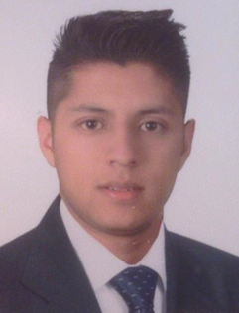

Effect of a commercial presentation of glyphosate on the preoptic area and the hypothalamus in Cardinal Tetra (Paracheirodon axelrodi)
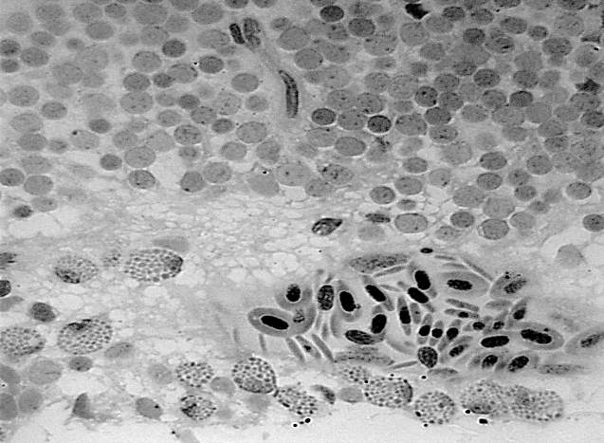
Camilo Riaño MsCc, Laura Rincón PhDc, Hernán Hurtado PhD, Edwin Gómez MsC
PGZ

Vi

Figure 1. Treatment with 5 mg / L of Roundup Active® with MSCs (red arrows). Details of the periventricular gray zone optic tectum (PGZ) with an internal blood vessel (Vi). Bar 25 µm.
Abstract
Statement of the Problem: The use of commercial presentations of glyphosate (Roundup®) in Colombia has generated negative effects on the health of humans and animals due to the fumigations both agriculture and of Colombian drug policy. Much of the application of this herbicide is done near the Orinoco river basins inhabited by Neon Cardinal (Paracheirodon axelrodi), the ornamental fish that is exported in more number per individuals in Colombia. Methodology: an experiment was conducted with four treatments, 0 mg / L (Tr0), 0.1 mg / L (Tr1), 1 mg / L (Tr2) and 5 mg / L (Tr3) to determine the effect of a commercial formula of glyphosate (Roundup Active®) on preoptic area and hypothalamus of P. axelrodi. Individuals were processed for optical microscopy of high resolution (MOAR) and transmission electron microscopy (TEM). Results and Discussion: The main attributed effect Roundup Active® was the presence of cells similar to mast cells (MSCs) associated with the bloodstream, but also was found in some neuronal nuclei of the preoptic area (PA) and diencefálica posterior region (DPR) which it includes the hypothalamus being more abundant in Tr3. The appearance of MSCs is indicative of stress related to increased concentration of Roundup Active®. These cells are involved in inflammatory, allergic response, immunological tasks which shows a risk in reproductive dynamics, integration of visual, olfactory and sensory information, among other processes, which can reduce the reproductive success and survival capacity of the decreasing species population, and at the same time, affecting the domestic market of ornamental fish exports.
Barišića J, Dragunb K, Ramanic S, Marijićb V, Krasnićib N, Čož-Rakovaca R, Kostovd V, Reboke K, Jordanovae, M (2015) Evaluation of histopathological alterations in the gills of Vardar chub (Squalius vardarensis Karaman) as an indicator of river pollution. Ecotoxicology and Environmental Safety.
Cattaneo R, Clasen B, Lucia Loro V, Cavalheiro de Menezes C, Pretto A, Baldisserotto B, Santi A, de Avila L (2011) Toxicological Responses of Cyprinus carpio Exposed to a Commercial Formulation Containing Glyphosate Bull Environ Contam Toxicol. 87:597–602.
Glusczak L, Dos Santos DM, Silveira BM, Rodrigues RS, Chitolina RS, Morsch VM, Loro VL (2007) Acute effects of glyphosate herbicide on metabolic and enzymatic parameters of silver catfish (Rhamdia quelen). Comparative Biochemistry and Physiology, Part C 146: 519–524.

Keywords: Glyphosate, brain, Cells similar to Mast Cells (MSCs), survival.
Biography
Camilo Riaño has experience in environmental toxicology and histopathology, the investigations of the working group to which he belongs are focused on reporting the impacts of various herbicides on the organs and tissues of native Colombian fish and other model organisms.
Presenting author details
Full name (As per the passport): Camilo Andres Riaño Quintero
University/Industry/Organization name: Universidad Militar Nueva Granada
Designation (Director/Prof/Assistant or Associate prof/Researcher/Student): Master Student
Country: Colombia
Mobile number (country code – number): +57 3184331160
Email: u0500743@unimilitar.edu.co
Category (Oral presentation/ Poster presentation/Young researcher forum/E-poster): Poster presentation
Research interest: Envi. Toxicology, Pathology, Histology.
Your profile page URL in your department:
Year of birth: 1992
Linked In/Facebook/twitter account: https://www.facebook.com/camiloandresq1

